Method and Results
Zihao Zhang
2026-07-03

Vignette Effects

Multilevel Models
To examine the importance of different CARIN principles in people’s perceptions of welfare deservingness, we estimate the effect of vignette features on respondents’ deservingness ratings in the vignettes using hierarchical linear models with random intercept for each respondents.
Figure 1 shows that volunteering appears to be the most important feature shaping respondents’ deservingness judgements. Compared with someone who does not volunteer, a (hypothetical) person who volunteers for two hours per week receives a substantially higher deservingness rating by 0.52 units, and the effects are stronger for four and six hours at 0.61 and 0.76 units. The result provides clear support for the Reciprocity principle: people are judged as more deserving of welfare support when they are seen as having given something back to society. The monotonic increase across volunteering levels further suggests that respondents are not merely distinguishing volunteers from non-volunteers, but are sensitive to the extent of contribution.
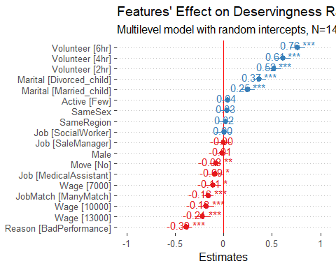
Figure 1
However, there is little evidence of differential perceptions by the person’s previous occupation. Relative to being a mechanician, being a social worker or sale manager does not significant change people’s perception of the hypothetical person’s welfare deservingness. Being a medical assistant, which we expect to signal pro-social behaviours, in fact leads to significantly, though moderately, lower perceived deservingness by 0.09 units. The occupation effects therefore do not support the Reciprocity principle. This null result, however, could be due to that the occupations do not clearly signal pro-social behaviours, but are instead confounded with industry and occupation-specific preconceptions.
The second strongest feature is the reason of job loss. Relative to unemployment due to company bankruptcy, being fire due to poor performance leads to a 0.39-unit decrease in perceived welfare deservingness. This indicates that respondents are much less willing to regard someone as deserving when their unemployment can be attributed to their own poor performance. This result supports the Control principle in the CARIN framework. Consistent with the Control principle, the hypothetical person is perceived as less deserving of welfare when there are many suitable jobs on the market, which means that the person has more control and thus responsibility for its situation.
The third most important feature is the person’s marital status, followed by the monthly income from their previous job. Compared to being single, being married and having a three-old child leads to a significant increase in perceived welfare deservingness by 0.25 units. The effect is even stronger for being divorced and having a three-old child, increasing to 0.37 units. Regarding income, higher income monotonically leads to lower perceived deservingness. Relative to a person who earns 4000 yuan a month from their previously job, a otherwise the same person that earns 13000 yuan receives 0.21 unit lower deservingness rating. These results strongly support the Need principle, as people preceive people in greater material needs more deserved of welfare assistance.
Finally, there is little support for the Attitude and Identity principles. Although unwillingness to relocate leads to significantly lower perceived deservingness, relative to being willing to relocate, the 0.08-unit decrease is relatively small. There is no significant difference between people who have sent many and few job applications. The person’s gender and region of origin and whether they have the gender or region as the respondents do not affect the perceived deservingness.

FE Models
Figure 2 shows that respondent fixed effect model yield almost identical results.
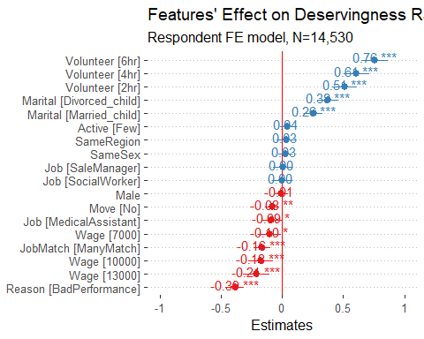
Figure 2

Respondent Charactertistics and Deservingness Rating
Here we explore how respondents’ deservingness perceptions and attitudes vary by their socio-demographic grounds. We consider the respondents’ average rating score in the vignette experiment and answers in the CARIN scale, summarised by a single factor.

Mean Vignette Rating
Overall, Figure 3 shows the average deservingness ratings in the vignette experiments are quite consistent across respondents. Except that unemployed respondents, on average, give significantly lower rating by 2.4 units, there are no significant differences by respondent characteristics, controlling for all other characteristics.
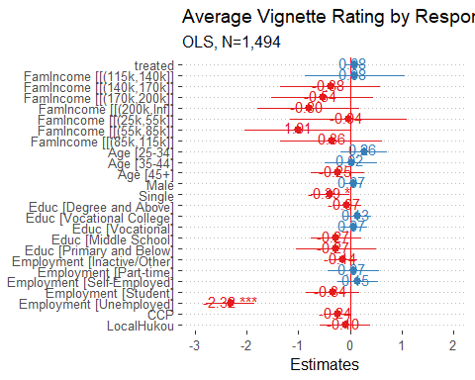
Figure 3

CARIN Factor
In contrast to the result on average vignette rating, respondents’ welfare attitude measured by the CARIN answers shows a more differentiated pattern. With greater values indicating less supportive attitudes toward generous welfare provision, Figure 4 shows that, controlling for other characteristics, respondents with higher household income are less supportive of generous welfare provision. Respondents with local hukou status is also less supportive of generous welfare.
Furthermore, interestingly, compared to full-time employed respondents, students and unemployed and economically inactive (e.g., retired, housewife/husband) respondents show less supportive positions. There is no significant difference between full-time, part-time and self-employed respondents. The pattern may suggest that labour market participation is an important factor shaping individuals’ attitudes toward welfare allocation.
Relative to respondents with high school education, there is no significant difference by education, except that respondents with middle school education have, on average, significantly more supportive attitude to generous welfare. There is also no significant age difference.
Overall, the result with answers to CARIN questions shows more substantial variation in people’s attitudes toward welfare allocation, particularly by household economic conditions and individuals’ labour market participation. Compared to the result based on mean vignette ratings, which show less variation by respondents’ characteristics, the result may suggest that people follow different logics when making contextual judgements and general claims about attitudes.
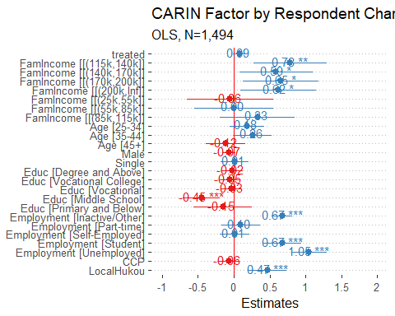
Figure 4

Moderating effect

With interaction
To examine whether people’s principles of deservingness judgement are affected by information about inequality, we estimate a multilevel model with all vignette dimensions interacted with the information treatment.
Figure 5 shows that all interactions between the vignette dimensions and the treatment are statistically insignificant, suggesting that people’s judgement principles are insensitive to the information exposure.
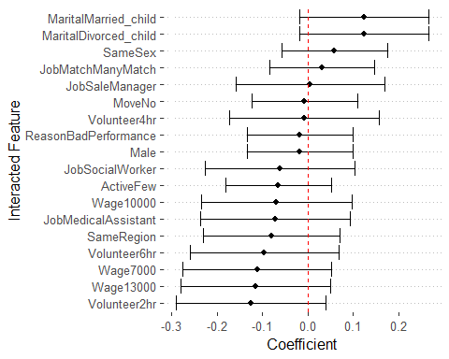
Figure 5

Ex-Post Power Analysis
However, the insignificant moderating effect in Figure 5 could be due the lack of statistical power instead of true null effects. To examine this possibility, we calculate the minimum detectable effect (MDE) for each interaction term. The MDE was obtained by multiplying the robust standard error of each interaction coefficient by 2.8, corresponding to 80 percent power (two-tailed α = 0.05). We then expressed these values as standardized effect sizes (Cohen’s d) by dividing the MDE by the standard deviation of the dependent variable (2.4).
Figure 6 shows that the resulting Cohen’s d values are all below 0.1, indicating that the study is well powered to detect very small effects.
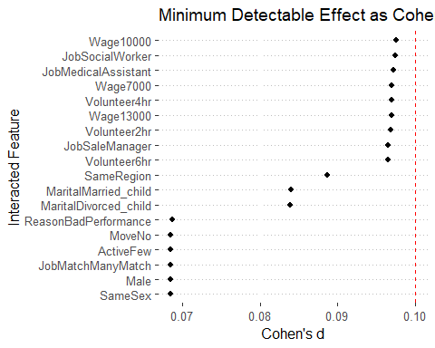
Figure 6

Interaction Effect Heterogeneity
Figure 5 shows the average moderating effects of the information treatment are statistically insignificant. However, there could be effect heterogeneity in which the moderating effect is stronger for some respondents. To test this possibility, we leverage the hierarchical structure of the data. With vignettes nested in respondents, we estimated multilevel models with random slopes for the interaction between the treatment and each vignette dimension.
Table 1 compares the logged likelihood of the baseline model without random slopes and models with random slopes for the interaction between treatment and vignette dimensions. 5 out of 11 models show statistically significant improvement in model fit, however, the magnitudes are all very small. The results suggest that for all dimensions, there is no or very small heterogeneity in people’s response to the information treatment.
Table 1: Model Fit with and without Random Slopes
Dimension | Baseline LL | LL w/ RS | p
Male | -30108.94 | -30108.70 | 0.79
Reason | -30108.94 | -29996.68 | 0.00
Job | -30108.94 | -30105.24 | 0.92
JobMatch | -30108.94 | -30089.25 | 0.00
Wage | -30108.94 | -30026.07 | 0.00
Move | -30108.94 | -30108.12 | 0.90
Marital | -30108.94 | -30075.01 | 0.00
Active | -30108.94 | -30108.08 | 0.89
Volunteer | -30108.94 | -30014.42 | 0.00
SameSex | -30108.94 | -30108.94 | 1.00
SameRegion | -30108.94 | -30108.77 | 0.84

Figure 7 shows the distributions of the predicted random slopes for each interaction term. Figure 8 shows the same distribution, grouped by vignette dimensions. The figures show that, consistent with the result in Table 1, the predicted random slopes for all feature concentrate around 0 with small variation.
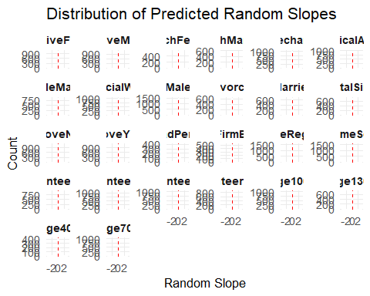
Figure 7
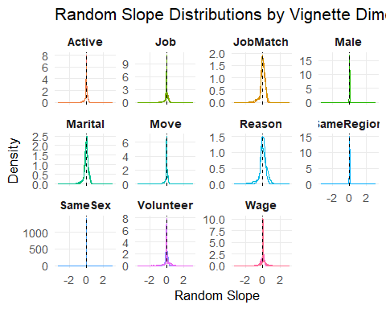
Figure 8

With stratified samples
Respondent FE models stratified by information treatment status, then stratified by subjective estimation or household income.
No consistent evidence for significant moderating effect.

All observations
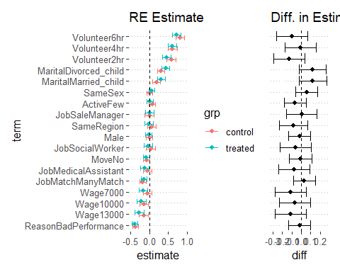

Stratified by subjective estimation
Respondents receive different information (i.e., accurately estimate/underestimate/overestimate their position) when receive the information treatment depending on their subjective evaluation of their relative economic positions. As shown above, respondents who overestimate their positions have significantly lower household income. This may create effect heterogeneity that is not accounted for when using the complete sample. Therefore, we fit the model separately for respondents who accurately estimate, underestimate and overestimate their economic positions; and seperately for respondents in different houesehold income quantiles.
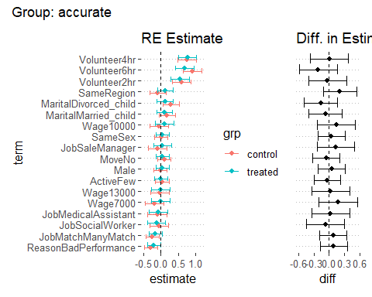
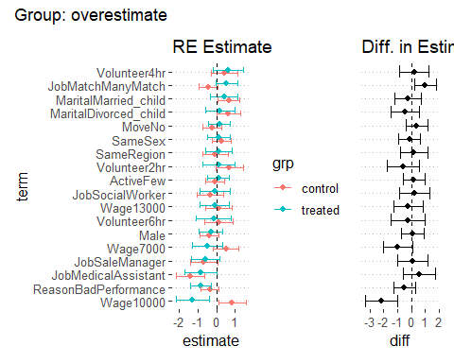
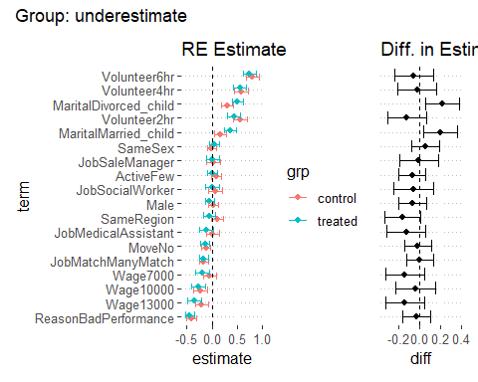

Stratified by household income
The 1st to the 3rd quantiles are combined because the proportions are too small (combined to 7.09%). People in the 1st to the 3rd quantiles appear to be more responsive to the person’s wage and occupation. The information treatment leads to more negative rating (or the untreated have less negative ratings?).
