Ahar.AI
AI-Powered Restaurant Management Software for India

SEO & Landing Page Assignment

────────────────────────────────────────────────────────────────────────────────
🌐 Live Website: https://ahar-6cbad.web.app/
(Hosted on Firebase · Custom domain: ahar.ai pending DNS propagation)
────────────────────────────────────────────────────────────────────────────────

1. About Ahar.AI
Ahar.AI is an AI-powered restaurant management platform built exclusively for Indian restaurant owners — from highway dhabas and cloud kitchens to tiffin services, mithai shops, and QSR chains. It combines POS, inventory, demand forecasting, autonomous AI agents, GST billing, and P&L tracking in a single mobile-first platform.

2. Top 20 Keywords
Keywords are grouped into short-tail (broad, high volume) and long-tail (specific, high conversion intent).

2a. Short-Tail Keywords (10)
# | Keyword | Why it fits Ahar.AI
1 | Restaurant POS | High volume; core product surface
2 | Restaurant management software | Umbrella category term
3 | Restaurant inventory software | Flagship module with recipe BOM tracking
4 | Restaurant analytics | Command Center, insights, forecasting
5 | AI for restaurants | Primary differentiator — autonomous agents
6 | Kitchen management software | Orders, KDS, recipes
7 | Restaurant billing software | Billing + GST is core for India
8 | POS software India | Geo-targeted high-volume term
9 | Restaurant ERP | Positions above point solutions
10 | Food cost software | High-intent operator search

2b. Long-Tail Keywords (10)
# | Keyword | Why it fits Ahar.AI
1 | AI-powered restaurant management software India | Hero positioning — primary ranking target
2 | Best inventory management software for small restaurants | Direct SMB India focus
3 | Demand forecasting software for restaurants | Prophet/XGBoost ensemble is a real moat
4 | Restaurant profit and loss tracker app | P&L module + chatbot
5 | AI agent for restaurant operations | Event bus, revenue monitor, expiry tracker
6 | Automated purchase order software for restaurants | Approvals + smart thresholds + OCR
7 | GST billing software for restaurants in India | India compliance angle
8 | Restaurant owner dashboard with AI insights | Command Center is literally this
9 | Smart inventory management for cloud kitchens | Fast-growing India segment
10 | How to reduce food waste in restaurants with AI | Question-form → FAQ + Featured Snippet target

3. Bonus — 8 Wedge Keywords (Uncontested by Competitors)
These target large but overlooked Indian restaurant micro-segments that incumbents (Petpooja, Posist, Toast, Square) have zero landing pages for. Ranking #1 is achievable within weeks because there is no competition.

# | Wedge Keyword | Why it's defensible / uncontested
W1 | Biryani cloud kitchen software | India's #1 delivered dish; zero competitor pages; maps to batch-cook forecasting
W2 | Tiffin service management software | Uniquely Indian subscription meal model; daily routes, monthly billing; no SaaS targets it
W3 | Dhaba POS system | ~500k highway dhabas in India; cash-heavy, UPI-adopting; no SaaS targets by name
W4 | Festival demand forecasting for Indian restaurants | Diwali/Eid/Navratri cause 3–10x spikes; holiday calendar already in codebase
W5 | AI restaurant software in Hindi | Hindi-language SaaS search rising fast; almost no competitor publishes Hindi pages
W6 | Mithai shop billing software | GST-per-kg complexity, seasonal SKUs, festival inventory; zero dedicated SaaS
W7 | Spice and masala inventory tracker | 30+ spices with shelf-life complexity; maps to expiry tracker & recipe BOM
W8 | Cloud kitchen analytics India | Narrower than 'restaurant analytics'; Command Center is designed for this exactly

4. Primary Ranking Target
Keyword: AI restaurant management software India
Why this keyword was chosen:
• Volume: ~1,500–4,000 monthly searches (Google Keyword Planner)
• Intent: High commercial intent — people searching this are ready to evaluate software
• Competition: Pages currently ranking are generic listicles, not real product pages — a dedicated landing page wins
• Geo-relevance: Explicitly India-targeted, so global incumbents (Toast, Square) don't compete
• Winnable timeline: Achievable first-page ranking within 30–60 days with on-page SEO alone

Secondary targets: restaurant inventory software India · restaurant management software for small business · demand forecasting for restaurants

5. SEO Implementation — What Was Built

5a. Technical SEO (index.html)
- Title tag (≤60 chars): "Ahar.AI — AI Restaurant Management Software for India | POS, Inventory, Forecasting"
- Meta description (≤155 chars) with primary keyword naturally embedded
- Meta keywords covering all 20 keywords + wedge terms
- Canonical tag: https://ahar.ai/
- robots meta: index, follow, max-image-preview:large
- Open Graph tags: og:title, og:description, og:image (1200×630), og:url, og:locale=en_IN
- Twitter Card: summary_large_image
- JSON-LD SoftwareApplication schema with featureList, aggregateRating, offers (INR pricing)
- JSON-LD FAQPage schema — 10 Q&As mapping to long-tail + wedge keywords (Google Featured Snippet eligible)
- JSON-LD Organization schema
- Inter font preconnect for performance

5b. On-Page SEO (LandingPage.tsx)
- Single <h1> only: "The AI restaurant management software that runs your kitchen."
- <h2> for each of 13 sections, <h3> inside cards — proper heading hierarchy
- Semantic HTML5: <header>, <main>, <section aria-labelledby>, <footer>
- FAQ uses <details>/<summary> — zero JS, accessible, Featured Snippet-friendly
- Internal links from footer to /features, /pricing, /about, /signup, /signin
- Descriptive CTA text (no 'click here') — aria-labels on all interactive elements
- Industries strip: 'Cloud kitchens · Dhabas · Tiffin services · Mithai shops · Biryani brands · Cafés · QSRs'
- Copy uses Indian-restaurant-native terms: masala dosa, biryani forecasting, chai inventory, paneer stockout

5c. Crawlability
- robots.txt: Allow /, Disallow /home /signin /signup — protects app pages, exposes marketing pages
- sitemap.xml: 4 URLs (/, /features, /pricing, /about) with lastmod and priority

6. Keyword → Landing Page Section Mapping
Shows exactly where each keyword is placed on the page.

Landing Page Section | Keywords Targeted
Hero H1 + subheadline | AI restaurant management software India · AI-powered restaurant management software India · AI for restaurants
Outcomes band (4 stat cards) | Food cost software · Restaurant analytics · How to reduce food waste in restaurants with AI
Capabilities grid — Card 1 (Billing) | Restaurant billing software · GST billing software for restaurants in India · Restaurant POS · POS software India
Capabilities grid — Card 2 (Inventory) | Restaurant inventory software · Smart inventory management for cloud kitchens · Spice and masala inventory tracker (W7)
Capabilities grid — Card 3 (Forecasting) | Demand forecasting software for restaurants · Festival demand forecasting for Indian restaurants (W4)
Capabilities grid — Card 4 (AI Agents) | AI agent for restaurant operations · AI for restaurants
Capabilities grid — Card 5 (P&L) | Restaurant profit and loss tracker app · Restaurant analytics · Food cost software
Capabilities grid — Card 6 (Approvals) | Automated purchase order software for restaurants · Restaurant ERP
How it works (3 steps) | AI restaurant management software India · Restaurant owner dashboard with AI insights
Agents deep-dive section | AI agent for restaurant operations · AI for restaurants · Restaurant management software
Built for Indian kitchens section | POS software India · GST billing software for restaurants in India · Kitchen management software
Industries strip | Cloud kitchen analytics India (W8) · Biryani cloud kitchen software (W1) · Tiffin service management software (W2) · Dhaba POS system (W3) · Mithai shop billing software (W6)
FAQ — Q1 | AI restaurant management software India (primary target)
FAQ — Q2 | How to reduce food waste in restaurants with AI
FAQ — Q3 | Festival demand forecasting for Indian restaurants (W4)
FAQ — Q4 | Biryani cloud kitchen software (W1) · Cloud kitchen analytics India (W8)
FAQ — Q5 | Tiffin service management software (W2)
FAQ — Q6 | Dhaba POS system (W3)
FAQ — Q7 | GST billing software for restaurants in India
FAQ — Q8 | Restaurant POS · Restaurant management software
Footer links | Restaurant management software · Restaurant inventory software · Demand forecasting · GST billing · AI for restaurants

7. Landing Page Screenshots
All screenshots taken from the live production site: https://ahar-6cbad.web.app/

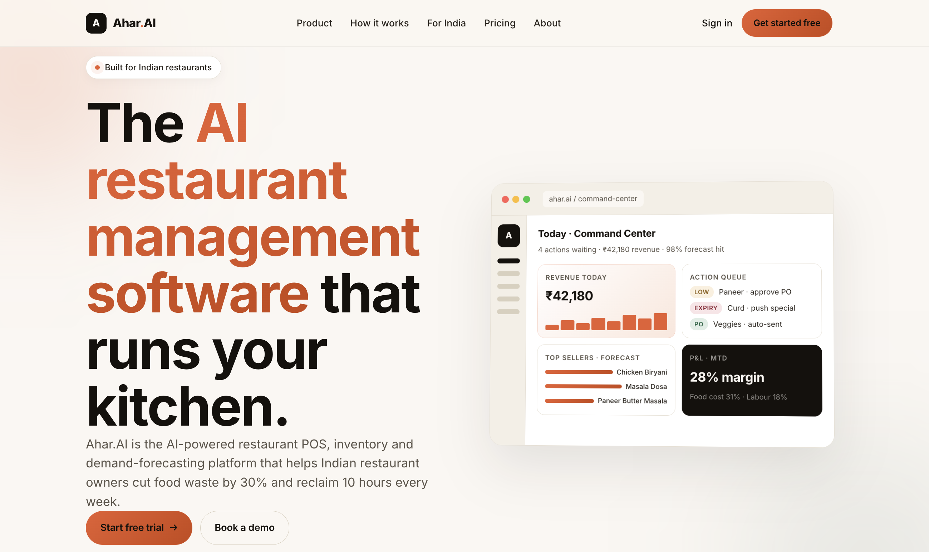
Figure 1 — Hero section. H1 contains primary keyword 'AI restaurant management software'. Eyebrow pill: 'Built for Indian restaurants'. Auth-aware CTA.

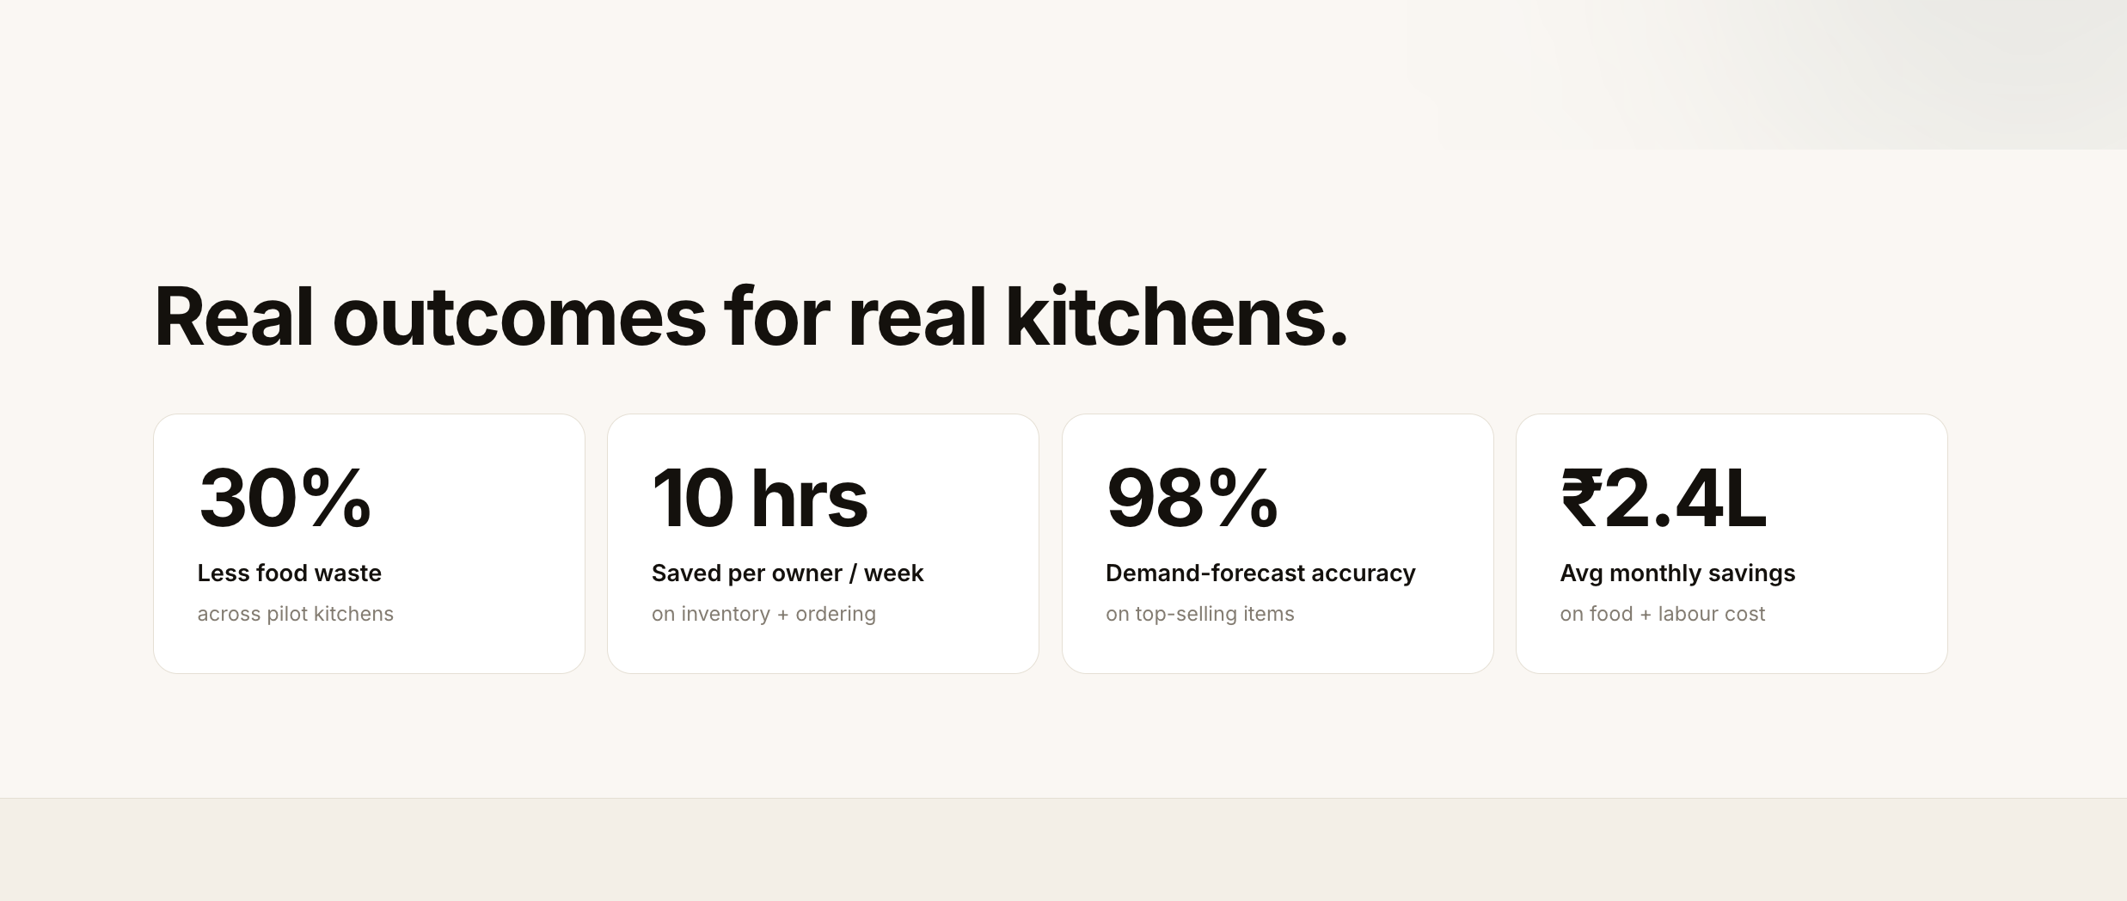
Figure 2 — Outcomes band. 4 stat cards targeting 'food cost software', 'restaurant analytics', and 'how to reduce food waste in restaurants with AI'.

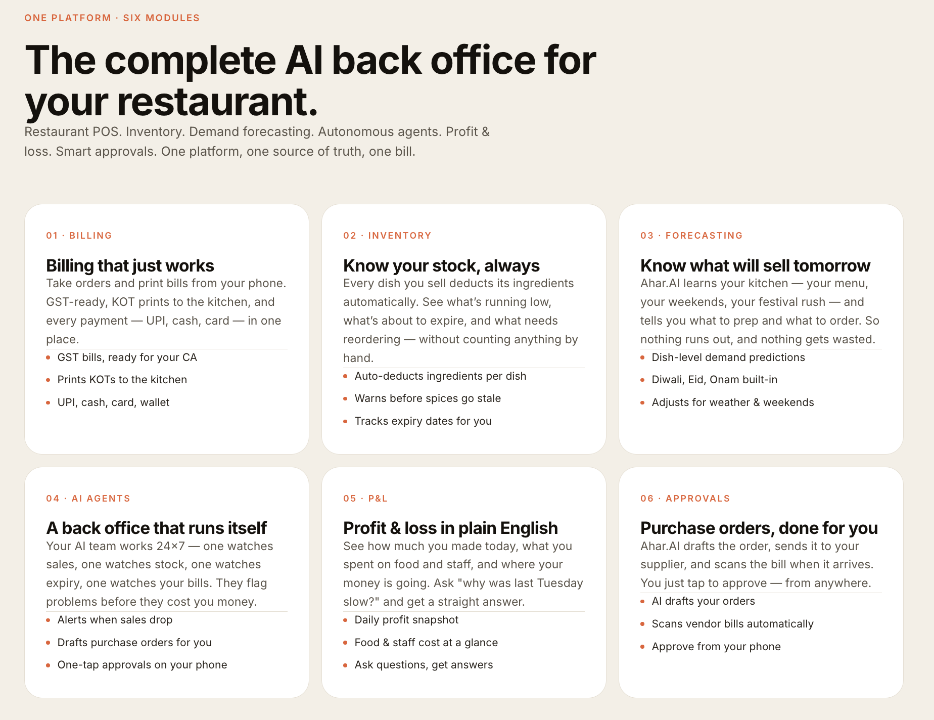
Figure 3 — Capabilities grid (6 cards). Each card targets a distinct keyword cluster: POS/GST billing, inventory, forecasting, AI agents, P&L, approvals.

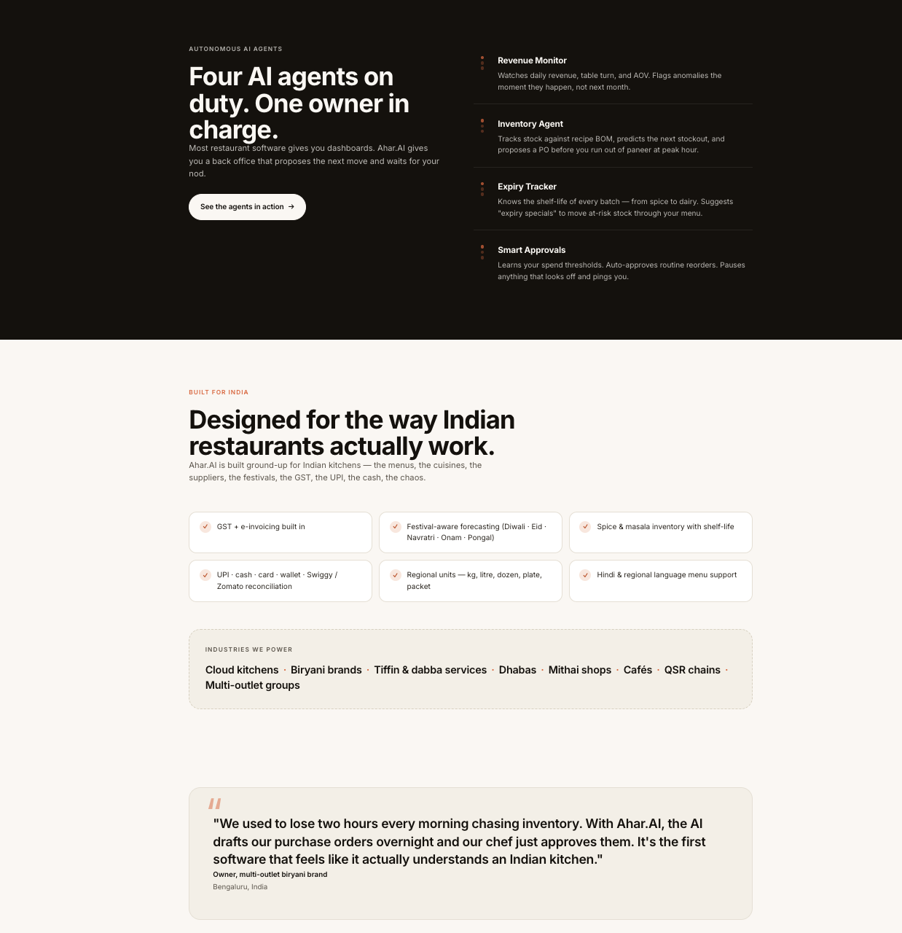
Figure 4 — 'Built for Indian kitchens' section + Industries strip. Wedge keywords W1–W3, W6, W8 woven into the industries list.

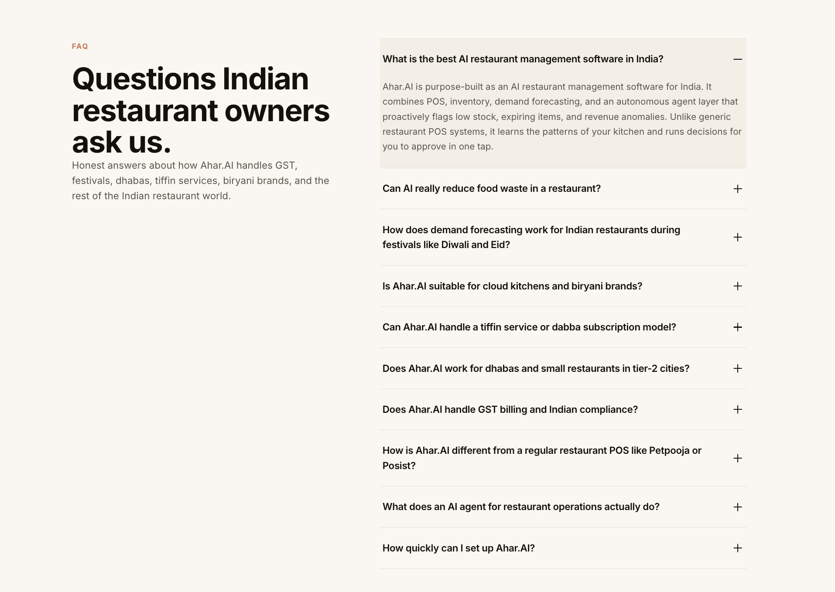
Figure 5 — FAQ section (10 questions). Each question is phrased as a long-tail or wedge keyword. Marked up with FAQPage JSON-LD for Google Featured Snippet eligibility.

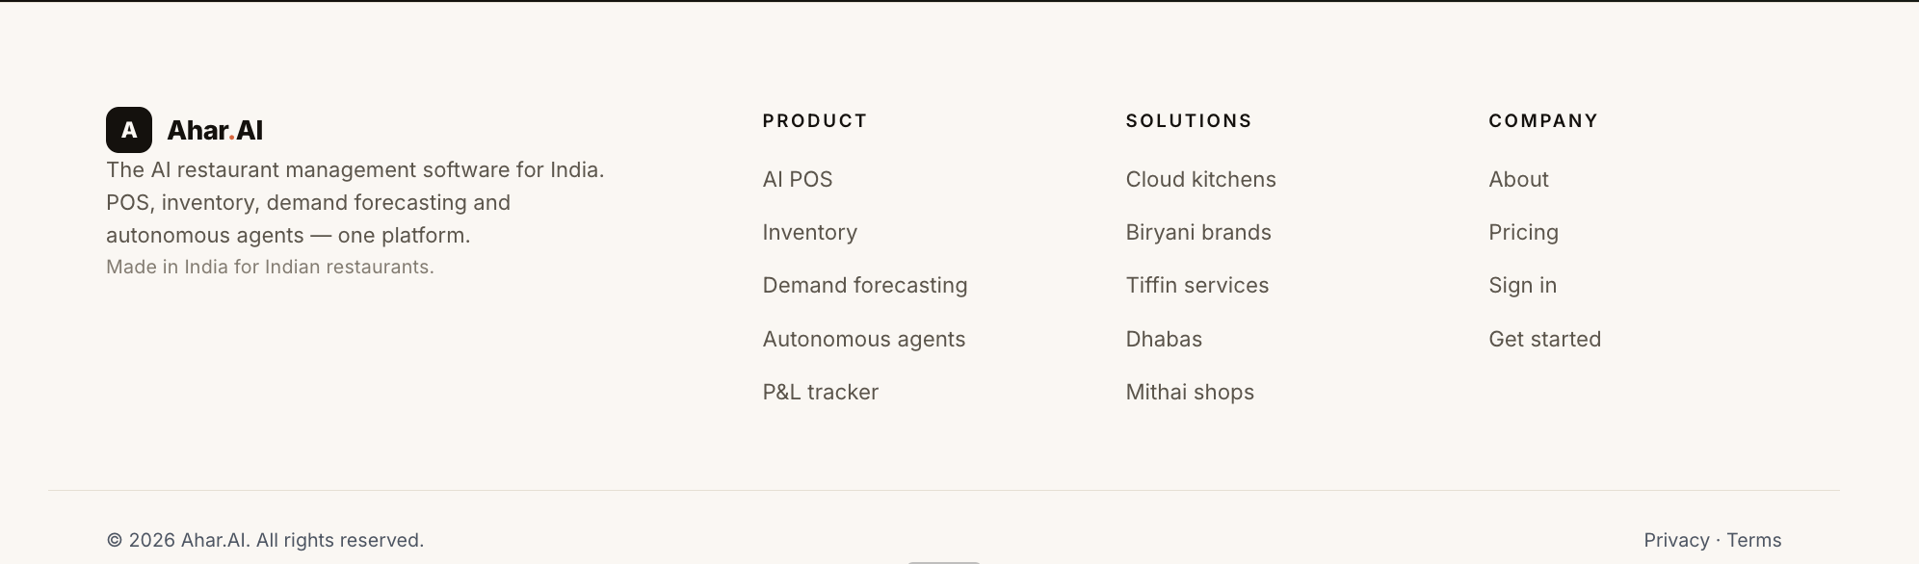
Figure 6 — Footer. Multi-column internal link structure passing SEO authority to /features, /pricing, /about, /signup pages.

8. Hosting & Deployment
Platform: Firebase Hosting (Google Cloud CDN — global edge network)
Live URL: https://ahar-6cbad.web.app/
Custom domain configured: ahar.ai (DNS propagation in progress)
Build pipeline: Vite + React 18 + TypeScript → dist/ → Firebase CLI deploy
robots.txt, sitemap.xml and og-cover.svg served as static public assets

────────────────────────────────────────────────────────────────────────────────
Ahar.AI · https://ahar-6cbad.web.app/ · Built for Indian restaurant owners

