Duke Dusty 2 & Roomba Research on ROS Platform, Summer 2010 Logbook

Chris Tralie

Adviser: Matt Reynolds

**Tuesday 6/22/2010:**

***Note to self: Don’t forget to unplug the Hokuyo when charging the base station; otherwise the hokuyo will drain more power than is coming in through the AC adapter and the thing will be dead by the time I get to it.***

I accidentally deleted my logbook that I had started earlier this week when I reformatted my computer last night. To make up for it, let me summarize a few key findings I’ve made over the past couple of weeks, along with my goals for the summer:

**Goals:**

1. Primary Research Goal: Port the functionality of the EL-E platform over to Dusty 2 here at Duke, with the idea that semi-autonomous control can be combined with low bandwidth input from users with disabilities on a cheap, affordable platform. Get navigation up and running and experiment with arm

NOTE: The arm will need to be constructed at Georgia Tech

1. Secondary Research Goal: Do experiments with high-band antenna to see how well I can predict the locations of objects; this is important because I need to get as close as possible to the objects before the low-band antenna can be used.

*My initial idea for this is to try to collect as many localized RSSI readings as possible for a tag and to use RANSAC and triangulation to predict the tag’s location (since I’m expecting a good number of outliers from multipath)

3) Side Project; Explore arm in the lab

**Key findings so far:**

I’m using the **irobot_creat_rustic** library to control the roomba. Here is the topic interaction setup I have so far:

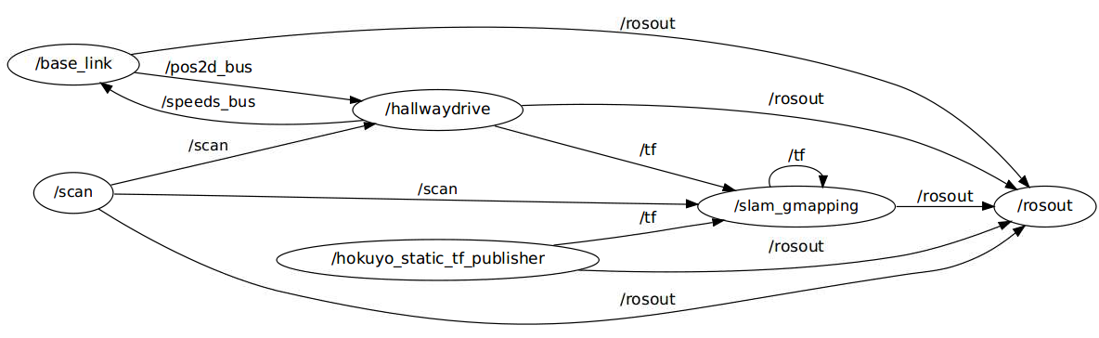

Figure : The topic interactions doing map building while autonomously navigating the hallway. The most important parameters for slam_gmapping are the tf transforms that take the odometer to the base of the laser (odom -> base_link) and the LaserScan message from the /scan topic published by the Hokuyo. Note also that

I can also manually override the hallwaydrive program’s commands if I set the parameter **/hallwaydrive/automatic** to 0. This allows me to use a GUI program to drive the robot myself. Here’s what the topic interaction graph looks like in that case:

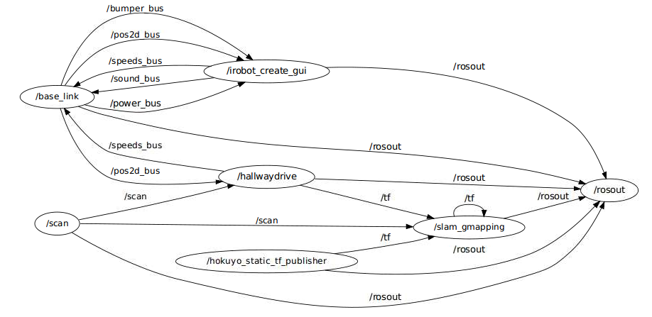

Figure : Map building with the potential to override using the "irobot_create_gui" node provided in the

I figured out how to look at the map-bulidng online. All that needs to be done is to execute *“rosrun nav_view nav_view”.* I found this out from the tutorial:

<http://www.ros.org/wiki/slam_gmapping/Tutorials/MappingFromLoggedData>

But this can be done online in spite of what the tutorial says.

Here’s an example of a map that I have generated using the software:

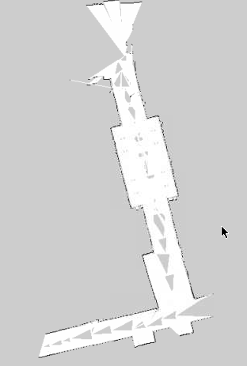

Figure : An example occupancy grid built in part of the hallway. The odometric drift doesn't actually seem too bad, but for some reason there are holes in the middle and I can't figure out why.

**\*\*I’ll have to come back later and figure out why those holes are there in the middle of the occupancy grid…**

**5:14 PM**:

I shifted my hours today so I could come and work late to get a decent map of the hallway after people left (I’ll be here until about 10 PM). There are a few things I need to fix before I can do that, though. The first thing I’m working on is making my local hallway navigation program better. I’m going to make it try to avoid obstacles that are a certain distance away, in addition to making it try to stay in the center of the hallway. I’ll have it turn away from a close obstacle when it’s within a certain distance, or if there isn’t an obstacle within a specified distance, I’ll do the centroid thing I did last year. Here are a few measurements (some of which I actually need for the navigation stack).

The roomba radius is about **21cm**

So I’ll have the close obstacle cutoff at about **0.5 meters** and experiment with that.

**6:54 PM**

After some tweaking I finally got the near obstacle avoidance plus centroid finder to work. There was a bug that took me a while to find where for some reason, some of the laser scan bins turned out to be zero. This was really screwing up what it thought to be the closest obstacle, and it was also causing divide by zero errors (since the sharpness of the turn is made to be inversely proportional to the distance). But now it works so well that it actually avoids all of the chairs in this lab and it’s able to get itself out of that. I just need to get the manual override working and then I’ll be ready to get some real data out in the hallway

**8:30 PM**

I’ve been building some maps but running into problems. The maps have holes in the center that sometimes really screw them up; the robot gets stuck in one of the holes and this makes the hallway artificially short, etc. Also, the loop on the 3rd floor CIEMAS is abysmal just like it was last year in that area where there’s tons of glass and the laser scanner misses it, and it tends to curve off there, making it impossible to close. I’m going to have to drive the robot really straight and really slowly in that area if it’s going to work. I’m going to add the feature to have it drive straight in the hallwaydrive program if I change a ROS parameter quickly on the fly.

**Wednesday 6/23/2010**

I figured out why the map was getting holes, thanks to Travis Deyle. Here’s an e-mail exchange I just had with him:

Okay great, thanks, that's a relief.  I suppose trying to view the map at the same time it's building on that dinky little netbook wasn't the best idea.  It definitely did look like the processor was maxing out.  I'll make a bag file and compare the results.  I'll also make sure to do multiple loops.  Or if this continues to be a problem, I'll just make a filter that gets rid of the gray stuff.   
Thanks,   
Chris   
  
Travis Deyle wrote:

The holes are likely due to the online mapping not incorporating all the data (processor-limited).  This could be handled using bag files to build offline maps instead.   
  
Actually, this shouldn't affect your map in the slightest.  After you save your map, only the black locations (which you can reinforce by editing the resulting map image) are used for localization.  The gray is "unseen" and you can manually remove it from your maps.  Beyond that, your only recourse is to slow the robot down (more scans), make multiple passes (which you should do for loop closure anyway), and / or do the map-building offline.   
  
~Travis   
  
  
  
On Wed, Jun 23, 2010 at 12:05 AM, Chris Tralie <[ctralie@princeton.edu](mailto:ctralie@princeton.edu) [<mailto:ctralie@princeton.edu>](mailto:ctralie@princeton.edu)> wrote:   
  
    Hi Travis,   
       I've gotten SLAM to work online, but I can't figure out why I'm   
    getting holes in my map.  I have attached an example map that I've   
    built to this e-mail.  Any ideas why there are holes in the center   
    along the path of the robot?  This sometimes really screws things   
    up as the map is being built as well.  The laser is not obstructed   
    up there, and I can't really think of another explanation for it.   
    Thanks,   
    Chris.

**12:20 PM**

Here’s another e-mail exchange I just had with Travis:

AMCL takes in odom and laser.  It updates a transformation from map (parent) to odom (child) -- you should not specify this transformation.  Look at tf view_frames after you get things running.

For navigation, you should just use the base_link expressed in the odom frame.

~Travis

On Wed, Jun 23, 2010 at 12:12 PM, Chris Tralie <[ctralie@princeton.edu](mailto:ctralie@princeton.edu)> wrote:

Hi Travis,  
  When I'm setting up the navigation stack, I'm getting odometry information from the roomba at the same time that AMCL is giving it's own version of "odom."  But it looks like AMCL only uses laser information?  So should I just ignore the roomba's version of odom and use AMCL's during navigation?  Is it the case that the roomba's odom is only important during map building and I can ignore it during navigation?  Also, I'm planning to do an identity transform between /odom and /map, is this correct?  
Thanks,  
Chris

I’m still a bit confused about the tf transforms here; is odom being updated by amcl but then overwritten by my published odom? I guess I’ll have to see what happens and maybe e-mail Travis again. But first I’ll look at tf view_frames and post what that looks like here.

Found a really good video tutorial on how to set up global path planning targets in RVIZ

<http://www.ros.org/wiki/navigation/Tutorials/Using%20rviz%20with%20the%20Navigation%20Stack>

Don’t forget to save RVIZ parameters after running this tutorial!

**3:00 Meeting with Matt**

Keep an eye on the odometry and whether it’s straight; does it have to do with **battery**?

Tweak the parameters listed on the gmapping site

<http://www.ros.org/wiki/gmapping>

especially the parameters: *linearUpdate, angularUpdate, temporalUpdate(?)*

**Task 1:** Assess the tradeoffs between making linearUpdate smaller or larger; is the time complexity of the linear algorithm such that it goes faster if more updates are done over a smaller length interval? Will that make it more or less accurate?

**Task 2:** Set up the RFID reader with Travis’s driver, make sure that the odometry doesn’t get messed up by the placement of the reader (it seems to be very straight lately and I don’t want that to be compromised)

**Research Idea Set 1**

* (Matt’s ideas on high-band RFID localization)
* *Try to maximize RSSI*
* Look up Travis’s paper “Foviated RFID […]” find on IEEE explorer
* Only update the goal periodically since RFID data is noisy
* Talk to Travis about some of the algorithms he’s been thinking of
* “Rumors of my death have been greatly exaggerated”

**Thursday 6/24/2010**

I just created a program that allows me to steer the robot manually with the keyboard and I noticed something interesting that I should have realized before….a positive “angle” turns the robot to the left (counter-clockwise), while a negative angle turns it to the right (clockwise). I suppose I thought “positive=right” before for some reason, but I guess this makes more sense.

I’m also going to have to keep my eye on the laser scans, because they appear to be backwards in RVIZ

**2:00 Skype Session with Travis**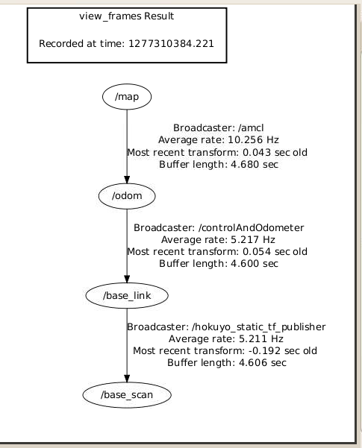

Figure : A transform tree showing what happens during navigation. As Travis explained it to me, AMCL publishes a transform between map, which is a fixed frame, and odom to correct for odometric drift (this transform is not static). So by the end the transform from map to base_link and base_scan has the best corrected position and orientation.

Problem for finding tags with highband: Tags were at different height

Travis’s ideas for research: Take antennas and use ROS to set up waypoints; take as many readings as you can.

If I have 50 tags in this room, how many can I realistically expect to read. How far away do I have to be?

Servoing works, but we have no idea how well it works in a **home**

**Research Idea Set 2**

PUBLISHING!!! ICRA: Due date September 15th

1. Get the create platform to the spot that EL-E was
2. Take the platform into an actual house and get “real-world” data; how many tags can I actually expect to read
3. Working on estimating the position of the tags with the particle filter; get localized tag readings and use that to get close enough so that there’s not as much multipath

Particle filter could works as a node

NOTE: **TF interpolates**, so all I have to do is save my bag file and use that when I want to figure out where a reading was taken

TODO over next couple of days:

*Do *Probabilistic Robotics* reading

*Look at RFID papers on healthcare robotics site

<http://www.hsi.gatech.edu/hrl/project_rfid.shtml>

***Do TF interpolation test and send Travis the results***

Now I’m going to do some more tests with map building. I’ve driven the robot around in a loop with a program that I made to manually drive it; it appears to go in straight lines now pretty well so I’m not going to bother using my centroid-finding program anymore since it gets so screwed up in the center of the glass walkway anyway. I’m going to play back the data in a bag file and attempt to generate a map varying several parameters of the map-builiding, such as linearUpdate and angularUpdate (probably the most relevant parameter will be linearUpdate). The first test will be done using default values:

***One thing I noticed during the tests was that the robot hardly drifted at all, which I said before was the reason I now manually drive it instead of having my centroid-finder program correct automatically on the fly. I had it going at a very slow speed most of the time (0.07m/sec ~ 0.157 mi/hour) and I’m wondering if this had something to do with it. I’m going to keep my eye on it once I attach the RFID reader and hopefully it remains good.***

Test 1: linearUpdate = 1m, gridResolution = 5cmx5cm per block

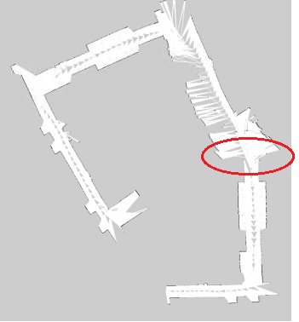

I have highlighted a trouble spot. I do want to point out a few positives, though. For the most part, the hallway corners do form right angles, and there is significantly less drift than there was last year. But there was one corner that completely hosed up all of the results, and I believe it’s because of all of the glass that’s there (**also, the robot got stuck on something while I was trying to move it on the circled red spot**). I’m going to do a few more tests with different parameters, but I think this might be an inherent problem with the data set. So I may either need to eliminate that segment of the data set or redo my testing with a different initial position of the robot.

Test 2: linearUpdate = 0.5m, gridResolution=5cmx5cm per block

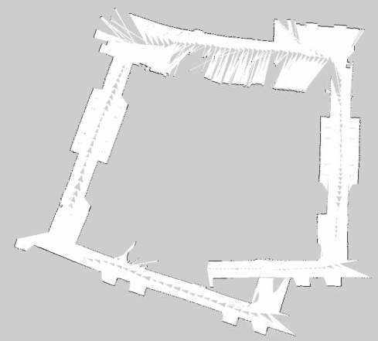

The results were actually much better this time! In the documentation it says that the parameter “linearUpdate” decides how to “process a scan each time the robot translates this far.” So I suspect it was throwing out a lot of laser scans which definitely would have caused problems in a particularly huge variation section like the turn I circled before. One thing I noticed this time around is that the processor was just about maxing out; it just finished one update right as the next one started. I’m going to try halving that parameter again, but I may need to run this test on a better computer (i.e. mine own personal laptop) in order for that to work and not hiccough. Here I go…

Test 3: linearUpdate = 0.25m, gridResolution=5cmx5cm per block

I’m noticing here that it can’t quite keep up with my request to have it update every 0.25 meters at all times. I’m going to try to move it onto my computer next and see if that helps. Actually, before I do that, I’m going to change the “publishing rate” of the rosbag client and see if that helps at all. I’ll make the publishing rate half and see if it’s able to keep up better. The only obvious drawback here is that I’m going to have to wait much longer for the tests to complete…

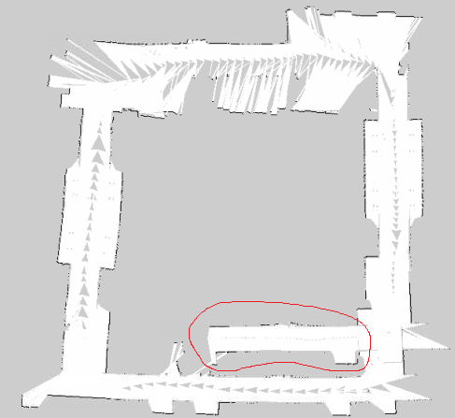

Wow! For the first time ever I’ve gotten loop closure! Now there is an obvious artifact where for some reason the left side of the map was longer than the right side of the map, so when it merged them back together there were some issues. I’m going to try running this on a faster computer and see if that fixes it. If not, there’s a possibility I may need to make a new dataset since it could be due either to odometry drifting or to the time my robot got stuck.

Test 4: linearUpdate = 0.25m, gridResolution=5cmx5cm per block (but this time I slowed down the playback to a quarter of the rate it originally was)

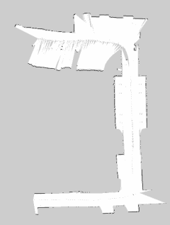

I’m cutting the test short because the results look so significantly better. I’m going to make the playback a tenth of what it is and move linearUpdate down to 0.1m for my next test. This is going to take a while so hopefully it’s worth it.

Test 5: linearUpdate = 0.1m, gridResolution=5cmx5cm per block (slowed down playback to 0.1x speed)

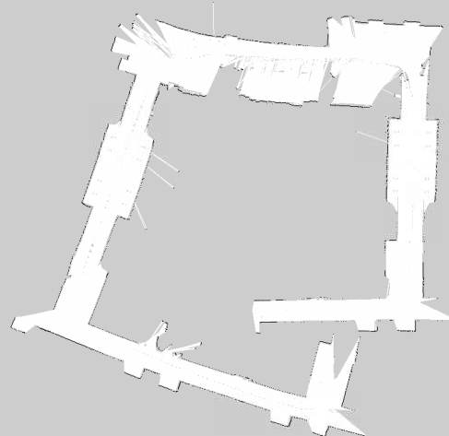

Test 6: linearUpdate = 0.05m, gridResolution=5cmx5cm per block (slowed down playback to 0.05x speed)

This test took over 10 hours on the netbook…

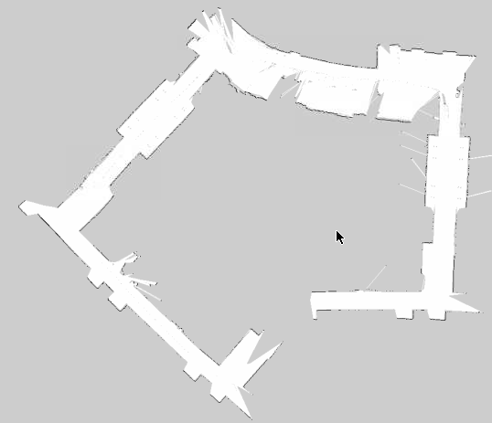

Now I’m noticing somewhat of an adverse effect of increasing linearUpdate. It actually seems to rely a bit too much on odometry, as seen by the drift up top. I’m going to go back to a linearUpdate of **0.25m** since that’s the only case where I got loop closure, and start varying some of the other parameters there to see if I can get even better results. At some point, I’ll also probably have to touch it up by hand.

Test 7: linearUpdate = 0.25m, slowed down to 0.4x speed, tested with 5 iterations of scan matching (left) versus 10 iterations of scan matching (right)

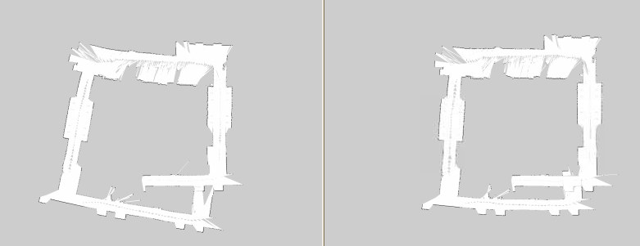

**Friday 6/25/2010**

I attached the RFID reader to the Hokuyo today, being careful to center it as much as possible. I even used industrial velcrow to hold it in place. I drove the robot straight and it did not appear to drift, so it looks good so far.

Here’s an e-mail I sent to Travis. He asked me to do some tests on how TF does interpolation, and I’m trying to get his RFID driver up and running.

Hi Travis,   
    As promised, I did some tests with TF interpolation.  My first test had just a linear increase of one coordinate of my translation vector, updated at 1hz and resampled at 100hz.  This was linearly interpolated as expected.  My second test had an exponential increase (doubling), published at 1hz and resampled at 10hz, which also appeared to linearly interpolate.  I attached my datasets to this e-mail as well as a few plots in matlab to show what I'm talking about.  It's especially clear by the exponential plot around the "bend" that linear interpolation is taking place.   
One caveat is that I looked back 5 seconds in time when I ran my tests; I was having trouble getting TF to interpolate at the current time.  But this certainly wouldn't be an issue for offline data; but I'll have to look more into doing this online.   
  
My next question for you is how do I launch your RFID driver?  I don't know Python (yet), and it doesn't appear to be a node as I expected (i.e. rosrun hrl_rfid doesn't autocomplete).  Once I have it running I intend to subscribe to the RFIDread message.   
Thanks,   
Chris

Here are the pictures I attached to my e-mail:

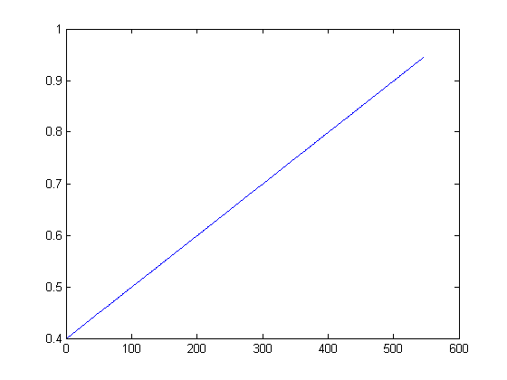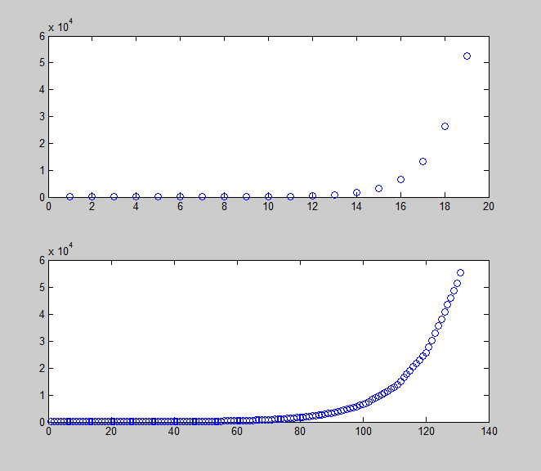

Now I’m working on getting the RFID driver up and getting navigation working simultaneously. My map isn’t perfect but I’ll attend to that later; the one where I got basic closure (linearUpdate=0.25) is good enough to start with. Also, Travis is helping me with the RFID driver.

**Tuesday 6/29/2010**

I was too lazy to make an entry yesterday so here’s my entry for today: I got Travis’s RFID driver up and running and I tested it with a few tags using **rostopic echo**, but I have been having a little trouble getting the C++ interface working to call the service (/rfid/mode [‘query’]); which means I have to do it the console for now (same thing with the actual RFIDread msg that’s published to the topic).

While I’m stuck on that, I went ahead and made another .bag file of the hallway, this time cutting out the section that was giving me trouble before (because I don’t need it for testing anyway). I ran the data back at 0.4x speed and did a linearUpdate every 0.25 seconds, and here are the results I got:

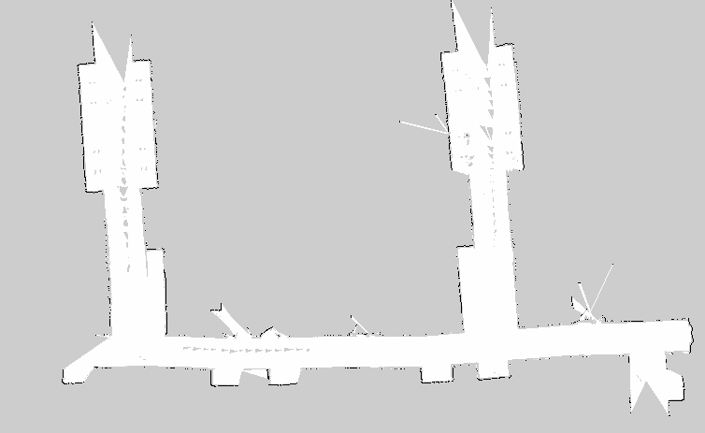

Now I’m going to try to get navigation up and running; I was also having trouble with this yesterday (it wasn’t able to find a path for some reason but I suspect it may have had something to do with the occupancy grid (I was using the previous one which had the phantom section of the hallway sticking out once the loop was closed). And just to be sure, I’m going to touch up the occupancy grid here and erase the little gray spots

Starting to run navigation tests, looks like the laser scans may be backwards (but I am at least getting path planning working now)

Aaaah no wonder, I had my quaternion wrong! I accidentally had it as a 180 degree rotation about the x-axis (my quaternion was (qx, qy, qz, qw) = (1, 0, 0, 0) instead of (0, 0, 0, 1) for identity)

Doing some more testing with the navigator; it looks like the rotational commands may need to be converted from radians per second to mm/sec. ROS gives them in radians/sec, but I need to look at the create’s open interface to see what it’s expecting. It seems to me like the rotation is going too quickly at the moment.

In the create’s open interface there’s only commands for controlling the different wheel speeds. The driver has some level of abstraction above that which I’m not sure about. So I’m going to try to reverse engineer the controller using a stopwatch. I put it to a rotational speed of 0.08 and counted 21.233 seconds for a full revolution.

Need to convert from **units/sec** to **radians/sec**

(2*pi / 21.233 radians/sec) / (0.08 units / sec) ~ 3.7 (radian/sec) / (units/sec)

Now let me verify that the speed is on a scale from 0m/s to 0.5m/s mapped to the range [0, 1.0]

Took 50 seconds to travel 8 feet at a speed of 0.06

(8 feet/ 50 sec) * (12 inches / foot) * (3.54cm /inch) = 6.8 cm / sec

0.06*50cm/s = 3.0 cm/sec

I’m surprised to find that the create went more than twice the speed I expected it to go. Is its max speed more than 50cm/sec? More testing is needed. But first I will try the new conversion factor for the angular velocity

It still seems to think it’s turning faster than it actually is, which is what I think is causing these artifacts of the laser scan:

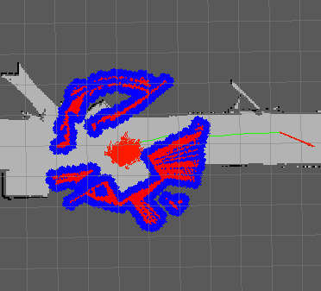

I’m going to redo the measurements and do some more tests for the turning rate conversions (I’m thinking to myself that I might need to re-calibrate these constants every time I add something to the base)

**Tuesday 7/6/2010**

It’s been a while since I’ve done an update; I’ve mostly been doing reading on Bayes, Kalman, and particle filters. I’ve also been stuck on the navigation control still (and I’ve been off since Thursday, today is my first day back). Here’s part of an e-mail I sent to Travis about the navigation control problem:

I've also been having an issue with the navigation stack that maybe you could have some insights on; it loads properly but there seems to be some discrepancy between the drive commands that are being sent on "cmd_vel" and the commands that the roomba accepts; cmd_vel gets Twist messages published to it, while my roomba driver accepts this "Speeds" command with "forward" and "rotate" as its fields:  
  
<http://www.ros.org/doc/api/irobot_create_rustic/html/msg/Speeds.html>  
  
I tried doing timing measurements to get a mapping from "rotate" units to radians per second, but it varies based on whether forward is nonzero (or small) or not, because if the robot is barely moving forward both wheels oppose each other, but if it is moving forward and turning both wheels are going forward, but one is faster than the other; so the turn rates are different for the same "rotate" field if the speeds are different.  Anyway, ***what I've noticed as a result is that the robot fumbles around a lot for a frustratingly long time before it gets to its destination.***

I tried timing it to figure out if I could come up with a mapping between the commands between cmd_vel and Roomba’s “Speeds” command, but I couldn’t get it to work. Here are a few excel plots I made in the process

|  |  |  |  |
| --- | --- | --- | --- |
| "Rotate" | Time 1 Revolution | | Radians / sec |
| 0.1 | 15.8 | 0.063291 | 0.39767 |
| 0.2 | 8.429 | 0.118638 | 0.745425 |
| 0.3 | 5.461 | 0.183117 | 1.150556 |
| 0.4 | 4.115 | 0.243013 | 1.526898 |
| 0.5 | 3.276 | 0.30525 | 1.917944 |
| 1 | 1.780286 | 0.561708 | 3.529313 |

So the conversion appeared to be **3.4849** **radians/sec** for every “unit” in the roomba’s Speeds “rotate” field. But this only works if it’s stationary.

I also did a similar thing for the “forward” part of the Speeds field in isolation and got the following table

|  |  |  |  |
| --- | --- | --- | --- |
| "Forward" | Time to travel 2.44m | velocity | Conversion Factor |
| 0.1 | 26.504 | 0.092062 | 0.920616 |
| 0.2 | 12.458 | 0.195858 | 0.97929 |
| 0.3 | 8.629 | 0.282767 | 0.942558 |
| 0.4 | 6.268 | 0.389279 | 0.973197 |
| 0.25 | 10.92 | 0.223443 | 0.893773 |

But I’ve decided now it’s not worth using the rustic driver; I’m instead going to go back and use the **irobot_create_2_1** driver because it allows me to specify commands exactly in mm/sec, and it also has a command that drives the robot in a circle.

If I want a certain linear velocity, **v**, and a certain angular velocity, **omega**, all I have to do is specify that the robot travels around a circle at speed **v** which has a radius **v/(2*pi*omega)**. If omega is below (0.01), then I will simply tell the robot to drive forward at speed **v**.

Now I have to go code this up…

Looking at the IRobot Create open interface documentation, I noticed that the variable **angle** in **sensorPacket** stores how many degrees the robot has rotated in either direction since the beginning. It’s a signed int, so it overflows at 32767 (it actually saturates and does nothing). This means that I’m okay as long as I don’t do more than **91 revoultions** (I won’t worry about this for now). Distance stores the distance traveled in millimeters (also an int) since the last time it was requested.

I just realized that somehow this **irobot_create_2_1** driver already accepts **cmd­_vel** commands.

**Wednesday 7/7/2010**

I went to look at **driver.py** in the irobot_create_2_1 src directory when I noticed that not only does it already subscribe to cmd_vel and take care of that on its own, but it also publishes its own odometry information and the tf transform from **/odom** to **/base_link**. I was running into a lot of problems doing my own odometry and I think that was really screwing up navigation, so now I can ditch the entire **controlAndOdometer.cpp** file.

I got navigation working!! After switching to this new driver and letting it take care of odometry and cmd_vel commands, I noticed that the create was still fumbling around a lot very slowly and getting confused. So I decided to go back to the default parameter limits for the local navigation since I knew now that the robot would do what they said (since the new driver subscribes to cmd_vel and is able to correctly actuate those commands). Here are the parameters I’m using now:

TrajectoryPlannerROS:

max_vel_x: 0.45 (m/s)

min_vel_x: 0.1 (m/s)

max_rotational_vel: 1.0 (radians/sec)

min_in_place_rotational_vel: 0.4 (radians/sec)

acc_lim_th: 3.2 (radians/sec2)

acc_lim_x: 2.5 (m/s2)

acc_lim_y: 2.5 (m/s2)

holonomic_robot: true

Now all I need to do is get rid of that annoying song the robot plays every time this driver starts! But actually, my next step now will be to get the RFID driver up and running programmatically

Meeting with Matt

45 or 90 degrees

RFID + SLAM Dieter Fox Wolfram (ICCRA 2004 or 2006); referenced in the other papers

*Get another antenna (extra port on RFID reader)

-Create - $229

Netbook - $200-$300

Hokuyo - $2k

RFID Reader - $200

RFID Antennas - $20

TODO: Get two antennas on, try out other hokuyo

Josh Smith – Intel personal robotics effort

Youtube – Natal camera (3D camera), CIEMAS camera

Have lunch with Mac Mason

***Ramesh Raskar

Goals for the week:

* ~~Get Travis’s RFID reader up programmatically~~
* ~~Put two antennae on in V shape and rebuild roomba~~
* ~~Try out new Hokuyo~~
* Get video of navigation in action
* ~~Read papers: RIFD + SLAM Dieter Fox and Matt/Travis’s RFID paper~~
* ~~Backup code to repository~~
* Try navigating to a place off of the map

Today before demo:

* ~~Get RFID reader up~~
* ~~Build new occupancy grid~~

I’ve been playing around some more with Travis’s RFID reader. Annoyingly enough, I can’t do

#include <hrl_rfid/RFIDread.h>

Even though I put “hrl_rfid” into manifest.xml, it doesn’t resolve the path to that header file. Instead I have to do “/home/createbrain/ros/ros/hrl/hrl_rfid/msg/cpp/hrl_rfid/RFIDread.h”. Hopefully I can fix this eventually.

RFID tags IDs are 96 bits long. It appears that in the RFIDread message, the **tagID** field stores each ID as a 16-byte string, so that it’s completely packed. This contrasts with the Player driver from last year, which I seem to remember having stored the IDs as hex “strings” where each character was a letter or number for each hex character (so the strings were 24 bytes long).

**Thursday 7/8/2010**

I’ve punched all of the proper holes into the new robot base so that everything can fit, and I’ve done a few measurements on where everything ended up:

Center of laser is **16.5cm** in front of center of robot

Camera will be **14cm** in front

Here’s a diagram of where I placed the center of the right RFID reader:

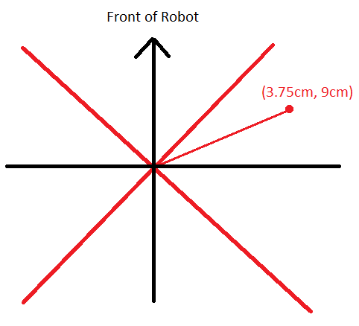

The black axes are aligned with the front of the robot, but I measured the position with respect to the red axes, which are offset by 45 degrees. I need to specify the transformation with respect to the original coordinate system, though. This requires doing a -45 degree rotation from the red coordinate system. In black coordinates, this is:

3.75cm * (sqrt(2)/2, -sqrt(2)/2) + 9cm*(sqrt(2)/2, sqrt(2)/2) = (12.75sqrt(2)/2, 5.25sqrt(2)/2)

~ (9.02cm, 3.71cm)

This means that the other antenna is at position (-9.02cm, 3.71cm)

But actually TF specifies the transformations with x towards the front of the robot (<http://www.ros.org/wiki/navigation/Tutorials/RobotSetup/TF>) so I have to change this again by rotating everything by -90 degrees, making the first antenna **(3.71cm, -9.02cm)** and the second antenna at position **(3.71cm, 9.02cm)**.

The orientation of the first antenna is at **–pi/4 radians**, while the other one is at **pi/4 radians.** Here is a pictorial summary of everything I just explained:

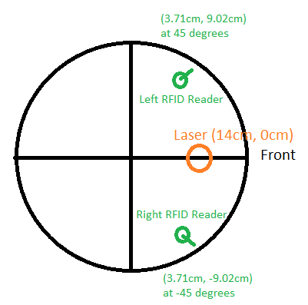

* Quaternion for -PI/4 radians about z-axis: (qx, qy, qz, qw) = cos(angle/2) + sin(angle/2)*urot  = (0, 0, -3.827, 0.9239)

**Static transform from base_link to laser:** **(x y z qx qy qz qw) = (0.14, 0, 0, 0, 0, 0, 1)**

**Static transform from base_link to right RFID reader: (x y z qx qy qz qw) = (0.0371, -0.0902, 0, 0, 0, -0.3827, 0.9239)**

**Static transform from base_link to left RFID reader: (x y z qx qy qz qw) = (0.0371, 0.0902, 0, 0, 0, 0.3827, 0.9239)**

After I code up these static transforms I should look in RVIZ to make sure they look right

**Monday 7/12/2010**

**\*\*NOTE:** **Something I should have noted a long time ago; running RVIZ through VNC is tricky because it requires GL extensions. This means that it can’t be run through one of the :1, :2, :3, etc. TightVNC virtual desktops; it has to be run on the actual desktop that’s being displayed on the screen (Ubuntu’s primary remote desktop server)**

Goals for the week:

* Get video of navigation in action
* ~~Try navigating to a place off of the map~~
* ~~Try map building with new Hokuyo~~
* ~~Make static TF transforms for RFID reader~~
* ~~Verify the static TF transforms in RVIZ~~
* ~~Figure out which antennas are which~~
* ~~Do preliminary servoing tests rotating the robot 360 degrees and plotting the RSSI versus bearing~~
* ~~Get servoing working~~
* Begin working on RVIZ visualization tools for RFID tags (particle clouds + external GUI control program for tags)
* Look for explore behavior in the navstack (explore)

**Not doing after all this week:**

* Begin particle filter implementation
* Figure out how to find the closest navigable position to a point on an occupancy grid

**2:22PM Update: The robot is working!!**

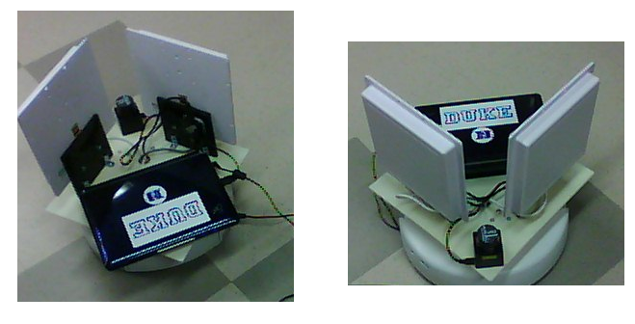

Here’s an e-mail transaction I just had with Matt:

Looks great, Chris! Sorry about the long delay in remembering where the Hokuyo was stashed.

One question: How well does map building seem to work with the new Hokuyo vs the old one? Supposedly the new one has somewhat reduced range and angular resolution (it's cheaper)? I expect that odometry will be pretty much the same (i.e. kinda crappy) unless we get lucky on center of mass of the new platform?

Look forward to seeing the servoing and RFID-enhanced map building coming to life.

Regards,

Matt

On Jul 12, 2010, at 2:30 PM, Chris Tralie wrote:

> The new robot platform has been finished; everything and working, including the new Hokuyo URG-04LX-UG01. I just took it for a spin through the hallway and it's working extremely well with the navigation stack, and the odometry appears no less stable than before. I hope to start working on servoing today, and hopefully be underway with the particle filter collaborating with Travis by the end of the week.

> -Chris

> <newrobot.png>

I did notice the angular resolution was a bit less when I looked at this in RVIZ. I should try to get exact numbers on this. This didn’t seem to affect navigation at all (I ran a couple of tests and the particle filter was able to track the position pretty well, and eventually correct itself when it was off). I will try to make a new map though.

Another interesting thing Matt mentioned was RFID-enhance map-building. This reminds me that I need to make some visualization tools for RVIZ for the RFID tags. Maybe I’ll have a particle filter visualization tool similar to the one that’s being used for odometry.

Got the numbers; there are 454 bins apparently on this new scanner between -80 and 80 degrees. Looking back at what I had running in Player last summer, it looks like I only sampled 180 bins. So this is better than that, but I didn’t get a chance to look at how many bins there actually were in the other Hokuyo.

The official specifications says that the Hokuyo R325-URG-04LX-UG01 (the new one) and the R283-HOKUYO-LASER1 both have an angular increment of **0.36 degrees**, though, so I’m not sure (this increment matches with what ROS told me).

Bottom line I’m not sure how important the exact numbers are but I will test it out.

Here’s a screenshot I took in RVIZ of the transforms

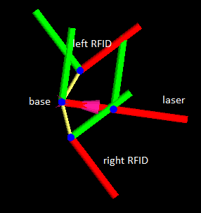

It looks like red is +x and green is +y. This looks correct to me

Just thinking to myself as I’m running a new mapping test; I’m expecting this laser to work just as well as the last one because these hallways are so narrow; even though the maximum range is smaller that shouldn’t matter so much here except around open space

Another thing that I’m thinking of now; I’m reading Travis’s paper on the “foveated RFID reader” and looking at the section that talks about servoing, is that I should do a test where I place an RFID tag in front of the robot and turn the robot 360 degrees around, recording the RSSI value over the 360 degree interval and then plotting this value for both antennas. What I should expect is a symmetric graph with the middle being a global max of the RSSI corresponding to the antenna bearing of zero degrees with respect to the tag. As such, I would expect the two graphs for the two antennas to be horizontal translations of each other. So I’ll run this test ASAP and then think of how to implement servoing based on the results

If anything, my robot appears to be drifting to the right slightly as I’m building this new map…

Some ideas for navigating towards a specified tag (thoughts while I’m still collecting data):

* If tag is not in view at all, navigate along the original path that the robot took to build the map; that is, sample the positions of the robot along the map-building path and create waypoints that cover most of the path
* Recalculate the goal every time the variance decreases below some threshold
* Navigate towards the nearest open spot of the estimated pose is not within the occupancy grid?

**Tuesday 7/13/2010**

After collecting data, I slowed things down by 10x and constructed the new map overnight using a linearUpdate of 0.25 and a grid resolution of 5cmx5cm as before

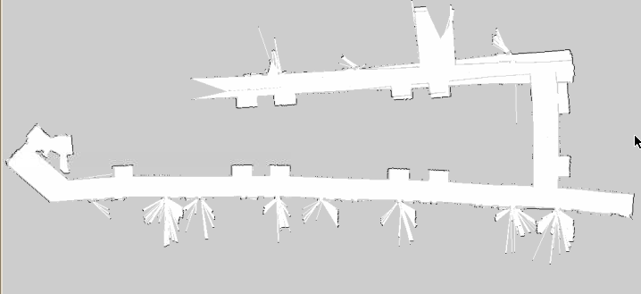

The results are slightly disappointing but I think it’s because I did it over such a large area, so it wasn’t really a controlled test.

I’m working on getting the RFID reader all configured now. I have the antennas plugged in such that the left antenna is called “EleLeftEar” in Travis’s driver, and the right antenna is called “EleRightEar.” I’m using the “Venture Research Inc” RFID antenna strength indicator to make sure the driver is working. I noticed that when both antennas are being queried at the same time, the thing only blinks about half as fast on the strength indicator, which makes sense if it’s switching back and forth between which antenna it’s querying.

I was wondering before why the RFID driver wouldn’t go into query mode even though I made a service call from my C++ client. I used to have to start the query manually from the console. But after some more testing I realized that it doesn’t work putting it into query mode until after the driver has initialized and is “waiting for instructions.” I’m going to have to figure out a way to detect when it’s gotten to this phase and to avoid making the service call before then.

Skyping with Travis:

Base_Local_Planner

Data-Driven Model: 3D histogram (range, bearing, RSSI)

Make a more general histogram for roomba??

*Look for explore behavior in the navstack (explore)

~~*Look into using NavView?~~

*Marker for ground truth; external GUI for particles

Modified Research Ideas:

*Environments to test in: Capture a dataset in my apartment

*Make sensor models??

Main Goal: Set up good, realistic ground truth data sets and gather RFID reads by “exploring” around: lab, apartment, hallway

Set up tags: different heights, get a pseudo-3D model

Do evaluation on realistic settings

1. Get visualization working
2. Think about how to build the model, how to test the model, and how to capture the ground truth everywhere

Archive.org if publishing date not met?

<http://arxiv.org/abs/0902.2186>