Gimbal Assist for Helicopter Powerline Inspection

Jason Maynard, Fall 2011

U30503758

# Abstract

This project introduces a new design for the helicopter power line / transmission line inspection industry that is a first step in a series of product designs that will increase pilot and helicopter crew safety, and will significantly reduce liability and operating costs. The design is a prototype solid model of a new gimbal assistant that will greatly aid the operator’s ability to get faster and more accurate readings of powerline couplings for long reach applications. Safety features are integrated into the design to ensure that the helicopter is safe from rotor obstruction. Considerations have been made for size, weight, cost, and producibility. The SolidWorks Solid Model demonstrates the feasibility of the design and also provides production ready drawings for prototype manufacturing.

Contents

Abstract 1

Introduction 2

Solid model and assembly design 3

High level 3

Detail design 3

Tolerancing and bearing analysis 3

Gimbal pin fit 3

Design of materials 3

Proof of design/analysis 3

Conclusions and future recommendations 3

Appendix 3

Works Cited 3

Figure 1: Transmission lines (Transmission, 2011) 3

Figure 2: Transmission line splice with sleeve (Splice, 2011) 3

Figure 3: SensorLink sensor (SensorLink, 2011) 3

Figure 4: Hot stick operation (Horn, 2011) 3

Figure 5: 14' hot stick operation helicopter and transmission line (Horn, 2011) 3

Figure 6: Unsecured 14' hot stick operation (Horn, 2011) 3

Figure 7: UAV example (UAV , 2011) 3

Figure 8: Robotic crawler example (Robot, 2011) 3

Figure 9: Gimbal assist assembly operator view 3

Figure 10: Gimbal assist assembly side view 3

Figure 11: Gimbal assist assembly alternate position 3

Figure 12: Gimbal assist assembly close up 3

Figure 13: SensorLink hot stick assembly detail (ref. only) 3

Figure 14: Gimbal assist position x 3

Figure 15: Gimbal assist position y 3

Figure 16: Gimbal assist side view 3

Figure 17: Gimbal assist front view 3

Figure 18: Gimbal assist isometric view 3

Figure 19: Gimbal assist fully articulated 3

Figure 20: Gimbal assist inner sleeve and spacer detail 3

Figure 21: Gimbal assist exploded view 3

Figure 22: General tolerance requirements 3

Figure 23: Hot stick tolerancing 3

Figure 24: Gimbal sleeve bearing OD tolerance 3

Figure 25: Inner ring press fit tolerance 3

Figure 26: Outer ring clearance tolerance 3

# Introduction

Electric power transmission depends on the reliability and maintenance of high voltage transmission lines (Figure 1). These lines span great distances over rural areas and are difficult to inspect. The US power grid is over 60 years old and prone to failure. Electricity cannot be effectively stored so generation must match demand which leads to periods of peak loads. It is during these times of peak load that the transmission line may fail resulting in widespread electrical failure which is extremely disruptive and expensive.

Typical inspection techniques include the use of a helicopter to look for problem areas which most often occur where long transmission lines are spliced together with a sleeve (Figure 2). Like a light bulb that is burning too hot and ready to fail, an area of higher resistance at the sleeve will result in a higher temperature reading at that point. A common way to test for hot spots is with an infrared sensor. A typical helicopter mission calls for manual temperature readings of sleeve/splice areas looking for hot spot anomalies. While infrared is often useful for identifying areas that are prone to failure, sometimes it becomes impractical due to extreme cold conditions or times when wind speed is high. When these environments are present, the infrared numbers are skewed or simply inaccurate.

As an alternative, direct electrical measurement on both sides of the splice is required. If a difference of more than ± 5% is detected then the splice is flagged to be replaced before a peak load causes failure at that point. This is a challenging and ultimately expensive task when performed in locations only accessible by helicopter. These costs are incurred because of the criticality of successful power grid operations and the enormous cost of a blackout.

Operators use a special insulated “hot stick” coupled with a SensorLink (Figure 3) sensor to take these measurements (Figure 4). Standard operation calls for a 3 foot hot stick (Figure 4). In typical operation the operator places the transmission line within the forks of the SensorLink via the hot stick to receive a reading. This needs to be performed on both ends of the splice while the helicopter pilot keeps the helicopter, platform and pilot in position. This is no easy task and can take a significant amount of time and fuel. Some operations require the use of a longer Ohmstick up to 14 feet in length to clear the transmission lines. This longer operation introduces exponentially more difficulty for the operator, pilot, and overall operation. One area of particular concern is the hot stick operator losing control and allowing the hot stick to rise upwards and interfere with the helicopter rotors. If this happens the helicopter can crash. Unfortunately crashes are not uncommon.

*[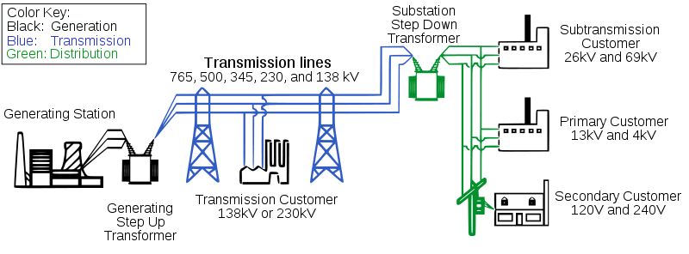](http://upload.wikimedia.org/wikipedia/commons/4/41/Electricity_grid_simple-_North_America.svg)*

Figure 1: Transmission lines (Transmission, 2011)

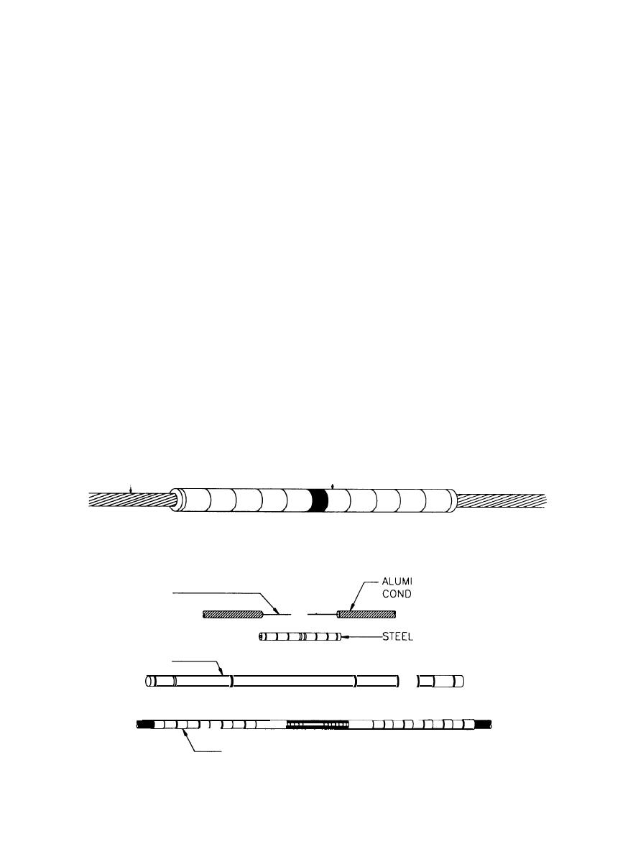

Figure 2: Transmission line splice with sleeve (Splice, 2011)

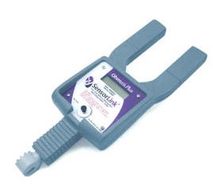

Figure 3: SensorLink sensor (SensorLink, 2011)

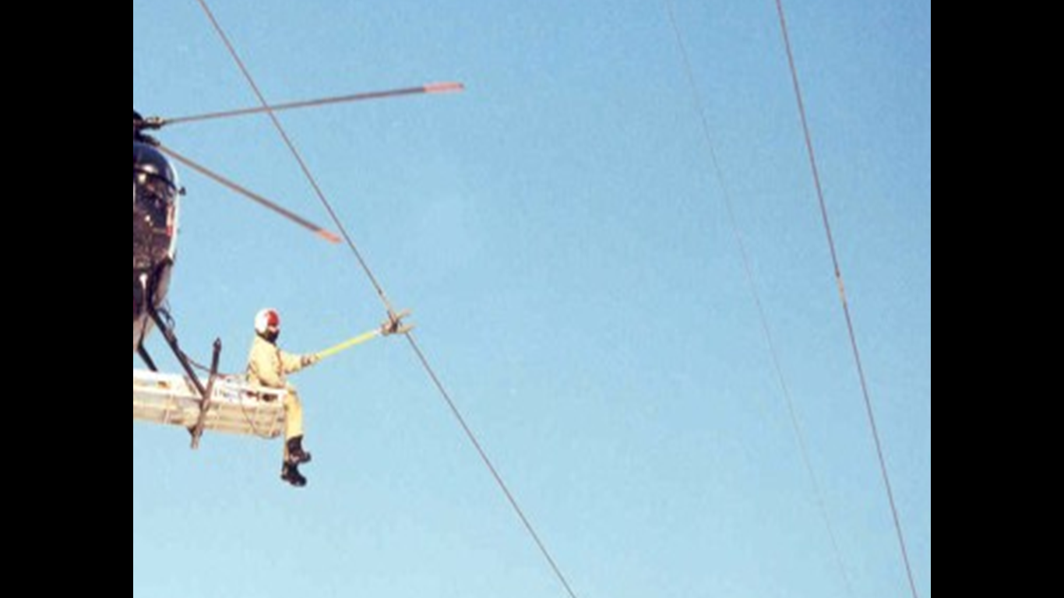

Figure 4: Hot stick operation (Horn, 2011)

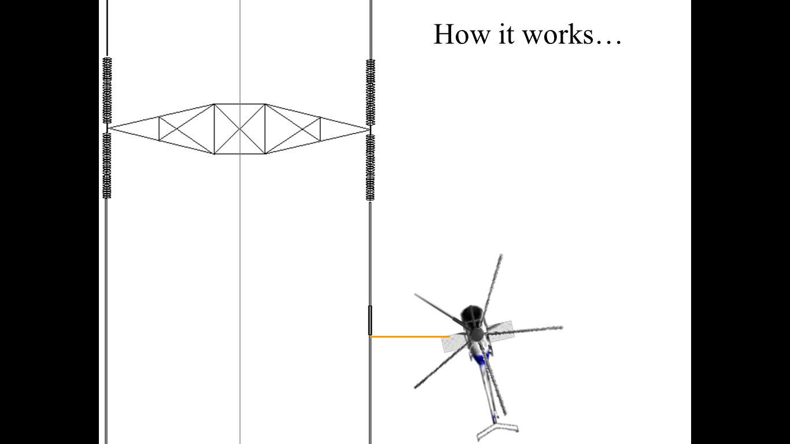

Figure 5: 14' hot stick operation helicopter and transmission line (Horn, 2011)

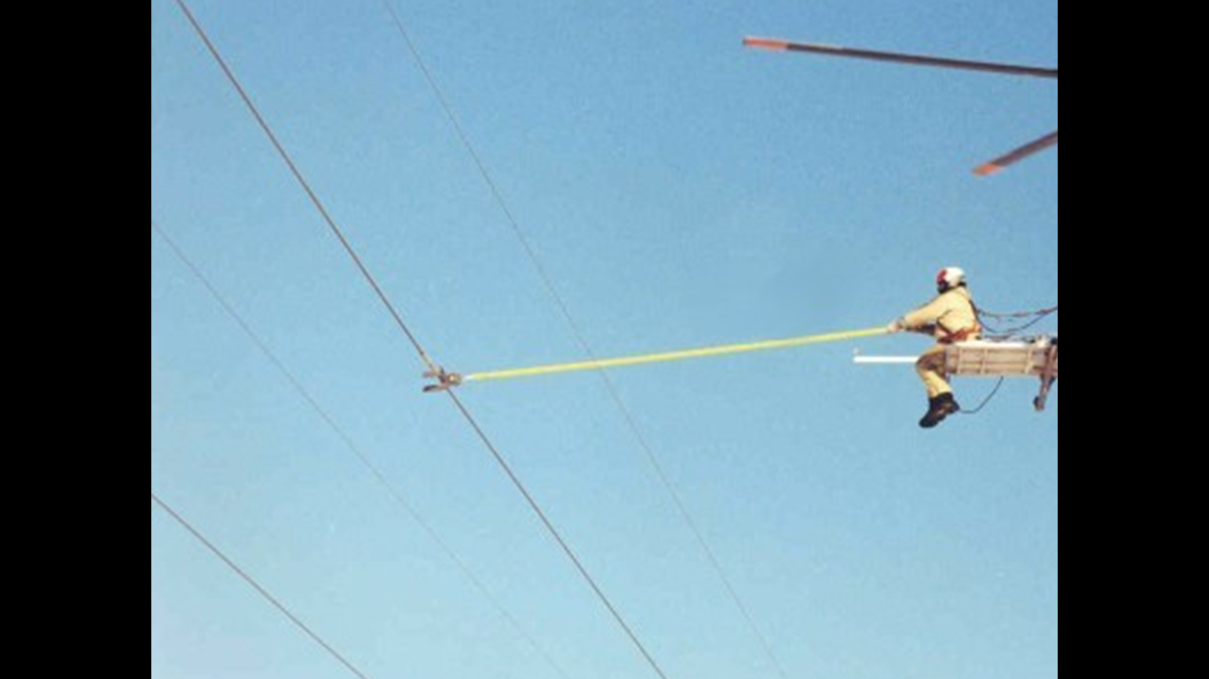

Hot stick unsecured and in danger of rotating upwards into rotors (Operator on “Platform”)

Figure 6: Unsecured 14' hot stick operation (Horn, 2011)

The purpose of this project is to design an assistant for the operator to enable easier sensor readings and reduce the risk of the hot stick rising upwards and interfering with rotors and causing a crash.

A variety of design alternatives were considered before selecting the gimbal assist design. This project would be best rolled out as a multi-phase project:

1. **Phase I:** gimbal assist – The purpose of this phase is to make an immediate impact on current operations for long stick (i.e. 14’) operations where infrared readings are not desired.
2. **Phase II:** Automated gimbal assist with electronic upgrade – This design would incorporate the use of automated splice end detection coupled with gimbal feedback and positioning systems to minimize the need for human assist.
3. **Phase III:** This phase would eliminate the use of the helicopter and operator. In its place, an Unmanned Aerial Vehicle (UAV) (Figure 7) or “Crawler” () would be fully automated and accomplish the same task with significantly less liability, cost, and time. Operations would include the integration of a fully automated signal processing application, ground links, and post processing. The end result for the user would be an automated dashboard displaying hot spots and recommended areas for improvement with cost tradeoffs.

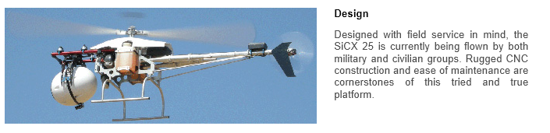

Figure 7: UAV example (UAV , 2011)

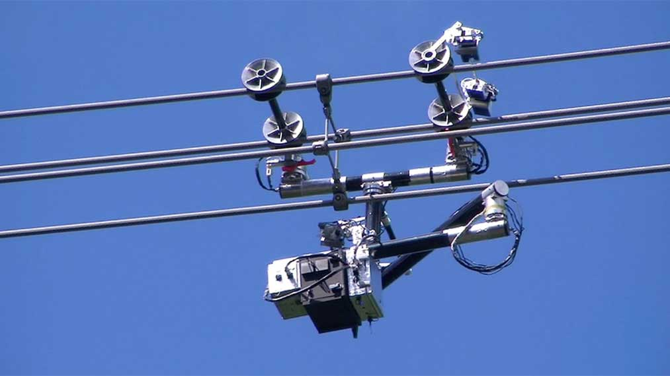

Figure 8: Robotic crawler example (Robot, 2011)

# Solid model and assembly design

## High level

The gimbal assist mechanism is designed to attach to the existing helicopter platform (See Figure 6). The platform, hot stick and SensorLink shown in Figure 9, Figure 10, and Figure 11 are shown for reference only but are useful for understanding proof of design and overall hot stick operation.

The solid model figures show various orientations from both the operator (Figure 9) and other angles. Figure 12 shows the use of a counter balance and stopper. The counter balance or count weight helps the operator by making the hot stick virtually weightless and the stopper ensures that the hot stick does not fall out of the gimbal. The stopper can also be moved to different hot stick lateral locations to aid in safety ensuring that the hot stick does not have the ability to rotate upwards and interfere with the helicopter rotors.

A key advantage to the use of the gimbal assist is that by manipulating the hot stick transversely in and out of the sleeved inner ring of the gimbal, the operator can produce gross movements in all axis when the hot stick is engaged farther in to the gimbal assist due to mechanical leverage while at the same time produce precision, effort-free, motions by pulling back on the hot stick thus reducing mechanical leverage.

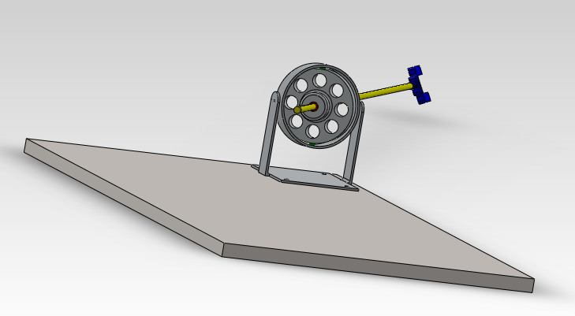

Figure 9: Gimbal assist assembly operator view

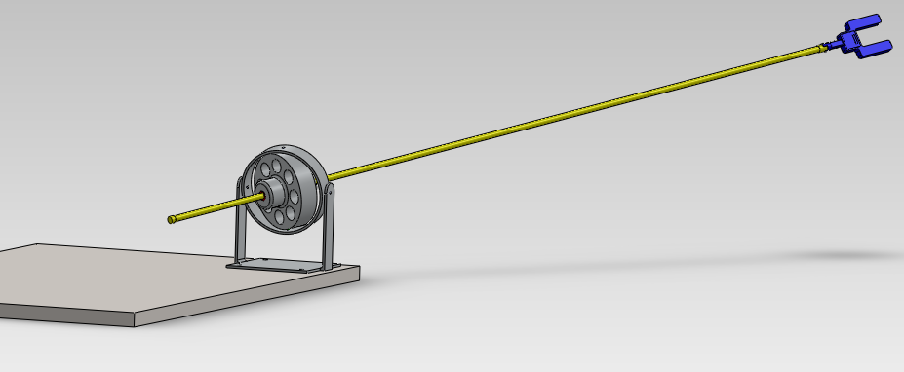

Figure 10: Gimbal assist assembly side view

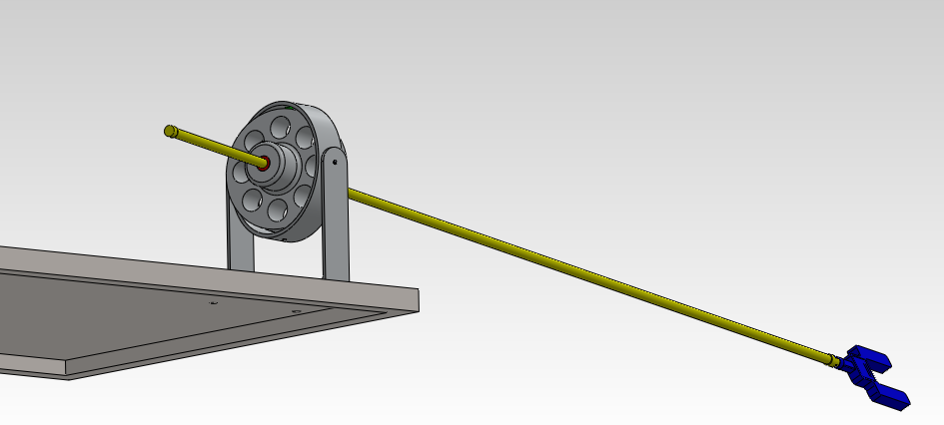

Figure 11: Gimbal assist assembly alternate position

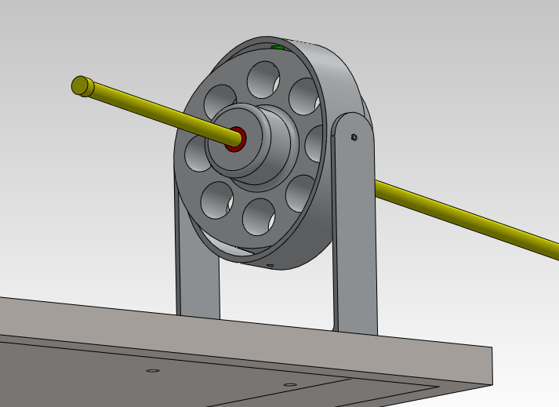

Counter balance and safety stopper.

Figure 12: Gimbal assist assembly close up

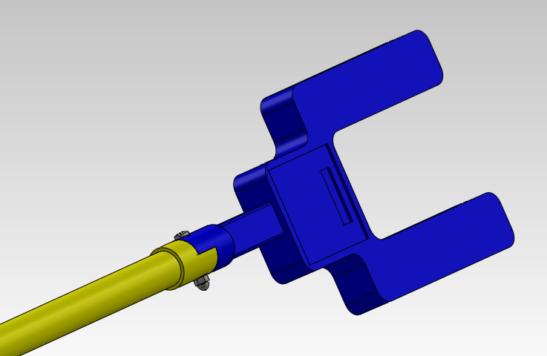

Figure 13: SensorLink hot stick assembly detail (ref. only)

## Detail design

The detail design consists of the core gimbal assist ring design. Figure 14 through Figure 21 show a variety of proof of concept designs including an exploded assembly view (Detailed ballooned SolidWorks exploded view in appendix). The purpose of these views is to illustrate the aspects of the animated design showing the inner rings and outer ring in various orientations constrained by the SolidWorks mates. A fully function animation showing the movement and angles of gimbal rings and hot stick operation is available upon request.

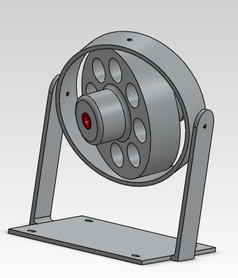

Figure 14: Gimbal assist position x

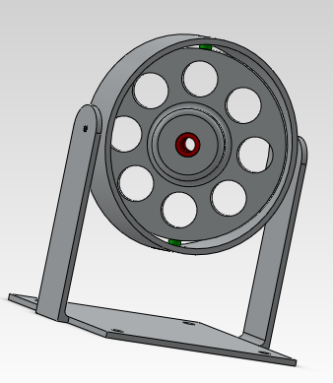

Figure 15: Gimbal assist position y

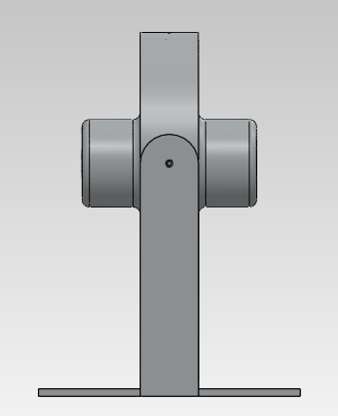

Figure 16: Gimbal assist side view

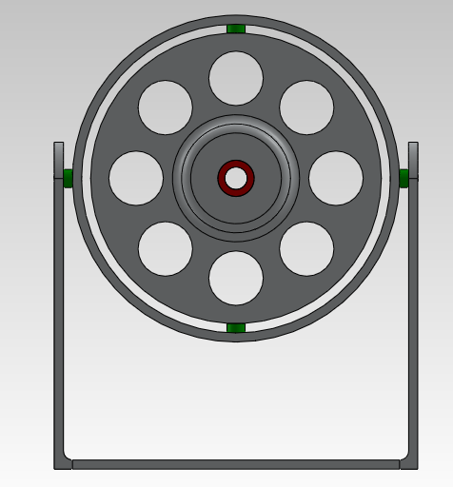

Figure 17: Gimbal assist front view

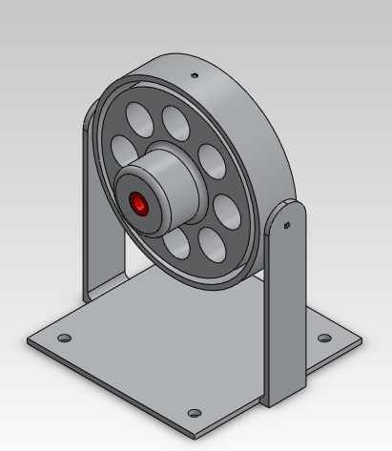

Figure 18: Gimbal assist isometric view

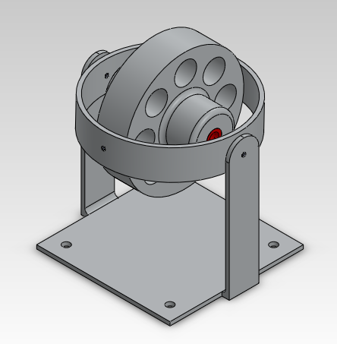

Figure 19: Gimbal assist fully articulated

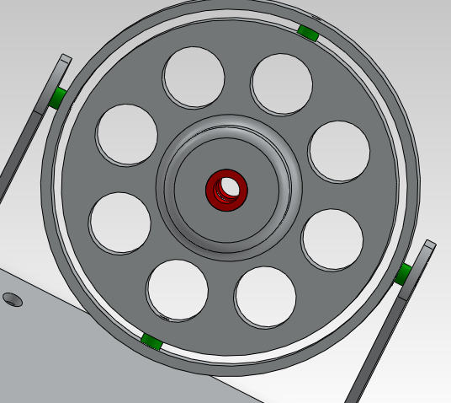

Figure 20: Gimbal assist inner sleeve and spacer detail

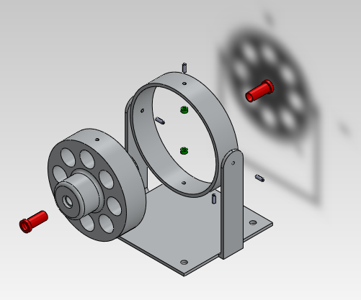

Figure 21: Gimbal assist exploded view

### Tolerancing and bearing analysis

In general, tolerance requirements for this design are not rigorous. This is because of the size of the gimbal and the application. The outer gimbal ring is 18” and precise tolerances are not required. There are a few key design areas where tolerance analysis was required. These include the gimbal pins, and related gimbal ring holes along with the gimbal inner ring hot stick sleeve bearings.

Most tolerances are set by industry standard units per the drawing sheets (Figure 22). Care was taken in all part and assembly drawings to call out reasonable tolerance specifications based on number of decimal places. In most cases only two decimal places are required resulting normal tolerance requirements of +/- 10 thousands/mil. Unless required +/- 5 mil tolerances should be avoided to reduce manufacturing cost.

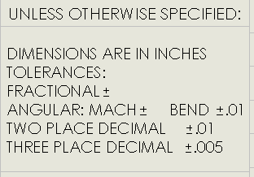

Figure 22: General tolerance requirements

#### Inner ring

The inner gimbal ring serves the main function of supporting the rotation and transverse motion of the hot stick from the operator to the transmission line. The 8 holes in the inner gimbal ring serve two functions 1. They reduce weight 2. They increase operator visibility (Figure 17). In order to make this motion as smooth and cost effective as possible two sleeve bearings are used to support the hot stick, ensure smooth effortless motion, and reduce wear. Sleeve bearings require two important fits - clearance and interference fits.

The areas where tolerances are most important are listed below. The fiberglass hot stick nominal diameter is 1.25 in. Since this is a fiberglass shaft with little need for tight precision it is assumed that the tolerance range will be +/- 0.05in resulting in a Dmax of 1.30in and a Dmin of 1.20in. As shown in the appendix and (Figure 23) the hot stick sleeve inner diameter is tolerance for a minimum of 1.300in +0.1 / - 0.0.

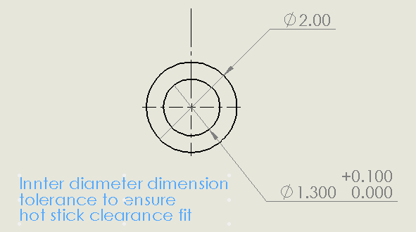

Figure 23: Hot stick tolerancing

Hot stick outer diameter dimensioning follows similar but opposite design requirements to ensure an interference or press fit within the inner gimbal ring (Figure 24).

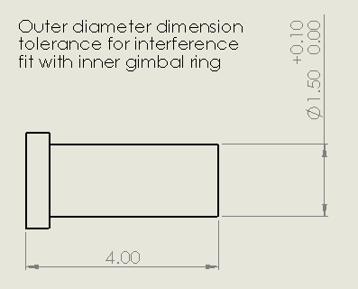

Figure 24: Gimbal sleeve bearing OD tolerance

The clearance fit is used between the hot stick and inside diameter of the sleeve bearing and the interference fit is used to secure the bearing into the inner ring housing.

### Gimbal pin fit

Gimbal pins press fit into inner ring, clearance fit to outer ring, press fit into gimbal platform. Gimbal pins are constructed of plain machine steel with a +/- .005in tolerance on a 0.500in diameter. This results in a pin Dmin of 0.495 and a Dmax of 0.505. In order to ensure an interference press fit into the inner ring member the inner ring tolerances is defined as follows (Figure 25).

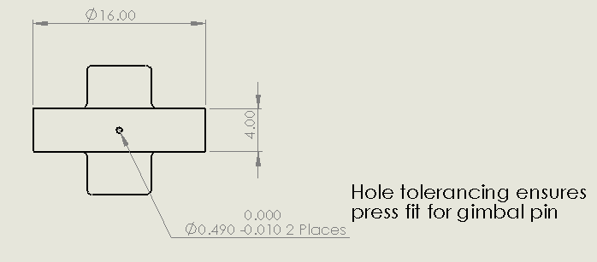

Figure 25: Inner ring press fit tolerance

While a press fit is desired for the inner ring gimbal part, a clearance running fit is required along with gimbal spacer for connection and proper function to the outer ring (Figure 26). Since a press fit is desired for the gimbal platform housing the same dimensions are used as in Figure 25.

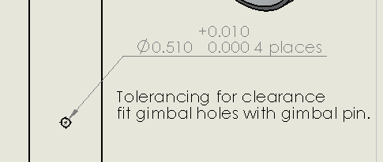

Figure 26: Outer ring clearance tolerance

# Design of materials

The basic choice for the main mechanical parts for the gimbal assembly is aluminum due to weight, strength, and cost constraints. This is also the leading choice of materials for aircraft and helicopter applications. After researching various alloys and making tradeoffs for machinability and cost the 6061 alloy appears to be a good choice. However, this could be changed based on discussions with machine shops or manufacturers.

The design tradeoffs include a balance of what is readily available yet possesses a good mix of production quality along with cost considerations while remaining light and strong at the same time. The overall mechanical design of the gimbal assist affords the use of a standard material due to the size of the design and anticipated stress/strain requirements. According to tpoparts.com 6061 is a reasonable choice for the prototype gimbal assist.

***6061***

*6061 alloy is an extremely common modern aluminum alloy. It has good strength, it is easily machined, and it resists corrosion. It is also lower cost than most other alloys. Due to these factors it is extremely popular for aftermarket parts used in motorcycles. If you see a part labeled "billet aluminum" or "aircraft aluminum" but the alloy is not specified, then it is safe to assume that it is 6061 alloy. Note that this is misleading as 6061 alloy is generally NOT used for aircraft applications as there are other alloys which have better mechanical properties. Despite this, many people will call 6061 "aircraft aluminum" anyway. We use 6061 Alloy only for low-stress parts where unusual strength is not required, such as spacers and license plate brackets. However, many companies do use 6061 for high-stress parts simply becasue it is inexpensive, easy to machine, and it also lets them put the "aircraft aluminum" name on their parts—even though 6061 is not a high performance alloy at all.* (Aluminum, 2011)

Sleeve bearings and gimbal spacer material specified as Nylon 101. Nylon chosen for light weight and wear against fiberglass hot stick. Gimbal platform, hot stick fiberglass rod, and SensorLink are provided as model reference items. Material choices have not been assigned to these parts accordingly.

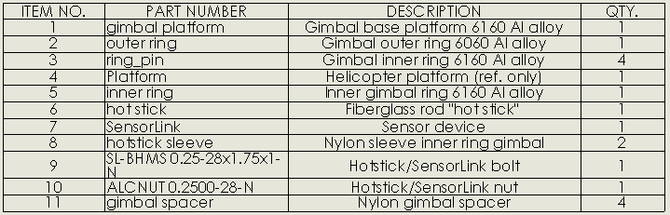

Figure 27: Overall BOM

# Proof of design/analysis

The overall proof of design is greatly increased with the use of a solid model like the one constructed for this project in SolidWorks. The ability to “dry fit” this design with the hot stick and work the gimbal in different directions is highly valuable. This design reflects the needs and requirements of industry practitioners and executives. By combining these elements, the probability of success increases the confidence that this design will prove valuable. However, it is still important to receive customer feedback and construct and field test a prototype before finalizing the design.

# Conclusions and future recommendations

The prototype should work, it is producible, and is cost effective based on the design and analysis presented in this paper. Future recommendations include the need to prove out the prototype, make incremental design changes and reduce size, weight, and production costs. There is a significant amount of improvements that can be made in the automation of this design especially in the areas of data collection, analysis, and post processing.

In addition to this specialized market, there is a potential to expand this offering to other related industries that require rapid positioning, safety, and cost constraints. Examples include fire fighting, tree trimming, painting, etc. Ultimately, we will see the introduction of low cost UAVs () and robotic crawlers capable of automating this task while increasing reliability, accuracy, cost, and most important safety.

# Appendix

Appendix includes individual SolidWorks dimensioned and tolerance drawings for each part and overall assembly.

# Works Cited

*Aluminum*. (2011). Retrieved December 2011, from TPO Parts: http://www.tpoparts.com/articles/aluminumalloys.html

*Robot*. (2011). Retrieved December 2011, from DigInfo TV.

*SensorLink*. (2011). Retrieved December 2011, from SensorLink: http://www.sensorlink.com/product?id=45

*Splice*. (2011). Retrieved December 2011, from Integraded publishing: http://www.tpub.com/content/NAVFAC/mo200/mo2000050.htm

*Transmission*. (2011). Retrieved December 2011, from wikipedia: http://en.wikipedia.org/wiki/Electric_power_transmission

*UAV* . (2011). Retrieved December 2011, from Guided Systems Technology.

Horn, R. (2011). Horn. *Ohmstick demo.pps*.