# A loomo robot and a computer: a dream team for area learning

This project demonstrates (1) getting a variety of data from a loomo robot captured by its sensors, such as the color images, the depth images, and the parameters of cameras, and (2) receiving and processing these data on a computer.

From a robot, data captured by its sensors are published via the middleware framework rosjava to corresponding topics. These topics are subscribed by a program running on a computer which processes the received data and publishes the results to other topics for visualization.

The communication between a robot and a computer is established by connecting both the robot and the computer to the same Wi-Fi network. In the software level, the ROS framework supports the communication between a loomo robot and a computer as an app (ROS node) for publishing data runs on the robot and the roscore node operates on the computer.

This project has been tested on a computer with Ubuntu 16.04 and ROS kinetic, and android studio 2.3.

## Install the publishing app on loomo

The publishing app publishes the data acquired by the loomo robot via the rosjava framework to corresponding topics. For this purpose, rosjava is used because a loomo robot runs the android OS. Currently the publishing app still undergoes active development. In the near future, it will be provided as an app available for installation from the Google Play store. Now for the completeness of this document, the installation from source of the publishing app is explained in the following.

Before actually building the app from source, the ROS and android environment should be configured on the computer.

1. Configure the environment

(Test environment: Ubuntu 16.04, ROS kinetic, android studio 2.3.3)

Assume ROS (<http://wiki.ros.org/kinetic/Installation>) and android studio (<http://wiki.ros.org/android/kinetic/Android%20Studio/Download>) has been installed.

Then prepare the ROS environment for android development according to (<http://wiki.ros.org/android>) as summarized below,

```

sudo apt-get install ros-kinetic-rosjava-build-tools

mkdir -p ~/android_core

wstool init -j4 ~/android_core/src https://raw.github.com/rosjava/rosjava/kinetic/android_core.rosinstall

source /opt/ros/kinetic/setup.bash

# You only need to do the next step if you opted for a source installation of rosjava:

source ~/rosjava/devel/setup.bash

cd ~/android_core

catkin_make #If you failed on this step, do this step by root.

```

2. Revise the android_tutorial_camera sample

You will get a catkin workspace android_core after step 1. There is a folder, android_tutorial_camera, in that workspace. The publishing app is developed mainly based on this sample by modifying several files. The revised files are not disclosed at the moment. Suppose these revised files are at hand, replace the following 6 files in the catkin workspace created in step 1 with the revised ones.

android_core/src/android_tutorial_camera/src/org/ros/android/android_tutorial_camera/LoomoRosBridgeNode.java

android_core/src/android_tutorial_camera/src/org/ros/android/android_tutorial_camera/MainActivity.java

android_core/src/android_10/src/org/ros/android/view/camera/CompressedImagePublisher.java

android_core/src/android_tutorial_camera/build.gradle

android_core/src/android_tutorial_camera/res/layout/main.xml

android_core/src/android_tutorial_camera/res/values/strings.xml

3. Build from source

```

cd ~/android_core

catkin_make

```

4. Install and configure the app on loomo

Firstly, connect the computer and loomo through a USB cable.

Secondly, open the android_core project by android studio and choose the program android_tutorial_camera as the build target (Fig. 1), then click run. If successful, there will be an app CameraTutorial shown up on loomo (Fig. 2).

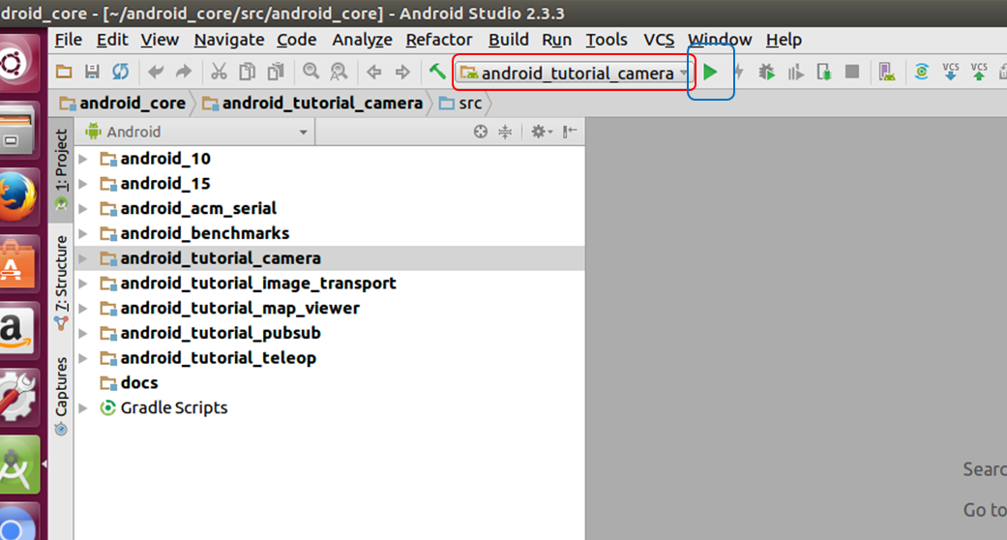

**Fig. 1. The backdrop of the android_tutorial_camera sample**

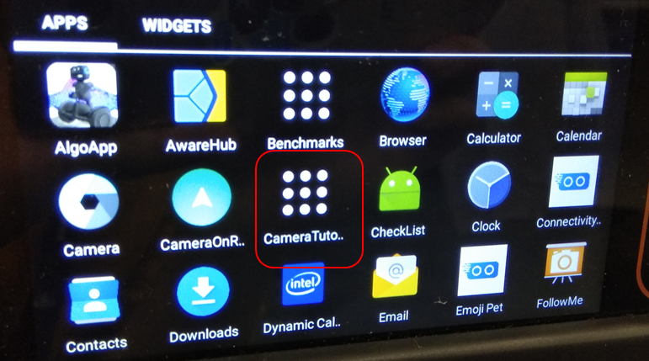

**Fig. 2. The CameraTutorial app installed on loomo**

To enable the robot publishing the acquired data from its sensors, first start the roscore program in a terminal of a computer. Then click the app CameraTutorial on loomo, change the IP address part of the URI blank to the IPv4 address of the computer (note ipconfig in Windows and ifconfig in Linux to check the IP address) and click the connect button (Fig. 3). If everything is OK, there will be a tip showing binding successfully. On the subsequent screen, there are five toggle buttons deciding whether a corresponding data type is published (Fig. 4). By default, nothing is published.

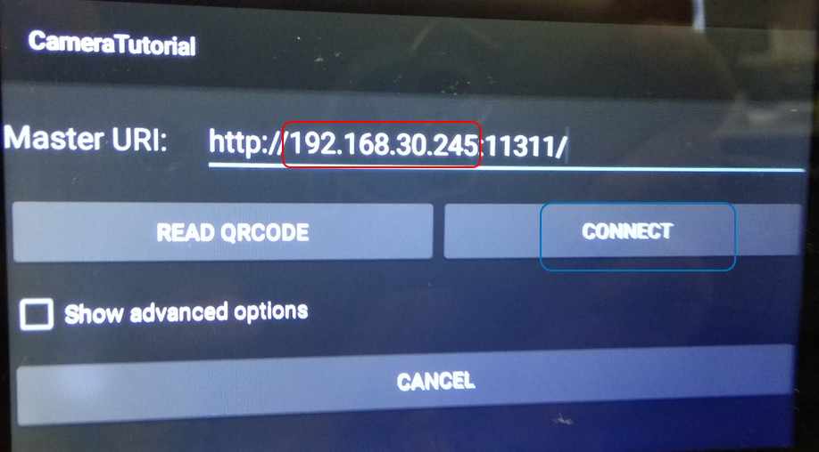

**Fig. 3. The GUI of the CameraTutorial app**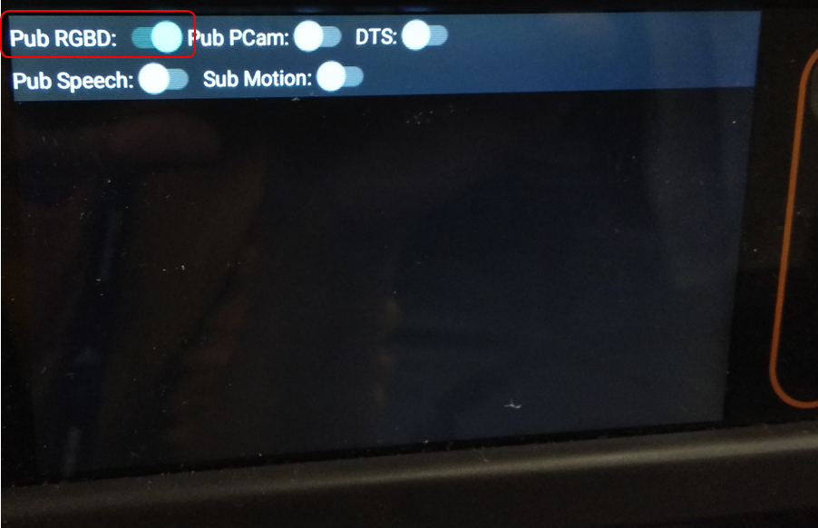

**Fig. 4. The panel of toggle buttons indicating which data to publish. This screen shows that publishing the RGBD data is enabled.**

## Install the loomo_vision program on a computer

The loomo_vision program on the computer subscribes to these topics where a robot publishes data at, processes the received data, and publishes the results to other topics, such as pointCloud.

1. To build the program，firstly, create an empty catkin workspace loomo_ws according to (http://wiki.ros.org/catkin/Tutorials/create_a_workspace).

2. Secondly, open a terminal and type the below commands.

```

mkdir -p ~/loomo_ws/src

cd ~/loomo_ws/src

git clone <https://github.com/segway-robotics/vision_msg_proc.git>

cd ..

catkin_make

```

## Team up the robot and computer for a demo

1. Run roscore on a computer. Open a terminal, and type

```

roscore

```

2. Start and configure the app on loomo as in Fig. 3 and 4. For now, assume the robot publishes at least the RGBD data.

3. Run the loomo_vision program on the same computer. Open a terminal, and type

```

roslaunch loomo_vision vision.launch

```

4. visualize the pointCloud. Open a terminal, and type

```

roscd loomo_vision

rviz -d ./pclConfig.rviz

```

pclConfig.rviz is config file.

The rqt_graph depicts the data flow (Fig. 5) for the above demo.

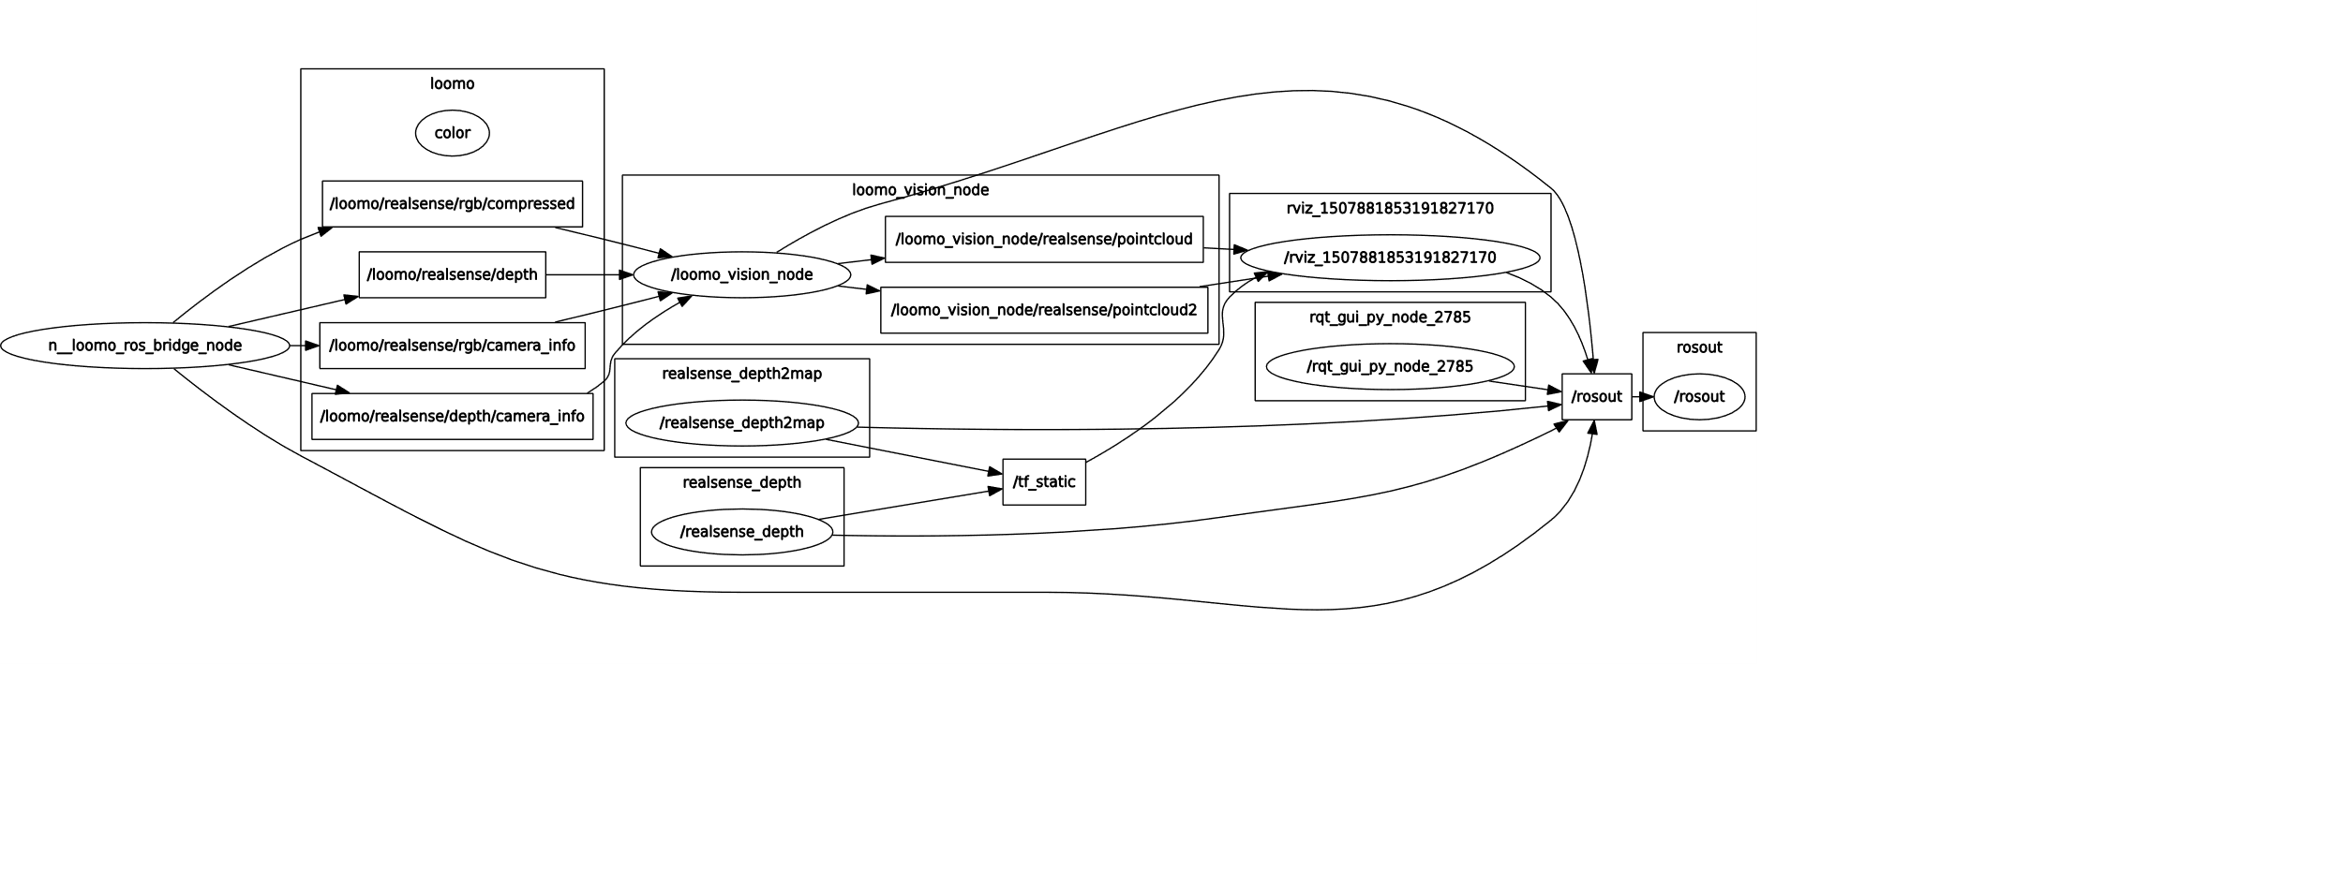

**Fig. 5. The relationship between different nodes**