Whole-genome characterisation of Escherichia coli isolates from older women with urinary tract infection and asymptomatic bacteriuria

Marlies Mulder, Department of Medical Microbiology, Infectious Diseases and Infection Prevention, Maastricht University Medical Centre (MUMC+), Maastricht, The Netherlands.
Manu P. Bilsen, Leiden University Center of Infectious Diseases (LUCID), Leiden University Medical Center, Leiden, The Netherlands.
Martha T. van der Beek, Leiden University Center of Infectious Diseases (LUCID), Leiden University Medical Center, Leiden, The Netherlands
Antoni P.A. Hendrickx, National Institute for Public Health and the Environment (RIVM), Centre for Infectious Disease Control, Bilthoven, the Netherlands.
Merel M. C. Lambregts, Leiden University Center of Infectious Diseases (LUCID), Leiden University Medical Center, Leiden, The Netherlands
Caroline Schneeberger-van der Linden, Department of Medicine for Older People, Amsterdam UMC Location Vrije Universiteit, Amsterdam, The Netherlands

Keywords: urinary tract infection, WGS, virulence factors, older adults, asymptomatic bacteriuria

Abstract (292 woorden, max 300 woorden)
Objectives: Diagnosing urinary tract infection (UTI) in older women is complicated due to the high prevalence of asymptomatic bacteriuria (ASB). We aimed to evaluate whether pathogen-related factors differ between older women with UTI and ASB and to gain more insight into the persistence of Escherichia coli in ASB.
Methods: In this exploratory study, E. coli isolates of 46 participants were analysed. This study included women aged ≥ 65 years with UTI (≥ 2 new-onset lower urinary tract symptoms, pyuria, and bacteriuria) or ASB (E. coli ≥ 10⁴ CFU/mL in 2 consecutive samples) from the community and long-term care facilities. Whole-genome sequencing was used to identify previously described putative urovirulence factors (PUFs), antimicrobial resistance genes, multilocus sequence typing (MLST) sequence type (ST), and Clermont phylotype.
Results: 31 isolates from UTI patients and 32 sequential isolates from 15 ASB patients were analysed. All patients in the ASB group carried genetically similar E. coli isolates in two consecutive samples (obtained within 2-4 weeks). The isolates belonged to a variety of different ST types, of which ST69, ST73 and ST141 were the most common. No significant difference in the number of PUFs between the two groups was found. We did, however, find individual differences in PUFs: more cnf1, hlya, hek, iroN and sfaH in UTI isolates versus more iha, iucc, sat and sitA in ASB isolates (≥15% difference).
Conclusions: Our results show possible individual differences in PUFs between individuals with UTI and ASB, which should be investigated further to find out their exact functional properties in the bladder epithelium to elucidate its role in persistence in the bladder and UTI pathogenesis. Also, they should be analysed in relation to individual host factors, which could also play an important role in this process.
Introduction (2564 woorden, max niet veel meer dan 2500)
Urinary tract infections (UTIs) are among the most common infections, particularly in women, making them one of the leading reasons for prescribing antimicrobial drugs and contributing significantly to antimicrobial resistance. (1, 2) Older individuals are especially susceptible to developing UTIs. Traditionally, the clinical diagnosis of a UTI involves evaluating a combination of clinical signs and symptoms, such as dysuria, frequency, urgency, suprapubic pain, and pyuria. This clinical assessment is typically complemented by the detection uropathogens in the urine, often determined through urinary culture.
Diagnosing UTIs in older people can be challenging for several reasons. First, they may have difficulty expressing their symptoms, particularly due to acute cognitive decline such as delirium. Second, older patients often experience chronic lower urinary tract symptoms (LUTS), including urinary incontinence and urgency. As these symptoms are not necessarily specific to UTIs, they can be difficult to distinguish from acute UTI episodes. (3) Finally, the prevalence of asymptomatic bacteriuria (ASB) increases with age, affecting 40-50% of older women in long-term care facilities.(4) Asymptomatic bacteriuria is often defined as the growth of a specified quantitative count of bacteria in an appropriately collected urine specimen obtained from a person without symptoms or signs referable to UTI. Asymptomatic bacteriuria may be misclassified as UTI if chronic LUTS and ASB co-occur or if nonspecific, non-genitourinary symptoms, e.g. altered mental status, are wrongfully attributed to UTI.
An important knowledge gap in this context is understanding which factors determine why one patient develops (persistent) bacteriuria without LUTS, while another progresses to UTI. This variation could presumably be attributed to a combination of host and pathogen factors. However, no identifiable causative factor has yet been found that is useful or commonly applied in clinical practice to distinguish between UTI and ASB. Learning and understanding these yet unknown factors is important, particularly because treating ASB has been shown to neither reduce mortality nor morbidity. On the contrary, treating ASB can lead to adverse effects, and colonization with more resistant bacteria as result of selection. (5, 6)
Recently, efforts have been made to improve the diagnosis of UTIs in older women by focusing on host factors, such as exploring inflammatory biomarkers in the urine. (7, 8) Additionally, pathogenicity factors also play a role; for instance, several putative urovirulence factors (PUFs) in uropathogenic E. coli (UPEC) have been implicated in urovirulence. (9-12) This was further supported by a recent study characterizing E. coli strains from patients with sepsis and septic shock, which revealed a high prevalence of virulence genes. (13)
However, little is known about the genetic differences in the most common uropathogen, E. coli, that cause both asymptomatic (ASB) and symptomatic bacteriuria (UTI) in older women. Therefore, our primary aim was to evaluate whether pathogen-related factors related to E. coli differ between older women with UTI and those with ASB. Additionally, we aimed to gain more insight into the persistence of genetically the same E. coli in these older women. This study serves as an exploratory study to investigate the future possibility to diagnose UTI using molecular analysis of the E. coli isolates.

Materials and methods
Study population
This explorative study includes a subset of participants of a prior case-control study evaluating urine biomarkers in older women >65 years with UTI and ASB.(14) The original study was conducted from June 2021 until July 2022 across several hospitals, long-term care facilities (LTCFs) and primary care centres with samples sent to the microbiology lab of the Leiden University Medical Center (LUMC). All participants of whom E. coli isolates were stored were included in this explorative study.
UTI patients were defined as having two new-onset LUTS (dysuria, frequency, urgency and/or suprapubic pain), in combination with pyuria (defined as ≥ 10 leukocytes/µl or ≥ 5 leukocytes per high-power field or presence of leukocyte esterase), and a urine culture that yielded E. coli ≥ 10⁴ CFU/mL. Participants were classified as having ASB if they did not have LUTS, but two consecutive urine cultures (obtained 2-4 weeks apart) yielded E. coli. The study excluded patients with advanced cognitive impairment, delirium, the presence of an indwelling catheter, immunosuppressive use, antimicrobial use within 48 hours prior to inclusion, current urolithiasis, and a previous UTI in the preceding month.
Sample collection
Midstream urine samples were collected in sterile urine containers. According to the protocol of the LUMC, 10 µL of non-centrifuged urine was placed on a 5% sheep blood agar plate and a cystine–lactose–electrolyte-deficient agar plate, and incubated for one day. A culture result was deemed a monoculture if ≥ 90% of the cultured colonies were of one micro-organism. In such cases, a susceptibility pattern was determined for the specific pathogen, using VITEK2 (bioMérieux). In instances where susceptibility testing with VITEK2 failed, disk diffusion was performed.
Breakpoints were used according to EUCAST (2019). Isolates falling into the category of area of technical uncertainty were classified as resistant. For ampicillin, oral breakpoints were used, whereas for cefuroxime, intravenous breakpoints were applied. Extended-spectrum beta-lactamase (ESBL) production was phenotypically confirmed by observing a ≥ 5mm difference between the disk diffusion zones of the isolate for cefotaxime (± clavulanic acid) and ceftazidime (± clavulanic acid).
Genomic analyses
Whole genome sequencing (WGS), assembly and typing
63 E. coli isolates included in this study were subjected to whole-genome sequencing (WGS) using Illumina next-generation sequencing. DNA was extracted using the DNeasy Blood & Tissue Kit (Qiagen, Hilden, Germany) and DNA libraries were prepared using Nextera DNA Flex Library Prep kit (Illumina, San Diego, CA, USA), followed by paired-end sequencing (2 x 150 bp) on the Illumina NextSeq550 platform (Illumina, USA), all according to the manufacturer’s protocols.(15) Read quality analysis and de novo assembly were done with the Juno-assembly v2.0.2 pipeline from the National Institute for Public Health and the Environment (RIVM) (https://github.com/RIVM-bioinformatics/juno-assembly). WGS data was used for: 1) Multilocus sequence typing (MLST); 2) whole-genome (wg)MLST (an in-house E. coli wgMLST scheme was used as described previously);(15) 3) the Clermont phylotype (16); 4) detection of 31 previously described putative uropathogenicity factors (PUFs) (using an in-house “PUFsfinder”; ≥90% identity = present) (10-12, 17); and 5) the identification of resistance genes using ResFinder (version 4.1.0) from the Center for Genomic Epidemiology (18); a threshold of 95% was used for identity and 60% for the minimum length for ResFinder);
Statistical analysis
This study was designed as a hypothesis-generating exploratory study, with most results presented descriptively. A Mann-Whitney U test was performed to investigate the difference in the number of PUFs between women with UTI and women with ASB.
Ethical considerations
The original study was approved by the regional medical ethics committee (Leiden, Den Haag, Delft, The Netherlands) and conducted in accordance with the Declaration of Helsinki. Written informed consent was obtained from all participants. All participants included in this secondary analysis provided separate consent for the use of their samples in additional studies.
Results
General characteristics of study population
The original cohort included 213 patients, of which 46 patients were included in this study, 31 patients in the UTI group and 15 patients in the ASB group. (Figure 1) Among the 31 UTI patients, 4 (12.9%) had fever (T ≥ 38°C) at the time of diagnosis. All but one ASB patient had colony counts ≥10⁵ CFU/mL in both samples. In 2 ASB patients, 3 samples were collected instead of 2 samples, all samples were analysed. The ASB patients were generally older (20% 65-74, 33.3% 75-84 and 46.7% >84 years) and more frequently residing in LTCFs (53.3%) compared to the UTI patients (41.9% 65-74, 45.2% 75-84 and 12.4% >84 years; 12.9% admitted to LTCF).
Genetic characterization of isolates
The 46 sequenced E.coli isolates (31 from UTI group and 15 (included only once in this analysis, because isolates from second sample were genetically similar) from the ASB group) belonged to 29 different sequence types (ST), with ST69, ST73 and ST141 being the most common. ST141 was more prevalent in UTI patients than in ASB patients (4 (12.9%) vs 0 (0%)). (Supplementary table 1). Phylotyping revealed that Clermont phylotype B2 was the most common phylotype in both the UTI (17/31; 54.8%) and the ASB (10/15; 66.7%) groups, followed by Clermont phylotype D in both groups (Figure 2). Furthermore, we investigated the presence of 31 previously described PUFs (Table 1). (10) The PUFs feoB and fimH were present in all E. coli isolates, the PUFs ompT, sitA, chiuA, fyuA and irp2 were also very common (≥ 70% of isolates in each group). Some PUFs (e.g. cnf1, hek, hlyA, iroN and sfaH) were more prevalent in UTI isolates, whereas others (e.g. iha, iucc, sat and sitA) were more common in ASB-retrieved E. coli isolates (≥15% difference between both groups). No significant difference was found in the median number of PUFs between the UTI group (median 12, IQR 9 - 19) and the ASB group (median 14, IQR 8 - 16). (Supplementary Figure 1).
Persistence of E. coli in ASB
E. coli isolates from the paired samples of all 15 ASB patients had the same wgMLST group and clustered together, strongly suggesting that these patients were persistently colonized by the same E. coli strain for at least 2-4 weeks. In one patient with three consecutive urine samples, the first sample contained an E. coli strain from a different wgMLST group than the E. coli isolates in the second and third samples, which were in the same wgMLST group and clustered together. (Figure 3)
Antimicrobial resistance
Antimicrobial resistance was generally low; a genotypical cause for phenotypic resistance was established in most resistant isolates. The results can be found in Supplementary file 1.
Discussion
Diagnosing UTI, particularly in older patients, can be challenging. We explored whether genomic characteristics distinguished E. coli isolates from older female patients with UTI (n = 31) and ASB (n = 15). We found no clear differences in ST-types and Clermont phylotypes between the two groups. Furthermore, no significant differences in the number of PUFs between the two groups were found. However for various PUFs differences may exist between UTI and ASB that warrant further investigation in a larger cohort, as the sample size in this study was too small to draw formal conclusions. Also, we investigated paired E. coli isolates from women with ASB and showed these isolates persisted for several weeks.
We found a wide variety of ST types, the most common ones in our study were ST69, ST73 and ST141 with only ST141 being more prevalent in the UTI group, although the numbers were low. In a Dutch study with nursing home isolates obtained from recurrent UTIs were ST131, ST73 and ST69 the most common, thus partially similar as in our study. (19) However, ST69 and ST73 are also common in bloodstream isolates (together with ST95 and ST131 accounting for 38-61% of the isolates). (13) This seem to indicate that these ST types are belonging to the most common ones and do not associate with severity of disease and virulence of the E. coli isolate.
We found a wide variety of ST types, with the most common ones in our study being ST69, ST73, and ST141, with only ST141 being more prevalent in the UTI group, although the numbers were low. In a Dutch study with nursing home isolates obtained from recurrent UTIs, ST131, ST73, and ST69 were the most common, which is partially similar to our study. However, ST69 and ST73 are also common in bloodstream isolates (along with ST95 and ST131), accounting for 38-61% of the isolates. This seems to indicate that these ST types are among the most common and do not necessarily associate with the severity of disease or the virulence of the E. coli isolate.
We also did not find any differences in the numbers of PUFs between the UTI and the ASB group. Notably, two toxins, cnf1 and hlyA, which are known to significantly contribute to inflammation and tissue damage were more present in the UTI isolates than in the ASB isolates.(20) However, several other toxins were similarly present or absent in the two groups: cdtB was almost absent in both groups; tsH and vat were equally present in both groups, whereas sat was more present in ASB isolates than in UTI isolates. Furthermore, several PUFs that are thought to play a role in the adhesion and invasion of uroepithelial cells (hek, sfaH and iroN) were more present in the UTI isolates and indeed adhesion and invasion of E.coli isolates are important mechanisms in the pathogenesis of UTI.(21) However, other PUFs related to adhesion, such as focH, papG2 and papG3, were equally present in both groups and the iha adhesion was more present in the ASB group. This diversity in outcomes in relation to adhesion associated PUFs warrants detailed analysis of the functional properties in the bladder epithelium. It might be that some of these virulence factors are important in causing the inflammation that expresses as a UTI, whereas other are more important for survival and persistence in the urinary tract (important in UTI and ASB).
We also showed that E. coli isolates in the ASB patients persisted for several weeks, which suggests that the E. coli population living in the urinary tract of these patients is of one subtype and is relatively constant. Since there were only several weeks between samples, we cannot draw conclusions about the population over a longer period. This was, however, also shown in another Dutch study investigating recurrent UTIs in nursing home residents with one third of recurrent UTI episodes caused by the same strain. (19) Thus, also persistence of the same strain does not typically distinguish between UTI and ASB. Unfortunately, we do not have any follow-up data on the possible development of UTIs afterwards.
This descriptive study on E. coli isolates in ASB and UTI in older patients provides important leads for future research. Characterizing E. coli isolates, especially in older patients, is rare. Also, distinguishing UTI from ASB in elderly patients is difficult. Therefore, while limited in numbers, this study is unique in its accurate and standardized description of the isolates in combination with the clinical manifestation in the participants.
In conclusion, we could not find any clear genomic differences between E. coli isolates of participants with UTI and ASB. Also, we found persistence of E. coli isolates in ASB patients, but this has also been found in recurrent UTIs in similar patients. (19) It could, therefore, be hypothesized that the individual host factors are more important than the urovirulence of the E. coli isolate in general or in these older individuals. Only by understanding the interplay between host factors and urovirulence factors can these elements be effectively considered in the clinical challenge of distinguishing between UTI and ASB.

Transparency declaration
Conflict of interest
Nothing to report.
Funding
Moet hier wat worden gerapporteerd?

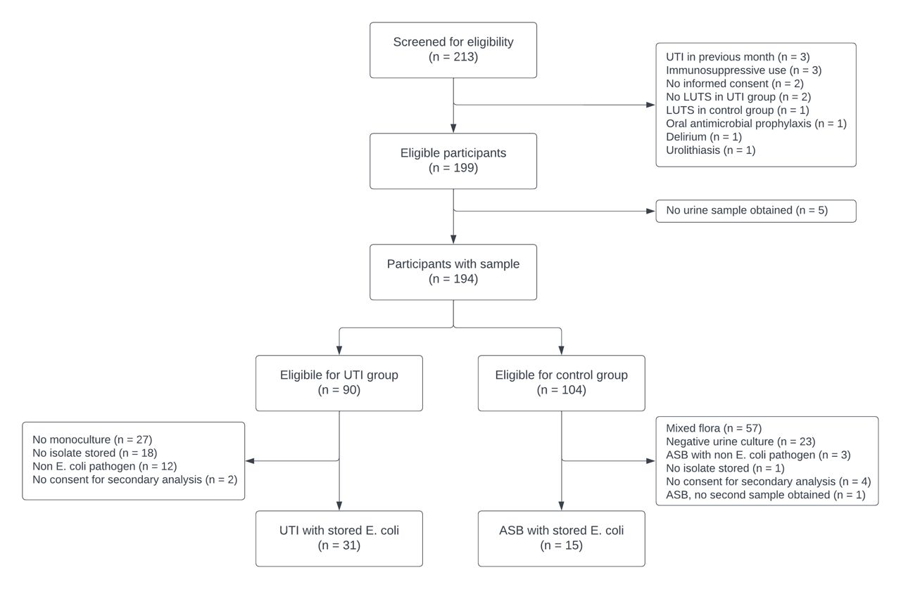Figure 1. Flowchart of sample selection of women who fulfilled the criteria to suffer from UTI or ASB.

Supplementary table 1: ST types of E. coli isolates in UTI and ASB patients
ST type | Overall, n (%) | UTI, n (%) | ASB, n (%)
10 | 2 (4.3) | 2 (6.5) | 0 (0)
12 | 2 (4.3) | 1 (3.2) | 1 (6.7)
59 | 2 (4.3) | 2 (6.5) | 0 (0)
69 | 4 (8.7) | 2 (6.5) | 2 (13.3)
73 | 4 (8.7) | 3 (9.7) | 1 (6.7)
88 | 1 (2.2) | 1 (3.2) | 0 (0)
91 | 1 (2.2) | 0 (0) | 1 (6.7)
95 | 3 (6.5) | 1 (3.2) | 2 (13.3)
127 | 1 (2.2) | 1 (3.2) | 0 (0)
131 | 2 (4.3) | 0 (0) | 2 (13.3)
141 | 4 (8.7) | 4 (12.9) | 0 (0)
162 | 1 (2.2) | 0 (0) | 1 (6.7)
174 | 1 (2.2) | 1 (3.2) | 0 (0)
349 | 2 (4.3) | 2 (6.5) | 0 (0)
357 | 1 (2.2) | 1 (3.2) | 0 (0)
538 | 1 (2.2) | 0 (0) | 1 (6.7)
569 | 1 (2.2) | 1 (3.2) | 0 (0.0)
602 | 1 (2.2) | 1 (3.2) | 0 (0)
636 | 1 (2.2) | 1 (3.2) | 0 (0)
963 | 1 (2.2) | 0 (0) | 1 (6.7)
998 | 2 (4.3) | 2 (6.5) | 0 (0)
1049 | 1 (2.2) | 1 (3.2) | 0 (0)
1193 | 1 (2.2) | 0 (0) | 1 (6.7)
1444 | 1 (2.2) | 1 (3.2) | 0 (0)
2521 | 1 (2.2) | 1 (3.2) | 0 (0)
4360 | 1 (2.2) | 1 (3.2) | 0 (0)
5420 | 1 (2.2) | 0 (0) | 1 (6.7)
8464 | 1 (2.2) | 1 (3.2) | 0 (0)
undefined | 1 (2.2) | 0 (0) | 1 (6.7)
* Similar isolates from two different samples from ASB group were included once. From two ASB patients, three samples were taken. One of those had three times the same E. coli isolates, which was included once. The other one had two time the same E. coli (which was included once) and one time another (which was not included (ST569)).

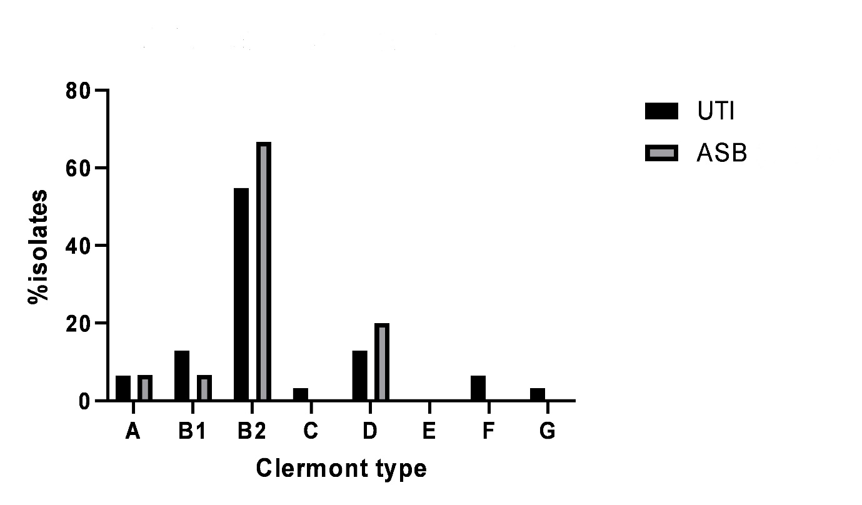
Figure 2: Percentage of isolates per Clermont phylotype.

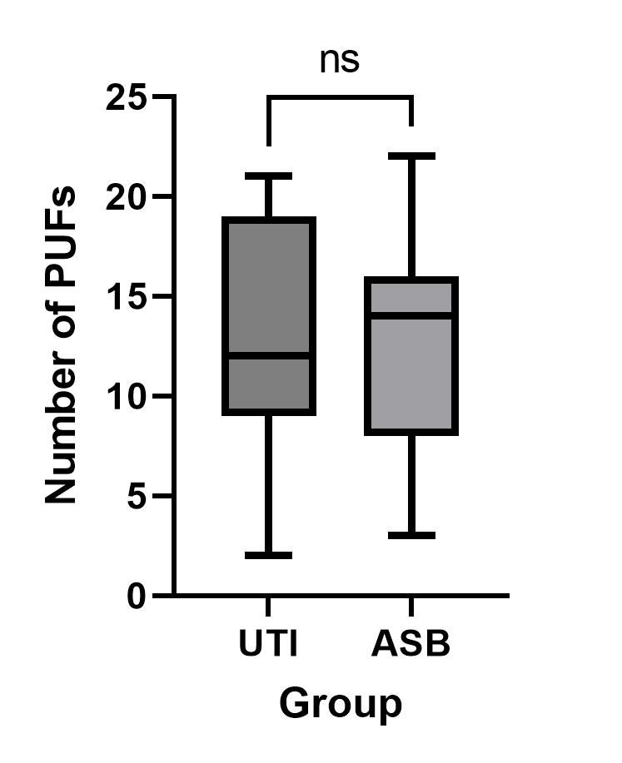
Figure 3: Number of putative uropathogenicity factors in E. coli isolates from patients with urinary tract infection (UTI) and asymptomatic bacteriuria (ASB).

Table 1. Percentages of isolates with the PUFs in the UTI and ASB group
PUF abbreviation | PUF description | Overall, n (%) | UTI group, n (%) | ASB group, n (%)
bmaE | Blood group M-specific adhesin | 0 (0) | 0 (0) | 0 (0)
cdtB | Cytolethal distending toxin | 1 (2) | 1 (3) | 0 (0)
chuA | Heme binding outer membrane | 37 (80) | 24 (77) | 13 (87)
cnf1 | Cytotoxic necrotizing factor 1 (toxin) | 12 (26) | 10 (32) | 2 (13)
cvaC | Colicin V | 6 (13) | 5 (16) | 1 (7)
draB | Dr antigen-specific adhesin | 0 (0) | 0 (0) | 0 (0)
feoB | Ferrous iron transport | 46 (100) | 31 (100) | 15 (100)
fimH | D-mannose–specific adhesin, lining the superficial bladder epithelium. | 46 (100) | 31 (100) | 15 (100)
focH | F1C pili adhesin | 12 (26) | 9 (29) | 3 (20)
fyuA | Yersiniabactin siderophore receptor | 36 (78) | 23 (74) | 13 (87)
hek | Auto-aggregating adhesin and invasin | 17 (37) | 13 (42) | 4 (27)
hlyA | a-Hemolysin (toxin) | 14 (30) | 11 (35) | 3(20)
ibeA | Invasion of brain endothelium | 10 (22) | 7 (23) | 3 (20)
iha | Nonhemagglutinin adhesin | 10 (22) | 4 (13) | 6 (40)
ireA | Iron-regulated element (siderophore receptor) | 4 (9) | 3 (10) | 1 (7)
iroN | Salmochelin siderophore receptor | 23 (50) | 17 (55) | 6 (40)
irp2 | Yersinia biosynthetic protein | 36 (78) | 23 (74) | 13 (87)
iucc | Aerobactin biosynthetic protein | 14 (30) | 7 (23) | 7 (47)
iutA | Ferric aerobactin receptor | 4 (9) | 3 (10) | 1 (7)
malX | Marker of pathogenicity-associated island | 29 (63) | 19 (61) | 10 (67)
ompT | Outer membrane protein T (protease) | 39 (85) | 25 (81) | 14 (93)
papG2 | P pili adhesin - Pyelonephritis-associated papG variant | 16 (35) | 11 (35) | 5 (33)
PapG3 | P pili adhesin - Cystitis-associated papG variant | 16 (35) | 11 (35) | 5 (33)
picU | Protein involved in Intestinal Colonization - serine protease | 8 (17) | 6 (19) | 2 (13)
sat | Secreted autotransporter toxin | 9 (20) | 4 (13) | 5 (33)
sfaH | S pili adhesin (marker for sfa operon) | 11 (24) | 10 (32) | 1 (7)
sitA | Periplasmic iron transport | 38 (83) | 24 (77) | 14 (93)
traT | Temperature-sensitive hemagglutinin - serine protease | 21 (46) | 13 (42) | 8 (53)
tsH | Surface exclusion (toxin) | 26 (57) | 18 (58) | 8 (53)
usp | Uropathogenic-Specific Protein (bacteriocin) | 30 (65) | 20 (65) | 10 (67)
vat | Vacolating autotransporter - serine protease (toxin) | 26 (57) | 18 (58) | 8 (53)

Supplementary file 1: phenotypic and genotypic resistance
Phenotypic antimicrobial resistance was low in both the UTI group and the ASB group. The highest resistance was observed for ampicillin (UTI group 25.8%; ASB group 26.7%), with many of these isolates also resistant to amoxicillin-clavulanic acid (UTI group 19.4%; ASB group 20.0%). Most of these isolates carried a bla_{TEM-1} gene. Three isolates (1 in UTI group and 2 in ASB group) were ESBL-positive, all carrying a bla_{CTX-M}. No phenotypic resistance to imipenem and meropenem was found, confirmed by the absence of carbapenemase genes.
Resistance to ciprofloxacin was 9.7% in the UTI group and 20.0% in the ASB group, all of these isolates had multiple point mutations in gyrA and parC genes, which were not found in susceptible isolates.
The aac genes are known to confer resistance to gentamicin and tobramycin (which were phenotypically tested. Two isolates were resistant to tobramycin and gentamicin, both carrying an aac(3)-gene.
All isolates resistant to sulfamethoxazole-trimethoprim carried a combination of a dfrA and a sul1 or sul2 gene. However, the one isolate phenotypically resistant to trimethoprim, but susceptible to trimethoprim-sulfamethoxazole also carried this gene combination.
No phenotypic nor genotypic resistance was found to nitrofurantoin and fosfomycin.

Overview of found phenotypic and genotypic resistance
 | Overall, n (%) | UTI, n (%) | ASB, n (%) | Genes
 | (n = 46) | n (=31) | n (=15)
ampicillin | 12 (26.1) | 8 (25.8) | 4 (26.7) | 10/12 TEM-1
amoxicillin-clavulanic acid | 9 (19.6) | 6 (19.4) | 3 (20.0) | 9/9 TEM-1
cefuroxime | 5 (10.9) | 3 (9.7) | 2 (13.3) | 3/5 CTX-M
3rd generation cephalosporins* | 3 (6.5) | 1 (3.2) | 2 (13.3) | 3/3 CTX-M
imipenem | 0 (0) | 0 (0) | 0 (0) | -
meropenem | 0 (0) | 0 (0) | 0 (0) | -
ciprofloxacin | 6 (13.0) | 3 (9.7) | 3 (20.0) | -
aminoglycosides** | 2 (4.3) | 1 (3.2) | 1 (6.7) | 2/2 aac3
trimethoprim | 8 (17.4) | 6 (19.4) | 2 (13.3) | 8/8 dfrA (and sul1 and/or sul2)
sulfamethoxazole-trimethoprim | 7 15.2) | 5 (16.1) | 2 (13.3) | 7/7 dfrA and sul1 and/or sul2
nitrofurantoin | 0 (0) | 0 (0) | 0 (0) | -
fosfomycin | 0 (0) | 0 (0) | 0 (0) | -
* ESBL positive
** both gentamicin and tobramycin were tested and resistant in both cases
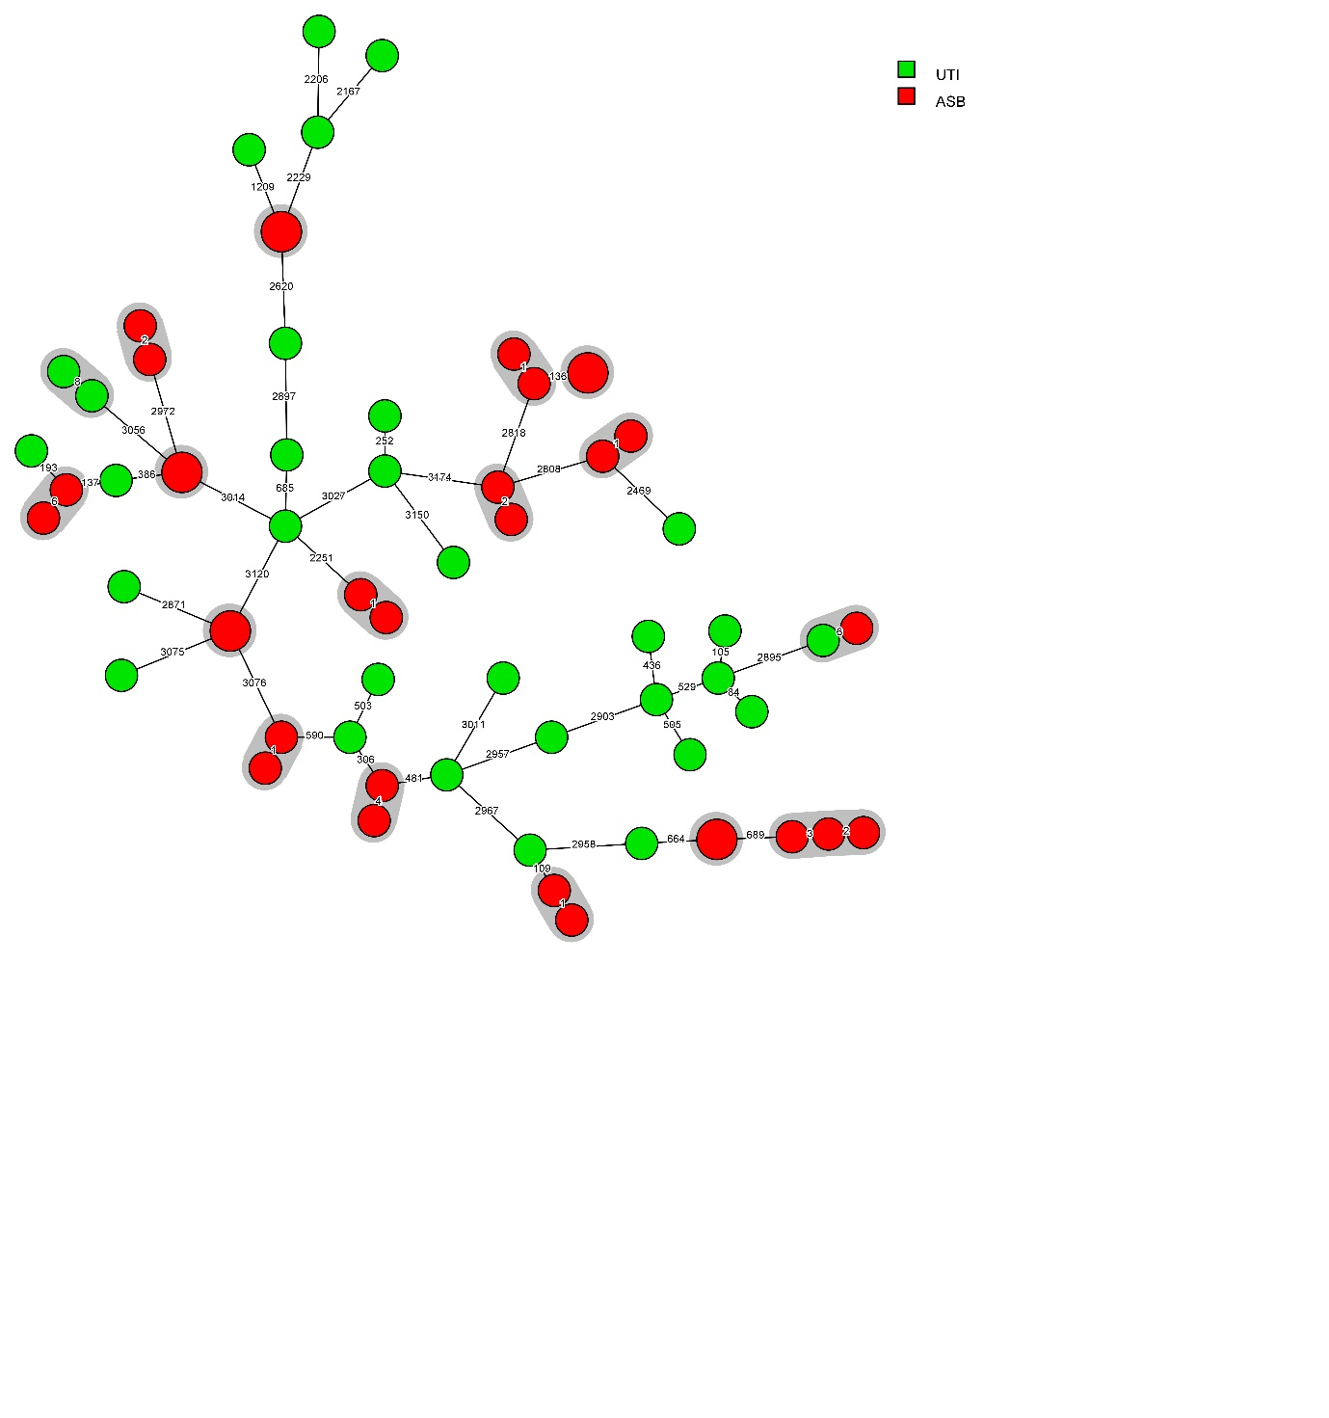
Figure 3: wgMLST-based minimum spanning tree of E. coli isolates analysed in this study. A genetic cluster is defined as ≥2 E. coli isolates differing ≤25 wgMLST alleles and can be regarded as the same strain. A grey halo indicates genetic clusters; the two (and in one case three) isolates in the cluster were all paired isolates that were obtained from two cultures from ASB patients. The other ASB patient with three isolates had one isolate that did not cluster with the paired isolates but clustered with another isolate obtained from a culture from a UTI patient.

References (max 30)
1. Foxman B. The epidemiology of urinary tract infection. Nat Rev Urol. 2010;7(12):653-60.
2. Mulder M, Baan E, Verbon A, Stricker B, Verhamme K. Trends of prescribing antimicrobial drugs for urinary tract infections in primary care in the Netherlands: a population-based cohort study. BMJ Open. 2019;9(5):e027221.
3. Irwin DE, Milsom I, Hunskaar S, Reilly K, Kopp Z, Herschorn S, et al. Population-based survey of urinary incontinence, overactive bladder, and other lower urinary tract symptoms in five countries: results of the EPIC study. Eur Urol. 2006;50(6):1306-14; discussion 14-5.
4. Rowe TA, Juthani-Mehta M. Urinary tract infection in older adults. Aging health. 2013;9(5).
5. Nicolle LE, Mayhew WJ, Bryan L. Prospective randomized comparison of therapy and no therapy for asymptomatic bacteriuria in institutionalized elderly women. Am J Med. 1987;83(1):27-33.
6. Abrutyn E, Berlin J, Mossey J, Pitsakis P, Levison M, Kaye D. Does treatment of asymptomatic bacteriuria in older ambulatory women reduce subsequent symptoms of urinary tract infection? J Am Geriatr Soc. 1996;44(3):293-5.
7. Bilsen MP, Treep MM, Aantjes MJ, van Andel E, Stalenhoef JE, van Nieuwkoop C, et al. Diagnostic accuracy of urine biomarkers for urinary tract infection in older women: a case-control study. Clin Microbiol Infect. 2024;30(2):216-22.
8. Ebrahimzadeh T, Basu U, Lutz KC, Gadhvi J, Komarovsky JV, Li Q, et al. Inflammatory markers for improved recurrent UTI diagnosis in postmenopausal women. Life Sci Alliance. 2024;7(4).
9. Johnson JR, Owens K, Gajewski A, Kuskowski MA. Bacterial characteristics in relation to clinical source of Escherichia coli isolates from women with acute cystitis or pyelonephritis and uninfected women. J Clin Microbiol. 2005;43(12):6064-72.
10. Schreiber HLt, Conover MS, Chou WC, Hibbing ME, Manson AL, Dodson KW, et al. Bacterial virulence phenotypes of Escherichia coli and host susceptibility determine risk for urinary tract infections. Sci Transl Med. 2017;9(382).
11. Mulder M, Notermans DW, Wielders CCH, Bos J, Witteveen S, Ganesh VA, et al. OXA-48-Producing Uropathogenic Escherichia coli Sequence Type 127, the Netherlands, 2015-2022. Emerg Infect Dis. 2023;29(12):2563-5.
12. Notermans DW, Schoffelen AF, Landman F, Wielders CCH, Witteveen S, Ganesh VA, et al. A genetic cluster of OXA-244 carbapenemase-producing Escherichia coli ST38 with putative uropathogenicity factors in the Netherlands. J Antimicrob Chemother. 2022;77(11):3205-8.
13. Maldonado N, Lopez-Hernandez I, Garcia-Montaner A, Lopez-Cortes LE, Perez-Crespo PMM, Retamar-Gentil P, et al. Whole-genome characterisation of Escherichia coli isolates from patients with bacteraemia presenting with sepsis or septic shock in Spain: a multicentre cross-sectional study. Lancet Microbe. 2024;5(4):e390-e9.
14. Bilsen MP, Treep MM, Aantjes MJ, van Andel E, Stalenhoef JE, van Nieuwkoop C, et al. Diagnostic accuracy of urine biomarkers for urinary tract infection in older women: a case-control study. Clin Microbiol Infect. 2023.
15. Landman F, Jamin C, de Haan A, Witteveen S, Bos J, van der Heide HGJ, et al. Genomic surveillance of multidrug-resistant organisms based on long-read sequencing. Genome Med. 2024;16(1):137.
16. Clermont Typing [Available from: http://clermontyping.iame-research.center/index.php.
17. Luo Y, Ma Y, Zhao Q, Wang L, Guo L, Ye L, et al. Similarity and divergence of phylogenies, antimicrobial susceptibilities, and virulence factor profiles of Escherichia coli isolates causing recurrent urinary tract infections that persist or result from reinfection. J Clin Microbiol. 2012;50(12):4002-7.
18. Bortolaia V, Kaas RS, Ruppe E, Roberts MC, Schwarz S, Cattoir V, et al. ResFinder 4.0 for predictions of phenotypes from genotypes. J Antimicrob Chemother. 2020;75(12):3491-500.
19. Hidad S, van der Putten B, van Houdt R, Schneeberger C, Kuil SD. Recurrent E. coli Urinary Tract Infections in Nursing Homes: Insight in Sequence Types and Antibiotic Resistance Patterns. Antibiotics (Basel). 2022;11(11).
20. Garcia TA, Ventura CL, Smith MA, Merrell DS, O'Brien AD. Cytotoxic necrotizing factor 1 and hemolysin from uropathogenic Escherichia coli elicit different host responses in the murine bladder. Infect Immun. 2013;81(1):99-109.
21. Feldmann F, Sorsa LJ, Hildinger K, Schubert S. The salmochelin siderophore receptor IroN contributes to invasion of urothelial cells by extraintestinal pathogenic Escherichia coli in vitro. Infect Immun. 2007;75(6):3183-7.

