PUNE INSTITUTE OF COMPUTER TECHNOLOGY,
DHANKAWADI PUNE-43.
A
Seminar Report
On
Latent Semantic Indexing and Analysis to Improve access to Information

SUBMITTED BY

Abhishek Deshpande
3123
T.E 1

GUIDED BY
PROF. Mukta Sunil Takalikar


COMPUTER ENGINEERING DEPARTMENT
Academic Year: 2015-16
PUNE INSTITUTE OF COMPUTER TECHNOLOGY,
DHANKAWADI PUNE-43.
CERTIFICATE

This is to certify that Mr./Miss. Abhishek Hemant Deshpande Roll No. 3123 a student of T.E. (Computer Engineering Department) Batch 2014-2015, has satisfactorily completed a seminar report on “Latent Semantic Indexing and Analysis to improve access to information "under the guidance of prof.Mukta Sunil Takalikar towards the partial fulfillment of the third year Computer Engineering Semester II of Pune University.
_________ ________
Internal Guide Head
Prof. Prof.
Date:-

Latent Semantic Indexing and Analysis to Improve access to Information

Abstract:
An innovative method for automatic indexing and retrieval is described. The approach is to take advantage of implicit higher-order structure in the association of terms with documents ("semantic structure") in order to improve the detection of relevant documents on the basis of terms found in queries. The particular technique used is singular-value decomposition, in which a large term by document matrix is decomposed into a set of k-orthogonal factors from which the original matrix can be approximated by linear combination. Documents are represented by k- item vectors of factor weights. Queries are represented as pseudo-document vectors formed from weighted combinations of terms, and documents with supra-threshold cosine values are returned. Initial tests find this completely automatic method widely applicable and a promising way to improve users’ access to many kinds of textual materials, or to objects and services for which textual descriptions are available.

Keywords:
Keyword extraction, Latent semantic Indexing ,Text Terms Weighting ,SVD, Text summarization, Information discovery.

Introduction:
The growing number of electronic textual documents has created the need of intelligent access to the information implied by them. The unstructured nature of documents, however, makes it difficult to realize the goal. In the present scenario a large volume of data is available related to each and every issue. This increase in the amount of data has led to a situation where users are swamped with information and have difficulty sifting through the reams of material, much of which is not relevant to them. This is commonly referred to as the problem of information overload.
An innovative approach for automatic indexing and information retrieval has been studied. The traditional approach that have been used for a long time try to match words of queries with words of documents. The problem is that users want to retrieve on the basis of conceptual content, and individual words provide unreliable evidence about the conceptual topic or meaning of a document. There are usually many ways to express a given concept, so the literal terms in a user’s query may not match those of a relevant document. In addition, most words have multiple meanings, so terms in a user’s query will literally match terms in documents that are not of interest to the user.
LSI overcomes two of the most problematic constraints of Boolean keyword queries: multiple words that have similar meanings (synonymy) and words that have more than one meaning (polysemy). Synonymy is often the cause of mismatches in the vocabulary used by the authors of documents and the users of information retrieval systems. As a result, Boolean or keyword queries often return irrelevant results and miss information that is relevant.
A typical Information Retrieval ( IR ) system responds to the user’s query by selecting documents and ranking them in terms of relevance .To be effective in its attempt to satisfy the user information need, an information retrieval system must somehow interpret the content of the information items in a collection and rank them according to the degree of their relevance to the user query. This interpretation of document content involves extracting the syntactic and se-mantic information from the document text and using this information to match user information need. The problem with the traditional technique is solved by extracting out the latent semantic structure in the data . “Latent semantic indexing” (LSI) analysis uses singular-value decomposition. We take a large matrix of term-document association data and construct a "semantic" space wherein terms and documents that are closely associated are placed near one another. Thus the terms that are not actually in the document but logically can be associated with the same end up being close to the document. The position of the documents along with the position of the user query in the k dimensional space provide a base for semantic indexing and retrieval and help in fetching the right document based on proximity of the document vector to the query vector.

Proposed Mathematical model:
Let S be the system that defines the process of latent semantic indexing :
S be defined as :
S={S , E , X , Y , F ,Su ,Fa ,DD,NDD}
S=start state
S={T,D}
T=terms : {t1,t2,t3,..................t n}
D= set of documents :{d1,d2,d3..........dn}
E= end state :The appropriate document based on the query input is retrieved
X= Set of Input X={x1} where x1=q ( search query fired for retrieving document)
q ={ [A-Z]* U [a-z]* U [0-9]*}
Y=Set of output Y={set of ranked documents}
Y={y1,y2,y3,y4................yn}
where y_{i} : ranked document
y_{i} :-D_{r} D_{r}={d1,d2,d3,d4,d5............dn} documents in descending order
F=Set of functions applied
F={f1,f2,f3,f4,f5,f6,f7}
f1=Eliminating stop words
Sp={set of stop words}
Dw={words in given documents}
Dw=Dw-Sp
f2=constructing the term-document matrix
X=term -document Matrix
X= t x d matrix
t={no of terms }
d={no of documents}
(tn,dn)={1,0}
(tn,dn) = 1 if term tn is in dn
(tn,dn) = 1 if term tn is not in dn
f3=SVD:-function to decompose the matrix applying single value decompostion
X=T0 S0 D0'
T0 = t x m matrix
S0 = m x m matrix
D0′ = m x d matrix
T0 has orthogonal, unit-length columns (T0 ′ T0 =I )
D0′ has orthogonal, unit-length columns (D0 ′ D0 =I )
S0 is the diagonal matrix of singular values
t is the number of rows of X
d is the number of columns of X
m is the rank of X ( ≤ min( t , d ))
f4: reduced model
Function to reduce model to rank k model. Result of model is X ~ Xhihat =TSD ′
T = t x k matrix
S = k x k matrix
D′ = k x d matrix k (≤m ) is the chosen number of dimensions (factors) in the reduced model.
f5:function to find new coordinates of query and documents vectors in SVD reduced k dimensional space
d=(di1,di2,............dik)
f6: function to find the k-dimension coordinates of query (pseudo-document)
q=(qi1,qi2,................qik)
f7: function to sort documents i decreasing order of cosine similarity values
Su: success case
successfully implemented the ranking and returned the appropriate document on given query input
Fa: failure case
failed to execute the LSI algorithm
DD : deterministic data: {given set of documents}
NDD: non deterministic data
{ the search query}

DESIGN AND ANALYSIS OF SYSTEM
Accept user Query
Document preprocessing and term document Matrix formation
Singular Value Decomposition

Start

Document coordinate calculation
Query(pseudo-document) coordinate calculation
Ranking based on query-document cosine similarity

displaying top result/ and or n results
End state

Preprocessing:
Stop Word Removal: In computing, stop words are words which are filtered out before or after processing of natural language data (text). Though stop words usually refer to the most common words in a language, there is no single universal list of stop words used by all natural language processing tools, and indeed not all tools even use such a list. Some tools specifically avoid removing these stop words to support phrase search.
Any group of words can be chosen as the stop words for a given purpose. For some search engines, these are some of the most common, short function words, such as the, is, at, which, and on. In this case, stop words can cause problems when searching for phrases that include them, particularly in names such as "The Who", "The The", or "Take That". Other search engines remove some of the most common words—including lexical words, such as "want"—from a query in order to improve performance.
Matrix Extraction: Just after preprocessing the cleaned data set is then can be used for matrix formation. The document is in form of term-document formation where the rows represent the term words and the column represent the documents. The cells of matrix X is represented in form of binary represented i.e 0 or 1 ,where 1 indicates the particular term in document.
The Singular Value Decomposition (SVD) Model.
This section details the mathematics underlying the particular model of latent structure, singular
value, decomposition, that we currently use. Any rectangular matrix, for example a t xd matrix of terms and documents, X , can be decomposed into the product of three other matrices:
X =T₀ S₀ D₀ ′,
such that T₀ and D₀ have orthonormal columns and S 0 is diagonal. This is called the singular value decomposition of X . T₀ and D₀ are the matrices of left and right singular vectors and S 0 is the diagonal matrix of singular values. Singular value decomposition (SVD) is unique up to certain row, column and sign permutations and by convention the diagonal elements of S₀ are constructed to be all positive and ordered in decreasing magnitude. In general, for X =T₀ S₀ D₀ ′ the matrices T₀, D₀ , and S₀ must all be of full rank. The beauty of an SVD, however, is that it allows a simple strategy for optimal approximate fit using smaller matrices. If the singular values in S 0 are ordered by size, the first k largest may be kept and the remaining smaller ones set to zero. The product of the resulting matrices is a matrix Xhihat which is only approximately equal to X , and is of rank k . It can be shown that the new matrix Xhihat is the matrix of rank k which is closest in the least squares sense to X . Since zeros were introduced into S ₀ , the representation can be simplified by deleting the zero rows and columns of S₀ to obtain a new diagonal matrix S , and then deleting the corresponding columns of T₀ and D₀ to obtain T and
S respectively.
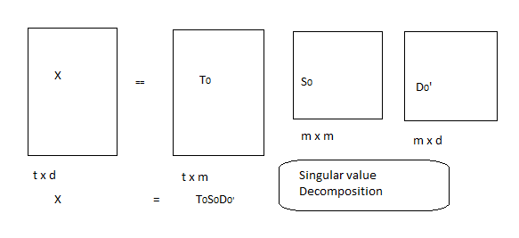
The result is a reduced model: X ~ Xhihat =TSD ′
which is the rank-k model with the best possible least-squares-fit to X . It is this reduced model,
presented in Figure 3, that we use to approximate our data.
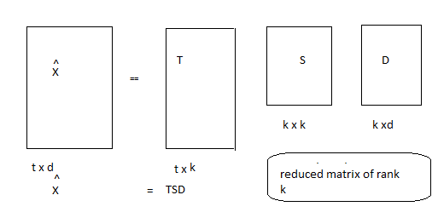
Finding representations for pseudo-documents: We want to be able to take a completely novel query, find some point for it in the space, and then look at its cosine with respect to terms or documents in the space. Another example would be trying, after-the-fact, to find representations for documents that did not appear in the original analysis. The new objects in both these examples are very much like the documents of the matrices, X and Xhihat , in that they present themselves as vectors of terms. It is for this reason that we call them pseudo −documents.
Ranking: Rank documents in decreasing order of query-document cosine similarities.
DISCUSSION ON IMPLEMENTATION RESULTS
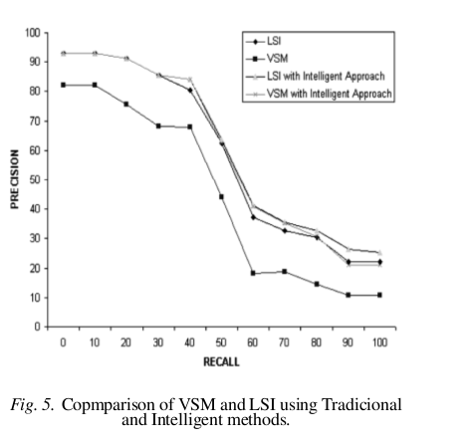

The LSI approach performs much better than the traditional VSM approach for information retrieval.
Step 1:
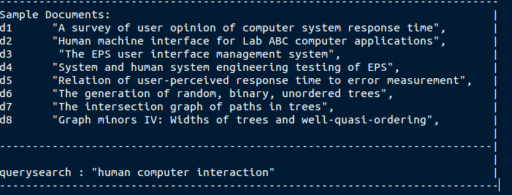

: 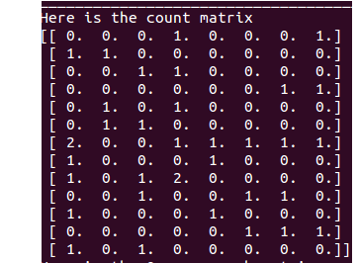
Xhihat matrix. can be generated after SVD().It does not exactly match the original term by document matrix X (it gets closer and closer as more and more singular values are kept). This is what we want; we don’t want perfect fit since we think some of the 0’s in X should be 1 and vice versa. The document vector can be obtained from the matrix D and pseudo document form of query processing similarly gives us the coordinates in k-d space for query q. They are illustrated in the diagram
: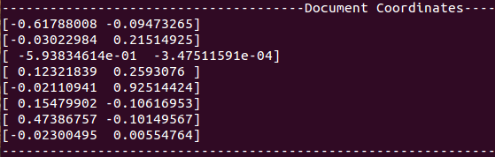
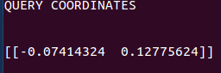
The graphical representation:
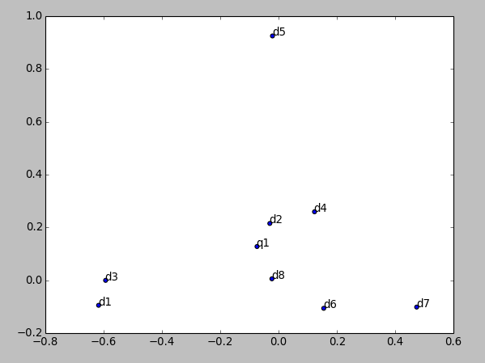
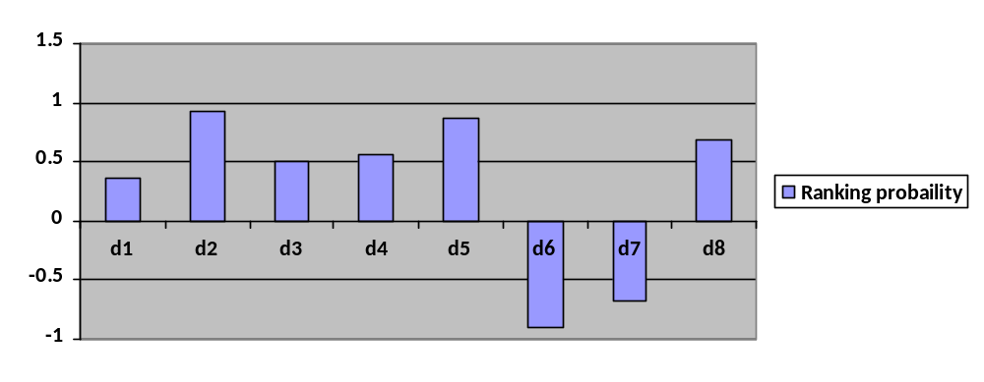

Conclusion and Future Enhancement:
The latent structure approach is useful for helping people find textual information in large collections. It helps overcome vocabulary problems that pose severe limits on human-computer interaction by automatically extracting underlying semantic factors. In terms of helping users find objects of interest, the LSI approach compares quite favorably with existing keyword-based methods, and suggests some new possibilities for customization and selection. The latent structure method is widely applicable and involves almost no human intervention. The term by object matrix can be automatically constructed for any set of text objects, and the underlying concepts are identified by a completely automatic statistical process. The matrix decomposition step is currently computer intensive, but it need only be done once for each dataset. The resulting semantic space provides a compact representation of the original dataset with much of its redundancy and noise squeezed out. There are many outstanding research issues.
Performance can greatly improved by incorporating short phrases, differential term-weighting, and allowing Boolean combinations of terms. "LSI by random projection", a Probabilistic analysis can be implemented in a way for speeding the LSI algorithm In the latent structure domain, we can explore different similarity measures, use relevance feedback techniques to better place the query, and examine other methods of uncovering latent structure, including highly parallel "learning machines". Advancement in pre-processing stage can be done by applying Porter Stemming Algorithm which removes the commoner and morphological words. Scope for improvement in the efficiency can be studied further considering data structure such as the k-d tree in conjunction with LSI.

References:
1.Barbara Rosario,“Latent semantic Indexing: An overview”,IS250 Computer-Based Communications and Computational Linguistics, Infosys Spring 2014.
2. A.N..K Zaman ,Charles Grant Brown,“Latent Semantic Indexing for Large Dataset: Study Of terms weighting Schemes". Conference: Fifth IEEE International Conference on Digital Information Management,ICDIM 2010,Lakehead University, Thunder Bay, Canada
3. Susan T. Dumais George W. Furnas Thomas K. Landauer,“Using Latent Semantic Analysis To improve access to textual information” ,Bell System Technical Journal- 2014,Uniuversity of Wortrts Chatz,Leipzig.

