Campus Convenience Store POS
Commit History and Refactoring Documentation
IT415 Midterm Practical Examination · Scenario 5
Item | Details
Repository | https://github.com/Ahdamn513/CampusConvenienceStorePOS
Branch | main
Commits covered | 6 (from cdb891f to 4b3ae85)
Date | October 13, 2026
Technologies | HTML5, CSS3, vanilla JavaScript, Git, GitHub

1. Overview 2
2. Commit History 2
3. Commit Details 2
3.1 cdb891f – Initial commit 2
3.2 2e16314 – First Debugging 2
3.3 f707b24 – Joined the payment confirmation and the receipt 3
3.4 31fe2fd – Final UI fix 3
3.5 869cfc6 – Refactoring 4
3.6 4b3ae85 – AI log update 4
4. Refactoring 5
4.1 Goal and approach 5
4.2 getCartLines(): one shared product lookup 5
4.3 updateCart(): shared start and end of every cart action 6
4.4 incrementItem(): one maximum-quantity check 6
4.5 detailRow(): shared confirmation and receipt rows 6
4.6 Product photos defined in the PRODUCTS list 7
4.7 Merged duplicate .peso-input rule 7
5. Testing the Refactoring 7
5.1 Automated before-and-after comparison 7
5.2 Syntax check 8
5.3 Browser check 8
6. Further Refactoring Opportunities 9

1. Overview
This document records how the Campus Convenience Store POS changed after it was first placed under version control. It covers two kinds of work:
- Debugging and UI fixes (three commits): moving the receipt into a pop-up overlay, joining the payment confirmation with the receipt, and redesigning the interface with product photos and the school logo.
- Refactoring (one commit): removing repeated code in app.js and style.css without changing how the application behaves.
Section 2 lists every commit. Section 3 explains each commit in detail. Section 4 describes the refactoring with before-and-after code, and Section 5 explains how the refactoring was tested.

2. Commit History
Commits are listed from oldest to newest. Line counts come from git show --stat.
# | Commit | Message | Files | Lines
1 | cdb891f | Initial commit: Campus Convenience Store POS | 7 | +1406
2 | 2e16314 | First Debugging | 4 | +138 / −33
3 | f707b24 | debugging: fixed the separated payment successful notif to receipt | 4 | +63 / −36
4 | 31fe2fd | final fix for the ui | 11 | +215 / −86
5 | 869cfc6 | Refactor cart logic and rendering to remove duplication | 2 | +86 / −90
6 | 4b3ae85 | Fill in AI log for Prompt 2 (refactoring) | 1 | +5 / −3

3. Commit Details

3.1 cdb891f – Initial commit
The first version of the project as generated and reviewed. It already met the functional requirements (FR1–FR12): a product grid, cart with quantity controls, automatic subtotals and totals, payment validation with the exact required messages, change computation, a digital receipt, and a New Transaction reset.
In this version, products were shown with emoji icons, and the receipt appeared as a card at the bottom of the page with a New Transaction button.
Files
index.html, css/style.css, js/app.js, README.md, docs/AI_LOG.md, docs/REQUIREMENTS.md, docs/screenshots/.gitkeep

3.2 2e16314 – First Debugging
Problem
After payment, the receipt was placed at the bottom of a long page, so the app had to scroll the cashier down to it. The receipt was easy to lose sight of and an empty receipt placeholder was always visible.
Changes
- Replaced the bottom receipt section with a pop-up overlay using the built-in HTML <dialog> element. It dims the page behind it.
- Added openReceipt(), closeReceipt() and handleDialogBackdropClick(). The overlay closes with the ✕ button, the Esc key, or a click outside it.
- Added View Receipt and New Transaction buttons to the payment confirmation box so the cashier can reopen the receipt.
- Removed renderEmptyReceipt() and the always-visible placeholder.
- Added overlay styles (backdrop, open animation, close button) to style.css and updated the README.
Files
index.html, css/style.css, js/app.js, README.md

3.3 f707b24 – Joined the payment confirmation and the receipt
Problem
The "Payment successful" confirmation stayed in the payment card while the receipt opened in the overlay, so the cashier saw the result of one payment in two separate places.
Changes
- Moved the confirmation (transaction number, total, amount paid, change) into the overlay above the receipt, and renamed the overlay title to "Payment Confirmation".
- Renamed New Transaction to Next Order and added a Close button next to it in the overlay.
- Added an "Order paid" panel to the payment card with View Receipt and Next Order buttons, shown only after payment, in case the overlay was closed.
- Removed handleConfirmationClick(); each button now has its own listener in bindEvents().
- Changed the toast message to "New transaction started. Ready for the next order." and updated the README.
Files
index.html, css/style.css, js/app.js, README.md

3.4 31fe2fd – Final UI fix
Changes
- Replaced the emoji product icons with real product photos used as card backgrounds, with a dark gradient so the white text stays readable. Cards in the cart turn green.
- Added the Davao del Norte State College logo to the top bar and as the browser tab icon.
- Added Google Fonts (Plus Jakarta Sans for text, JetBrains Mono for the receipt), with Segoe UI and Consolas as offline fallbacks.
- Made the payment error message shake every time it appears, not only the first time.
- Restyled buttons, cards, the cart table and hover effects in style.css, and added the images/ folder to the README's folder structure.
Files
index.html, css/style.css, js/app.js, README.md, and 7 images: ballpen.jpg, chips.jpg, dnsc-logo.png, noodles.jpg, notebook.jpg, soda.jpg, water.jpg

3.5 869cfc6 – Refactoring
Removed repeated code in js/app.js and css/style.css. The application looks and behaves the same as after commit 4. Section 4 explains every change.
Files
js/app.js, css/style.css

3.6 4b3ae85 – AI log update
Filled in the Prompt Used, Purpose and AI Response sections for Prompt 2 (Debugging and Refactoring) in docs/AI_LOG.md.
Files
docs/AI_LOG.md

4. Refactoring

4.1 Goal and approach
Refactoring means improving the structure of code without changing what it does. Before the refactor, app.js repeated the same steps in several functions. Repeated code is harder to maintain: if one copy is changed and another is forgotten, the copies stop matching and bugs appear.
The code was reviewed first and the candidates were ranked by value. The changes below are the ones applied. Each one keeps the same inputs, outputs and on-screen messages.
# | Change | Where | Benefit
1 | getCartLines() helper | app.js | One product lookup shared by cart, summary, total and receipt
2 | updateCart() wrapper | app.js | Payment lock and screen refresh written once instead of four times
3 | incrementItem() helper | app.js | 99-item limit checked in one place
4 | detailRow() helper | app.js | Confirmation and receipt rows built by one function
5 | Product photos in PRODUCTS | app.js, style.css | A product is defined in one place instead of two
6 | Merged .peso-input rule | style.css | Removed a duplicate CSS rule

4.2 getCartLines(): one shared product lookup
Problem
renderCart(), renderSummary() and completeTransaction() each looped over the cart and looked up the product and subtotal for every item themselves.
Before (repeated in three functions)
const rows = cart.map((item) => {
const product = findProduct(item.productId);
...
formatPeso(getSubtotalCents(item))
});
After
function getCartLines() {
return cart.map((item) => {
const product = findProduct(item.productId);
return { product, quantity: item.quantity,
subtotalCents: product.priceCents * item.quantity };
});
}

// Each caller now reads the ready-made values:
getCartLines().map(({ product, quantity, subtotalCents }) => ...)
getTotalCents() also uses getCartLines(), and the old getSubtotalCents() was removed. The formula Subtotal = Unit Price × Quantity now appears in exactly one place.

4.3 updateCart(): shared start and end of every cart action
Problem
addToCart(), increaseQuantity(), decreaseQuantity() and removeFromCart() all began with the same payment-lock check and ended with the same two lines.
Before (in all four functions)
if (isPaid) return; // cart is locked after payment
...
clearPaymentMessage();
renderAll();
After
// Runs a cart change, then refreshes the screen.
// The change returns false when nothing changed, which skips the refresh.
function updateCart(change) {
if (isPaid) return;
if (change() === false) return;
clearPaymentMessage();
renderAll();
}

function removeFromCart(productId) {
updateCart(() => {
cart = cart.filter((item) => item.productId !== productId);
showToast(MESSAGES.removed(findProduct(productId).name));
});
}

4.4 incrementItem(): one maximum-quantity check
Problem
addToCart() and increaseQuantity() each had their own copy of "if the quantity is already 99, show a message, otherwise add 1".
After
// Adds 1 to an item already in the cart; returns false if it is at the maximum
function incrementItem(item) {
if (item.quantity >= MAX_QUANTITY) {
showToast(MESSAGES.maxReached(findProduct(item.productId).name));
return false;
}
item.quantity += 1;
return true;
}
Both functions now call incrementItem(). If the store changes the limit rule later, only this function needs to change.

4.5 detailRow(): shared confirmation and receipt rows
Problem
renderConfirmation() and renderReceipt() wrote nine label/value rows by hand, with the Total, Amount Paid and Change rows appearing in both.
Before
<div class="highlight-row"><dt>Change</dt><dd>${formatPeso(transaction.changeCents)}</dd></div>
After
function detailRow(label, value, isHighlighted = false) {
const rowClass = isHighlighted ? ` class="highlight-row"` : "";
return `<div${rowClass}><dt>${label}</dt><dd>${value}</dd></div>`;
}

${detailRow("Change", formatPeso(transaction.changeCents), true)}

4.6 Product photos defined in the PRODUCTS list
Problem
Each product's photo was set by its own CSS rule. Adding a product meant editing both PRODUCTS in app.js and style.css, and forgetting the CSS left the card without a photo.
Before (style.css, one rule per product)
.product-card[data-product="noodles"] { --product-image: url("../images/noodles.jpg"); }
.product-card[data-product="chips"] { --product-image: url("../images/chips.jpg"); }
/* ...four more rules... */
After (app.js)
{ id: "noodles", name: "Instant Noodles", priceCents: 1800, image: "images/noodles.jpg" },

// In renderProducts(): a full URL so the path works no matter which file reads it
const imageUrl = new URL(product.image, document.baseURI).href;
<article class="${cardClass}" style="--product-image: url('${imageUrl}')">
The six CSS rules were removed. The path is converted to a full URL because a relative path stored in a CSS variable can be resolved against a different folder in different browsers.

4.7 Merged duplicate .peso-input rule
style.css declared .peso-input twice: once for its layout and once more just for its transition. The two rules were merged into one.

5. Testing the Refactoring
A refactor must not change behaviour, so the old code (commit 31fe2fd) and the refactored code were tested against each other in three ways.

5.1 Automated before-and-after comparison
A test script loaded each version of app.js into a simulated page, ran the same 18 steps on both, and recorded everything on screen after each step: the product grid, cart, item count, order summary, payment message, confirmation and toast message. The two recordings (163 lines each) were identical.
Step | Action | Result
1 | Open the app | Identical
2 | Pay with an empty cart | Identical: "Your cart is empty…"
3–5 | Add noodles, add noodles again, add chips | Identical: quantity 2, not duplicated
6–7 | Increase chips, decrease noodles | Identical
8 | Decrease noodles from 1 | Identical: item removed
9 | Increase an item not in the cart | Identical: nothing happens
10–11 | Add water 99 times, then increase again | Identical: maximum-quantity message
12 | Remove water | Identical
13–15 | Pay blank, negative, then insufficient amount | Identical: exact required messages
16 | Pay ₱100.50 | Identical confirmation, receipt and change
17 | Try to add an item after paying | Identical: cart stays locked
18 | Next Order | Identical: everything cleared

5.2 Syntax check
node --check js/app.js reported no errors.

5.3 Browser check
The refactored app was opened in Google Chrome. The six product photos and the school logo load correctly, which confirms the change in section 4.6.
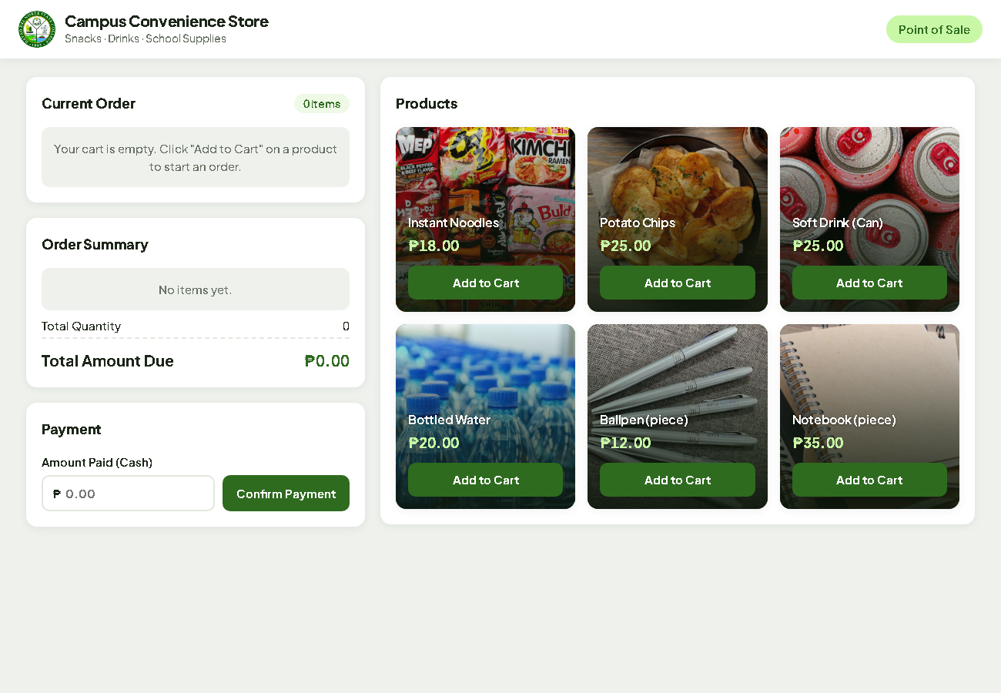
Figure 1. The refactored POS in Google Chrome

6. Further Refactoring Opportunities
These smaller improvements were found during the review but not applied. They are optional.
- Build the cart table and receipt table with one shared renderTable() helper.
- Combine the three checks in validatePayment() that all return "Please enter a valid payment amount." into one condition.
- Move the actions lookup in handleCartClick() to a constant so it is not rebuilt on every click.
- In style.css, store the repeated dark green rgba(46, 107, 31, …) and the repeated 1px dashed receipt border in CSS variables, and give the three pill-shaped labels a shared class.

