**统计分析系统迁移数据库**

**安装配置手册**

数据库实列字符集编码格式查询：

SQL> select * from nls_database_parameters where parameter ='NLS_CHARACTERSET';

1. **安装准备**
   1. RedHat Linux Server 6.2安装文件
   2. Oracle 10g Linux安装文件
   3. 搭建本地yum源检查安装包

1. 首先把DVD里的OS镜像mount处理，如果插入光驱自动mount的话，一般在/media下面，比如RHEL_6.2 x86_64 Disc 1

如果没有的话，可以自己mount, 比如mount /dev/cdrom /mnt

2. 在本地建立目录比如 mkdir /yum

3. 把mount出来的rpm包拷到本地，Redhat6.2的rpm包都在Packages下面，把这下面的所有rpm包考到/yum

把/mnt/下面的RPM-GPG-KEY-redhat-release也拷贝到/yum目录下

4. 在/yum目录下，执行createrepo /yum

5. 在/etc/yum.repos.d下新建一个yum.repo。内容如下：

[RHEL]

name=RHEL6.2

baseurl=file:///yum

gpgcheck=1

gpgkey=file:///yum/RPM-GPG-KEY-redhat-release

enabled=1

如果/etc/yum.repos.d下面还有其他的.repo文件，最好把它们的enabled设置为0. 以免干扰。

6. umount /mnt

rpm -qa |grep make

automake-1.11.1-1.2.el6.noarch

make-3.81-19.el6.x86_64

rpm -qa|grep glibc

glibc-common-2.12-1.47.el6.x86_64

glibc-2.12-1.47.el6.i686

glibc-headers-2.12-1.47.el6.x86_64

glibc-devel-2.12-1.47.el6.i686

compat-glibc-headers-2.5-46.2.x86_64

glibc-2.12-1.47.el6.x86_64

glibc-utils-2.12-1.47.el6.x86_64

glibc-devel-2.12-1.47.el6.x86_64

compat-glibc-2.5-46.2.x86_64

rpm -qa |grep libaio

libaio-devel-0.3.107-10.el6.i686

libaio-0.3.107-10.el6.x86_64

libaio-devel-0.3.107-10.el6.x86_64

libaio-0.3.107-10.el6.i686

rpm -qa |grep gcc

gcc-objc-4.4.6-3.el6.x86_64

gcc-objc++-4.4.6-3.el6.x86_64

compat-gcc-34-g77-3.4.6-19.el6.x86_64

gcc-gfortran-4.4.6-3.el6.x86_64

gcc-gnat-4.4.6-3.el6.x86_64

compat-gcc-34-c++-3.4.6-19.el6.x86_64

gcc-java-4.4.6-3.el6.x86_64

gcc-4.4.6-3.el6.x86_64

compat-gcc-34-3.4.6-19.el6.x86_64

gcc-c++-4.4.6-3.el6.x86_64

libgcc-4.4.6-3.el6.i686

libgcc-4.4.6-3.el6.x86_64

rpm -qa |grep compat-libstdc

compat-libstdc++-296-2.96-144.el6.i686

compat-libstdc++-33-3.2.3-69.el6.i686

compat-libstdc++-33-3.2.3-69.el6.x86_64

rpm -qa |grep compat-gcc

compat-gcc-34-g77-3.4.6-19.el6.x86_64

compat-gcc-34-c++-3.4.6-19.el6.x86_64

compat-gcc-34-3.4.6-19.el6.x86_64

rpm -qa |grep libXp

libXp-1.0.0-15.1.el6.x86_64

libXp-devel-1.0.0-15.1.el6.x86_64

libXpm-3.5.8-2.el6.i686

libXpm-devel-3.5.8-2.el6.x86_64

libXp-devel-1.0.0-15.1.el6.i686

libXpm-3.5.8-2.el6.x86_64

libXpm-devel-3.5.8-2.el6.i686

libXp-1.0.0-15.1.el6.i686

rpm -qa |grep openmotif(rpm -ivh libXmu-1.0.5-1.el6.i686.rpm, rpm -ivh libXmu-devel-1.0.5-1.el6.i686.rpm, rpm -ivh openmotif22-2.2.3-19.el6.i686.rpm)

openmotif-devel-2.3.3-4.el6.x86_64

openmotif-2.3.3-4.el6.x86_64

openmotif22-2.2.3-19.el6.x86_64

openmotif22-2.2.3-19.el6.i686

rpm -qa |grep compat-db

(rpm -ivh libstdc++-4.4.6-3.el6.i686.rpm, rpm -ivh libstdc++-devel-4.4.6-3.el6.i686.rpm,)

compat-db43-4.3.29-15.el6.x86_64

compat-db43-4.3.29-15.el6.i686

compat-db42-4.2.52-15.el6.i686

compat-db-4.6.21-15.el6.i686

compat-db-4.6.21-15.el6.x86_64

compat-db42-4.2.52-15.el6.x86_64

准备安装的软件：   
rpm -q xxx*  
yum install xxx  
rpm -ivh xxx.rpm

做成直接安装的命令：

yum install \  
binutils \  
compat-libstdc++-33 \  
compat-libstdc++-33*.* \  
elfutils-libelf \  
elfutils-libelf-devel \  
gcc \  
gcc-c++ \  
glibc \  
glibc*.* \  
glibc-common \  
glibc-devel \  
glibc-devel*.* \  
glibc-headers \  
ksh \  
libaio \  
libaio*.* \  
libaio-devel \  
libaio-devel*.* \  
libgcc \  
libgcc*.* \  
libstdc++ \  
libstdc++*.*\  
libstdc++-devel \  
make-3.81 \  
sysstat*.*\  
unixODBC*.* \  
unixODBC-devel \  
unixODBC \  
libXp \  
libXp*.*

yum install libXp.so.6 libXt.so.6 libXtst.so.6

1. **硬件要求**
   1. 物理内存至少2G

查看命令：grep MemTotal /proc/meminfo

* 1. 交换分区：至少1G，最好是物理内存的2倍

查看命令：grep SwapTotal /proc/meminfo

* 1. 硬盘空闲区至少4G

查看命令：df –h

1. **创建安装oracle 所需的组和用户**

以下操作需要使用root账户创建。

* 1. 创建oinstall用户组

groupadd -g 701 oinstall

* 1. 创建dba用户组

groupadd -g 702 dba

* 1. 创建oracle用户

useradd -g oinstall -G dba oracle

* 1. 初始化oracle用户密码

passwd oracle

创建oracle安装文件目录 /orainstall

chmod -R 777 /orainstall/

拷贝安装文件到 /orainstall

zcat 10201_database_linux_x86_64.cpio.gz | cpio -idmv

1. **创建Oracle安装目录**

本示例中，Oracle安装路径为：**/oracle/product/10.2.0/db_1**

* 1. 创建oracle安装目录

mkdir -p /oracle/product/10.2.0/db_1

* 1. 修改目录所属用户为oracle用户

mkdir oradata

mkdir logdata

chown -R oracle:oinstall /oracle

chown -R oracle:oinstall /oradata/

chown -R oracle:oinstall /logdata/

chown -R oracle:oinstall /orainstall/

chmod -R 755 /oradata/

chmod -R 755 /logdata/

* 1. 修改目录权限

chmod -R 755 /oracle **或者**

chmod -R ug=rwx,o=rx /oracle

1. **配置内核参数**
   1. 编辑vi /etc/sysctl.conf文件，添加或修改如下的行：

**本人实际配置环境中，红色部分是需要修改行，蓝色部分为添加行。**

kernel.shmall = 4194304

kernel.shmmax = 17179869184

kernel.shmmni = 4096  
kernel.sem = 250 32000 100 128  
fs.file-max = 65536  
net.ipv4.ip_local_port_range = 1024 65000  
net.core.rmem_default=262144  
net.core.rmem_max=262144   
net.core.wmem_default=262144  
net.core.wmem_max=262144

参数含义参考文档：sysctl.doc

Linux内核对一个文件被打开数有限制，所以我们需要修改一个系统配置文件；

A、改进用户的有关 nofile(可打开的文件描述符的最大数)和nproc(单个用户可用的最大进程数量)

# vi /etc/security/limits.conf

# 添加如下的行

oracle soft nproc 2047

oracle hard nproc 16384

oracle soft nofile 32768

oracle hard nofile 65536

oracle soft nproc 2047

oracle hard nproc 16384

oracle soft nofile 32768

oracle hard nofile 65536

B、要使 limits.conf 文件配置生效，必须要确保 pam_limits.so 文件被加入到启动文件中。查看 vi /etc/pam.d/login 文件中有：

session required /lib/security/pam_limits.so

session required /lib/security/pam_limits.so

* 1. 查看当前内核参数的值

/sbin/sysctl -p

修改 linux 内核文件

#vi /etc/sysctl.conf后执行sysctl  -P 报错

error: "net.bridge.bridge-nf-call-ip6tables" is an unknown key  
error: "net.bridge.bridge-nf-call-iptables" is an unknown key  
error: "net.bridge.bridge-nf-call-arptables" is an unknown key

解决方法如下：

modprobe bridge

lsmod|grep bridge

注：（一般为内存的0.7倍）OLTP系统SGA+PGA<(Total Memory)*0.8

SAG<(Total Memory)*0.8*0.8

1. **修改/etc/hosts**

增加下面内容，如果没有oracle 的监听器无法启动

127.0.0.1 localhost

172.28.12.150 test

怎样修改主机名：

第一步：  
 #hostname   
 第二步：  
 修改/etc/sysconfig/network中的hostname  
 第三步：  
 修改/etc/hosts文件

重启机器。

1. **设置oracle用户环境变量**

注意以下命令为,必需以oracle用户身分登录：

添加环境变量，定义SID等

su - oracle

vi .bash_profile

export ORACLE_BASE=/oracle

export ORACLE_HOME=$ORACLE_BASE/product/10.2.0/db_1

export ORACLE_SID=orcl

export PATH=$ORACLE_HOME/bin:$PATH

export LD_LIBRARY_PATH=$ORACLE_HOME/lib:$LD_LIBRARY_PATH

umask 022

unset USERNAME

#alias sqlplus='rlwrap sqlplus'

#alias rman='rlwrap rman'

#alias ggsci='rlwrap ggsci'

export ORACLE_BASE=/oracle

export ORACLE_HOME=$ORACLE_BASE/product/11g/db_1

export ORACLE_SID=orcl

export PATH=$ORACLE_HOME/bin:$PATH

export LD_LIBRARY_PATH=$ORACLE_HOME/lib:$LD_LIBRARY_PATH

umask 022

unset USERNAME

#alias sqlplus='rlwrap sqlplus'

#alias rman='rlwrap rman'

#alias ggsci='rlwrap ggsci'

执行环境设置

source ~/.bash_profile

* 1. 检查设置的环境变量

echo $ORACLE_HOME

echo $ORACLE_BASE

echo $ORACLE_SID

* 1. 使环境变量生效

[oracle@~]$ . .bash_profile

1. **修改Linux的发行标记**

1）、如在redhat5上安装oracle，需要将文件 'vi /etc/redhat-release'的内容由：

Red Hat Enterprise Linux Server release 5 (Tikanga)

修改为：

Red Hat Enterprise Linux Server release 4 (Tikanga)

2）、修改增强的Linux安全设置：vi /etc/selinux/config

SELINUX=disabled

1. **oracle 中文乱码的解决 root用户下修改:** vi etc/sysconfig/i18n

LANG=”en_US.UTF-8”

1. **使用root用户登陆图形界面，执行以下命令：**

xhost +

新加：nstall libXtst.so.6

su - oracle

export LANG=en_US

1. **使用oracle用户登陆，安装oracle**

**./runInstaller**

**把dba组加到系统 使用root用户**

**echo 702 > /proc/sys/vm/hugetlb_shm_group 不做安装会出错**

**这行命令的含义参考 hugetlb_shm_group**

**安装时，最好选择高级安装模式“Advanced Installation”，这样可以设置数据库字符集。**

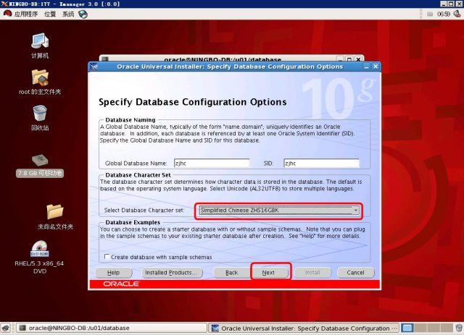

创建库

用oracle用户登录，在$ORACLE_HOME/bin 目录下，直接输入dbca即可进入安装，步骤很简单，其他步骤没特殊条件默认即可，到此数据库创建完

登录Oracle数据库：sqlplus  /nolog

查看创建数据库成功： conn /as sysdba

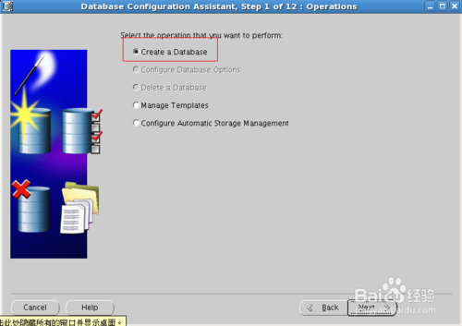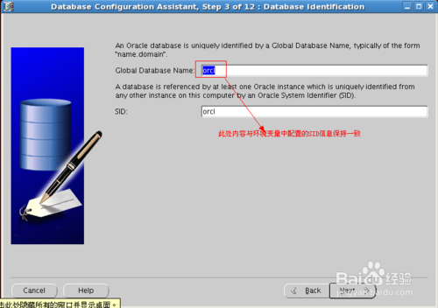

• 最后一步就是设置监听了

创建监听服务（充当Oracle服务器，让别的oracle客户端连接本Oracle服务器），再Oracle用户下新开启一个终端，输入命令netca

启动监听：lsnrctl start

查看监听状态:lsnrctl status

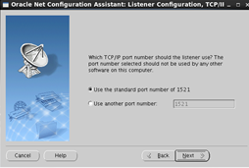

升级数据库版本从10.0.2.1 到10.0.2.5.4

单实例下的升级步骤比较简单：

1.     备份整个ORACLE_HOME目录,Instance

2.     升级ORACLE 软件到10.2.0.5

3.     升级实例到10.2.0.5.4

4.     打10.2.0.5.4 的Patch

5.     检查无效对象

**一.系统和DB信息检查**

# getconf LONG_BIT

32

# uname -a

Linux dave 2.6.18-164.el5xen #1 SMP Tue Aug18 16:06:30 EDT 2009 i686 i686 i386 GNU/Linux

sqlplus / as sysdba;

SQL*Plus: Release 10.2.0.1.0 - Productionon Sun Oct 9 14:26:17 2011

Copyright (c) 1982, 2005, Oracle.  All rights reserved.

Connected to:

Oracle Database 10g Enterprise EditionRelease 10.2.0.1.0 - Production

With the Partitioning, OLAP and Data Miningoptions

SQL> select name from v$database;

NAME

---------

ANQING

SQL> select * from v$version;

BANNER

----------------------------------------------------------------

Oracle Database 10g Enterprise EditionRelease 10.2.0.1.0 - Prod

PL/SQL Release 10.2.0.1.0 - Production

CORE   10.2.0.1.0      Production

TNS for Linux: Version 10.2.0.1.0 -Production

NLSRTL Version 10.2.0.1.0 - Production

SQL>

**二.升级Oracle 软件 到10.2.0.5**

**2.1 关闭实例，监听 和 OEM**

# su - oracle

 lsnrctl stop

LSNRCTL for Linux: Version 10.2.0.1.0 -Production on 09-OCT-2011 15:26:50

Copyright (c) 1991, 2005, Oracle.  All rights reserved.

Connecting to (DESCRIPTION=(ADDRESS=(PROTOCOL=IPC)(KEY=EXTPROC1)))

The command completed successfully

 emctl stop dbconsole

TZ set to PRC

Oracle Enterprise Manager 10g DatabaseControl Release 10.2.0.1.0

Copyright (c) 1996, 2005 OracleCorporation.  All rights reserved.

http://dave:1158/em/console/aboutApplication

Stopping Oracle Enterprise Manager 10gDatabase Control ...

 ... Stopped.

sqlplus / as sysdba;

SQL*Plus: Release 10.2.0.1.0 - Productionon Sun Oct 9 15:27:00 2011

Copyright (c) 1982, 2005, Oracle.  All rights reserved.

Connected to:

Oracle Database 10g Enterprise EditionRelease 10.2.0.1.0 - Production

With the Partitioning, OLAP and Data Miningoptions

SQL> shutdown immediate

Database closed.

Database dismounted.

ORACLE instance shut down.

**2.2 运行Patch**

**Cd /orainstall**

**unzip p8202632_10205_Linux-x86-64.zip**

**cd Disk1/**

运行runInstaller

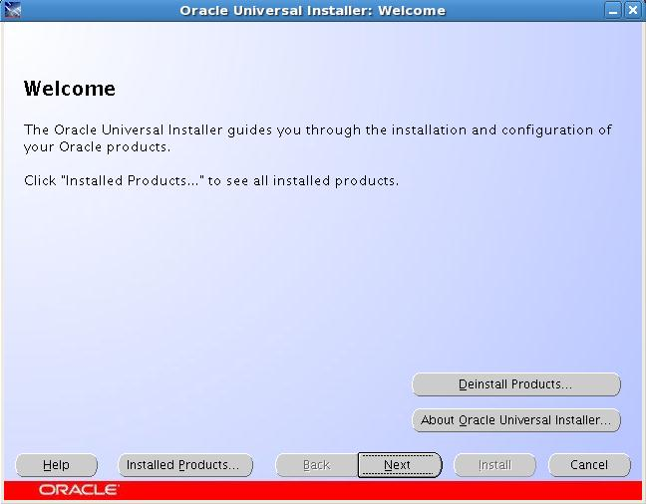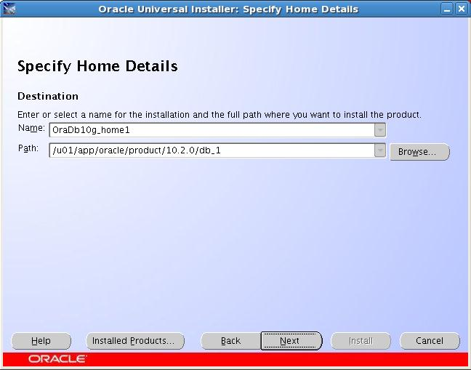

选择我们需要升级的ORACLE_HOME

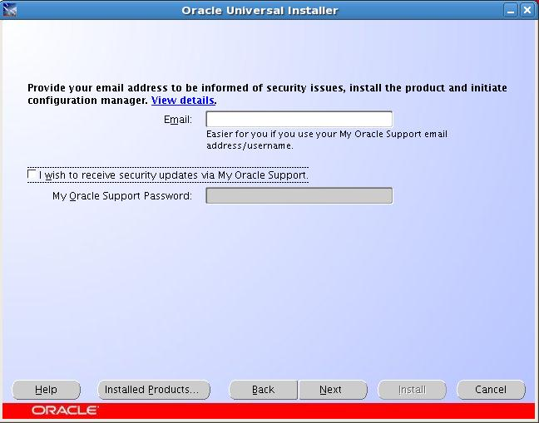

修改完执行:

# sysctl –p

使修改的参数生效，然后重新检测。全部通过后如下：

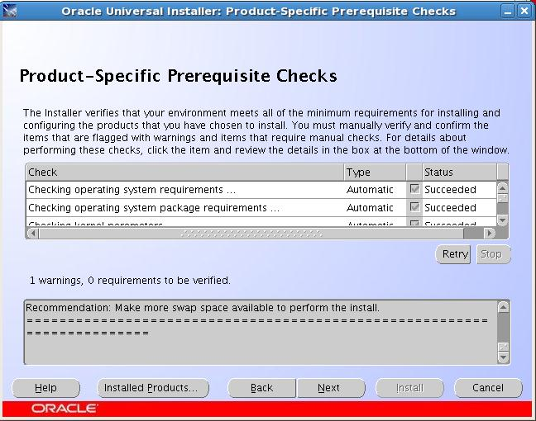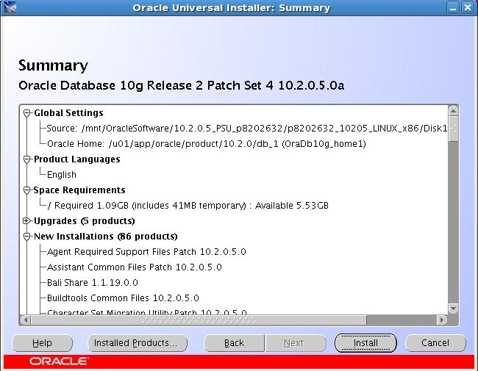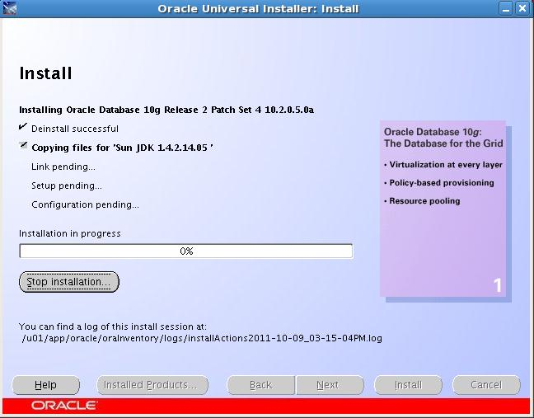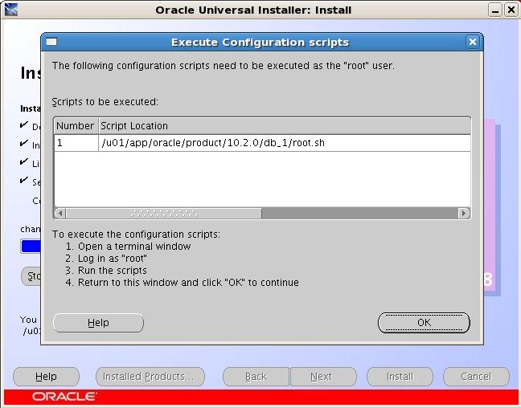

用root 用户运行脚本：/home//oracle/product/10.2.0/db_1/root.sh。 运行结束后升级操作结束。 整个过程十几分钟搞定。

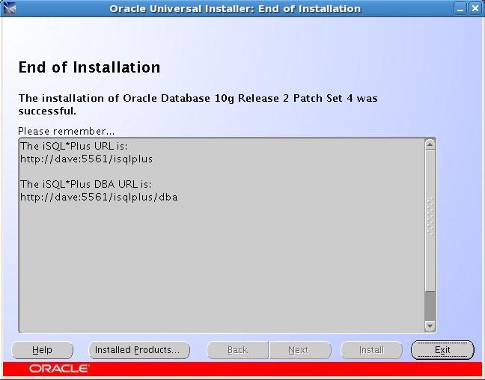

**三.升级Instance到10.2.0.5**

使用dbua。 Dbua 工具是把相关的命令封装了起来，操作起来相对简单。

**3.1 使用DBUA工具**

我这里使用DBUA 工具来升级Instance。用Oracle 用户运行dbua命令。

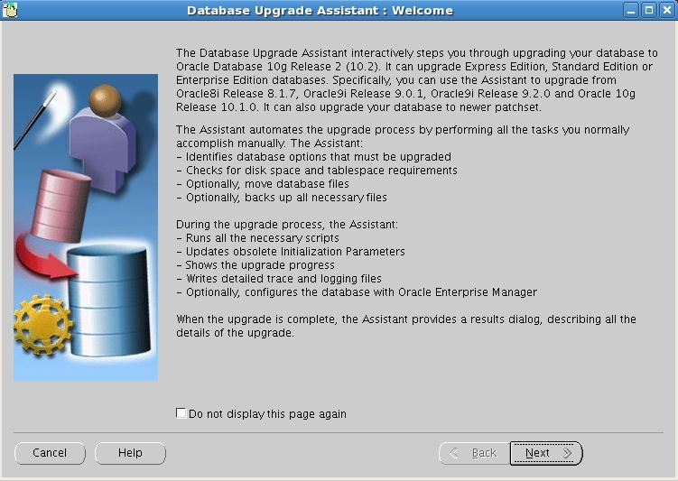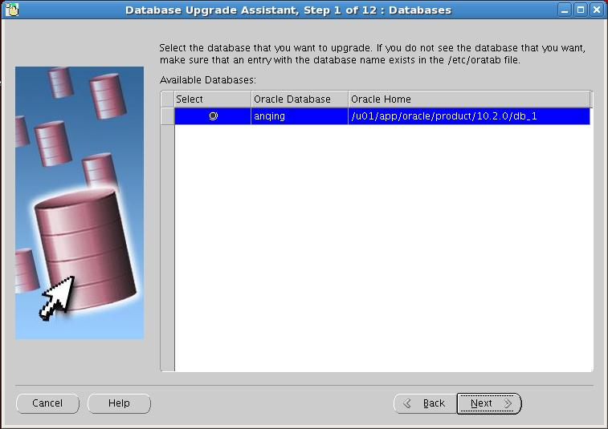

这里我们并没有启动实例，dbua命令会自动完成这些操作。

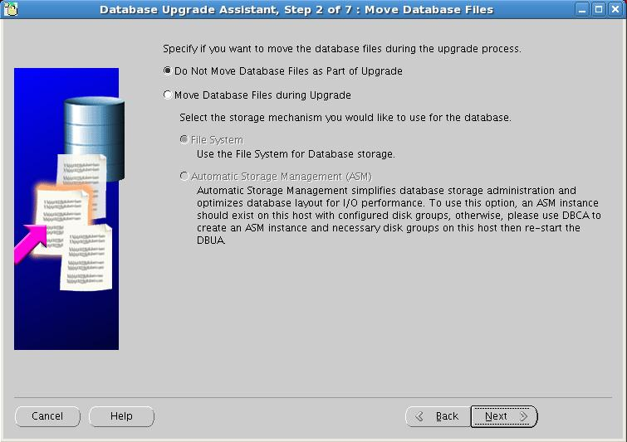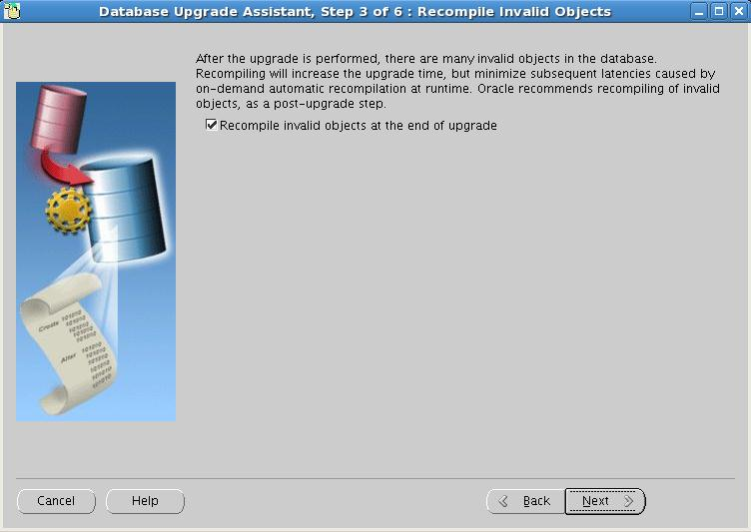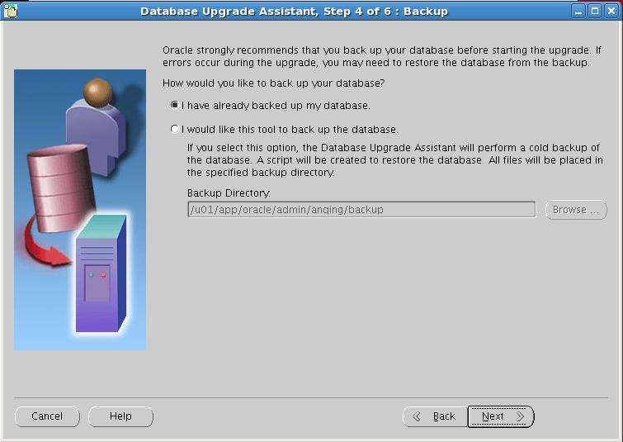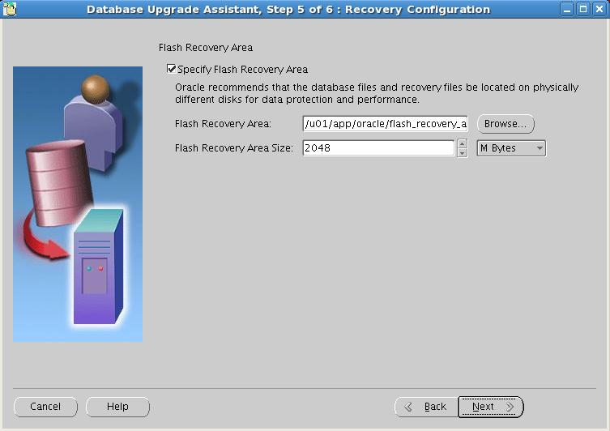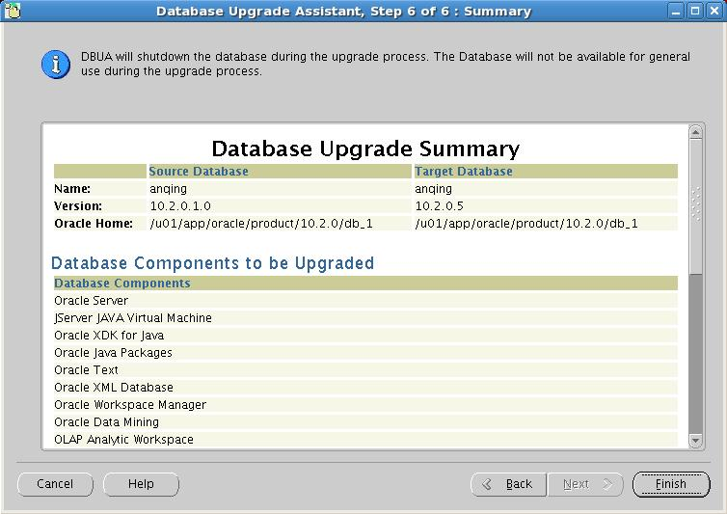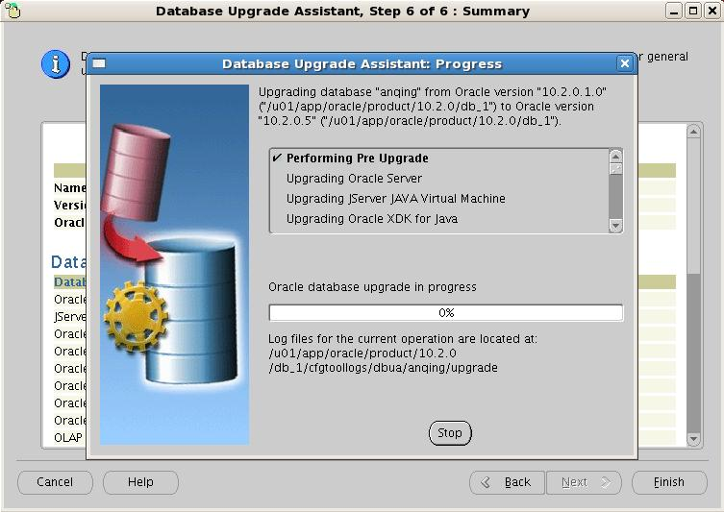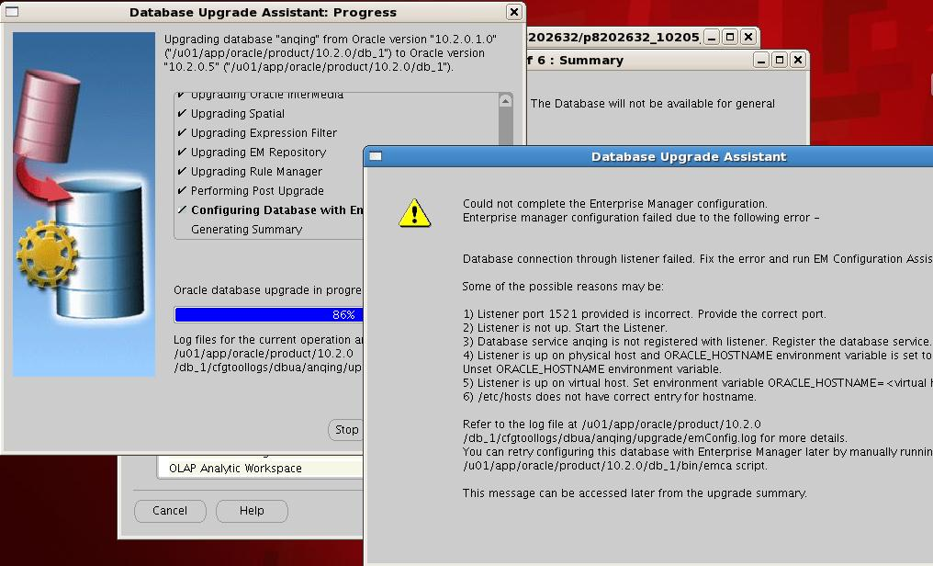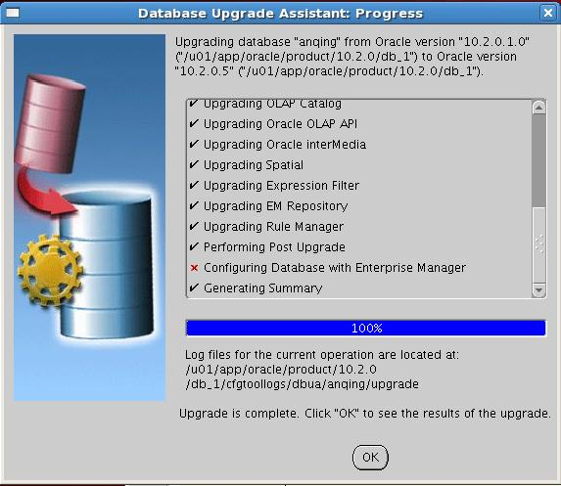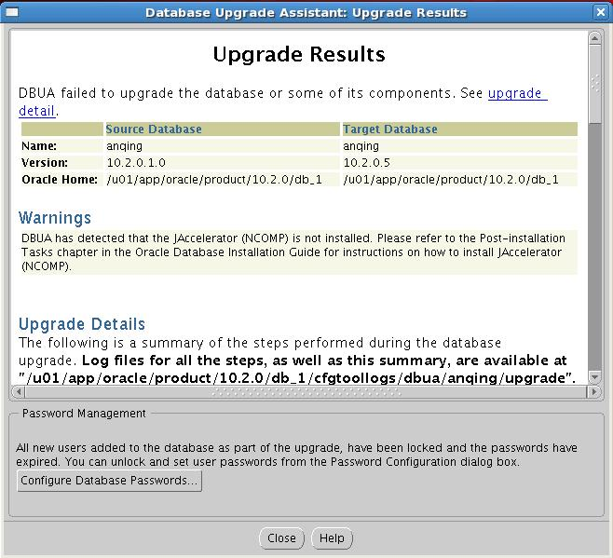

这个过程比较漫长，需要近一个小时。倒数第二步EM配置出错。 这里我们先继续。EM 可以最后在单独配置。

**3.3 检查实例版本信息**

sqlplus / as sysdba;

SQL*Plus: Release 10.2.0.5.0 - Productionon Sun Oct 9 17:02:12 2011

Copyright (c) 1982, 2010, Oracle.  All Rights Reserved.

Connected to:

Oracle Database 10g Enterprise EditionRelease 10.2.0.5.0 - Production

With the Partitioning, OLAP, Data Miningand Real Application Testing options

SQL> col comp_name format a40

SQL> col version for a20

SQL> SELECT COMP_NAME,VERSION,STATUS FROM SYS.DBA_REGISTRY;

COMP_NAME                                VERSION              STATUS

------------------------------------------------------------ ------------------

Oracle Database Catalog Views            10.2.0.5.0           VALID

Oracle Database Packages and Types       10.2.0.5.0           VALID

Oracle Workspace Manager                 10.2.0.5.0           VALID

JServer JAVA Virtual Machine             10.2.0.5.0           VALID

Oracle XDK                               10.2.0.5.0           VALID

Oracle Database Java Packages            10.2.0.5.0           VALID

Oracle Expression Filter                 10.2.0.5.0           VALID

Oracle Data Mining                       10.2.0.5.0           VALID

Oracle Text                              10.2.0.5.0           VALID

Oracle XML Database                      10.2.0.5.0           VALID

Oracle Rule Manager                      10.2.0.5.0           VALID

COMP_NAME                                VERSION              STATUS

------------------------------------------------------------ ------------------

Oracle interMedia                        10.2.0.5.0           VALID

OLAP Analytic Workspace                  10.2.0.5.0           VALID

Oracle OLAP API                          10.2.0.5.0           VALID

OLAP Catalog                             10.2.0.5.0           VALID

Spatial                                 10.2.0.5.0           VALID

Oracle Enterprise Manager                10.2.0.5.0           VALID

17 rows selected.

实例的版本已经升级到10.2.0.5.0了

**3.4**

**四.打10.2.0.5.4Patch**

现在数据库和实例的版本都是10.2.0.5.0的版本，在这个版本的基础上，我们在升级到10.2.0.5.4. Patch NO 是：12419392

**4.1 OPatch 版本检测**

       安装10.2.0.5.4 的Patch，OPatch 的版本至少需要10.2.0.5.4.

You must use theOPatch 10.2 version 10.2.0.5.0 or later to apply this patch. Oracle recommendsthat you use the latest released OPatch 10.2, which is available for downloadfrom My Oracle Support patch [6880880](http://updates.oracle.com/ARULink/PatchDetails/process_form?patch_num=6880880) byselecting the 10.2.0.0.0 release.

查看现有OPatch 的版本：

$ORACLE_HOME/OPatch/opatch version

Invoking OPatch 10.2.0.4.9

OPatch Version: 10.2.0.4.9

OPatch succeeded.

这里显示的OPatch的版本低于10.2.0.5。 不能用来安装10.2.0.5.4的patch。 需要从MOS 上下载10.2.0.5的OPatch。Patch NO: [6880880](http://updates.oracle.com/ARULink/PatchDetails/process_form?patch_num=6880880).该Patch 28M。

**4.2 One-off Patch Conflict Detection and Resolution（Patch 冲突检测）**

$ORACLE_HOME/OPatch/opatch prereq CheckConflictAgainstOHWithDetail -phBaseDir./12419392

Invoking OPatch 10.2.0.4.9

Oracle Interim Patch Installer version10.2.0.4.9

Copyright (c) 2009, OracleCorporation.  All rights reserved.

PREREQ session

Oracle Home       : /home/oracle/product/10.2.0/db_1

Central Inventory :/home/oracle/oraInventory

  from           : /etc/oraInst.loc

OPatch version    : 10.2.0.4.9

OUI version       : 10.2.0.5.0

OUI location      : /home/oracle/product/10.2.0/db_1/oui

Log file location :/home/oracle/product/10.2.0/db_1/cfgtoollogs/opatch/opatch2011-10-09_20-23-29PM.log

Patch history file:/home/oracle/product/10.2.0/db_1/cfgtoollogs/opatch/opatch_history.txt

Invoking prereq"checkconflictagainstohwithdetail"

ZOP-40: The patch(es) hasconflicts/supersets with other patches installed in the Oracle Home (or) amongthemselves.

Prereq"checkConflictAgainstOHWithDetail" failed.

Summary of Conflict Analysis:

Patches that can be applied now without anyconflicts are :

12419392

Following patches are not required, as theyare subset of the patches in Oracle Home or subset of the patches in the givenlist :

8350262

Following patches will be rolled back fromOracle Home on application of the patches in the given list :

8350262

Conflicts/Supersets for each patch are:

Patch : 12419392

$ORACLE_HOME/OPatch/opatch prereq CheckConflictAgainstOHWithDetail -phBaseDir./12419392

Invoking OPatch 10.2.0.5.1

Oracle Interim Patch Installer version10.2.0.5.1

Copyright (c) 2010, OracleCorporation.  All rights reserved.

PREREQ session

Oracle Home       : /home/oracle/product/10.2.0/db_1

Central Inventory :/home/oracle/oraInventory

  from           : /etc/oraInst.loc

OPatch version    : 10.2.0.5.1

OUI version       : 10.2.0.5.0

OUI location      : /home/oracle/product/10.2.0/db_1/oui

Log file location :/home/oracle/product/10.2.0/db_1/cfgtoollogs/opatch/opatch2011-10-09_21-34-40PM.log

Patch history file:/home/oracle/product/10.2.0/db_1/cfgtoollogs/opatch/opatch_history.txt

Invoking prereq"checkconflictagainstohwithdetail"

Prereq"checkConflictAgainstOHWithDetail" passed.

OPatch succeeded.

**4.3 安装Patch**

opatch apply

Invoking OPatch 10.2.0.5.1

Oracle Interim Patch Installer version10.2.0.5.1

Copyright (c) 2010, OracleCorporation.  All rights reserved.

Oracle Home       : //oracle/product/10.2.0/db_1

Central Inventory :/oracle/oraInventory

  from           : /etc/oraInst.loc

OPatch version    : 10.2.0.5.1

OUI version       : 10.2.0.5.0

OUI location      : /oracle/product/10.2.0/db_1/oui

Log file location :/oracle/product/10.2.0/db_1/cfgtoollogs/opatch/opatch2011-10-09_21-36-53PM.log

Patch history file:/oracle/product/10.2.0/db_1/cfgtoollogs/opatch/opatch_history.txt

ApplySession applying interim patch'12419392' to OH '/u01/app/oracle/product/10.2.0/db_1'

Running prerequisite checks...

Prerequisite check "CheckActiveFilesAndExecutables"failed.

The details are:

Following executables are active :

/u01/app/oracle/product/10.2.0/db_1/bin/oracle

ApplySession failed during prerequisitechecks: Prerequisite check "CheckActiveFilesAndExecutables" failed.

System intact, OPatch will not attempt torestore the system

OPatch failed with error code 74

报错：

ApplySession failed during prerequisitechecks: Prerequisite check "CheckActiveFilesAndExecutables" failed.

有活动的文件存在，该Patch 的安装文档上并没有提到需要关闭监听和实例。 不过从这个错误提示来看，是需要关闭监听和实例的。

 lsnrctl stop

LSNRCTL for Linux: Version 10.2.0.5.0 -Production on 09-OCT-2011 21:45:32

Copyright (c) 1991, 2010, Oracle.  All rights reserved.

Connecting to(DESCRIPTION=(ADDRESS=(PROTOCOL=IPC)(KEY=EXTPROC1)))

The command completed successfully

 emctl stop dbconsole

TZ set to PRC

Oracle Enterprise Manager 10g DatabaseControl Release 10.2.0.5.0

Copyright (c) 1996, 2010 OracleCorporation.  All rights reserved.

https://dave:1158/em/console/aboutApplication

Stopping Oracle Enterprise Manager 10gDatabase Control ...

 ... Stopped.

 sqlplus / as sysdba;

SQL*Plus: Release 10.2.0.5.0 - Productionon Sun Oct 9 21:46:10 2011

Copyright (c) 1982, 2010, Oracle.  All Rights Reserved.

Connected to:

Oracle Database 10g Enterprise EditionRelease 10.2.0.5.0 - Production

With the Partitioning, OLAP, Data Miningand Real Application Testing options

SQL> shutdown immediate

Database closed.

Database dismounted.

ORACLE instance shut down.

SQL> exit

Disconnected from Oracle Database 10g EnterpriseEdition Release 10.2.0.5.0 - Production

With the Partitioning, OLAP, Data Miningand Real Application Testing options

关闭监听，EM和instance 之后，在打Patch。 可以正常安装Patch了。

opatch apply

Invoking OPatch 10.2.0.5.1

Oracle Interim Patch Installer version10.2.0.5.1

Copyright (c) 2010, OracleCorporation.  All rights reserved.

Oracle Home       : /oracle/product/10.2.0/db_1

Central Inventory :/oracle/oraInventory

  from           : /etc/oraInst.loc

OPatch version    : 10.2.0.5.1

OUI version       : 10.2.0.5.0

OUI location      : /home/oracle/product/10.2.0/db_1/oui

Log file location :/home/oracle/product/10.2.0/db_1/cfgtoollogs/opatch/opatch2011-10-09_21-46-56PM.log

Patch history file:/home/oracle/product/10.2.0/db_1/cfgtoollogs/opatch/opatch_history.txt

ApplySession applying interim patch'12419392' to OH '/u01/app/oracle/product/10.2.0/db_1'

Running prerequisite checks...

Patch 12419392: Optional component(s)missing : [ oracle.rdbms.dv, 10.2.0.5.0 ] , [ oracle.rdbms.dv.oc4j, 10.2.0.5.0]

Provide your email address to be informedof security issues, install and

initiate Oracle Configuration Manager.Easier for you if you use your My

Oracle Support Email address/User Name.

Visithttp://www.oracle.com/support/policies.html for details.

Email address/User Name:

You have not provided an email address fornotification of security issues.

Do you wish to remain uninformed ofsecurity issues ([Y]es, [N]o) [N]:  y

OPatch detected non-cluster Oracle Homefrom the inventory and will patch the local system only.

Please shutdown Oracle instances runningout of this ORACLE_HOME on the local system.

(Oracle Home ='/u01/app/oracle/product/10.2.0/db_1')

Is the local system ready for patching?[y|n]

y

User Responded with: Y

Backing up files and inventory (not for auto-rollback)for the Oracle Home

Backing up files affected by the patch'12419392' for restore. This might take a while...

Backing up files affected by the patch'12419392' for rollback. This might take a while...

Execution of 'sh /mnt/OracleSoftware/10.2.0.5.4_PSU_p12419392/p12419392_10205_LINUX/12419392/custom/scripts/pre-apply 12419392 ':

Return Code = 0

Patching component oracle.rdbms,10.2.0.5.0...

Updating archive file"/u01/app/oracle/product/10.2.0/db_1/lib/libserver10.a"  with "lib/libserver10.a/kcbl.o"

…..

Updating jar file"/home/oracle/product/10.2.0/db_1/sysman/jlib/emjsp.jar" with"/sysman/jlib/emjsp.jar/_database/_dbObjectsList.class"

Copying file to"/home/oracle/product/10.2.0/db_1/oc4j/j2ee/oc4j_applications/applications/em/em/admin/rep/editUserSummary.uix"

Patching component oracle.xdk.rsf,10.2.0.5.0...

Updating archive file"/home/oracle/product/10.2.0/db_1/lib/libxml10.a"  with "lib/libxml10.a/lpxpar.o"

Patching component oracle.precomp.common,10.2.0.5.0...

Patching component oracle.rdbms.rman,10.2.0.5.0...

Running make for target client_sharedlib

Running make for target ioracle

Running make for target iwrap

Running make for target client_sharedlib

Running make for target proc

Running make for target irman

ApplySession adding interim patch'12419392' to inventory

Verifying the update...

Inventory check OK: Patch ID 12419392 isregistered in Oracle Home inventory with proper meta-data.

Files check OK: Files from Patch ID12419392 are present in Oracle Home.

The local system has been patched and canbe restarted.

OPatch succeeded.

**4.4 后续工作**

**4.4.1 再次进行patch的冲突检测**

$ORACLE_HOME/OPatch/opatch prereq CheckConflictAgainstOHWithDetail -phBaseDir./12419392

Invoking OPatch 10.2.0.5.1

Oracle Interim Patch Installer version10.2.0.5.1

Copyright (c) 2010, OracleCorporation.  All rights reserved.

PREREQ session

Oracle Home       : /home/oracle/product/10.2.0/db_1

Central Inventory :/home/oracle/oraInventory

  from           : /etc/oraInst.loc

OPatch version    : 10.2.0.5.1

OUI version       : 10.2.0.5.0

OUI location      : /home/oracle/product/10.2.0/db_1/oui

Log file location :/home/oracle/product/10.2.0/db_1/cfgtoollogs/opatch/opatch2011-10-09_21-52-52PM.log

Patch history file:/home/oracle/product/10.2.0/db_1/cfgtoollogs/opatch/opatch_history.txt

Invoking prereq"checkconflictagainstohwithdetail"

ZOP-47: The patch(es) has supersets withother patches installed in the Oracle Home (or) among themselves.

Prereq"checkConflictAgainstOHWithDetail" failed.

Summary of Conflict Analysis:

Patches that can be applied now without anyconflicts are :

12419392

Following patches will be rolled back fromOracle Home on application of the patches in the given list :

12419392

Conflicts/Supersets for each patch are:

Patch : 12419392

       Bug Superset of 12419392

       Super set bugs are:

       6402302,  10269717,  10327190, 8865718,  10017048,  9024850, 8394351,  8546356,  9360157, 9770451,  9020537,  9772888, 8664189,  10091698,  12551710, 7519406,  10132870,  8771916, 9109487,  10173237,  10068982, 8350262,  11792865,  11724962, 11725006,  9184754,  8544696, 9320130,  7026523,  8277300, 9726739,  8412426,  12419392, 6651220,  9150282,  9659614, 9949948,  10327179,  8882576, 7612454,  9711859,  9714832, 10248542,  9952230,  9469117, 9952270,  8660422,  10324526, 12419258,  9713537,  10010310, 9390484,  9963497,  12551700, 12551701,  10249537,  12551702, 12551703,  8211733,  12551704, 9548269,  12551705,  12551706, 9337325,  12551707,  7602341, 12551708,  9308296,  10157402, 11737047

OPatch succeeded.

**五.检查组件版本信息**

SQL> select * from v$version;

BANNER

----------------------------------------------------------------

Oracle Database 10g Enterprise EditionRelease 10.2.0.5.0 - Prod

PL/SQL Release 10.2.0.5.0 - Production

CORE   10.2.0.5.0      Production

TNS for Linux: Version 10.2.0.5.0 -Production

NLSRTL Version 10.2.0.5.0 - Production

SQL> SELECT COMP_NAME, VERSION, STATUSFROM SYS.DBA_REGISTRY;

COMP_NAME                                VERSION              STATUS

------------------------------------------------------------ ------------------

Oracle Enterprise Manager                10.2.0.5.0           VALID

Spatial                                 10.2.0.5.0           VALID

Oracle interMedia                        10.2.0.5.0           VALID

OLAP Catalog                             10.2.0.5.0           VALID

Oracle XML Database                      10.2.0.5.0           VALID

Oracle Text                              10.2.0.5.0           VALID

Oracle Expression Filter                 10.2.0.5.0           VALID

Oracle Rule Manager                      10.2.0.5.0           VALID

Oracle Workspace Manager                 10.2.0.5.0           VALID

Oracle Data Mining                       10.2.0.5.0           VALID

Oracle Database Catalog Views            10.2.0.5.0           VALID

COMP_NAME                                VERSION              STATUS

------------------------------------------------------------ ------------------

Oracle Database Packages and Types       10.2.0.5.0           VALID

JServer JAVA Virtual Machine             10.2.0.5.0           VALID

Oracle XDK                               10.2.0.5.0           VALID

Oracle Database Java Packages            10.2.0.5.0           VALID

OLAP Analytic Workspace                  10.2.0.5.0           VALID

Oracle OLAP API                          10.2.0.5.0           VALID

17 rows selected.

（1）验证PSU

 $ORACLE_HOME/OPatch/opatch lsinv -bugs_fixed|grep PSU

[oracle@tjfxdb 14275629]$ $ORACLE_HOME/OPatch/opatch lsinv -bugs_fixed|grep PSU

ENCAPSULATED BY EXCEPTION HANDLING

9952230 14275629 Thu Apr 10 20:06:38 CST 2014 DATABASE PSU 10.2.0.5.1 (INCLUDES CPUOCT2010)

10248542 14275629 Thu Apr 10 20:06:38 CST 2014 DATABASE PSU 10.2.0.5.2 (INCLUDES CPUJAN2011)

11724962 14275629 Thu Apr 10 20:06:38 CST 2014 DATABASE PSU 10.2.0.5.3 (INCLUDES CPUAPR2011)

12419392 14275629 Thu Apr 10 20:06:38 CST 2014 DATABASE PSU 10.2.0.5.4 (INCLUDES CPUJUL2011)

12827745 14275629 Thu Apr 10 20:06:38 CST 2014 DATABASE PSU 10.2.0.5.5 (INCLUDES CPUOCT2011)

13343471 14275629 Thu Apr 10 20:06:38 CST 2014 DATABASE PSU 10.2.0.5.6 (INCLUDES CPUJAN2012)

13349665 14275629 Thu Apr 10 20:06:38 CST 2014 ORA-600 [KKSLMTL-VALNOTFOUND] WITH PSU 10.2.0.5.5

13775862 14275629 Thu Apr 10 20:06:38 CST 2014 AFTER TO APPLY PSU PATCH DVA FAILS WITH 500

TOP OF PSUS >= 10.2.0.5.3

14269955 14275629 Thu Apr 10 20:06:38 CST 2014 MISSING KFD.O IN PSU 10.2.0.5.6 10.2.0.5.7 10.2.0.

**重新配置EM**

在Oracle10.2.0.4和10.2.0.5的版本里，OEM 有个bug，具体参考：

[Oracle 10.2.0.4和10.2.0.5中 OEM bug 8350262](http://blog.csdn.net/tianlesoftware/article/details/6568690" \o "Oracle 10.2.0.4和10.2.0.5 中 OEM bug 8350262)

<http://blog.csdn.net/tianlesoftware/article/details/6568690>

重建的步骤如下：

（1）检查/etc/hosts 文件：

dave:/home/oracle> cat /etc/hosts

# Do not remove the following line, orvarious programs

# that require network functionality willfail.

127.0.0.1               localhost.localdomainlocalhost

10.0.103.12 tjfxdb

（2） 启动监听：

lsnrctl start

LSNRCTL for Linux: Version 10.2.0.5.0 -Production on 09-OCT-2011 17:01:10

Copyright (c) 1991, 2010, Oracle.  All rights reserved.

Starting/u01/app/oracle/product/10.2.0/db_1/bin/tnslsnr: please wait...

TNSLSNR for Linux: Version 10.2.0.5.0 -Production

System parameter file is/u01/app/oracle/product/10.2.0/db_1/network/admin/listener.ora

Log messages written to/u01/app/oracle/product/10.2.0/db_1/network/log/listener.log

Listening on:(DESCRIPTION=(ADDRESS=(PROTOCOL=ipc)(KEY=EXTPROC1)))

Listening on:(DESCRIPTION=(ADDRESS=(PROTOCOL=tcp)(HOST=dave)(PORT=1521)))

Connecting to(DESCRIPTION=(ADDRESS=(PROTOCOL=IPC)(KEY=EXTPROC1)))

STATUS of the LISTENER

------------------------

Alias                     LISTENER

Version                   TNSLSNR for Linux: Version10.2.0.5.0 - Production

Start Date                09-OCT-2011 17:01:11

Uptime                    0 days 0 hr. 0 min. 0 sec

Trace Level               off

Security                  ON: Local OS Authentication

SNMP                      OFF

Listener Parameter File   /home/oracle/product/10.2.0/db_1/network/admin/listener.ora

Listener Log File        /home/oracle/product/10.2.0/db_1/network/log/listener.log

Listening Endpoints Summary...

 (DESCRIPTION=(ADDRESS=(PROTOCOL=ipc)(KEY=EXTPROC1)))

 (DESCRIPTION=(ADDRESS=(PROTOCOL=tcp)(HOST=dave)(PORT=1521)))

Services Summary...

Service "PLSExtProc" has 1instance(s).

 Instance "PLSExtProc", status UNKNOWN, has 1 handler(s) forthis service...

The command completed successfully

（3）打EM的bug： 8350262

--安装patch

$ORACLE_HOME/OPatch/opatch apply

Invoking OPatch 10.2.0.4.9

Oracle Interim Patch Installer version10.2.0.4.9

Copyright (c) 2009, Oracle Corporation.  All rights reserved.

Oracle Home       : /home/oracle/product/10.2.0/db_1

Central Inventory :/home/oracle/oraInventory

  from           : /etc/oraInst.loc

OPatch version    : 10.2.0.4.9

OUI version       : 10.2.0.5.0

OUI location      : /home/oracle/product/10.2.0/db_1/oui

Log file location :/home/oracle/product/10.2.0/db_1/cfgtoollogs/opatch/opatch2011-10-09_18-35-54PM.log

Patch history file:/home/oracle/product/10.2.0/db_1/cfgtoollogs/opatch/opatch_history.txt

ApplySession applying interim patch'8350262' to OH '/u01/app/oracle/product/10.2.0/db_1'

Running prerequisite checks...

OPatch detected non-cluster Oracle Homefrom the inventory and will patch the local system only.

Backing up files and inventory (not forauto-rollback) for the Oracle Home

Backing up files affected by the patch'8350262' for restore. This might take a while...

Backing up files affected by the patch'8350262' for rollback. This might take a while...

Patching componentoracle.sysman.agent.core, 10.2.0.5.0a...

…

Updating jar file"/home/oracle/product/10.2.0/db_1/sysman/jlib/emd_java.jar" with"/sysman/jlib/emd_java.jar/oracle/sysman/eml/sec/util/SecConstants.class"

ApplySession adding interim patch '8350262'to inventory

Verifying the update...

Inventory check OK: Patch ID 8350262 isregistered in Oracle Home inventory with proper meta-data.

Files check OK: Files from Patch ID 8350262are present in Oracle Home.

OPatch succeeded.

（4）删除OEM的 dbconsole 和repository

dave:/home/oracle/product/10.2.0/db_1/bin>emca -deconfig dbcontrol db -repos drop

STARTED EMCA at Oct 9, 2011 5:33:12 PM

EM Configuration Assistant, Version10.2.0.5.0 Production

Copyright (c) 2003, 2009, Oracle.  All rights reserved.

Enter the following information:

Database SID: anqing

Listener port number: 1521

Password for SYS user:

Password for SYSMAN user:

----------------------------------------------------------------------

WARNING : While repository is dropped thedatabase will be put in quiesce mode.

----------------------------------------------------------------------

Do you wish to continue? [yes(Y)/no(N)]: y

Oct 9, 2011 5:33:35 PMoracle.sysman.emcp.EMConfig perform

INFO: This operation is being logged at/u01/app/oracle/product/10.2.0/db_1/cfgtoollogs/emca/anqing/emca_2011-10-09_05-33-12-PM.log.

Oct 9, 2011 5:33:38 PMoracle.sysman.emcp.util.DBControlUtil stopOMS

INFO: Stopping Database Control (this maytake a while) ...

Oct 9, 2011 5:33:50 PM oracle.sysman.emcp.EMReposConfiginvoke

INFO: Dropping the EM repository (this maytake a while) ...

Oct 9, 2011 5:33:50 PMoracle.sysman.emcp.EMReposConfig dropRepository

INFO: Dropping the EM repository (this maytake a while) ...

Oct 9, 2011 5:35:14 PM oracle.sysman.emcp.EMReposConfiginvoke

INFO: Repository successfully dropped

Enterprise Manager configuration completedsuccessfully

FINISHED EMCA at Oct 9, 2011 5:35:15 PM

--执行用了3分钟

（5）重建EM的dbcontrol 和 repository

/home/oracle/admin/anqing/bdump>emca -config dbcontrol db -repos create

STARTED EMCA at Oct 9, 2011 8:03:22 PM

EM Configuration Assistant, Version10.2.0.5.0 Production

Copyright (c) 2003, 2009, Oracle.  All rights reserved.

Enter the following information:

Database SID: anqing

Listener port number: 1521

Password for SYS user:

Password for DBSNMP user:

Password for SYSMAN user:

Email address for notifications (optional):

Outgoing Mail (SMTP) server fornotifications (optional):

-----------------------------------------------------------------

You have specified the following settings

Database ORACLE_HOME ................/home/oracle/product/10.2.0/db_1

Local hostname ................ localhost

Listener port number ................ 1521

Database SID ................ tjfx

Email address for notifications...............

Outgoing Mail (SMTP) server fornotifications ...............

-----------------------------------------------------------------

Do you wish to continue? [yes(Y)/no(N)]: y

Oct 9, 2011 8:03:40 PM oracle.sysman.emcp.EMConfigperform

INFO: This operation is being logged at/home/oracle/product/10.2.0/db_1/cfgtoollogs/emca/anqing/emca_2011-10-09_08-03-22-PM.log.

Oct 9, 2011 8:03:44 PMoracle.sysman.emcp.EMReposConfig createRepository

INFO: Creating the EM repository (this maytake a while) ...

Oct 9, 2011 8:06:32 PMoracle.sysman.emcp.EMReposConfig invoke

INFO: Repository successfully created

Oct 9, 2011 8:06:51 PMoracle.sysman.emcp.util.DBControlUtil secureDBConsole

INFO: Securing Database Control (this maytake a while) ...

Oct 9, 2011 8:08:02 PMoracle.sysman.emcp.util.DBControlUtil secureDBConsole

INFO: Database Control securedsuccessfully.

Oct 9, 2011 8:08:02 PMoracle.sysman.emcp.util.DBControlUtil startOMS

INFO: Starting Database Control (this maytake a while) ...

Oct 9, 2011 8:09:57 PMoracle.sysman.emcp.EMDBPostConfig performConfiguration

INFO: Database Control started successfully

Oct 9, 2011 8:09:57 PMoracle.sysman.emcp.EMDBPostConfig performConfiguration

INFO:>>>>>>>>>>> The Database Control URL is https://localhost:5500/em<<<<<<<<<<<

Enterprise Manager configuration completedsuccessfully

FINISHED EMCA at Oct 9, 2011 8:09:57 PM

至此，整个数据库的安装及版本更新结束，后续进行原统计分析数据库导入新统计分析数据库的工作。

安装过程中出现的问题：1 在安装过程中，在Word 里面直接复制粘贴进行配置，这样会造成一些文件内出现特殊字符，造成安装过程中出现错误。建议使用VI编辑器。

2 在安装过程中出现了ins_emdb.mk 这是oracle10g 出现的BUG 可以继续进行安装。

3 在使用Xmanager 过程中，发现设置完环境变量之后，打开另一个终端结果查询发现环境变量消失。重启系统在远端查询一样是不生效，但是在主机上面查询 就是有效的。这一点需要进行注意。

Oracle数据库启动过程：

• Linux中启动oracle的数据库实例，需要注意以下几点。

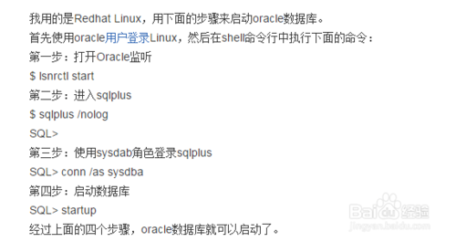

• 下面是Linux启动oracle数据库的步骤

首先打开命令行窗口，切换到su - oracle，这点很重要。

启动数据库监听

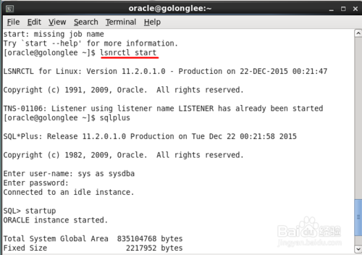

• 打开sqlplus

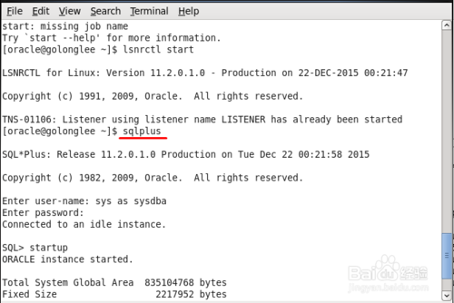

• 用sys账户以sysdba的身份登录

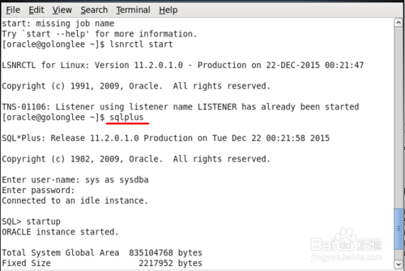

• 输入sys用户的密码，然后按下enter

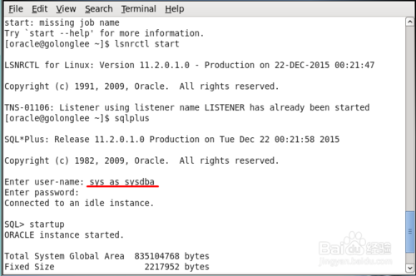

• 登录成功后，输入startup

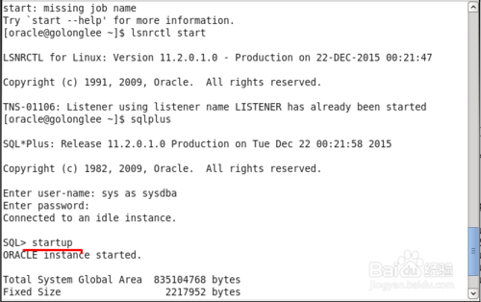

• 稍等片刻，可以看到数据库实例已经运行了。

