Scenario

***Real Estate (House Price Predictor)***

**New users register on the Real Estate platform, providing their username, password, email, and specifying their user type (Buyer/Seller/Agent).**

**Users log in to the system using their credentials, initiating a session. User authentication is mandatory for all subsequent actions.**

**Users, predominantly buyers, perform property searches based on criteria such as location, budget, and features. The system records each search in the user's search history.**

**Users explore property details, including features, listing prices, and historical transactions. The system displays accurate and up-to-date information.**

**Sellers add properties to the system for selling, providing details such as address, area, bedrooms, bathrooms, features, and the desired selling price. Each property is associated with the respective seller.**

**Users, both buyers and sellers, initiate predictions for selected properties to estimate future house prices. The system uses a Linear Regression model to provide accurate predictions.**

**When buyers decide to purchase a property, they initiate a transaction. The system records the transaction details, including the property, buyer, seller, transaction date, and price.**

**Users can review their search history to track previously explored properties. The system links each entry in the search history to the corresponding user and property.**

**Sellers mark their properties as sold when transactions are completed. The system records the selling details, including the seller, property, selling price, and date.**

**Users log out of the system, ending their session. The system records the logout time in the user session history.**

**The system manages user sessions, allowing users to have multiple sessions and keeping track of login and logout times.**

**Each property is associated with features and types. Features, such as "Swimming Pool" or "Garden," are linked to properties, providing additional information to users. Properties also belong to specific types, such as "Apartment" or "House."**

**This scenario outlines a typical user journey on the Real Estate platform, incorporating actions like property search, selling, prediction, and transaction. The system's entities, attributes, and relationships ensure accurate and transparent information for users, contributing to a reliable real estate experience.**

***ERD***

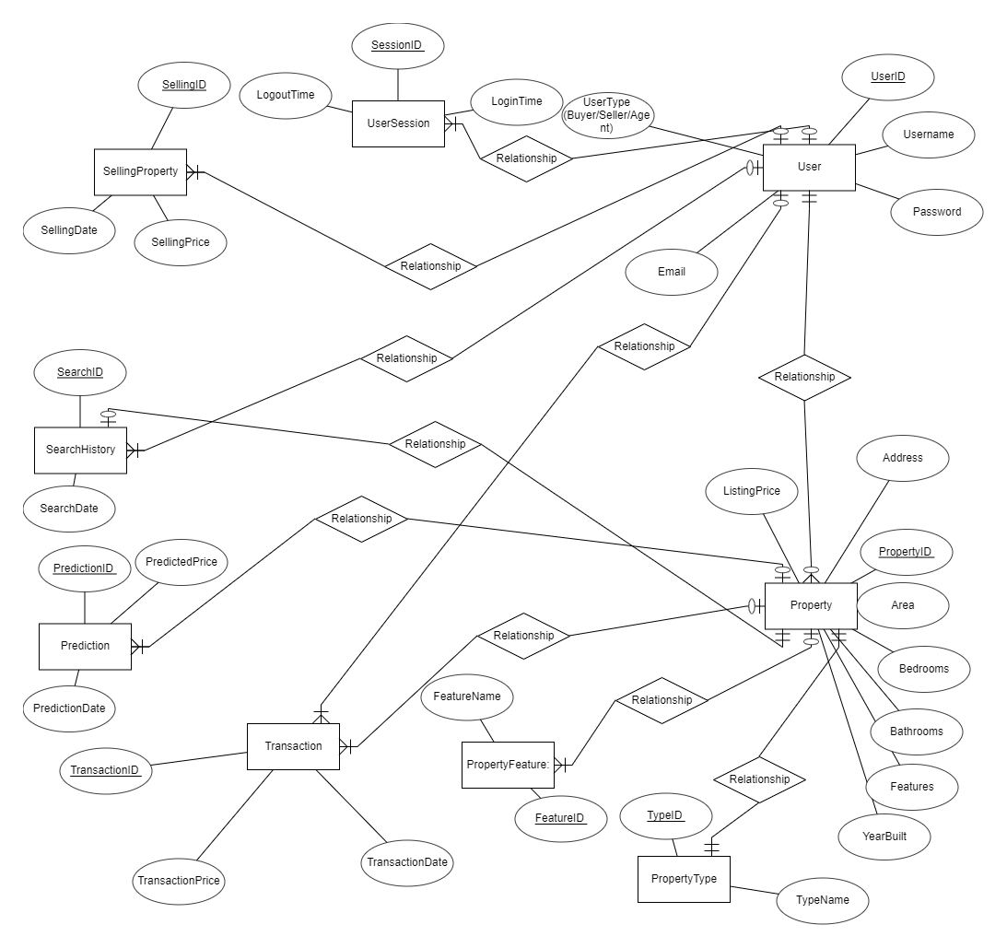

**View Table**

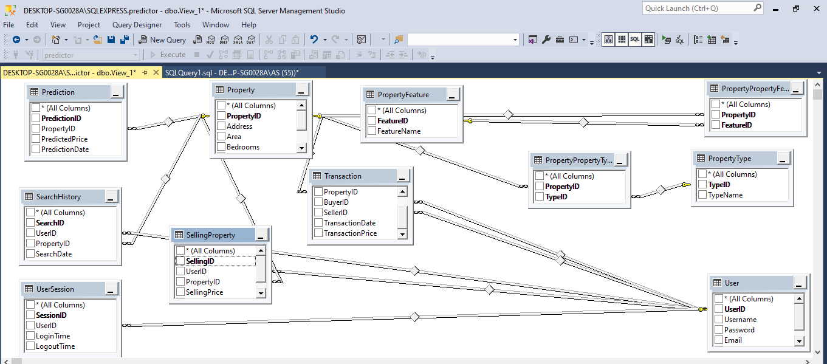

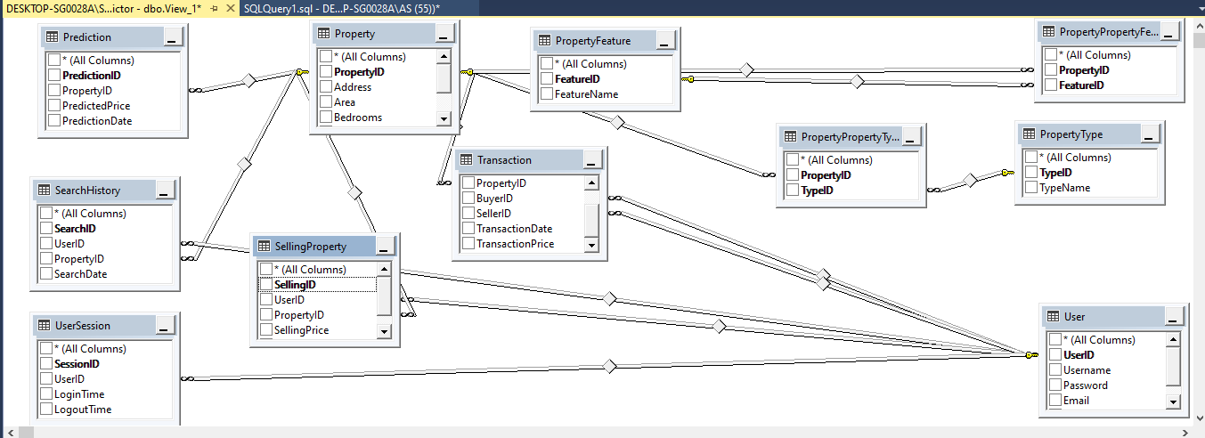

SQL SCRIT

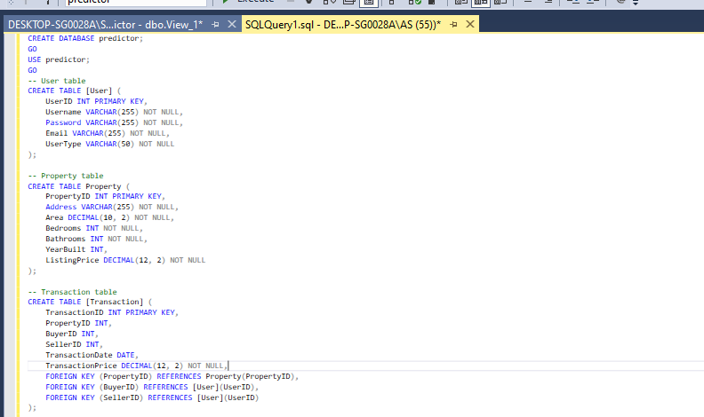

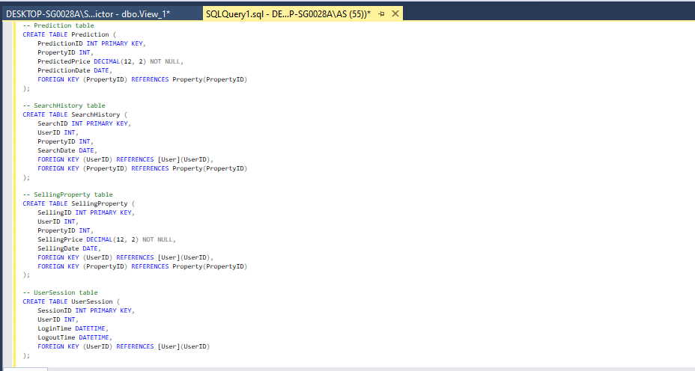

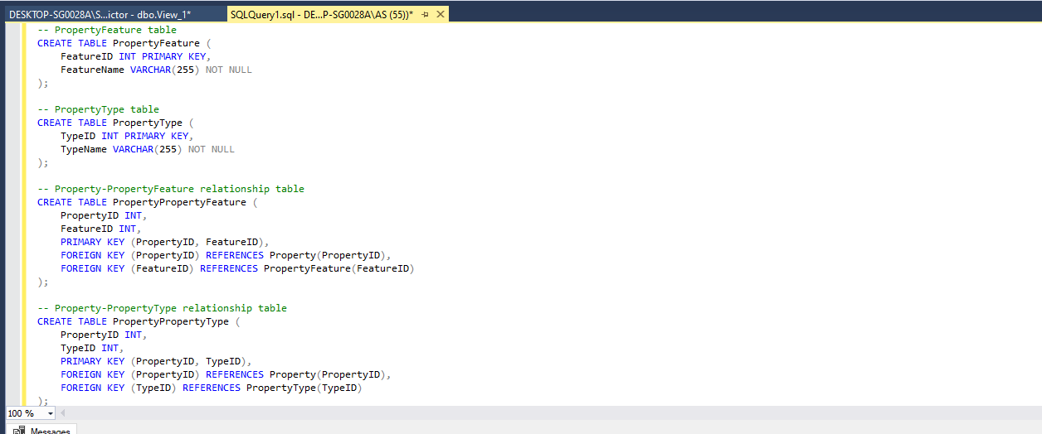

**Report View**

