Data Structures in Python

Alejandra Hernandez

College of DuPage

# 

# 

# DATA STRUCTURES IN PYTHON

**Queue**

A queue is a data structure that holds data much like a stack. This data container uses a *first-in-first-out(*FIFO) method. This means that whatever is appended first to the structure leaves first. A queue can be implemented using an array or a linked-list.

**Figure 1**

**Representation of a FIFO (first in, first out)**

Note. By Vegpuff/Wikipedia, 2019. *Representation of a FIFO (first in, first out) queue, Queue (abstract data type).* [*https://en.wikipedia.org/wiki/Queue_(abstract_data_type)*](https://en.wikipedia.org/wiki/Queue_(abstract_data_type))*. Accessed 17 Nov, 2020.*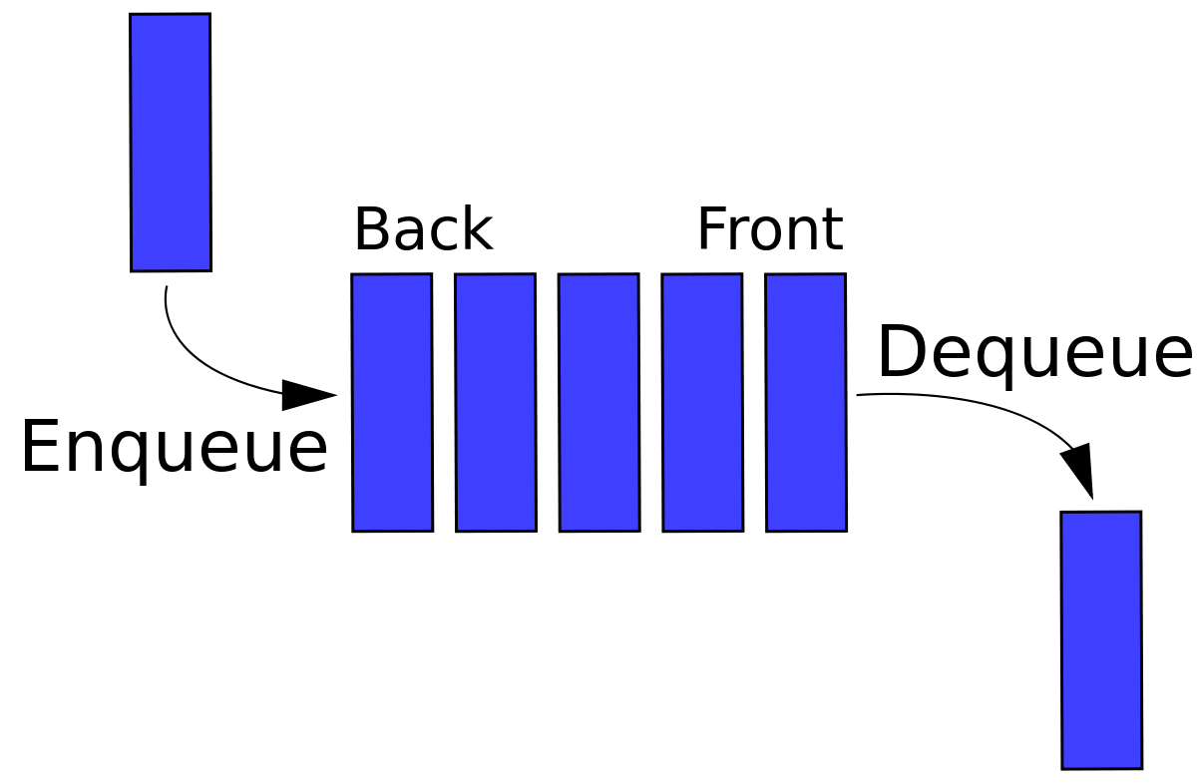

**Implementation.** Queues are typically used in waiting lines. For example, at a call center, your call is put in a queue. These calls are managed by a handler, they are handled in the order the calls came in using the queue’s FIFO.

Another example is game waiting queues. Lead developer Darrell Tunnell says, “when game servers are busy, new players wishing to join can have their requests placed in a queue.” So once again, those who were placed in the queue first, will be handled first.

**Hashing**

The hashing data structure uses a hash function to map a value to a key to access elements faster. In other words hashing is used to take any length of input and return a value with a fixed length creating the hash value.

**Figure 2**

**Hashing Data Structure**

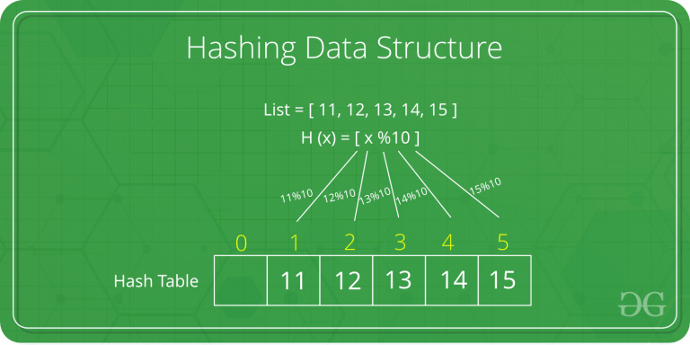

Note. 2019. *Hashing Data Structure, https://www.geeksforgeeks.org/hashing-data-structure. Accessed 17 Nov, 2020.*

**Implementation.** Hashing is used in password verification. When a user inputs their password in a website, the hash value of their password is sent to the server to be verified with the corresponding hashed value which then grants you the login.

Hashing is also used in our very own file systems. The file name and file path are the two components that are linked together using a map function. This is implemented using a hash table.

**Binary Trees**

The binary tree data structure is meant to store and organize data. A binary tree is composed of pointers and nodes. Each node is capable of at most two children.

**Figure 3**

**Diving deep with complex Data Structures**

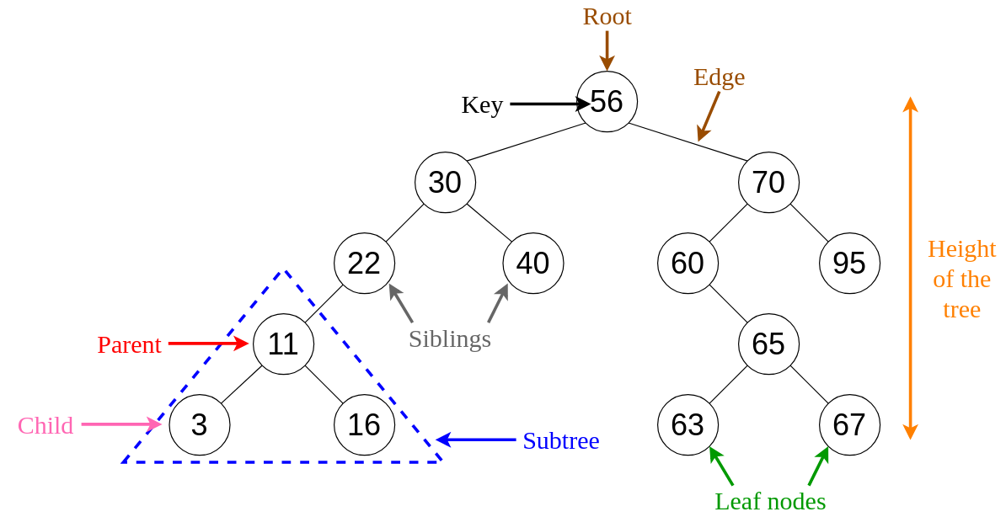

Note. By Eli Kantor, 2019. *An Intro to Binary Search Trees, https://levelup.gitconnected.com/an-into-to-binary-search-trees-432f94d180da. Accessed 17 Nov, 2020.*

**Implementation.** Binary Trees can be used in many search applications where data is constantly entering/leaving. An example would be map and set objects in languages' libraries.

# 

# Conclusion

# There are many data structures with different functions. Furthering your knowledge in data structures will help with decision making and help your programs run faster and more efficiently.

# References

Edpresso, What is a Binary Tree? (n.d.). Retrieved November 19, 2020, from <https://www.educative.io/edpresso/what-is-a-binary-tree>

Gupta, S. (2020, November 13). Why Is Hashing Your Top Priority For Data Security? Retrieved November 19, 2020, from <https://www.audienceplay.com/blog/hashing/>

Tunnell, D. (2018, February 10). *What are the applications of queues?* Quora.

<https://www.quora.com/What-are-the-applications-of-queues>