The Quintessential Wedding Bouquet: A Bride's Floral Elegance

A wedding bouquet is more than just a bunch of flowers; it's a symbol of love, beauty, and the bride's unique style. This timeless accessory has been an essential part of weddings for centuries, and it continues to hold a special place in the hearts of brides today. In this article, we will delve into the significance of the wedding bouquet, explore various bouquet styles, and offer tips on how to choose the perfect one for your big day.

The Symbolism of the Wedding Bouquet

The wedding bouquet has a rich history filled with symbolism. Traditionally, it symbolizes fertility and new beginnings, as the flowers represent the blossoming of a new life together. It's also a reflection of the bride's personality and taste, serving as a beautiful accessory that complements her bridal attire.

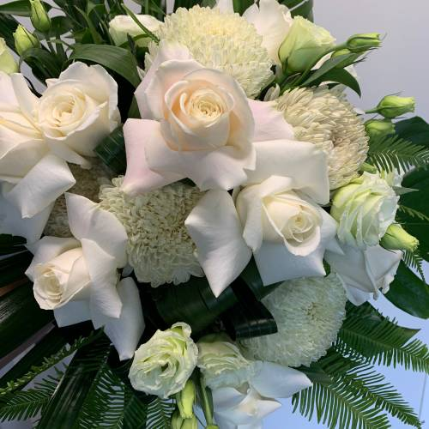

Types of Bouquets

There are several popular bouquet styles to choose from, each with its own unique charm:

**Round Bouquet**: This classic choice features a tightly bound cluster of flowers in a perfect sphere. It exudes timeless elegance and is versatile enough to suit any wedding theme.

**Cascade Bouquet**: Also known as the "waterfall bouquet[,"](https://ahhflowers.com.au/) this style features a flowing arrangement of flowers that tumbles gracefully, creating a romantic and dramatic effect.

**Hand-Tied Bouquet**: A rustic and natural-looking bouquet, the hand-tied style is loosely bound, often with a ribbon, creating a casually elegant and organic feel.

**Posy Bouquet**: Small and compact, the posy bouquet is a sweet and dainty option, perfect for brides who prefer a more minimalist approach.

**Nosegay Bouquet**: Similar to the posy, a nosegay bouquet is a compact cluster of flowers but often includes more greenery for a balanced and textured look.

**Composite Bouquet**: This style is a true work of art, as individual petals or smaller blooms are wired or glued together to create a single, breathtaking flower.

**Pomander Bouquet**: For a unique twist, brides can opt for a pomander bouquet, which is a ball of flowers suspended from a ribbon, often carried by a loop on the wrist.

Choosing the Perfect Bouquet

Selecting the right bouquet is a deeply personal decision, and there are several factors to consider:

**Wedding Theme**: Your bouquet should harmonize with your chosen wedding theme, whether it's rustic, vintage, modern, or romantic. Consider the color palette and style of your wedding when selecting flowers.

**Season**: The availability of certain flowers varies with the season. Choosing seasonal blooms not only ensures freshness but also helps you stay within budget.

**Dress Style**: The style of your wedding gown can influence your bouquet choice. A sleek, minimalist dress might pair beautifully with a simple posy, while a grand ball gown may call for a cascading bouquet.

**Personal Preferences**: Consider your favorite flowers and colors. Your bouquet should reflect your personality and make you feel comfortable and confident as you walk down the aisle.

**Budget**: Different flowers have different price points. Discuss your budget with your florist and explore cost-effective options while maintaining the overall look you desire.

**Meaning**: Many flowers have symbolic meanings. Research the meanings associated with the flowers you're considering to add an extra layer of sentiment to your bouquet.

Conclusion

Your wedding bouquet is more than just a collection of flowers; it's an extension of your personality, a symbol of your love, and a stunning accessory on your special day. Whether you opt for a classic round bouquet, a romantic cascade, or a unique composite creation, remember that your choice should be a reflection of your love story and your style. So, as you prepare for your wedding day, take the time to select the perfect bouquet that will make your journey down the aisle even more unforgettable.