1st page 2nd page

3rd page

4th page

5th page 6th page

7th page

n

1st page

2nd page

3rd page

4th page

5th page

6th page

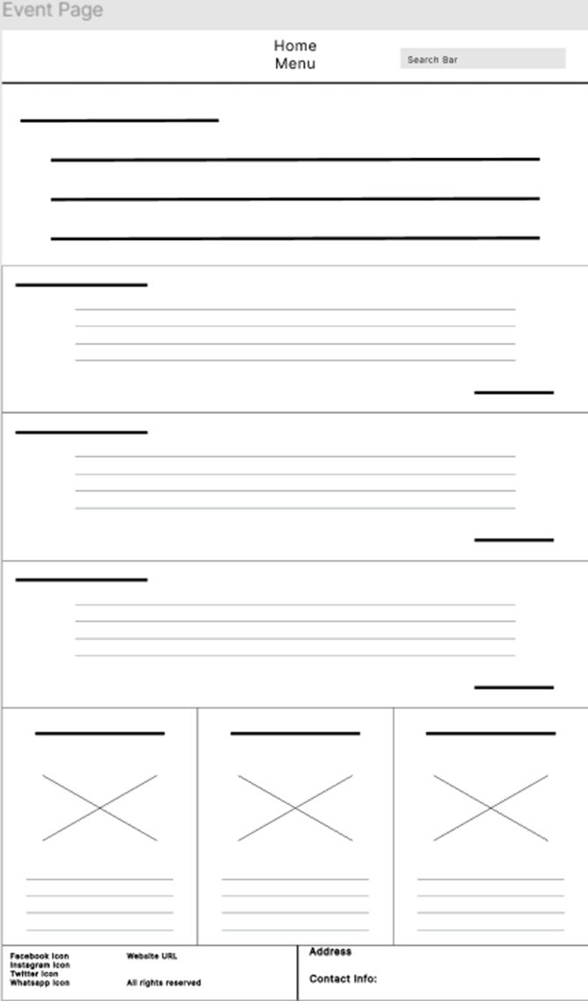

7th page