**MCT/MCTE 4323 MACHINE VISION: QUIZ 2 (20 marks)**

**Name:**

**SID:**

Pupillometry is the study of the pupil diameter. It is used in psychology and medicine. A pupil can be well approximated with a circle. Moreover, its darker colour with respect to the iris gives a very strong edge response. As a machine vision programmer, you are required to develop an algorithm which will load an image and detect any number of (relevant) circles in it.

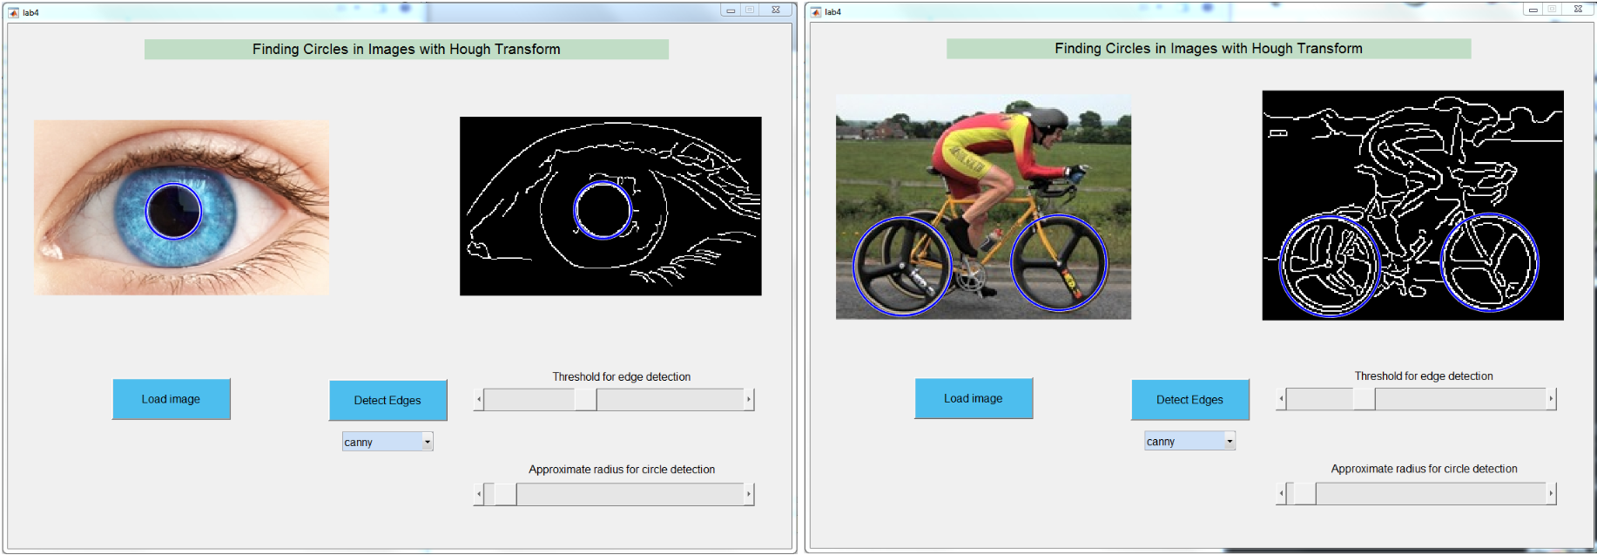

*Figure 1: Using circular hough transform to detect (a) left: eye pupil and (b) right: bike’s wheels.*

Concretely, your task is to perform circular hough transform so that you can detect and localize the significant circle in an image (e.g. pupil in Figure 1(a) and wheels in Figure 1(b)).

1. Using any image on the internet containing eye pupil, write a MATLAB/ Python script that reads the image, **binarizes** it, converts it into an **edge map** and then performs the **circular hough transform** to detect the eye pupil. **(10 marks)**
2. Write a comment at each important code line to describe the operation. Make a flowchart to discuss the flow of the algorithm. **(5 marks)**
3. Make a Graphical User Interface (GUI) that will load an image and detect any number of circles in it (bonus marks for designing a slider where you can change the relevant parameters in real-time). Your GUI should look similar to the one shown in Figure 1. **(5 marks)**