SE- LAB2
PROJECT TITLE: GROUP TRAVEL EXPENSE SIMPLIFICATION ENGINE
NAME: AHIDWISH JAVALI SRN: PES1UG24CS037
EPICS:
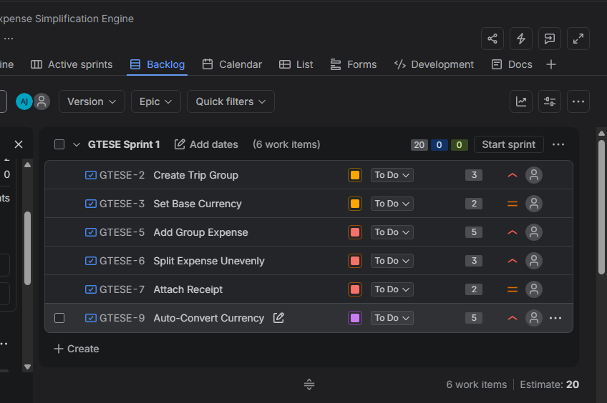
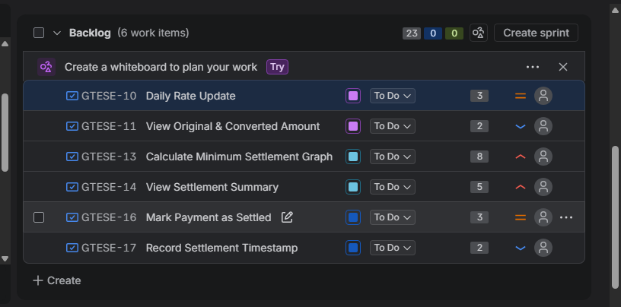
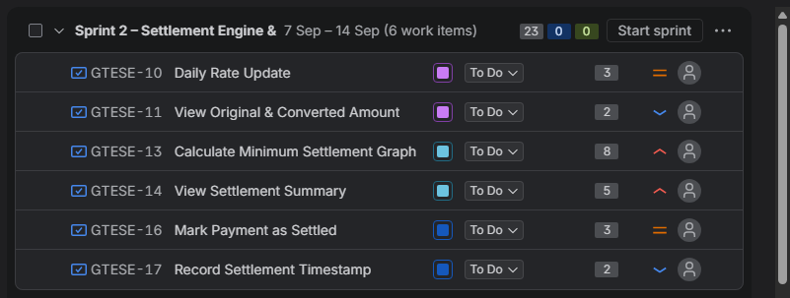

PROGRESS SPRINT1:
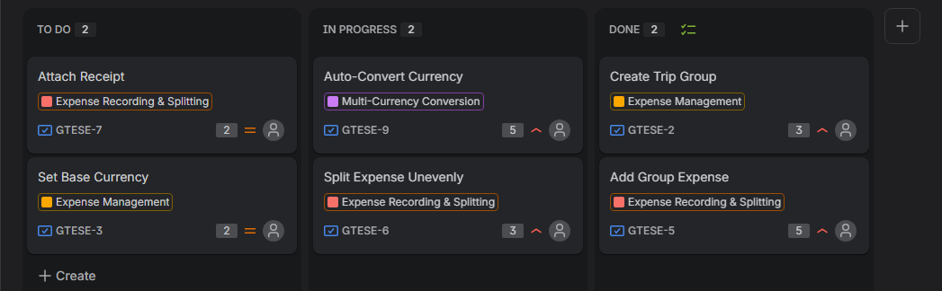
PROGRESS SPRINT 2:
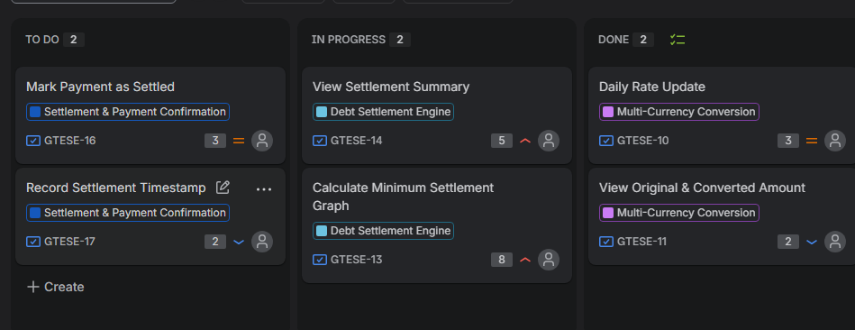

BURNDOWN CHARTS:
SPRINT 1:
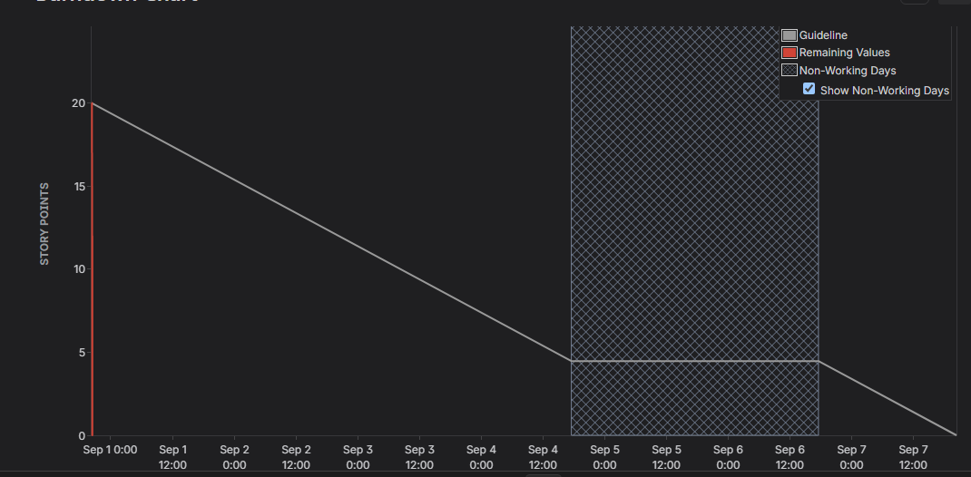
SPRINT 2:
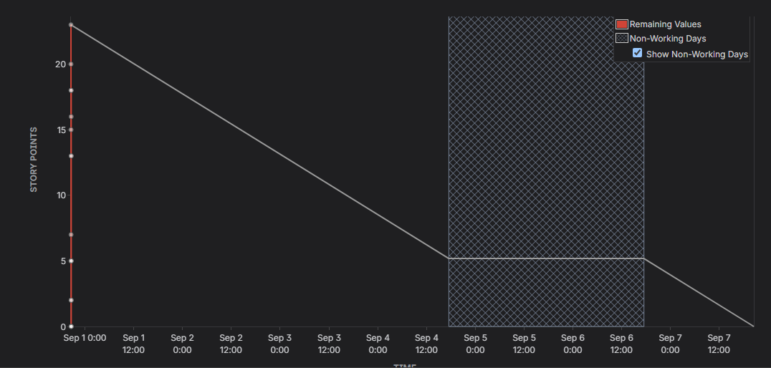
1. Did your estimations reflect the actual effort?
Yes. The Story Points generally matched the complexity of the stories. Smaller tasks were given 2 to 3 points, while complex tasks such as the settlement graph were given 8 points.
2. Was your backlog well prioritized?
Yes. High priority core features such as expense recording, currency conversion, and settlement calculation were prioritized before lower priority supporting features.
3. How did your simulated sprint align with your plan?
The simulation followed the planned allocation. Sprint 1 had 20 Story Points and Sprint 2 had 23 Story Points. Both sprints were completed successfully as planned.
4. What insights did the burndown chart give about your team's capacity?
The chart showed the remaining work decreasing from 23 to 0 Story Points. It showed that the team was able to complete the planned workload, although progress was not perfectly uniform because stories had different complexities.

