27 January 2026
14:13

• to compare the diffraction pattern to theory,
• to calibrate the Ronchi ruling (slit spacing and slit width),
• and to establish a quantitative baseline for later spatial filtering.

Complete Frauendorfer Diffraction and Spatial Filtering, Get Data

Removing the Variable Diffraction with the Ronchi Ruling. Following the Fraunhofer Diffraction procedure on the Lab script on Pg 39.

Lowered the Exposure of the Real Camera to 43000
Gamma to 1
and Gain to 18

Focused on the Zero Lettering on the Ronchi Ruling, despite turning the dial on the Condensor Lense, the focus seems to be changing.

For fine focusing, we are trying to focus on the blemishes, some chipped off metal on the lettering.

Our fourier Image was centro symmetrical hence that verified our Square Elements

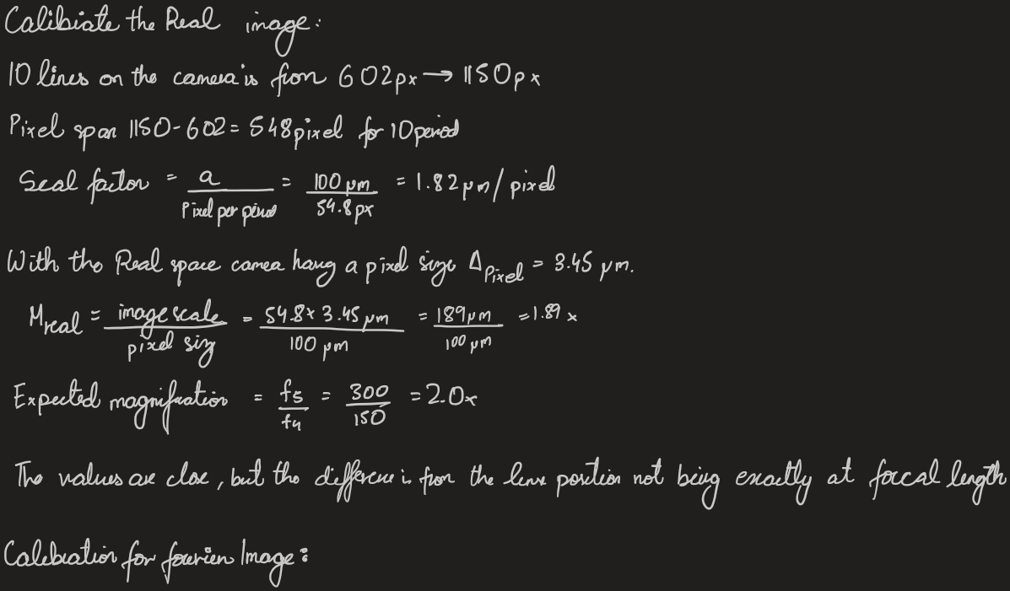

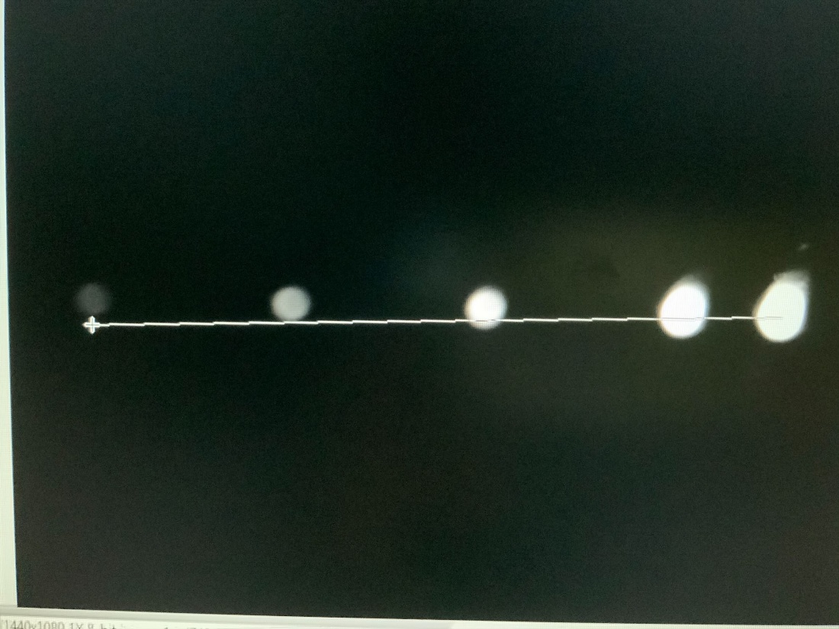

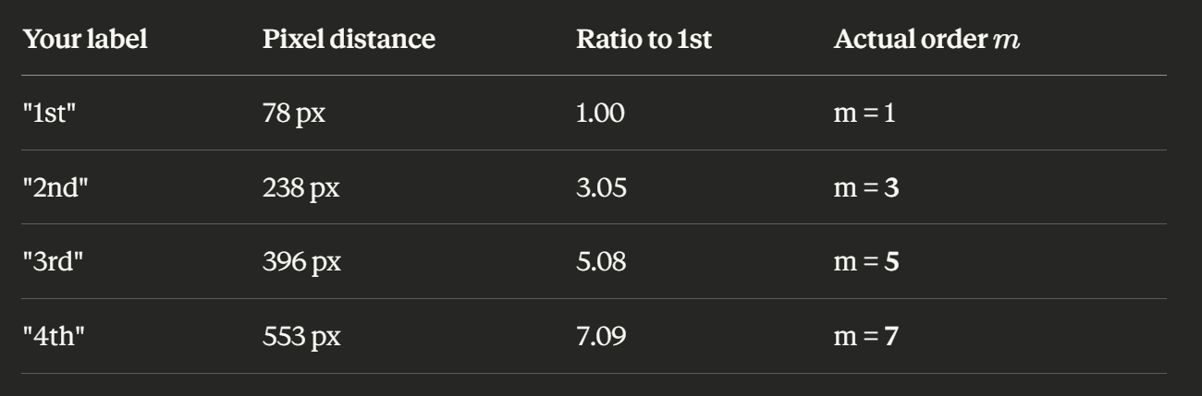

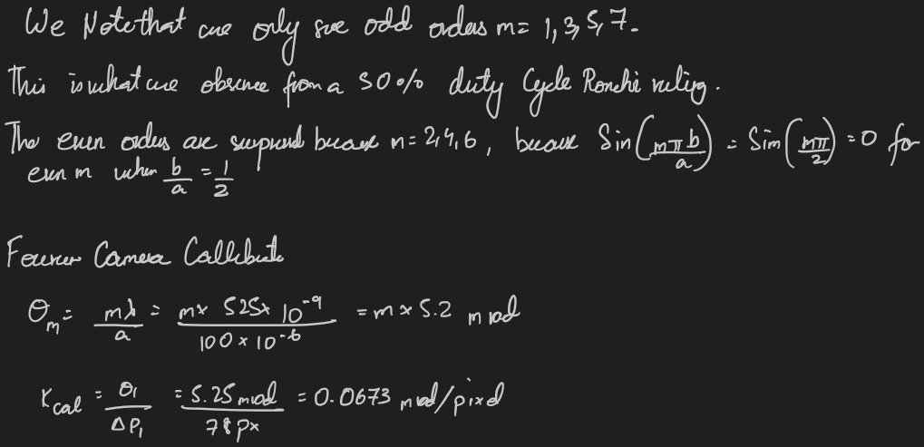

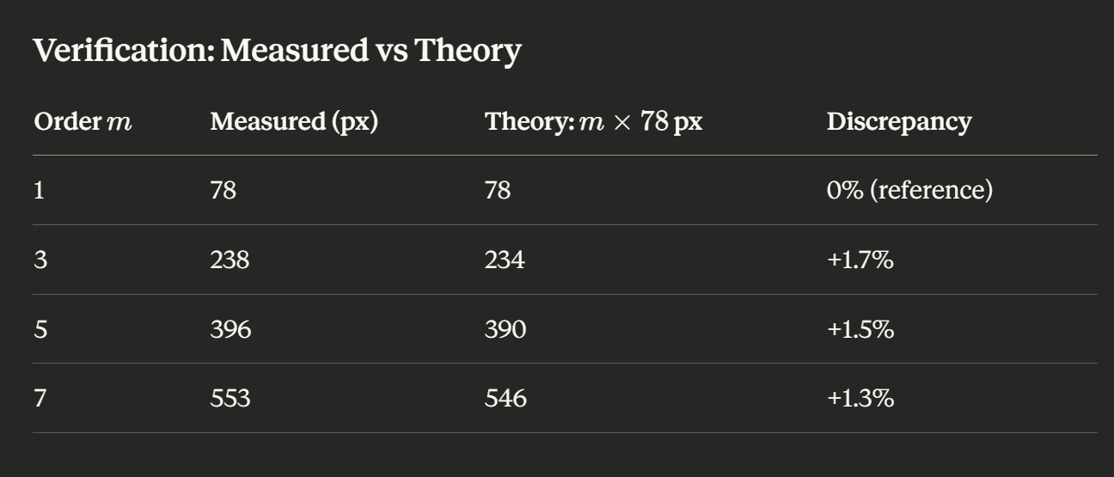

Excellent linearity! The small systematic offset (~1.5%) could be due to:
- Slight deviation from small-angle approximation at higher orders
- Minor lens aberrations
- Grating period slightly different from nominal 100 μm

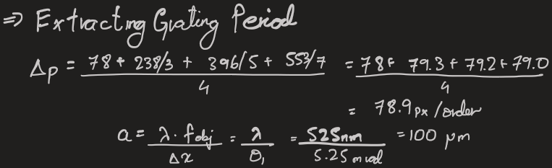

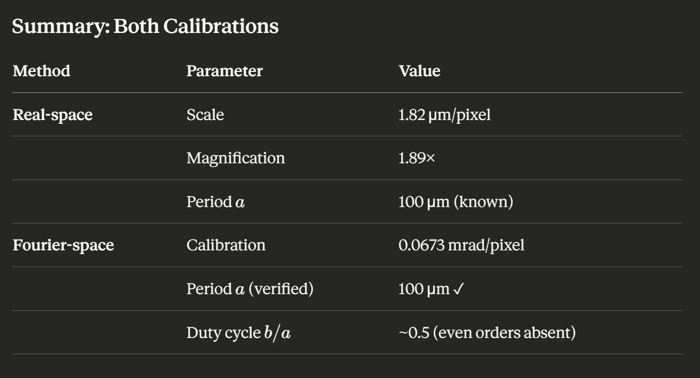

2:57 PM

Spatial Filtering

Doing the prcudure as stated as on Pg 41

Verified the fourier Patters are symmtrical and well focused

The focus and shapness is lost. The peaks on the line profile get lost .

Saved as file: Defualt and blocked-ve1to1

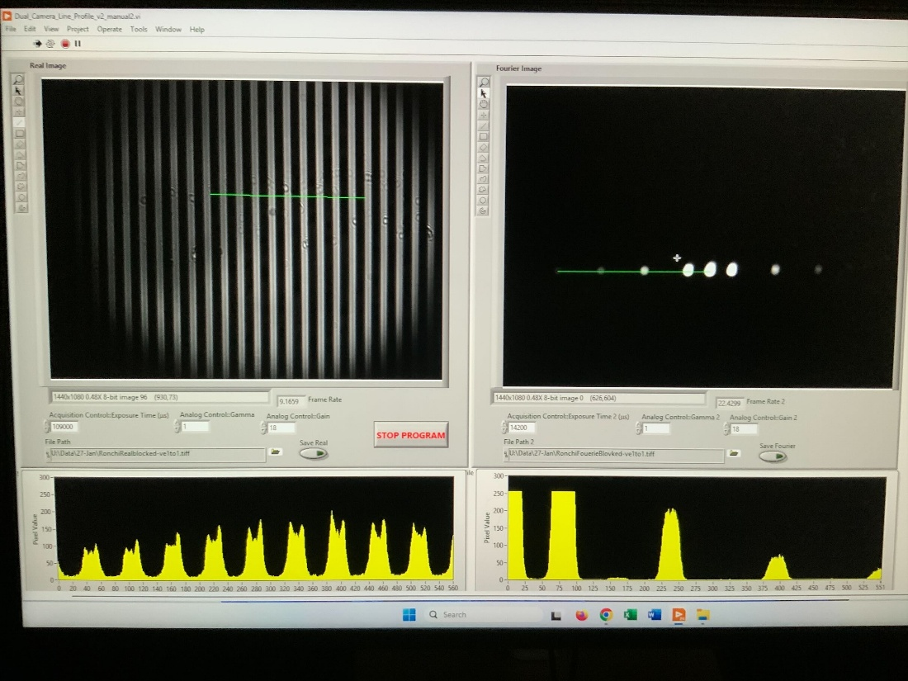

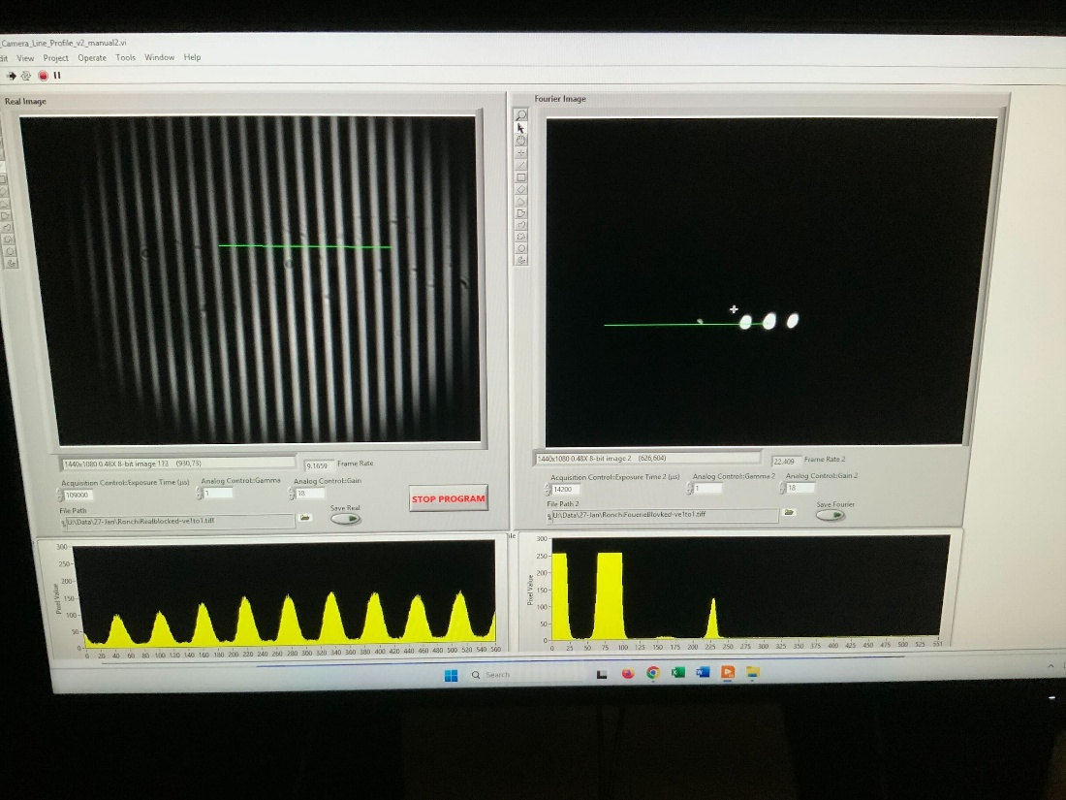

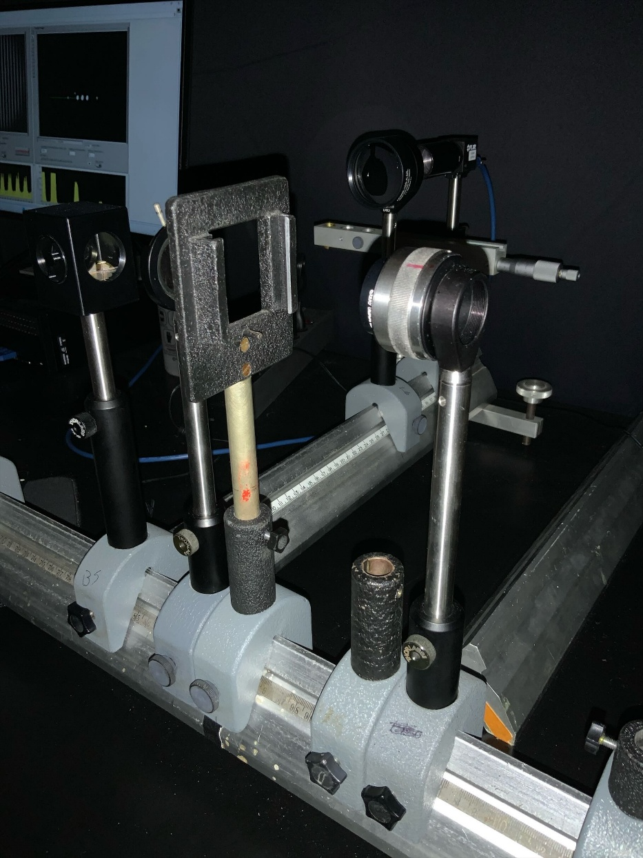

At the Fourier Plane, afte tht econdesnor lense, before the Beam Splitter. We placed a post, on this post we are making masks to block different diffraction patterns.

TIP: We are using an hellend screw with a translatioal stage. This works very very well!

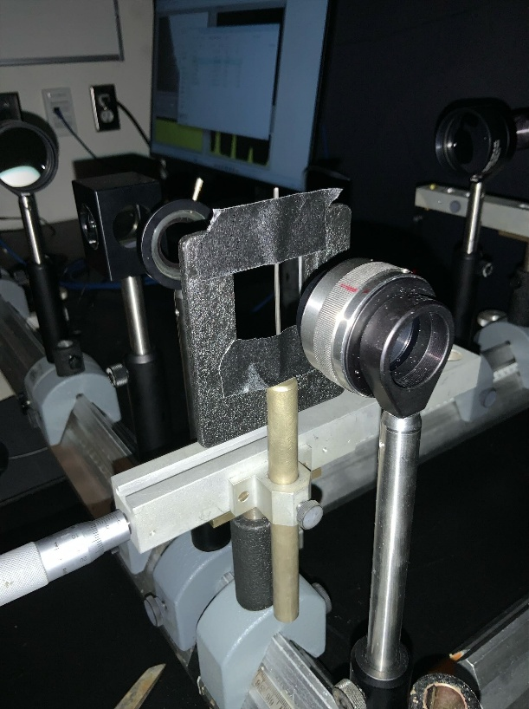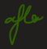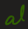

(a) All orders (reference case)
Saved Images as "RonchiReal-A.tiff"
"RonchiFourier-A.tiff"
Default image. Looks bright and the real image is all well illuminated

We accidenlty increased the Irirs so new images as

Saved Images as "RonchiReal-A2.tiff"
"RonchiFourier-A2.tiff"

(b) Zero order only;
Intensity Reduced

Saved Images as "RonchiReal-B.tiff"
"RonchiFourier-B.tiff"

(c) +1 only;
(d) 0, +1 (Abbe minimal criterion);

We have moved it forwards, to make the mask larger and slided it on the trnaslatinal stage.

Saved Images as "RonchiReal-D.tiff"
"RonchiFourier-D.tiff"

More noticeable lines in between each solid white line
(e) +1, 0,−1;

Were make this new mask by using a largen Allen Key. And Taping that on the Stage.
The intensity is further reducted.

(f) +1,−1;

Uisng the thinnst Allen key and a similar size Screw driver.
Saved Images as "RonchiReal-F.tiff"
"RonchiFourier-F.tiff"

(g) +2, 0,−2 and also +2,−2 (note: for a perfect square wave, even harmonics such as ±2 would
be suppressed);
(h) All positive orders (oblique dark field);
(i) All positive orders and the zero order (half shadow);
(j) All orders except zero (dark-field / dark-ground method);

Uisng a Slit Mask, just blocked the Centeral Maximum
Saved Images as "RonchiReal-F.tiff"
"RonchiFourier-F.tiff"

Just a uniform dark screen on the Real image.
(k) −mmax, . . . ,−1, 0, +1, . . . ,+mmax (low-pass filtering; choose at least two values of mmax in

addtiton to 1 e.g. 1, 3, 5);

Doing outer Filtering, from -2 to + 2.

And

Saved Images as "RonchiReal-K2.tiff"
"RonchiFourier-K2.tiff"

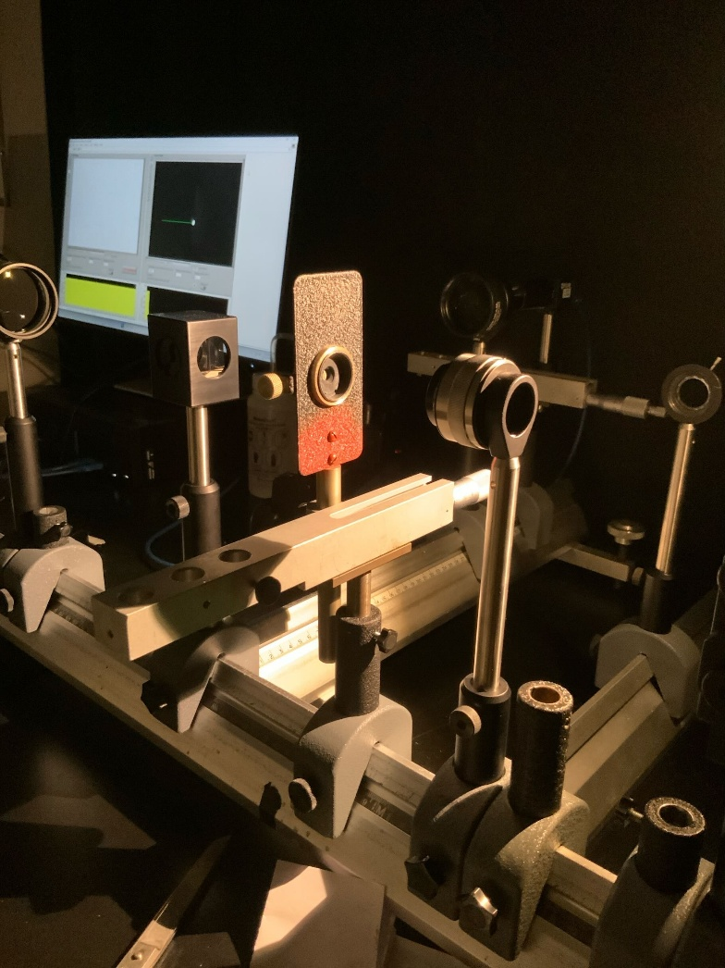

Doing B2.

Following procedure in B2

Page 43.

