Assignment No: 05
Name: RUTUJA TIKHOLE
PRN: 22310034
Roll NO: 381004

Problem Statement:
Build and expose REST APIs using FastAPI and containerize using Docker.

Theory:
1. Introduction
Machine learning models or business logic often need to be exposed as REST APIs so they can be consumed by applications, dashboards, or external services. Manually serving models or scripts is inefficient and does not scale. FastAPI is a modern Python web framework that allows developers to build high-performance REST APIs quickly, while Docker enables packaging these APIs into portable containers for consistent deployment across environments.
Together, FastAPI and Docker provide a powerful combination for deploying ML models or microservices in a reliable, scalable, and reproducible way.

2. FastAPI
FastAPI is a Python web framework designed for building APIs quickly and efficiently. It is based on Python type hints and provides automatic validation and documentation. Key features include:
- High Performance – Built on Starlette and Pydantic, it is one of the fastest Python frameworks.
- Automatic Documentation – Generates Swagger and ReDoc UI for testing APIs.
- Data Validation – Uses Python type hints and Pydantic models to validate input/output.
- Asynchronous Support – Natively supports async I/O for scalable applications.
- Ease of Use – Minimal code to define endpoints and serve ML models or business logic.

3. Docker
Docker is a platform for building, shipping, and running applications inside lightweight, portable containers. It ensures that the application runs the same way across development, testing, and production environments. Key features include:
- Containerization – Package APIs, dependencies, and environment into a single container.
- Portability – Run containers on any system with Docker installed.
- Scalability – Deploy multiple containers using orchestration tools (e.g., Kubernetes).
- Version Control – Create and manage container images with version tags.
- Isolation – Each container runs independently, ensuring security and stability.

4. Importance of FastAPI and Docker for API Deployment
- Reproducibility – APIs run consistently across environments.
- Scalability – Containers can be scaled horizontally to handle more traffic.
- Efficiency – FastAPI provides low-latency APIs, while Docker reduces setup overhead.
- Collaboration – Teams can share Docker images, ensuring consistent environments.
- Integration – APIs can be easily integrated with frontend apps, mobile apps, or other microservices.

5. Workflow for Building and Containerizing APIs
- Develop API with FastAPI
  - Define endpoints (e.g., /predict) to serve model predictions or logic.
  - Use Pydantic models for input validation and automatic docs.
- Test Locally
  - Run with uvicorn main:app --reload and test endpoints via Swagger UI.
- Create Dockerfile
  - Define a Dockerfile with Python base image, dependencies, and FastAPI app startup command.
- Build Docker Image
  - Run docker build -t fastapi-app . to create the container image.
- Run Docker Container
  - Execute docker run -p 8000:8000 fastapi-app to serve the API in a container.
- Deploy
  - Push the container to Docker Hub or a registry and deploy to cloud or orchestration platforms (AWS, GCP, Kubernetes).

6. Key Differences Between FastAPI and Docker
Aspect | FastAPI | Docker
Purpose | Framework for building REST APIs | Platform for packaging and deploying apps
Functionality | Defines endpoints, handles requests | Encapsulates app + dependencies in container
Usage in ML | Serve model predictions as REST APIs | Ensure consistent deployment environment
Deployment Role | Application-level | Environment & infrastructure-level
Best Use Case | Building and exposing APIs | Packaging APIs for scalable deployments

Execution:
Code:
!pip install fastapi uvicorn nest-asyncio pyngrok
import nest_asyncio
from fastapi import FastAPI
from pyngrok import ngrok
nest_asyncio.apply() # Needed to run FastAPI in Colab
app = FastAPI(title="FastAPI Colab Demo")
items = []
@app.get("/")
def read_root():
return {"message": "Welcome to FastAPI in Colab!"}
@app.get("/items")
def get_items():
return {"items": items}
@app.post("/items")
def create_item(name: str):
item = {"id": len(items) + 1, "name": name}
items.append(item)
return item
@app.get("/items/{item_id}")
def get_item(item_id: int):
for item in items:
if item["id"] == item_id:
return item
return {"error": "Item not found"}
# ============================================
# STEP 1: Install dependencies
# ============================================
!pip install fastapi uvicorn nest-asyncio pyngrok requests
# ============================================
# STEP 2: Import modules & prepare async loop
# ============================================
import nest_asyncio
from fastapi import FastAPI
from pyngrok import ngrok
import uvicorn
import requests
nest_asyncio.apply()
# STEP 3: Create FastAPI app
from fastapi import FastAPI
app = FastAPI(title="FastAPI Colab Demo")
items = []
@app.get("/")
def read_root():
return {"message": "Welcome to FastAPI in Colab!"}

@app.get("/items")
def get_items():
return {"items": items}
@app.post("/items")
def create_item(name: str):
item = {"id": len(items) + 1, "name": name}
items.append(item)
return item
@app.get("/items/{item_id}")
def get_item(item_id: int):
for item in items:
if item["id"] == item_id:
return item
return {"error": "Item not found"}
# ============================================
# STEP 4: Connect ngrok & run FastAPI in background
# ============================================
NGROK_AUTH_TOKEN = "32m1UEjtf03EFS0wdgKqDAHqVEV_2rPS9NqbE8y4ZjkF8gq3A"
ngrok.set_auth_token(NGROK_AUTH_TOKEN)
# Create ngrok tunnel
public_url = ngrok.connect(8000)
BASE_URL = public_url.public_url # <-- Correct way
print(f"🚀 Public URL (Swagger UI): {BASE_URL}/docs")
# Run uvicorn in background thread
def run_app():
uvicorn.run(app, host="0.0.0.0", port=8000)
thread = threading.Thread(target=run_app, daemon=True)
thread.start()
# ============================================
# STEP 5: Programmatically test endpoints
# ============================================
# Test GET /
print("GET /:", requests.get(f"{BASE_URL}/").json())

# Test GET /items (empty at first)
print("GET /items:", requests.get(f"{BASE_URL}/items").json())
# Test POST /items
resp = requests.post(f"{BASE_URL}/items", params={"name": "Apple"})
print("POST /items:", resp.json())
# Test GET /items again
print("GET /items:", requests.get(f"{BASE_URL}/items").json())
# Test GET /items/1
print("GET /items/1:", requests.get(f"{BASE_URL}/items/1").json())
# ============================================
# STEP 6: Generate multiple test items
# ============================================
for i in range(5):
data = {"name": f"Item {i+2}"}
response = requests.post(f"{BASE_URL}/items", params=data)
print("Added:", response.json())
print("\nAll items:", requests.get(f"{BASE_URL}/items").json())
# ============================================
# STEP 7: Create Dockerfile (simulation)
# ============================================
dockerfile_content = """
FROM python:3.12-slim
WORKDIR /app
COPY requirements.txt .
RUN pip install --no-cache-dir -r requirements.txt
COPY . .
EXPOSE 8000
CMD ["uvicorn", "main:app", "--host", "0.0.0.0", "--port", "8000"]
"""
with open("Dockerfile", "w") as f:
f.write(dockerfile_content)
print("✅ Dockerfile created!")
# ============================================
# STEP 8: Create requirements.txt
# ============================================
with open("requirements.txt", "w") as f:
f.write("fastapi\nuvicorn\n")
print("✅ requirements.txt created!")
import time
import requests
# Use the ngrok public URL printed earlier
BASE_URL = "https://30f4833f88c9.ngrok-free.app" # Example: "http://1234abcd.ngrok.io"
# Add a small delay to allow the server to start
time.sleep(2)
response = requests.get(f"{BASE_URL}/")
print("GET / response:", response.json())
response = requests.get(f"{BASE_URL}/items")
print("GET /items response:", response.json())
data = {"name": "Sample Item"}
response = requests.post(f"{BASE_URL}/items", params=data)
print("POST /items response:", response.json()
for item in all_items['items']:
item_id = item['id']
response = requests.get(f"{BASE_URL}/items/{item_id}")
print(f"Item {item_id} details:", response.json()

Output:
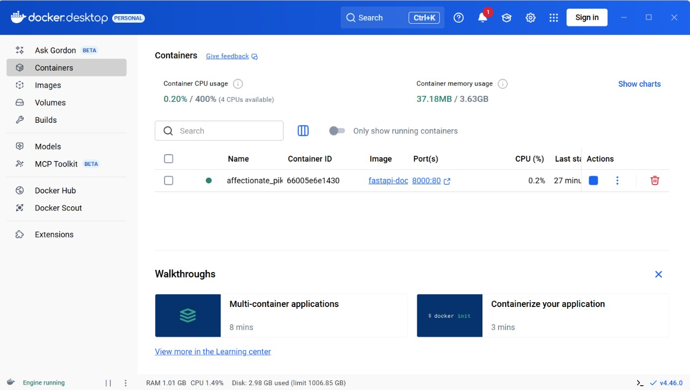
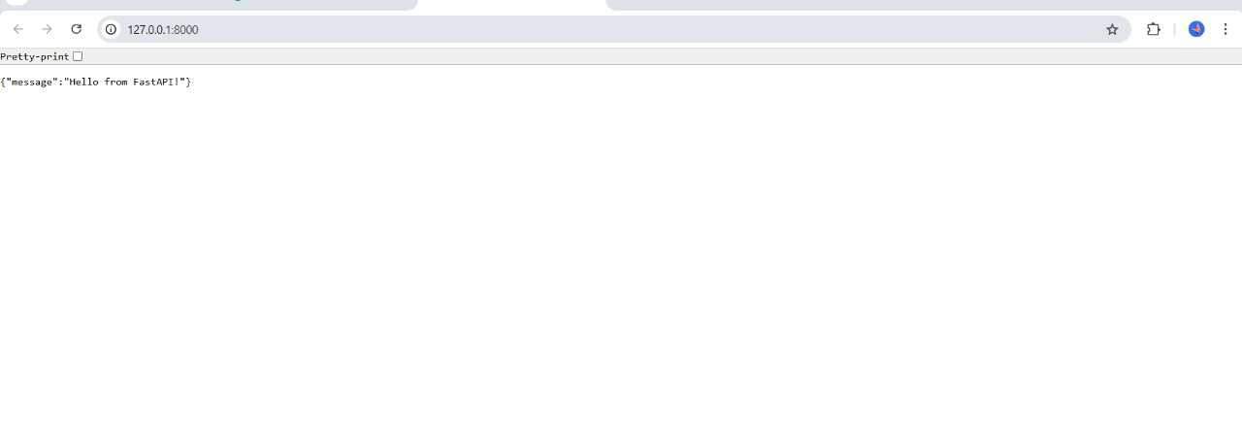
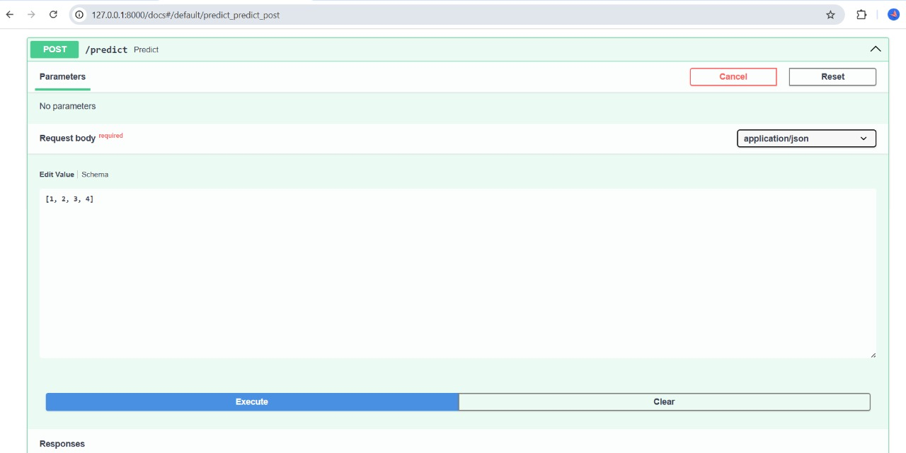
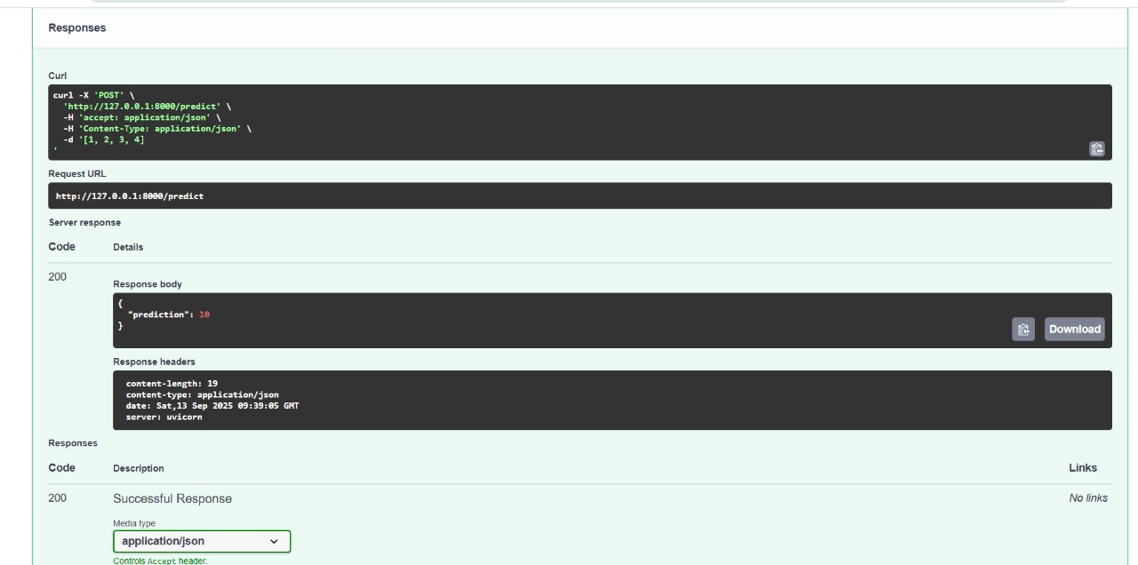

Conclusion:
Building REST APIs is a crucial step in operationalizing machine learning models or exposing business logic. FastAPI simplifies API development by providing high performance, automatic documentation, and input validation with minimal effort. Docker complements this by containerizing the API, ensuring consistent deployment across environments and enabling scalability.
By combining FastAPI and Docker, teams can develop, test, and deploy APIs efficiently—whether on local machines, cloud platforms, or large-scale orchestration systems. This approach ensures that APIs are reproducible, portable, and production-ready, ultimately accelerating the deployment of machine learning and data-driven applications.

