Assignment No:- 01

Name: RUTUJA TIKHOLE
PRN: 22310034
Roll NO: 381004

Problem Statement:
Implement dataset versioning using DVC

Theory:
1. Introduction
In modern machine learning projects, datasets are continuously updated and modified. Managing multiple versions of datasets is crucial to ensure reproducibility, traceability, and efficient collaboration among team members. Traditional version control systems like Git are not optimized for large datasets or binary files. This is where DVC (Data Version Control) becomes essential.
2. What is DVC?
DVC (Data Version Control) is an open-source version control system designed specifically for machine learning projects. It extends Git functionalities to manage large datasets, machine learning models, and experiment pipelines efficiently. DVC allows tracking of dataset versions without storing the full data in Git, keeping repositories lightweight and organized.
3. Working of DVC
- Initialization: dvc init creates configuration files to manage datasets.
- Add Dataset: dvc add <dataset> tracks datasets and generates .dvc metadata files.
- Push to Remote: dvc push uploads datasets to remote storage.
- Track Changes: Updates .dvc files when datasets change.
- Retrieve Versions: Use Git checkout + dvc pull to restore previous dataset versions
4. Benefits of Dataset Versioning with DVC
- Efficiency: No need to store large datasets in Git.
- Reproducibility: Enables consistent experiment results with exact dataset versions.
- Traceability: Every dataset change is tracked, making it easy to audit and manage.
- Collaboration: Team members can share datasets and code seamlessly.
- Integration with ML Pipelines: DVC integrates well with machine learning workflows, enabling end-to-end reproducible ML pipelines.

Executions:
Code:
# 1. Setup project
cd "C:\Users\hp\Desktop\Mlops assignment"
git init my-project
cd my-project
# Create Python virtual environment
python -m venv .venv
.venv\Scripts\activate # activate venv (Windows PowerShell)
# Install DVC
pip install dvc
# 2. Initialize DVC
dvc init
git add .dvc .dvcignore
git commit -m "init repo + dvc"
# 3. Add dataset
# Make data/raw folder
mkdir data\raw
copy "C:\Users\hp\Desktop\City_Growth_Stats.csv" data\raw\

# Track dataset with DVC
dvc add data/raw/City_Growth_Stats.csv
git add data/raw/City_Growth_Stats.csv.dvc .gitignore
git commit -m "add City_Growth_Stats dataset"
# 4. Add local remote (safe for assignment)
mkdir C:\Users\hp\Desktop\dvc_remote
dvc remote add -d localremote C:/Users/hp/Desktop/dvc_remote
git add .dvc/config
git commit -m "add local dvc remote"
# 5. Push dataset to remote
dvc push
# 6. (Optional) Create a pipeline stage
# Example preprocessing stage with your dataset
dvc stage add -n preprocess `
-d src/preprocess.py -d data/raw/City_Growth_Stats.csv `
-o data/processed/processed.csv `
python src/preprocess.py data/raw/City_Growth_Stats.csv data/processed/processed.csv
git add dvc.yaml dvc.lock
git commit -m "add preprocess stage for City_Growth_Stats.csv"
output
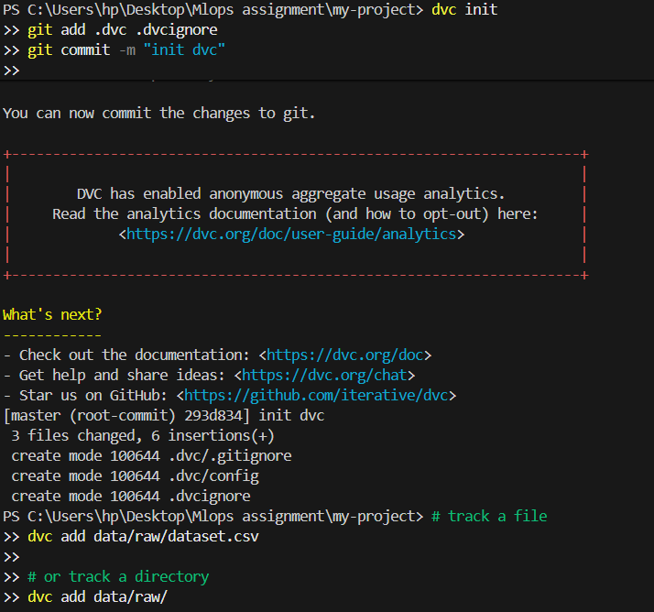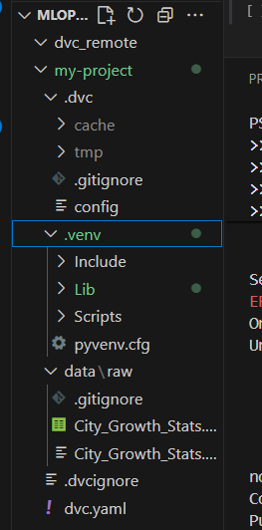
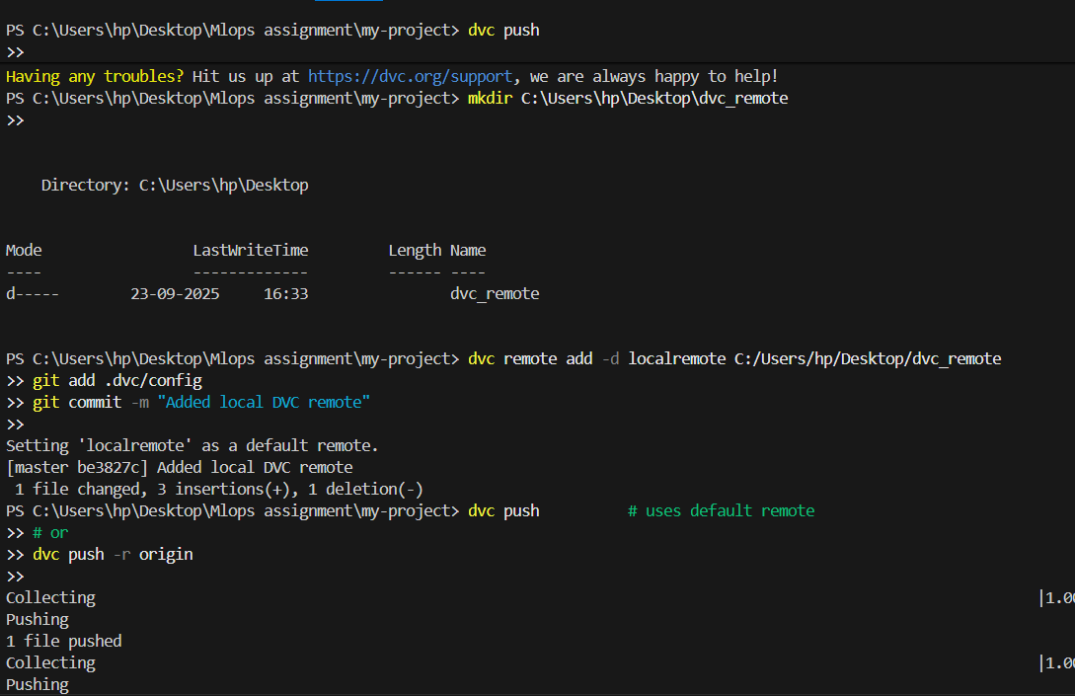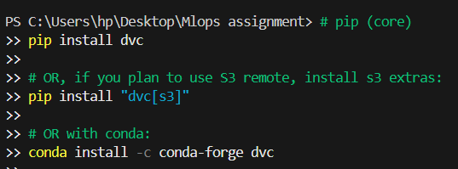

Conclusion:
Dataset versioning using DVC is a fundamental practice in modern machine learning projects. It ensures efficient management of datasets, reproducible experiments, and smooth collaboration. Using DVC, teams can maintain versioned datasets without overloading Git repositories, track changes, and integrate dataset management with model training pipelines.

