Assignment No: 03
Name: RUTUJA TIKHOLE
PRN: 22310034
Roll NO: 381004

Problem Statement:
Register and manage trained models using MLflow Model Registry or AWS SageMaker.

Theory:
1. Introduction
In machine learning projects, building a model is only the first step. Once trained, models must be versioned, tracked, and deployed reliably. Managing models manually—using file storage or ad-hoc versioning—can lead to errors, poor reproducibility, and difficulty in promoting models to production. Model registries solve this problem by providing a centralized system to register, store, compare, and deploy trained models.
Two widely adopted model registry tools are:
- MLflow Model Registry (open-source, self-hosted, flexible)
- AWS SageMaker Model Registry (cloud-native, fully managed, enterprise-ready)
Both platforms help teams govern the model lifecycle, ensure reproducibility, and streamline deployment into production environments.

2. MLflow Model Registry
MLflow is an open-source platform that supports the entire ML lifecycle, and its Model Registry provides features for:
- Model Registration – Register trained models from MLflow runs with a unique name.
- Version Control – Each new model is automatically assigned a version.
- Stage Transitions – Promote models across Staging, Production, or Archived stages.
- Annotations – Add descriptions, metadata, and comments for collaboration.
- Deployment – Serve models via MLflow’s REST API, MLflow Serving, or integration with external platforms.

3. AWS SageMaker Model Registry
Amazon SageMaker provides a fully managed Model Registry that integrates deeply with the AWS ecosystem. Key features include:
- Centralized Model Storage – Store model artifacts in S3 and register them in the Model Registry.
- Versioning – Automatically create and track model package versions.
- Approval Workflow – Manage lifecycle stages with statuses such as Pending Approval, Approved, and Rejected.
- Integration with CI/CD – Automate deployment pipelines using SageMaker Projects, CodePipeline, and CodeBuild.
- Deployment – Deploy models directly to real-time endpoints or batch transform jobs.

4. Importance of Model Registry
- Reproducibility – Ensures models are retrained, stored, and deployed consistently.
- Organization – Centralizes all model versions, metadata, and approval statuses.
- Governance – Tracks lineage, ownership, and stage transitions for auditability.
- Collaboration – Enables teams to share models and manage promotions between environments.
- Deployment Readiness – Simplifies integration with production systems and CI/CD pipelines.

5. Workflow of Model Registration and Management
- Train Model – Build and save trained models (MLflow or SageMaker).
- Register Model – Add the model to the registry with a name and description.
- Version Control – Each registered model gets a new version.
- Approval and Staging – Transition models across lifecycle stages (Staging, Production).
- Deployment – Use APIs (MLflow Serving) or endpoints (SageMaker) to deploy approved models.
- Monitoring and Updates – Track deployed model performance and register updated versions.

6. Key Differences Between MLflow and AWS SageMaker Model Registry
Feature | MLflow Model Registry | AWS SageMaker Model Registry
Hosting | Open-source, self-hosted | Fully managed on AWS cloud
Model Storage | Local / external storage | Amazon S3 (integrated)
Versioning | Yes, auto-versioned | Yes, with model package versions
Stage Transitions | Staging / Production / Archived | Pending / Approved / Rejected
Collaboration | Manual setup, integrations needed | Built-in with AWS IAM & service integrations
Deployment | MLflow Serving, REST API, 3rd party | Direct to SageMaker endpoints or batch jobs
Best Use Case | On-prem / hybrid teams | AWS-based enterprise ML workflows

Execution:
Code:
!pip install mlflow
!pip install pyngrok
import mlflow
import mlflow.sklearn
from pyngrok import ngrok
import mlflow
import mlflow.sklearn
import pandas as pd
import numpy as np
from sklearn.linear_model import LinearRegression
from sklearn.datasets import make_regression
from sklearn.model_selection import train_test_split
from sklearn.metrics import mean_squared_error
X, y = make_regression(n_samples=100, n_features=1, noise=10)
X_train, X_test, y_train, y_test = train_test_split(X, y)
import os
from pyngrok import ngrok

# Set up tracking URI and local directory
mlflow_tracking_uri = "file:///content/mlruns"
mlflow.set_tracking_uri(mlflow_tracking_uri)

# Start MLflow UI
get_ipython().system_raw("mlflow ui --port 5000 &")
ngrok.set_auth_token("30oDCENoR3P5GIwBFHyS870HAoQ_86gmfWCoyoNjXpoBSzvfr")
public_url = ngrok.connect(5000)
print("MLflow Tracking UI:", public_url)
mlflow.set_tracking_uri("https://0dce56f3b098.ngrok-free.app")
model_name = "LinearRegressionModel"

with mlflow.start_run():
model = LinearRegression()
model.fit(X_train, y_train)
preds = model.predict(X_test)
mse = mean_squared_error(y_test, preds)

mlflow.log_param("model_type", "LinearRegression")
mlflow.log_metric("mse", mse)

input_example = pd.DataFrame(X_test[:5])

# 🔥 Save and Register the model
mlflow.sklearn.log_model(
sk_model=model,
artifact_path="model",
registered_model_name=model_name, # This registers the model!
input_example=input_example
)

print(f"Model logged and registered as {model_name}")
!mlflow ui --port 5000 &
# Open the MLflow UI
public_url = ngrok.connect(5000)
print("MLflow UI:", public_url)

Output:

- Start MLflow Tracking Server

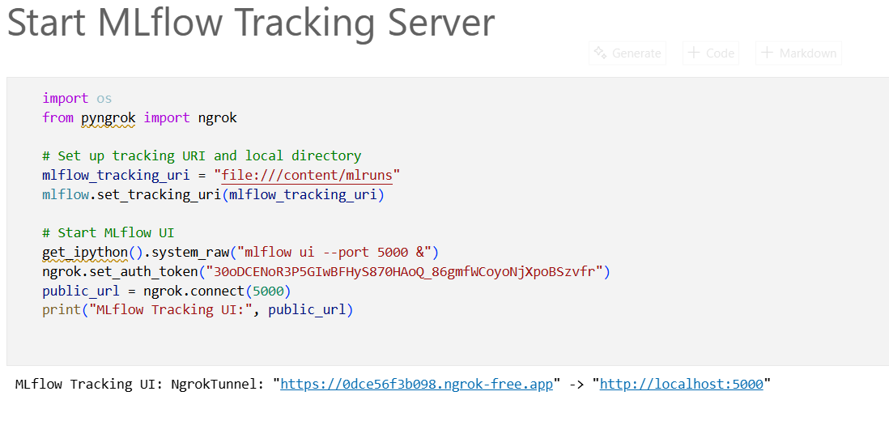
- Train Model and Log to MLflow (with Registered Name)

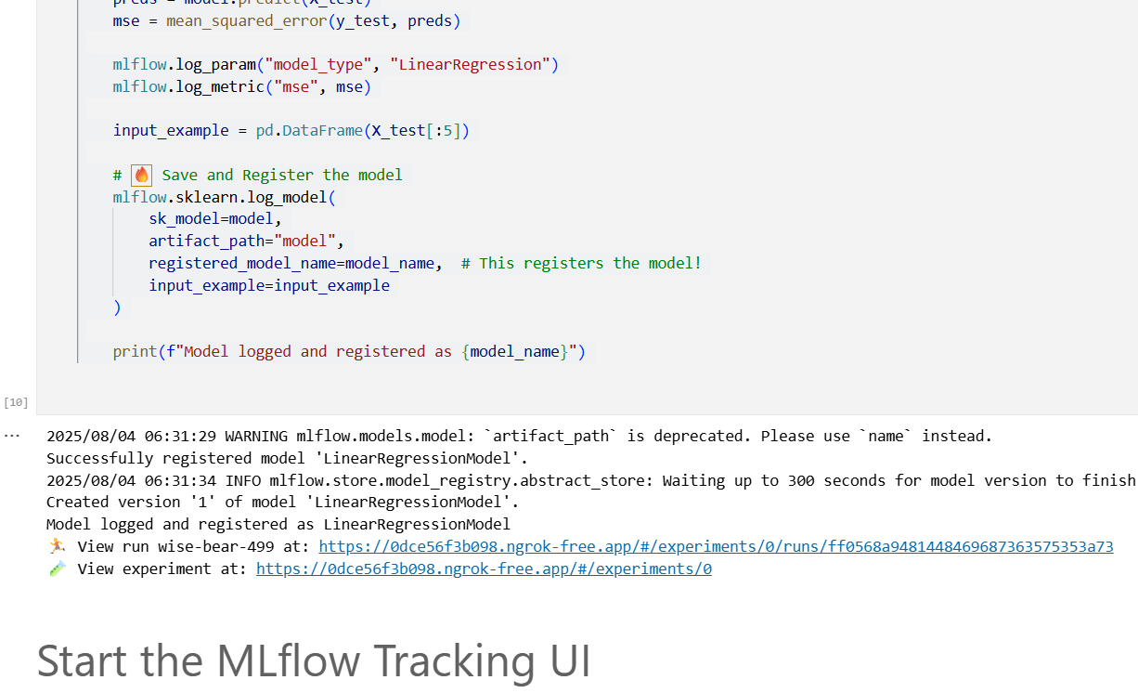

Conclusion:
Effective model management is essential to move machine learning projects from experimentation to production. MLflow Model Registry offers flexibility and open-source extensibility, making it well-suited for diverse environments and hybrid deployments. In contrast, AWS SageMaker Model Registry provides a fully managed, enterprise-grade solution tightly integrated with the AWS ecosystem.
By adopting either of these registries, teams can ensure reproducibility, streamline deployments, and establish governance over the entire ML lifecycle—ultimately making machine learning workflows more reliable, scalable, and collaborative.

