Assignment No: 02
Name: RUTUJA TIKHOLE
PRN: 22310034
Roll NO: 381004

Problem Statement:
Track experiments using MLflow or Weights & Biases.

Theory:
1. Introduction
In machine learning projects, multiple experiments are conducted to improve model performance by changing algorithms, hyperparameters, datasets, or feature engineering techniques. Managing and comparing these experiments manually is difficult and error-prone. Experiment tracking tools help systematically record, organize, and compare experiments, making ML workflows reproducible and collaborative.
Two popular experiment tracking tools are:
- MLflow (open-source, self-hosted)
- Weights & Biases (W&B) (cloud-based, collaborative)

2. MLflow
MLflow is an open-source platform for managing the machine learning lifecycle. It provides tools for:
- Tracking Experiments: Log parameters, metrics, artifacts (models, plots, data).
- Projects: Package code in a reproducible way.
- Models: Store and serve trained models easily.
- Model Registry: Manage model versions and deployment.

3. Weights & Biases (W&B) – Overview
Weights & Biases (W&B) is a cloud-based platform for experiment tracking, model management, and team collaboration. It provides:
- Automatic Logging: Tracks metrics, hyperparameters, system stats (CPU/GPU).
- Visualization: Real-time graphs and comparison dashboards.
- Collaboration: Share experiments and results easily with team members.
- Integration: Supports almost all ML frameworks like TensorFlow, PyTorch, Scikit-learn.

4. Importance of Experiment Tracking
- Reproducibility: Ensures that experiments can be rerun with the same parameters and dataset versions.
- Organization: Keeps all experiments, metrics, and models in one place.
- Comparison: Easily compare multiple runs to select the best model.
- Collaboration: Team members can share results and insights efficiently.
- Auditability: Provides a history of experiments for reporting or debugging.

5. Working of Experiment Tracking
- Initialize Tracking: Start a new experiment using mlflow.start_run() (MLflow) or wandb.init() (W&B).
- Log Parameters: Record hyperparameters like learning rate, batch size, number of estimators.
- Log Metrics: Record performance metrics like accuracy, loss, F1-score.
- Log Artifacts: Save models, plots, or data files for each run.
- Compare Runs: Use MLflow UI or W&B dashboard to analyze and select the best model.
- Reproduce Runs: Re-run experiments using the saved parameters and artifacts.

6. Key Differences Between MLflow and W&B
Feature | MLflow | W&B
Hosting | Local / self-hosted | Cloud-based
Dashboard / UI | Local web UI | Web dashboard (cloud)
Model Registry | Yes | Yes
Collaboration | Moderate (manual setup) | Very easy (cloud sharing)
Best Use Case | On-prem teams | Teams needing cloud dashboard and collaboration

Execution:
Code:
# 1. Install libraries
!pip install mlflow wandb scikit-learn pandas joblib --quiet
# 2. Import libraries
import pandas as pd
import numpy as np
from sklearn.model_selection import train_test_split
from sklearn.ensemble import RandomForestRegressor
from sklearn.metrics import mean_squared_error
import mlflow
import mlflow.sklearn
import joblib
import os
# 3. Create sample dataset
np.random.seed(42)
n_rows = 100 # 100 cities
data = {
"Pop_20_21": np.random.randint(1000, 5000, size=n_rows),
"HU_20_21": np.random.randint(500, 2000, size=n_rows),
"Job_20_21": np.random.randint(200, 1500, size=n_rows),
"Pop_21_22": np.random.randint(1000, 5000, size=n_rows), # target
"ObjectID": range(n_rows)
}
df = pd.DataFrame(data)
df.head()
# 4. Prepare features & target
TARGET = "Pop_21_22"
X = df.drop(columns=[TARGET, "ObjectID"])
y = df[TARGET]
X_train, X_test, y_train, y_test = train_test_split(X, y, test_size=0.2, random_state=42)
# 5. MLflow experiment
mlflow.sklearn.autolog() # autolog params, metrics, models
with mlflow.start_run(run_name="rf_city_growth_colab"):
model = RandomForestRegressor(n_estimators=100, random_state=42)
model.fit(X_train, y_train)
preds = model.predict(X_test)
# Calculate Mean Squared Error and then take the square root for RMSE
mse = mean_squared_error(y_test, preds
rmse = np.sqrt(mse)
print("MLflow RMSE:", rmse)
os.makedirs("models", exist_ok=True)
joblib.dump(model, "models/rf_model.joblib")
mlflow.log_artifact("models/rf_model.joblib")
# 6. W&B experiment
# Now you can proceed with the W&B experiment after logging in to W&B in the previous cell.
import wandb
run = wandb.init(project="city-growth-colab", config={
"n_estimators": 100,
"random_state": 42,
"dataset": "synthetic_city_growth"
})
config = run.config
model = RandomForestRegressor(n_estimators=config.n_estimators, random_state=config.random_state)
model.fit(X_train, y_train)
Output:
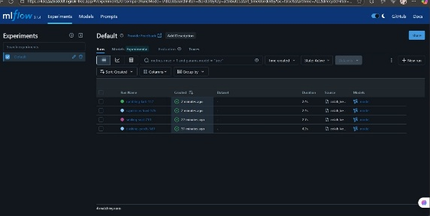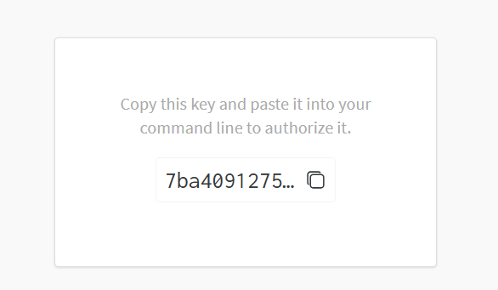
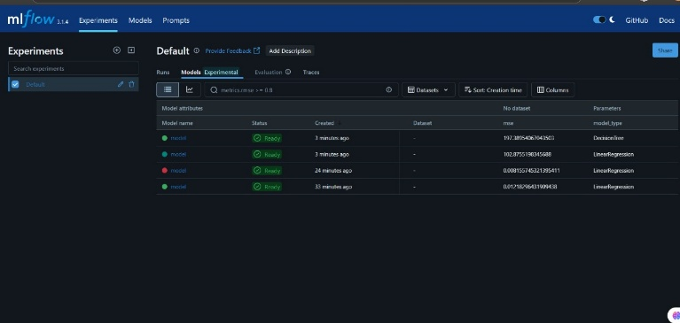

Conclusion:
Experiment tracking is an essential part of modern machine learning workflows. Using MLflow or W&B, practitioners can systematically log experiments, visualize results, reproduce models, and collaborate effectively. Choosing between MLflow and W&B depends on project needs: MLflow is ideal for self-hosted setups, while W&B excels in cloud collaboration and visualization.

