**Name: Arya Yemul**

**Roll No: 281015**

**Batch: A1**

**Assignment 4**

**Problem Statement:**

Apply appropriate ML algorithm on a dataset. Create confusion matrix based on the data

and find

a) Accuracy

b) Precision

c) Recall

d) F-1 score

**Objectives:**

1) To apply a supervised machine learning algorithm to predict customer response.

2) To analyze the dataset and preprocess the data for better model performance.

3) To evaluate model performance using a confusion matrix.

4) To compute key classification metrics (Accuracy, Precision, Recall, F1-score).

**Resources used:**

1) Software used: Visual Studio Code

2) Libraries used: Pandas, Matplotlib, Seaborn, SKLearn

**Theory:**

Classification is a supervised learning technique where the model learns to map input

features to predefined labels. The goal is to train a model that can accurately classify new

data points into one of the given categories. In this assignment, we focus on binary

classification (Customer will respond: Yes or No).

**Confusion Matrix:**

A confusion matrix is a performance measurement tool for classification models. It

consists of four components:

● True Positives (TP): Correctly predicted positive cases.

● True Negatives (TN): Correctly predicted negative cases.

● False Positives (FP): Incorrectly predicted positive cases (Type I Error).

● False Negatives (FN): Incorrectly predicted negative cases (Type II Error).

**Evaluation Metrics:**

● Accuracy: Measures the overall correctness of the model.

● Precision: Measures how many predicted positive cases were actually positive.

● Recall: Measures how many actual positive cases were correctly predicted.

● F1-Score: Harmonic mean of precision and recall, balancing both metrics.

**Methodology:**

1. Data Preprocessing

* Load the dataset using Pandas.
* Handle missing values (imputation or removal).
* Encode categorical variables (e.g., gender) using one-hot encoding.
* Normalize numerical features using MinMaxScaler or StandardScaler.
* Split the dataset into training and testing sets (e.g., 75% training, 25% testing).

2. Choosing the ML Algorithm & Training

* Choose an appropriate classification algorithm, such as Logistic Regression, Decision Tree, Random Forest, or SVM.
* Train the selected model using the training dataset.

3. Confusion Matrix & Performance Metrics Calculation

● Compute the confusion matrix (True Positives, True Negatives, False Positives,

False Negatives).

● Derive the following metrics from the confusion matrix:

a) Accuracy

b) Precision

c) Recall (Sensitivity)

d) F1-Score

**Results:**

* Accuracy: 1.00
* Precision: 1.00
* Recall: 1.00
* F1-Score: 1.00

Confusion Matrix:

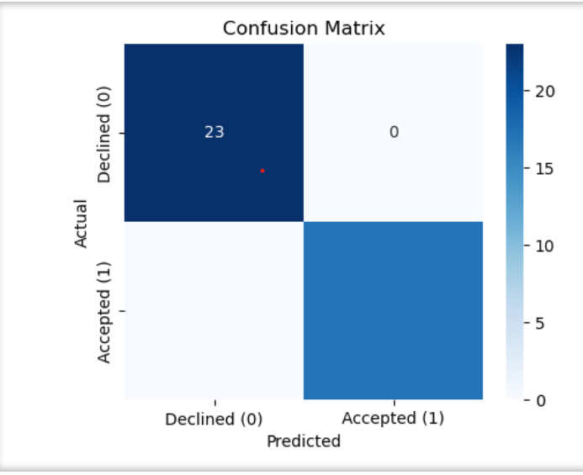

**Conclusion:**

● The chosen ML model was able to predict responses with reasonable accuracy.

● Based on the evaluation metrics, the model’s performance can be assessed for

further improvements.

● Feature engineering and hyperparameter tuning could further enhance the model's

effectiveness.