Name- Chinmay Ahire, RollNo-33503, Batch-T1, SeatNo-T109313402

Problem Statement:

Create a version control account using GitHub and using Git commands to create repository and push your code to GitHub.

Step 1:

Download Git for Windows link- [Git - Downloads (git-scm.com)](https://git-scm.com/downloads)

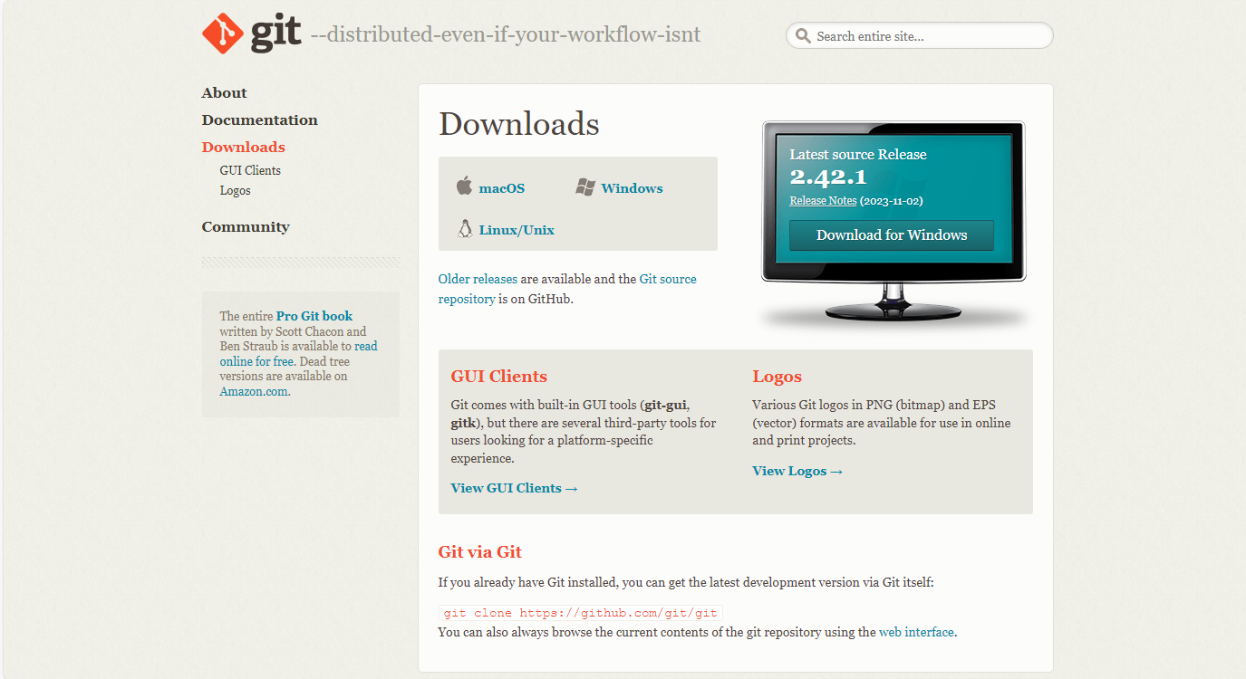

Step 2:

Create an account on GitHub and create a new repository

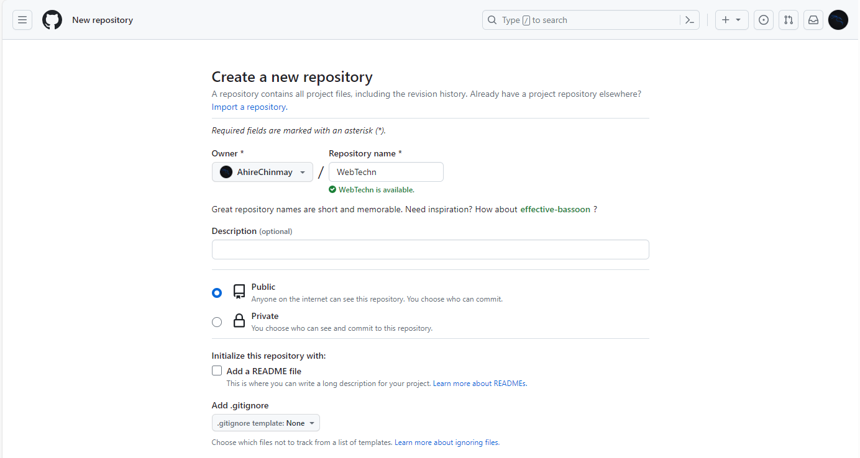

Step 3:

On Your desktop create a folder using command [mkdir <filename>]

Initialize git using [git init] command

Switch to main branch from master using command [git branch –M main]

Remote connect your GitHub repository to the folder using

[git remote add origin [https://github.com/<username>/<repo_name>.git](https://github.com/%3cusername%3e/%3crepo_name%3e.git)]

Use [git commit –m”Initial commit”] to commit initial status

Create file using touch command eg-[touch first.py]

Write into that file using any IDE or nano which is an terminal IDE [nano first.py]

To stage the files you need to use command [git add -A] “this will stage all unstaged files”

See branch status using command [git status]

Commit the changes on branch using [git commit –m “commit_message”]

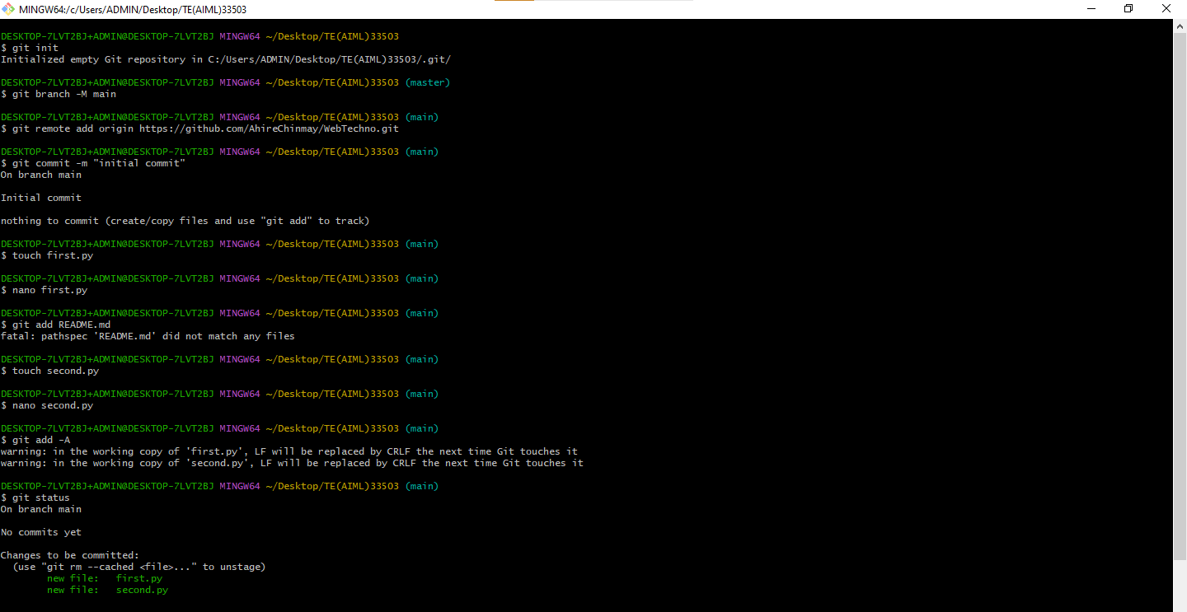

Step 4:

Push the files to main branch on your GitHub repository using command

[git push –u origin main]

To see the status of repository use command

[git log]

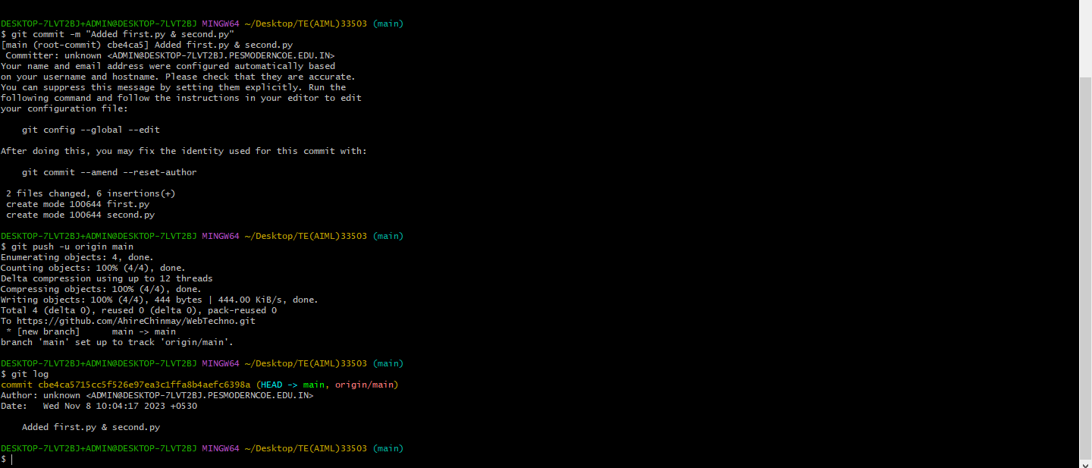

Step 5:

Check Your repository files will be uploaded there

