Experiment 1

Name: Avanti Lakhane

Roll No: 37

#include<iostream>

#include<string.h>

using namespace std;

int main()

{

char str[100];

int i,length,ch,ch2;

cout<<"Enter the string: ";

cin>>str;

cout<<"Choose an option"<<endl;

cout<<"1. Encrypt"<<endl;

cout<<"2. Decrypt"<<endl;

cin>>ch;

cout<<"Select Encryption/Decryption method:"<<endl;

cout<<"1. Shifting"<<endl;

cout<<"2. Reverse"<<endl;

cin>>ch2;

if(ch2==2){

length = strlen(str);

if(ch==1){

for(i = 0; i < length/2; i++)

{

char temp = str[i];

str[i] = str[length - i - 1];

str[length - i - 1] = temp;

}

cout<<"Encrypted String: "<<str<<endl;

}

else{

for(i = 0; i < length/2; i++)

{

char temp = str[i];

str[i] = str[length - i - 1];

str[length - i - 1] = temp;

}

cout<<"Decrypted String: "<<str<<endl;

}

}

if(ch2==1){

if(ch==1)

{

for(i=0; (i<100 && str[i]!='\0'); i++)

{

str[i]=str[i]+2;

}

cout<<"Encrypted string:"<<str<<endl;

}

else if(ch==2)

{

for(i=0; (i<100 && str[i]!='\0'); i++)

{

str[i]=str[i]-2;

}

cout<<"Decrypted string:"<<str<<endl;

}

else

{

cout<<"Error"<<endl;

}

}

return 0;

}

Encryption and Decryption using Shifting method

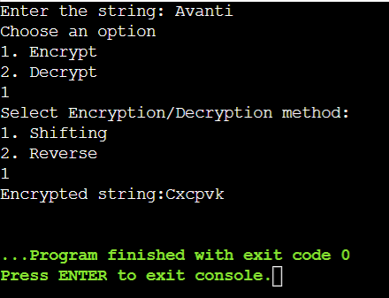

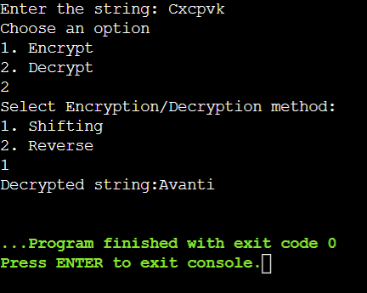

Encryption and Decryption using Reverse method

