Module-1 ( Fundamental)

1. What is SDLC

* SDLC Is a structure development of a software product that defines the process for planning, implementation, testing, documentation, deployment,

And ongoing maintenance support.

1. What is software testing

* Testing is a process used to identify correctness, completeness, quality of developed computer software.

1. Write SDLC phases with basic introduction

* There are 3 type of problem

1. Lack of clarity
2. Requirement confusion
3. Requirement amalgamation

* **Requirement collection gathering** : Although requirements may be documented in written form, incomplete, unambiguous or even incorrect.
* **Analysis** : the analysis phase defines the requirements of the system, intendent of how these requirements will be accomplished.
* **Desing** : design architecture documents implementation plan
* **Implementation :** in the implementation phase, the team builds the components either from scratch or by composition.
* **Testing** : a customer satisfied with the quality of product will remain loyal and wait for new functionality in the next version.
* **Maintenance** : 1 ) corrective maintenance 2) adaptive maintenance 3) perfective maintenance

1. Explain phases of the waterfall model

* Requirement collection gathering
* Analysis
* Desing
* Implementation
* Testing
* Maintenance

1. What Is agile methodology ?

* Agile SDCL model is a combination of iterative and incremental process model with focus on process adaptability and customer satisfaction by rapid delivery of working software product.

1. Write phase spiral model

* Planning
* Risk analysis
* Customer evaluation
* Engineering

1. What is class

* Class : is an collection of data member and member function with its behavior class class name

1 . data member

2. member function

9. What is object

* Object : is a instance of an class

Class name object name : new class name

10. What is oops

* Oops : object oriented programming system : black bok, functional

11. What is encapsulation

* data hiding : wrapping up of data into single unit.private your data member and member function

12. What is inheritance

* properties of parent class extends into child class
* main purpose is reusability, extendsiblity
* there are mainly 5 types

1) single

2) multilevel

3) hierarchical

4) multiple : java does not support directly

5) hybrid : java does not support directly

13. What is polymorphism

* Ability to take one name having different or many forms.
* There are mainly 2 types

1. Method overloading
2. Method overriding

14. What is SRS

* Software requirements specification (SRS) Is a complete description of the behaviour of the system to be developed.

15 . Write agile manifesto principles

* Customer satisfaction through early and continuous software delivery. Welcome changing requirements anytime during development. Face-to-face communication is most effective. Close collaboration business and developer.

16. Explain working methodology of agile model and also write pros and cons.

* The project is broken into small parts called sprints.

Teams plan, design, develop, test and deliver working software in each sprint.

**Pros of agile** : works for changing or fixed requirements delivers early working solution easy to mange, flexible for developers

**Cons of agile** : not good for complex dependencies risk for long-term maintenance needs strong planning and leadership strict delivery timelines.

17. Write basic concepts of oops

* Object
* Class
* Encapsulation
* Inheritance
* Polymorphism
* Overriding
* Overloading
* Abstraction

18. Draw use case on Online shopping product using payment gateway.

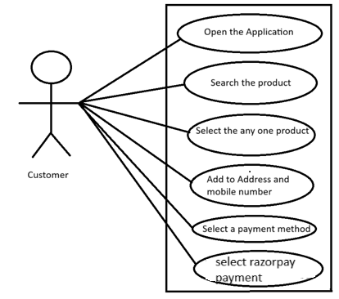

19. Draw Use case on online bill payment system (paytm)

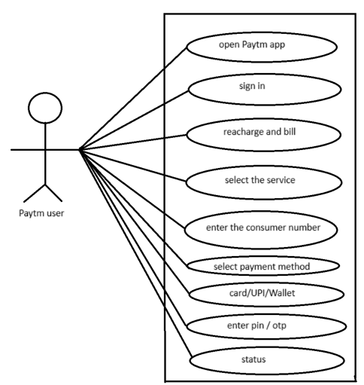

20. Draw Use case on banking system for customers.

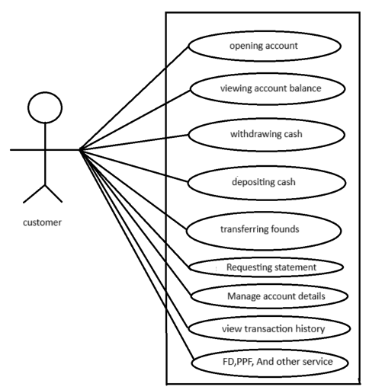

21. Draw use case on OTT Platform.

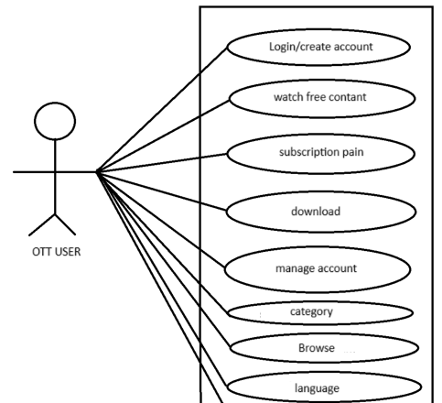

22. Draw Use case on Broadcasting System.

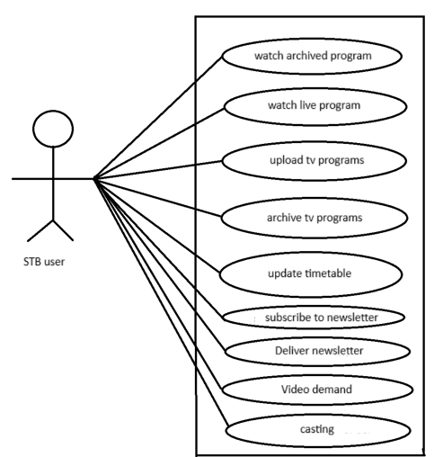

23. Draw use case on E-commerce application

