|  |  |
| --- | --- |
| Data Validation Testing: Why It is Important for ETL  Data validation task | FeBRUARie 2024    Adriaan Mostert  Grade 12 |

Contents

1. GUI Images 2

2. Table: Description of fields 2

3. Test Plan for validation 2

4. Testing Evidenc 2

5. Programming code 2

# GUI Before Data is Entered Images

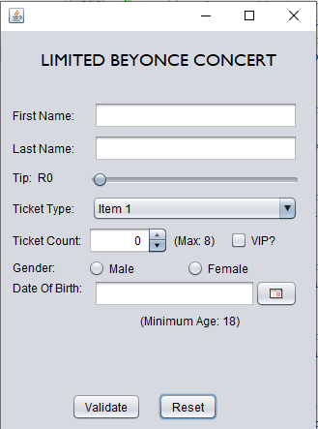

# Table: Description of fields

|  |  |  |  |  |
| --- | --- | --- | --- | --- |
| **Input field** | **Input**  **Component** | **Reason For Input Component** | **Data Validation Method** | **Reason For Data Validation** |
| First Name (String) | JTextField | First Name Input is a string | * Presence Check * Length Check * Format Check | * Ensures data is inputted. * Ensures input does not exceed max length of 20. * Ensures no digits are used. |
| Last Name (String) | JTextField | Last Name input is a string | * Presence Check * Length Check * Format Check | * Ensures data is inputted. * Ensures input does not exceed max length of 20. * Ensures no digits are used. |
| Tip (Double) | JSlider | Tip is a real number | * None | * No validation needed. |
| Ticket Type (String) | JComboBox<String> | There are a fixed number of ticket types to choose from | * None | * No validation needed. |
| Ticket Count (Int) | JSpinner | Forces user to enter an integer | * Range Check | * Ensures tickets are within acceptable range of 1 and 8. |
| VIP (Boolean) | JCheckBox | Allows input of either one of two states | * None | * No validation needed. |
| Gender (Boolean) | JRadioButton x2  With ButtonGroup | Forces user to choose one of two options | * Presence Check | * Ensures data is inputted. |
| Date Of Birth (LocalDate) | JDateChooser | Forces user to choose a valid date | * Presence Check * Logic check | * Ensures data is inputted. * Ensures user is at least 18 years of age. |

# Test Plan for validation.

## Testing for Presence check

## Testing for Length check

## Testing for Format check

## Testing for Range check

## Testing for Logic check

# Testing Evidence

## Testing for Presence check

## Testing for Length check

## Testing for Format check

## Testing for Range check

## Testing for Logic check

# Programming code