Metric Relationship Across Data Sources

We want to check if there is a relationship between the number of febrile fever individuals with negative malaria test results reported in the DHS-MIS surveys and the negative malaria tests reported by facilities in the DHIS2. The main assumption for DHIS2 data is only the suspected malaria fevers were tested.

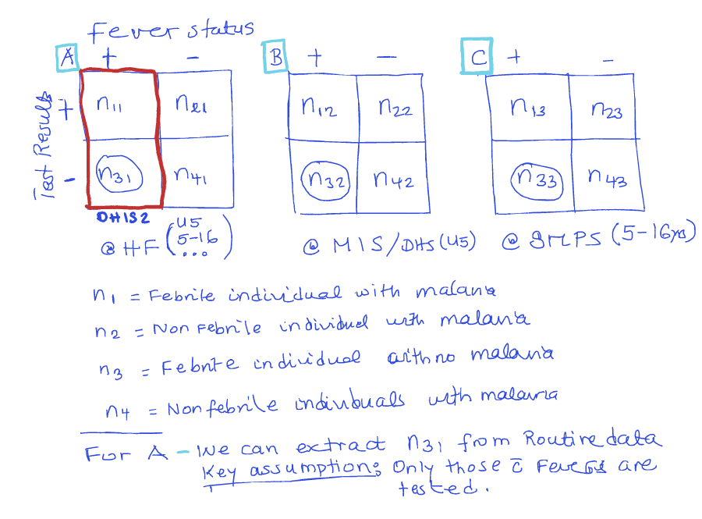
The core difficulty is linking two point datasets that don’t share locations and that differ in density, noise and positional accuracy. Some decisions should come first, because they affect every approach.

Decisions to make first

- Use a proportion, not a count. A facility’s number of febrile negatives depends on how many people it serves, while a DHS cluster’s count depends on its sample size. The comparable measure is the share of tested febrile people who are negative: (tested − positive) / tested in DHIS2, and febrile & RDT-negative / febrile & tested in DHS. Counts will mostly correlate with population size.

- Allow for DHS GPS displacement. DHS deliberately shifts cluster coordinates, by up to 2 km for urban clusters and up to 5 km for rural ones, with about 1% of rural clusters shifted up to 10 km. The “nearest facility” to a published cluster point may not be the nearest to the real cluster. Any linkage should use a buffer of at least that size, not a single nearest point.

- Match on age and time. Restrict DHIS2 to under-5s and to the months of DHS fieldwork in each region, or the season it covers. Pooling a whole year of DHIS2 data against a few weeks of survey data adds seasonal noise.

- Expect very small DHS denominators. A cluster may have only 0–8 febrile under-5s who were tested. Raw cluster proportions will be extremely noisy, which pushes any correlation toward zero even if the true relationship is strong. This is the main reason to prefer the modelling approaches below over a plain Pearson correlation.

Approach 1: Buffer-based facility linkage (simplest, good starting point)

For each DHS cluster, find all facilities within a radius (for example 5 km urban and 10 km rural) or the k nearest facilities (for example k = 3). Pool their DHIS2 numerators and denominators. Pooling sums is better than averaging percentages, because it gives larger facilities more weight. Distance-decay weights are a reasonable variant.

Then compare the pooled DHIS2 proportion to the cluster proportion. Repeat with several radii or values of k as a sensitivity analysis. If the association holds across choices, it’s more convincing.

Euclidean distance is a crude proxy for where people actually go for care. If you can, use travel time instead. The Malaria Atlas Project publishes friction surfaces and travel-time-to-facility layers that work for this.

Approach 2: Model the cluster data with DHIS2 as a predictor (recommended main analysis)

Rather than correlating two noisy percentages, fit a model at the child or cluster level:

Outcome: febrile & negative out of febrile & tested in each cluster, modelled as binomial.
Predictor: the logit of the linked DHIS2 proportion from Approach 1.
Random effects: a cluster effect and, ideally, a spatial random effect such as an SPDE in R-INLA or a Matérn GP in spaMM or glmmTMB.

This handles small denominators correctly, because clusters with two children count less than clusters with eight. It also accounts for spatial autocorrelation, which otherwise makes the p-value of a simple correlation too optimistic. The coefficient on the DHIS2 predictor, together with a pseudo-R² or the change in residual spatial variance, is your measure of association.

Approach 3: Geostatistical surface, compared at facility locations

This approach reverses the direction of the problem. Fit a model-based geostatistical surface of the febrile-negative proportion from the DHS clusters, with covariates such as rainfall, elevation and urbanicity if you like. Then predict that surface at every facility location, or averaged over each facility’s catchment, and compare those predictions to DHIS2.

This uses all the facilities rather than discarding most of them. The prediction uncertainty can be carried through, so you get a credible interval on the correlation. The cost is that the result depends on how good the surface model is, so do it after Approaches 1 and 2.

Approach 4: Aggregate both to administrative areas (robustness check)

Compute a survey-weighted estimate per region or council from DHS, using the sampling design with survey or srvyr in R. Compute a pooled proportion per area from DHIS2, and correlate the two across areas.

This sidesteps displacement and linkage problems entirely, and DHS is designed to be representative at region level. The drawback is that there are few units (26 regions in mainland Tanzania), and council-level DHS estimates are imprecise. Treat it as a check on whether the broad pattern agrees, not as the main result.

