REACT NATIVE COURSE NOTE
CreatedAt: 16/02/2024 (M7)

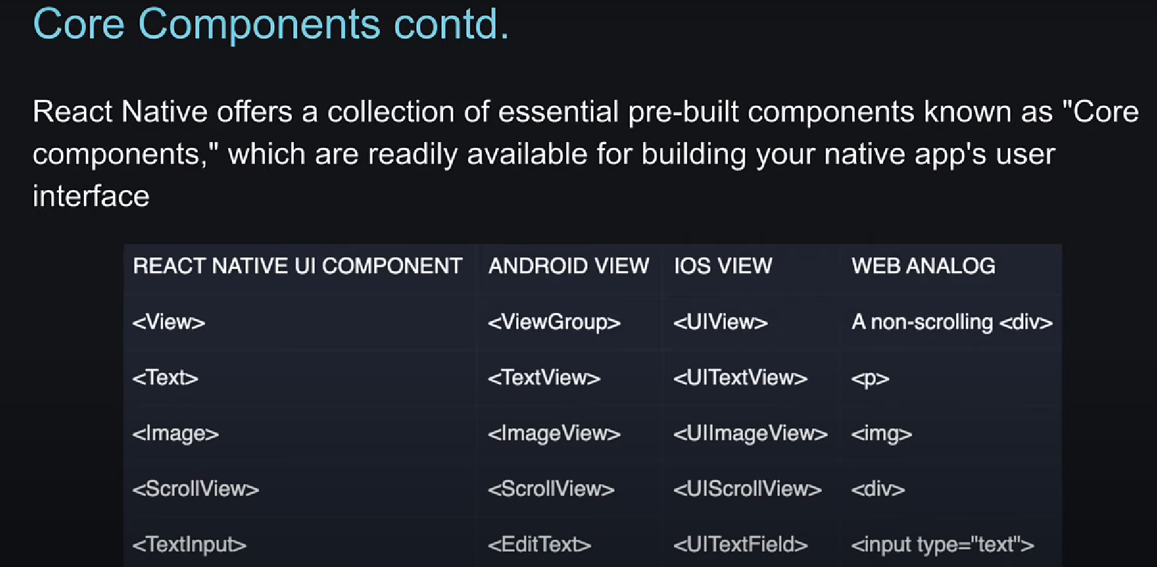

React Native Tutorial - 10 – Image
- Muốn lấy hình ảnh từ bên ngoài phải bỏ prop cho nó là uri.
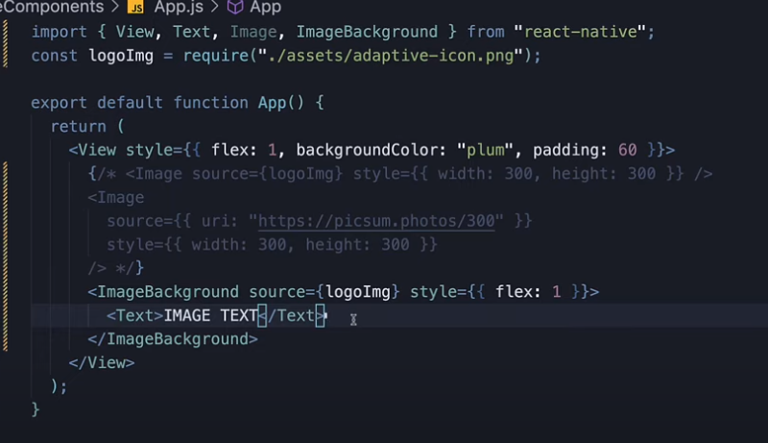
React Native Tutorial - 11 - Scroll View
<ScrollView>: Dùng để cuộn xuống ( View không giống hoàn toàn div trong web app vì nó kh tự cuộn được, bỏ <ScrollView> vào dưới <View> để có thể cuộn xuống).

CODE:
import { View, Text, Image, ImageBackground, ScrollView } from "react-native"; const logoImg = require("./assets/adaptive-icon.png") export default function App() { return <View style={{ flex: 1, backgroundColor: 'plum', padding: 60 }}> <ScrollView> <Image source={logoImg} style={{ width: 300, height: 300 }} /> {/* <Image source={{uri:"https://picsum.photos/300"}} style={{width:300, height:300}} /> <ImageBackground source={logoImg} style={{flex:1}}> <Text>IMAGE Text</Text> </ImageBackground> */} <Text> Lorem ipsum dolor sit amet, consectetur adipiscing elit. Nunc luctus hendrerit faucibus. Duis ornare vel nibh quis rutrum. In volutpat, justo id suscipit iaculis, nunc sapien scelerisque nunc, quis dictum lacus justo eget turpis. Phasellus tempor vulputate arcu non accumsan. In molestie, enim ac luctus maximus, nisl tortor bibendum velit, sit amet convallis purus lorem vel turpis. Phasellus vel ultricies tellus, quis finibus neque. Integer in dolor eros. Nulla sollicitudin ultrices nisl, consequat viverra urna pulvinar at. Aenean a diam commodo, dignissim libero id, luctus est. Phasellus tristique scelerisque lacinia. </Text> <Image source={logoImg} style={{ width: 300, height: 300 }} /> </ScrollView> </View> }

React Native Tutorial - 12 – Button
CODE:
import { View, Text, Image, ImageBackground, ScrollView, Button } from "react-native"; const logoImg = require("./assets/adaptive-icon.png") export default function App() { return ( <View style={{ flex: 1, backgroundColor: 'plum', padding: 60 }}> <Button title="Press" onPress={() => console.log("Button Pressd")} color="midnightblue" /> </View> ) }

React Native Tutorial - 13 – Pressable
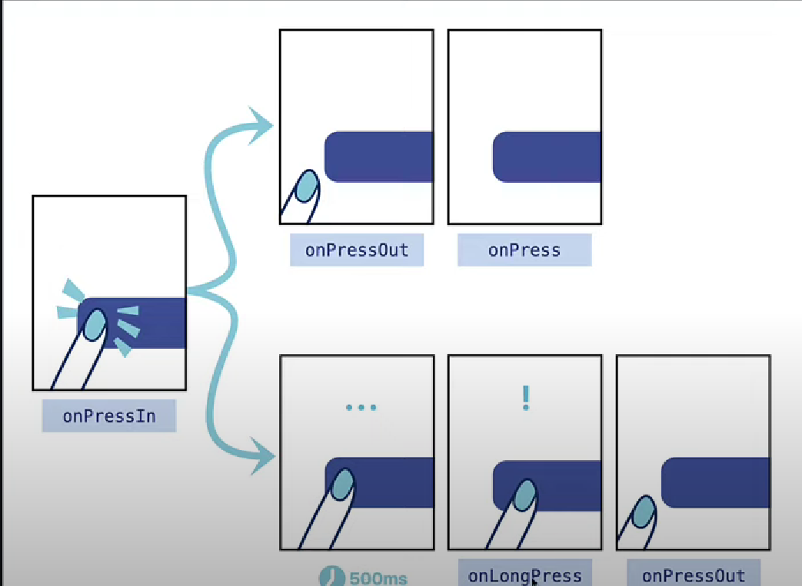

CODE:
import { View, Text, Image, ImageBackground, ScrollView, Button, Pressable } from "react-native"; const logoImg = require("./assets/adaptive-icon.png") export default function App() { return ( <View style={{ flex: 1, backgroundColor: 'plum', padding: 60 }}> <Button title="Press" onPress={() => console.log("Button Pressed")} color="midnightblue" /> <Pressable onPress={() => console.log("Image Pressed")}> <Image source={logoImg} style={{ width: 300, height: 300 }} /> </Pressable> <Pressable onPress={() => console.log("Text Pressed")}> <Text> Lorem ipsum dolor sit amet, consectetur adipiscing elit. Nunc luctus hendrerit faucibus. Duis ornare vel nibh quis rutrum. In volutpat, justo id suscipit iaculis, nunc sapien scelerisque nunc, quis dictum lacus justo eget turpis. Phasellus tempor vulputate arcu non accumsan. In molestie, enim ac luctus maximus, nisl tortor bibendum velit, sit amet convallis purus lorem vel turpis. Phasellus vel ultricies tellus, quis finibus neque. Integer in dolor eros. Nulla sollicitudin ultrices nisl, consequat viverra urna pulvinar at. Aenean a diam commodo, dignissim libero id, luctus est. Phasellus tristique scelerisque lacinia. </Text> </Pressable> </View> ) }

React Native Tutorial - 14 – Modal
animationType: slide, fade

CODE:
import { useState } from "react"; import { View, Text, Image, ImageBackground, ScrollView, Button, Pressable, Modal } from "react-native"; const logoImg = require("./assets/adaptive-icon.png") export default function App() { const [isModalVisible, setIsModalVisible] = useState(false); return ( <View style={{ flex: 1, backgroundColor: 'plum', padding: 60 }}> <Button title="Press" onPress={() => setIsModalVisible(true)} color="midnightblue" /> <Modal visible={isModalVisible} onRequestClose={() => setIsModalVisible(false)} animationType="slide" presentationStyle="pageSheet" > <View style={{ flex: 1, backgroundColor: 'lightblue', padding: 60 }}> <Text>Modal content </Text> <Button title="Close" onPress={() => setIsModalVisible(false)} color="midnightblue" /> </View> </Modal> </View> ) }

presentationStyle="pageSheet": chỉ hỗ trợ cho iOS

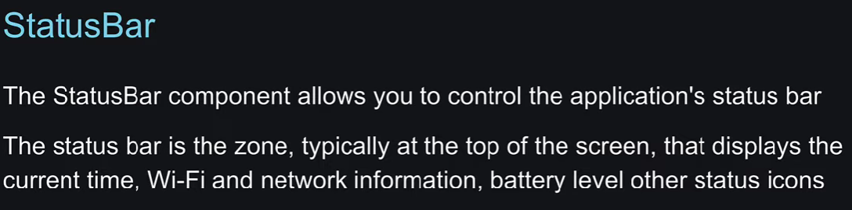
React Native Tutorial - 15 - Status Bar
import { useState } from "react"; import { View, Text, Image, ImageBackground, ScrollView, Button, Pressable, Modal, StatusBar } from "react-native"; const logoImg = require("./assets/adaptive-icon.png") export default function App() { return ( <View style={{ flex: 1, backgroundColor: 'plum', padding: 60 }}> <StatusBar backgroundColor="lightgreen" barStyle="light-content" hidden> </StatusBar> </View> ) }

React Native Tutorial - 16 - Activity Indicator
- Dùng để hiển thị trạng thái (loading) cho user.
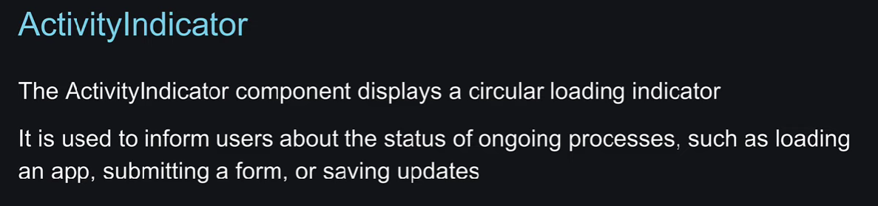
CODE:
import { useState } from "react"; import { View, Text, Image, ImageBackground, ScrollView, Button, Pressable, Modal, StatusBar, ActivityIndicator } from "react-native"; const logoImg = require("./assets/adaptive-icon.png") export default function App() { return ( <View style={{ flex: 1, backgroundColor: 'plum', padding: 60 }}> <ActivityIndicator /> <ActivityIndicator size="large" /> <ActivityIndicator size="large" color="midnightblue" /> <ActivityIndicator size="large" color="midnightblue" animating={false} /> </View> ) }

React Native Tutorial - 17 – Alert
Alert in android is 3 params (Example: Ask me later!, Ok, Cancle)
CODE:
import { useState } from "react"; import { View, Text, Button, Alert } from "react-native"; const logoImg = require("./assets/adaptive-icon.png") export default function App() { return ( <View style={{ flex: 1, backgroundColor: 'plum', padding: 60 }}> <Button title="Alert" onPress={() => Alert.alert("Invalid data!")} /> <Button title="Alert 2" onPress={() => Alert.alert("Invalid data!", "Phone is incorrect!")} /> <Button title="Alert 3" onPress={() => Alert.alert("Invalid data!", "Phone is incorrect!", [ { text: "Cancel", onPress: () => console.log("Cancel pressed"), }, { text: "Ok", onPress: () => console.log("Ok pressed"), } ])} /> </View> ) }

React Native Tutorial - 18 - Custom Components
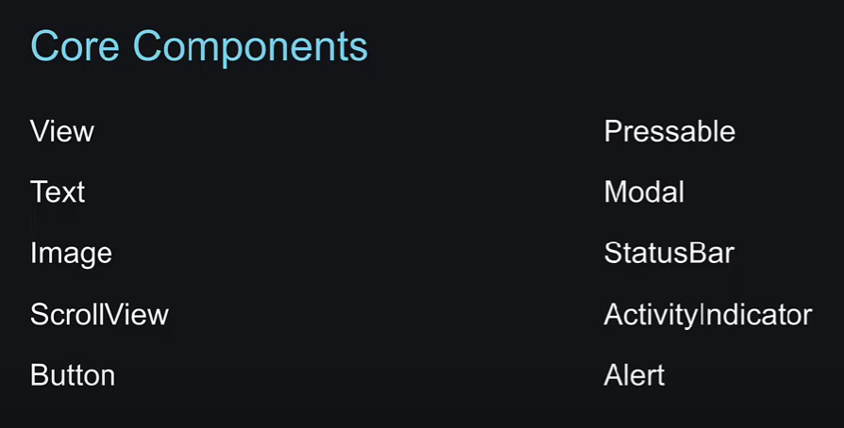
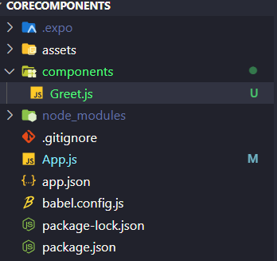
CODE:
Greet.js:
import { View, Text } from "react-native"; export default function Greet({name}) { return ( <View> <Text>Hello, {name} Thanh</Text> </View> ) }

App.js:
import { View, Text, Button, Alert } from "react-native"; import Greet from "./components/Greet"; export default function App() { return ( <View style={{ flex: 1, backgroundColor: 'plum', padding: 60 }}> <Greet name="Hieu Doan"/> <Greet name="Doan Hieu"/> </View> ) }

React Native Tutorials - 19 – Styling
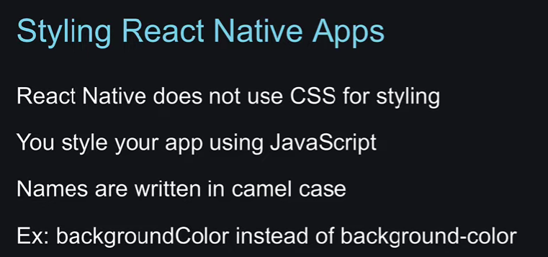


React Native Tutorial - 20 - StyleSheet API
CODE:
import { View, Text, StyleSheet } from "react-native"; export default function App() { return ( <View style={styles.container}> <Text>StyleSheet API</Text> </View> ) } const styles = StyleSheet.create({ container:{ flex:1, backgroundColor:'plum', padding:60 }, })
React Native Tutorials - 21 - Multiple Styles
Thứ tự ưu tiên: Ưu tiên phần tử cuối.
Ví dụ: <View style={[styles.box, styles.lightBlueBg]}>, sẽ ưu tiên style của styles.lightBlueBg

React Native Tutorials - 22 - Box Model
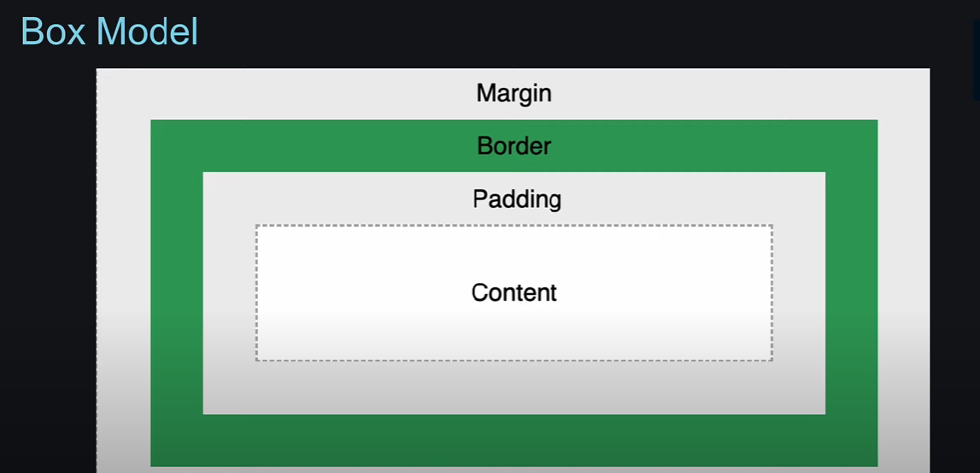
borderRadius với text chỉ hiển thị trên android.

