COMPUTING PROJECT

Hybrid Algorithm Based
3D Container Loading
Optimisation
LAB REPORT
Prepared by
Ahlad Modi

Container Loading Lab Report

Introduction
We tested two ways to pack boxes into a container. The aim was to use more space without putting boxes outside the container, overlapping them, or going over the weight limit.
At the 150 ms scoring cutoff, the hybrid-minus-First-Fit difference was +0.48 percentage points (paired 95% interval -0.32 to +1.26). The interval includes zero, so an overall improvement is not established. These cases were reused during development; the comparison is exploratory.
Both methods ran five trials per case. A packing counted only if it was ready by the 150 ms scoring cutoff. Some runs took longer because an attempt was already underway.

Materials and Methods

Materials
- Thirty generated cases in a 1200 x 1000 x 800 mm container, with 10, 15 or 20 boxes: ten geometry, ten payload and ten mixed cases. Full distributions and the QUBO equations are in docs/model.md and the technical report.
- Box sizes, weights and rotation rules. The geometry cases also have saved layouts that fill the container.
- Python for both methods and HiGHS to check the best answers available from the hybrid’s placement choices.

Test Setup
The main comparator was weight-aware multi-start First-Fit, using volume, longest edge, volume per gram and knapsack-guided orders before shuffled restarts. The hybrid searched a pool of placements built using varied corner priorities.
We averaged five scores per case and compared the 30 case averages. We also ran a separate test that required full support for raised boxes.

Results

Space Used at the Scoring Cutoff

Main Five-Trial Results
Method | Mean util. | Best util. | Mean boxes | Mean volume (L) | Mean ms | Max ms | Final violations
First-Fit | 69.15% | 70.09% | 10.31 | 663.82 | 126.44 | 162.34 | 0
Hybrid | 69.63% | 70.55% | 10.15 | 668.45 | 154.71 | 200.23 | 0
Best use of space is averaged over the best trial for each case. The time columns show actual elapsed time. First-Fit in this table means the enhanced multi-start comparator. The separate deterministic FFD reference averaged 65.79% utilization, 9.13 boxes and 631.60 L, with zero violations on the same inputs. Its 0.001899 s mean runtime is from the earlier recorded run.

Earlier Three-Trial Results
Case group | First-Fit | Hybrid | Gap in points | W/T/L
All | 69.41% | 68.89% | -0.52 | 13/9/8
Geometry | 98.72% | 95.24% | -3.48 | 1/3/6
Payload | 27.71% | 28.02% | +0.31 | 4/6/0
Mixed | 81.80% | 83.41% | +1.61 | 8/0/2

This table shows the earlier held-out run. The gap is the hybrid score minus the First-Fit score. W/T/L means hybrid wins, ties and losses.

Support Test
When the hybrid checks support | First-Fit | Hybrid | Gap in points
Post-repair check | 67.96% | 63.72% | -4.24
During search | 67.96% | 66.30% | -1.66

Checking support during search helped because the hybrid could avoid choices that would leave a box floating. All 90 returned raw selections passed the full-support rule in that version.

Why the Geometry Score Was Lower
HiGHS found the best possible answer for all 30 sets of available placements. Only 13 sets could fill the whole container. The hybrid found the best answer in 27 sets. On average, missing choices cost 4.55 points and the search cost 0.21 points.

Discussion
The test with a shared scoring cutoff changed the comparison. First-Fit had time to try more layouts, which helped on tight geometry. The hybrid was more useful when it had to choose boxes based on both size and weight. All final layouts passed the rules for their test.
The support test measures how much of a box base touches the boxes below. It leaves the strength of the boxes and how safe the load is outside the project.
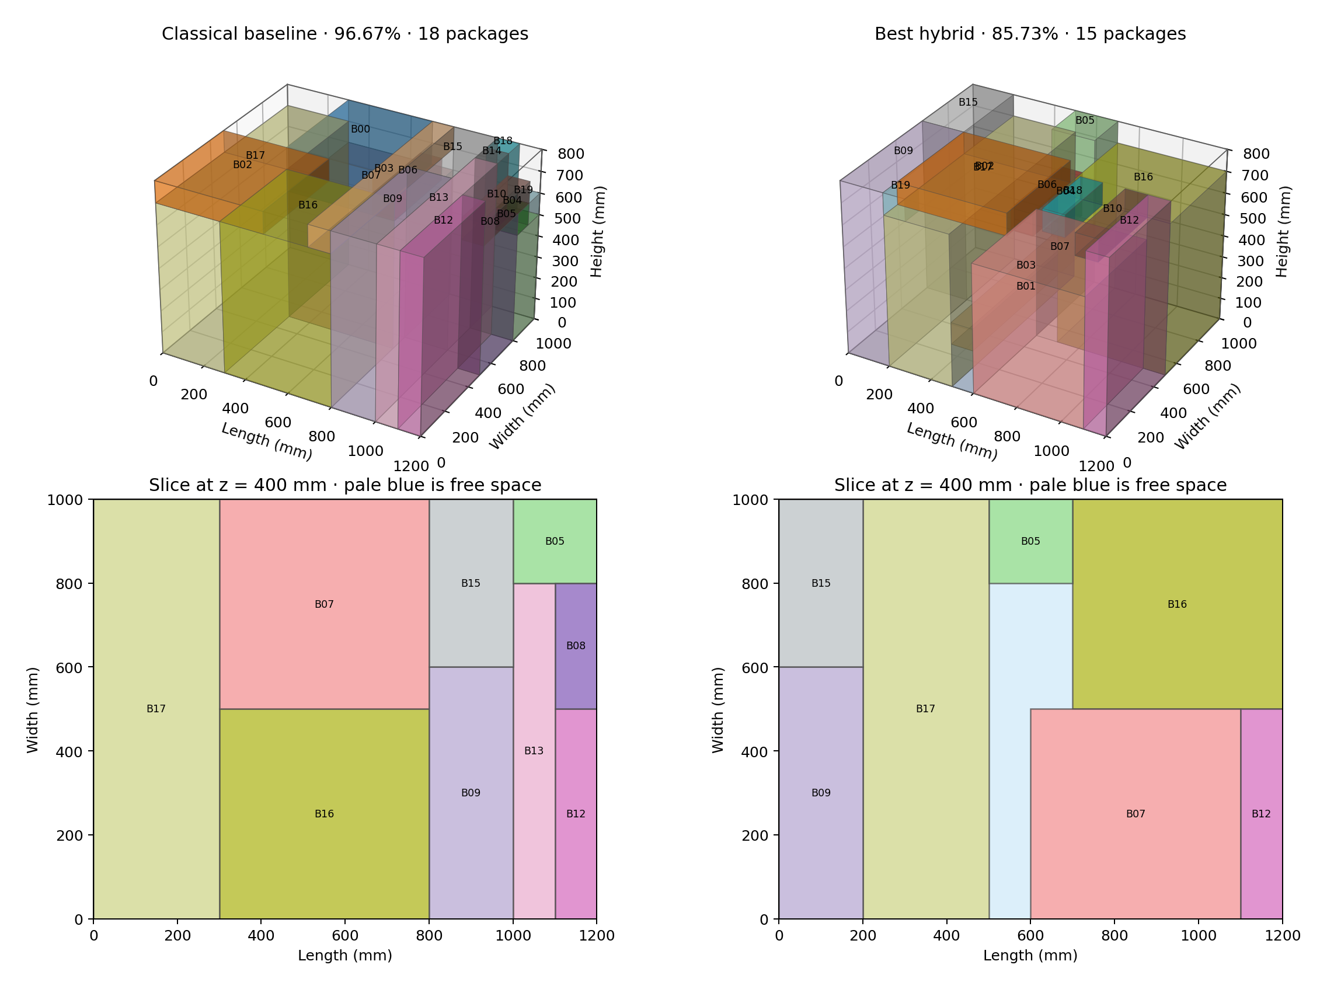
Figure 1. Historical geometry case 4108, seed 301 from the earlier three-trial run. This layout is not a main-v4 trial. Pale blue shows free space.

Conclusion
First-Fit is a good starting point for these tests. The hybrid is worth testing further when weight and space both matter. The geometry check shows that improving the list of possible placements should come before adding more search time.

References
- Project task brief for Hybrid Algorithm Based 3D Container Loading Optimisation.
- Held-out results, fixed-pool results and support tests in the project results folders.

Earlier Budget Sweep
Budget or cap | Cases | First-Fit | Hybrid | Mean attempts FF / H
4 attempts | 30 | 67.35% | 70.01% | 3.5 / 3.5
150 ms | 30 | 69.17% | 69.40% | 255.2 / 2.6
500 ms | 30 | 69.77% | 70.57% | 856.4 / 8.8
1.5 s | 30 | 70.35% | 70.99% | 2,564.2 / 26.1
5 s subset | 9 | 72.06% | 72.85% | 7,726.1 / 73.7
The five-second test used nine cases. The methods do different amounts of work per attempt, so we counted attempts and recorded time separately.

Weight and Search
Choosing a group of boxes by weight and then using First-Fit matched the hybrid on all ten payload cases. The mixed cases were harder because the chosen boxes also had to fit together.
The hybrid moves groups of placements and keeps the boxes from overlapping. It computes the best slack value directly. A separate check sampled every binary variable and tested different penalties.
HiGHS found that the recorded mixed pools could use 85.62% of the space on average. The hybrid used 83.41%, leaving 2.21 percentage points of available space.
Full-support space used (First-Fit / hybrid) Geometry 98.14%/91.33% | Payload 27.71%/27.99% | Mixed 78.03%/79.58%

What We Learned
Mixed cases show where the hybrid can help. A weight-only check already reaches the best payload score. Geometry still depends on which box positions the search is given. The results cover these cases and time limits. New cases with settings fixed in advance are needed before generalizing. The original main-run environment was not recorded; future runs save environment versions, source hashes and complete inputs.

