Student ID: 103031281

Name: Ahlam Hassen

# Setup Screenshot

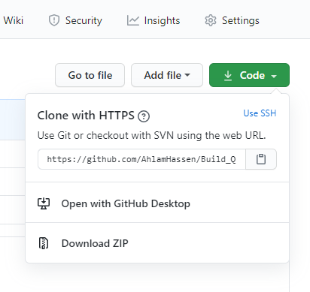

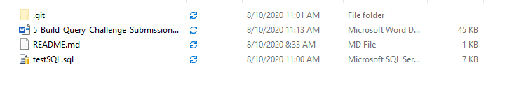

# Task 2 Screenshot

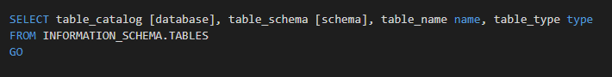

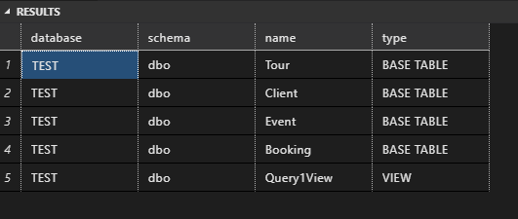

# Task 3 Screenshot

