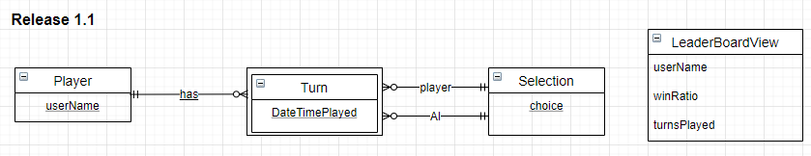

Player (userName)

Selection (choice)

Turn (userName, DateTimePlayed, playerchoice, AIchoice)

Foreign Key (userName) References Player

Foreign Key (playerchoice) References Selection (choice)

Foreign Key (AIchoice) References Selection (choice)

|  |  |  |  |  |
| --- | --- | --- | --- | --- |
| Table | Column | Data Type | Constraints | Notes |
| Player | userName | NVARCHAR (100) | PK | e.g. amiiy123 |
| Selection | choice | NVARCHAR (100) | PK | e.g. scissors |
| Turn | userName | NVARCHAR (100) | COMP PK  FK REF Player | As above |
| DateTimePlayed | DateTime | COMP PK | e.g. 6/19/2015 10:03:06 AM |
| playerchoice | NVARCHAR (100) | CHECK IN (‘rock’, ‘paper’, ‘scissors’) | e.g. paper |
| AIchoice | NVARCHAR (100) | CHECK IN (‘rock’, ‘paper’, ‘scissors’) | e.g. rock |