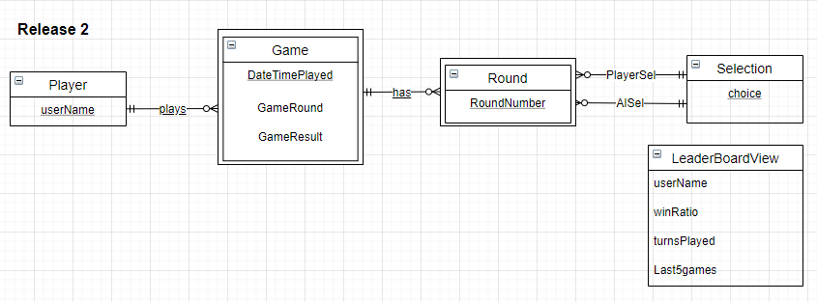

Player (userName)

Selection (choice)

Game (userName, DateTimePlayed, GameRound, GameResult)

Foreign Key (userName) References Player

Round (userName, DateTimePlayed, RoundNumber, PlayerChoice, CpuChoice)

Foreign Key (userName, DateTimePlayed) References Game

Foreign Key (PlayerChoice) References Selection (choice)

Foreign Key (CpuChoice) References Selection (choice)

|  |  |  |  |  |
| --- | --- | --- | --- | --- |
| Table | Column | Data Type | Constraints | Notes |
| Player | userName | NVARCHAR (100) | PK | e.g. amiiy123 |
| Selection | choice | NVARCHAR (100) | PK | e.g. scissors |
| Game | userName | NVARCHAR (100) | COMP PK  FK REF Player | As above |
| DateTimePlayed | DateTime | COMP PK | e.g. 6/19/2015 10:03:06 AM |
| GameRound | INT | CHECK IN (1, 3, 5) | e.g. 1 |
| GameResult | NVARCHAR (100) | CHECK IN (‘W’, ‘L’, ‘D’) | e.g. D |
| Round | userName | NVARCHAR (100) | COMP PK  FK REF Game | As Above |
| DateTimePlayed | DateTime | COMP PK  FK REF Game | e.g. 6/19/2015 10:03:06 AM |
| RoundNumber | INT | COMP PK  CHECK IN (1, 2, 3, 4, 5) | e.g. 1 |
| PlayerChoice | NVARCHAR (100) | FK REF Selection(choice)  CHECK IN (‘rock’, ‘paper’, ‘scissors’) | e.g. rock |
| CpuChoice | NVARCHAR (100) | FK REF Selection(choice)  CHECK IN (‘rock’, ‘paper’, ‘scissors’) | As above |