————-
Section 1 : intro
—————
- stateful vs state less applications
- state less apps : apps which does not need to store persistence data , configurations or state when :
1- processing different requests : every request is processed independently in any pod or any running instance of this app
2- restart or rescheduled
if pod restart and new pod created to replace it , the new pod can has new ip ( network ) or volume ( storge ) , and in general does not know any thing about the killed pod
- state ful apps : apps which need to store persistence data , configurations or state when :
1- processing requests :
ex 1 : database cluster like postgrsql , my sql or elastic where write operations must processed by specific pod like primary or master pod but read operations can be from any pod
ex 2 : sticky sessions in distributed systems or load balancer or key value database cluster like zookeeper
2- restart or rescheduled
ex of persistence networking : if primary pod restarted it should contain the same ( static ip ) or name ( pod-0)
ex of persistence storges : databases , message queues pods need when they restarted to connected to the same volume or storge
so state ful pods in general need unique identity in level of ( networking – storge - … ) so when current pod is crashed and new pod is created , it will has the same configurations or data of the killed pod.
- stateful vs deployment
gimini :
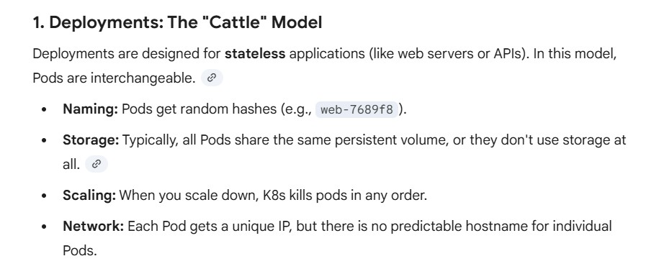
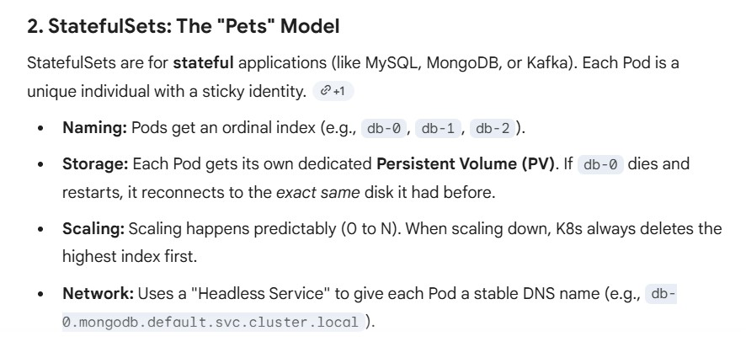
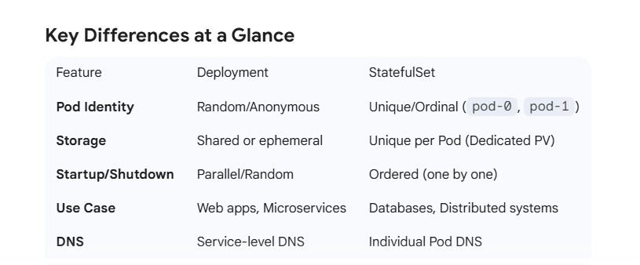

Chatgpt :
