**Fitman™**

**Overview**

This project is a runner game built using an Arduino UNO R4 and an LCD screen. The player controls a character with AI that enables it to run and jump over obstacles.

**Materials Used**

* Arduino UNO R4
* 16x2 LCD Screen
* Breadboard
* Jumper Wires
* Laptop

**Final Circuit Design**

LCD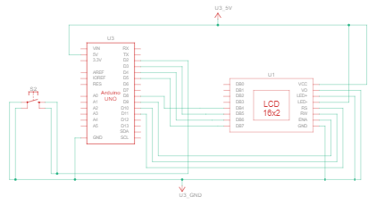

* RS - Pin 11
* RW - GND
* E - Pin 10
* D4 - Pin 9
* D5 - Pin 8
* D6 - Pin 4
* D7 - Pin 3
* VSS - GND
* VDD - 5V
* VO - GND
* A- 5V
* K - GND

**Explanation**

Game Mechanics

* The 16x2 LCD screen displays terrain (top and bottom rows).
* Character moves forward automatically.
* The player jumps to avoid obstacles.
* Distance increases the longer the player survives.

Graphics:

* Custom-created sprites are loaded into the LCD RAM.
* Sprites are like art blocks.
* Sprites include run1, run2, jump, jump lower, solid terrain, left/right terrain edges.

Game Loop:

* Advances in terrain every cycle.
* Handles jump transition and animations.
* Update the LCD screen with new terrain and character position.
* Update score (distance).
* Checks for collision (ends game if detected).

Input Handling:

* If the human player is standing, the input is 'jump' and the character jumps. If the human player is crouching, the input is executed, and the character continues to run.

**Challenges Faced**

* In TinkerCad, the simulation used a 220-ohm resistor; however, the LCD didn’t display properly on the real hardware.
* First, we replaced the fixed resistor with a variable resistor, which did not work. After that, we learned that connecting the RW pin to one of the pins worked without using any resistor.
* We experienced issues with integrating the AI software into the Arduino software.
* Then there was an issue with the input values changing too slowly, so we switched from an if() statement to a while() statement for quicker speed.

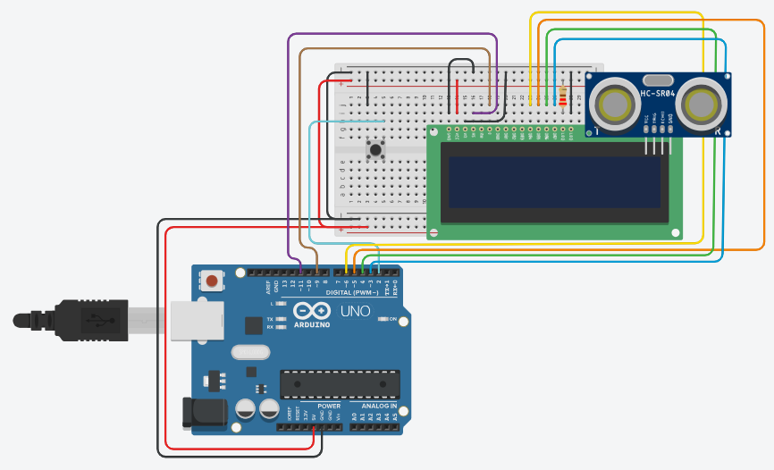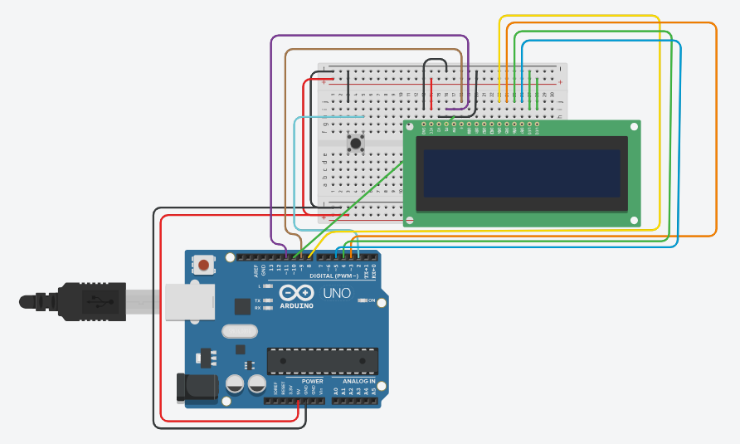

***Old TinkerCad New TinkerCad***

**Improvements**

* More neat and clean-looking hardware (3-D printed parts).
* More smooth game animations.
* Better and less funky game logic.
* A permanent high-score keeping logic.
* Add different types of difficulty (easy, medium, hard) or power-ups.