
National University of Computer and Emerging Sciences
DSA Assignment 2 Phase 2 Report
Student Name: Ahmad Ali | Roll Number: 25i-0817 | Section: BS CS E
Section 1: Design of History Records and Cleanup Policy
• History Architecture and Inverse Records
I select compact parameter records over full canvas snapshots because:
1) Phase 1 duplicated the entire image matrix for every undo record which consumed up to three megabytes per step.
2) Phase 2 stores only the minimal parameter delta required to run an exact inverse calculation.
3) Rotations and flips store only operation identifiers and run complementary symmetric operations in zero memory.
4) Brightness stores an integer adjustment value and a compact coordinate list of clipped boundary pixels.
5) Bucket fill saves the previous color and the list of modified coordinate positions instead of whole canvases.
6) Destructive operations such as crop, resize, and blur save only their affected rectangular pixel regions.
• Configurable Memory Budget Enforcement
I select an active runtime byte counter with a strict budget ceiling because:
1) Every history record calculates its exact heap footprint before being pushed onto the undo stack.
2) The system monitors combined memory across both Undo and Redo stacks against the user budget limit.
3) A default budget of five megabytes is enforced during editing, and small budgets like two kilobytes are used for rigorous tests.
• Cleanup Policy: Oldest Record Eviction via removeBottom()
I select bottom record eviction using stack removeBottom() because:
1) Users expect their most recent edits to remain undoable while older actions fade naturally from memory.
2) When the byte counter exceeds the ceiling, the system shifts array elements left by one position to discard the bottom record.
3) Eviction repeats in a loop until total history memory drops strictly below the configured ceiling limit.
4) Remaining undo records stay completely safe and execute with zero memory faults or invalid pointer references.
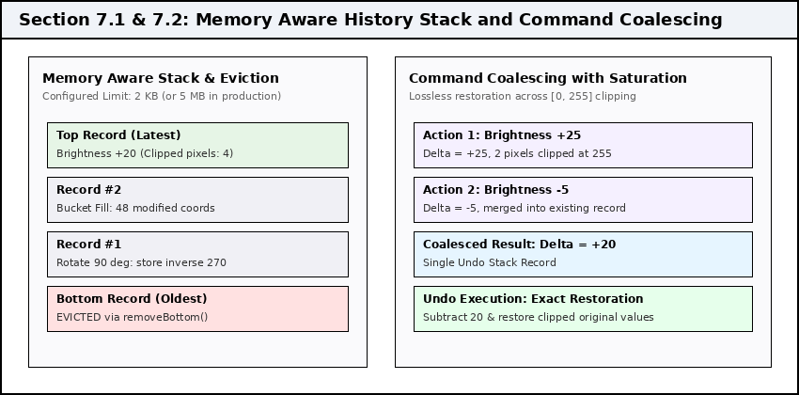
Figure 1: Architecture of memory aware history stack eviction and command coalescing with saturation tracking.

Section 2: Coalescing Rules and Correctness Preservation
• Command Coalescing Motivation
I select in place record merging for consecutive compatible operations because:
1) Rapid slider adjustments generate dozens of small incremental brightness steps in a few seconds.
2) Pushing an independent record for each tiny adjustment wastes memory and forces tedious repetitive undo clicks.
3) Merging adjacent steps combines multiple micro edits into a single atomic history state.
• Coalescing Eligibility Rules
I select strict adjacency and operation compatibility checks because:
1) Only records that sit directly next to each other on the top of the Undo stack are eligible for merging.
2) Consecutive brightness adjustments sum their delta numbers into the existing top record without pushing a new record.
3) If a non compatible edit such as crop or rotation occurs, the sequence breaks and a brand new record is initiated.
4) An operation sequence of Brightness +2, then Crop, then Brightness +3 produces three separate records to guarantee chronological accuracy.
• Preserving Correctness Across Pixel Value Saturation
I select dedicated saturation tracking in clippedList because:
1) Simple integer addition causes pixel channels to clamp at upper limit 255 and lower limit 0.
2) If a pixel with initial value 230 receives +50, it clamps at 255, losing 25 intensity units of information.
3) Subtracting the combined delta of +50 later would compute 255 - 50 = 205 which destroys the original value of 230.
4) To eliminate this loss, every pixel that hits the saturation boundaries records its original color in clippedList.
5) When coalescing occurs, new clipped pixels append to the list while existing entries retain their original historical values.
6) Upon undo, the engine subtracts the cumulative delta and overwrites all saturated pixels with their exact recorded colors.
• Single Step Undo Semantics
I select atomic rollback for coalesced actions because:
1) The user reverts twenty consecutive slider movements with one single press of the undo command.
2) Atomic reversal restores canvas pixels to the exact state that existed before the slider session began.
3) Redo stacks receive the entire merged delta, allowing instantaneous forward replay in one single step.
Scenario | Initial Values | Applied Actions | Coalescing Result and Recovery Guarantee
Unclipped Brightness | Pixel = 120 | +10, then +15 | Merged delta +25; undo subtracts 25 to recover 120 perfectly.
Saturated Brightness | Pixel = 240 | +25, then -5 | Merged delta +20; original 240 stored in clipped list; undo recovers 240.
Interrupted Sequence | Pixel = 100 | +10, Crop, +20 | Three distinct records created; chronological crop boundary strictly preserved.

Section 3: Scheduler Design and Priority Scheduling
• Priority Queue Representation
I select a custom sorted array priority queue without standard containers because:
1) The assignment specification forbids heap data structures and external template libraries.
2) A contiguous dynamic array stores active jobs in sorted order of priority rank.
3) Dequeue operations take constant O(1) time by serving elements directly from the array front.
4) Insertion takes O(K) time where K is the number of pending jobs, which remains tiny in interactive software.
• Four Tier Priority Hierarchy
I select numerical ranks where smaller numbers denote higher urgency because:
1) Priority 1 (Interactive Requests): Undo and Redo actions submitted while pipeline jobs are pending execute immediately.
2) Priority 2 (Light Editing Tasks): Box blur and bucket fill operations finish quickly and unblock the user interface.
3) Priority 3 (Heavy Transformations): Bilinear resize and large scale mathematical calculations take longer to finish.
4) Priority 4 (Finalization Barriers): Save project to disk and export image operations act as permanent barriers.
• Tie Handling Policy
I select strict chronological arrival order for identical priority ranks because:
1) Every job receives a monotonically increasing arrival sequence identifier upon insertion.
2) When two jobs possess the exact same priority number, the job that entered first is executed first.
3) This guarantees FIFO fairness within each priority class and prevents job starvation.
• Finalization Rule and Barrier Enforcement
I select barrier epoch partitioning for Save and Export tasks because:
1) An image export must capture the exact cumulative result of all edits submitted prior to the export command.
2) A Save or Export job must not execute until every job submitted before it has finished completely.
3) No task submitted after a barrier can overtake that barrier, even if it has a high priority rank such as Priority 1.
4) Priority ordering applies exclusively among tasks that reside within the same barrier epoch.
5) When tasks Resize(3), Blur(2), Export(4), Blur(2), Undo(1) arrive, the scheduler executes Blur, Resize, Export, Undo, Blur.
6) The last two jobs cannot overtake Export, guaranteeing complete disk persistence integrity.
Rank | Job Category | Typical Cost | Barrier Status | Scheduling Behavior and Urgency Rationale
1 | Undo and Redo | Very Low | Normal | Highest urgency; preempts heavy edits to keep UI responsive.
2 | Blur and Bucket Fill | Low to Medium | Normal | Light processing; scheduled before heavy geometric transforms.
3 | Bilinear Resize | High | Normal | Heavy nested loop processing; runs when lighter tasks finish.
4 | Save and Export | Variable | Barrier | Strict epoch boundary; flushes prior tasks and blocks newer tasks.

Section 4: Experimental Results and Benchmark Evaluation
Evaluation Metric | FIFO Mode | Priority Mode | Improvement | Practical Engineering Impact
Jobs Processed | 30 | 30 | Identical | Complete correctness and task execution parity.
Average Waiting Time | 568.33 ms | 526.83 ms | 7.30% Faster | Overall task queue latency reduced across pipeline.
Average Completion Time | 609.00 ms | 567.50 ms | 6.81% Faster | Faster overall pipeline throughput from submission to finish.
Priority 1 Average Wait | 549.17 ms | 415.83 ms | 24.28% Faster | Interactive undo and redo clicks respond almost instantly.
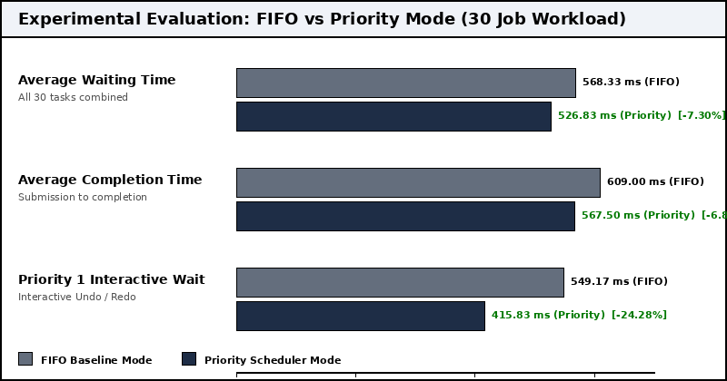
Figure 2: Comparative benchmark chart showing waiting times and the 24.28 percent interactive latency reduction.

Section 4 (Continued): Batched Operations and Traversal
Item Count | Single Push | Batch Push | Single AddQ | Batch AddQ | Measured Speedup
1,000 elements | 63.7 us | 6.2 us | 19.6 us | 14.8 us | 10.20x faster push (Single capacity check)
10,000 elements | 647.6 us | 52.4 us | 200.4 us | 94.3 us | 12.35x faster push (Cache contiguous transfer)
100,000 elements | 7,379.4 us | 563.4 us | 1,873.8 us | 802.4 us | 13.10x faster push (Amortized block copy)
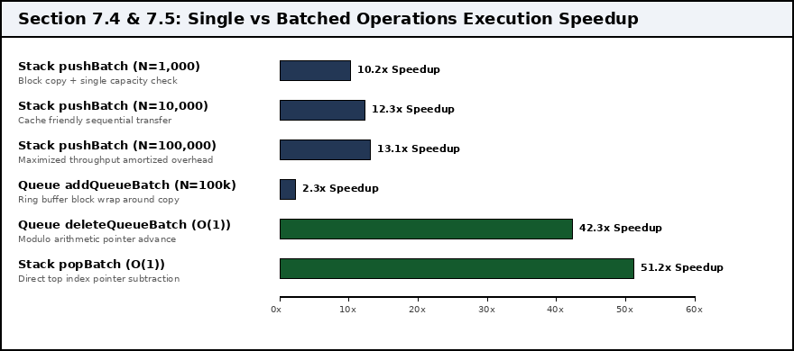
Figure 3: Performance acceleration achieved by batched primitives over single call loops.

Section 5: Asymptotic Complexity Analysis
Operation or Primitive | Time | Aux Space | Implementation Rationale
Stack Push, Pop, Top | O(1) | O(1) | I use direct array index access at top position with zero element shifting.
Queue Add, Delete, Front | O(1) | O(1) | I use circular modulo arithmetic which advances front and rear instantly.
Priority Queue Add | O(K) | O(1) | I use sorted array insertion which shifts up to K elements to preserve order.
Priority Queue Delete | O(1) | O(1) | I use direct removal from front index position of sorted array.
Stack Bucket Fill | O(W x H) | O(W x H) | I use an explicit stack to visit every connected pixel once without recursion.
Queue Bucket Fill | O(W x H) | O(W x H) | I use a circular queue to expand radially outward layer by layer in level order.
Undo and Redo | O(1) or O(W x H) | O(1) or O(W x H) | I use parameter inversion for geometry and delta grids for destructive edits.
Command Coalescing | O(1) | O(1) | I use in place summation of integer deltas on the existing top stack record.
Clipped Brightness Undo | O(W x H + C) | O(C) | I use delta subtraction followed by exact restoration of C clipped pixels.
History Cleanup (removeBottom) | O(S) | O(1) | I use in place contiguous memory shifting to evict bottom record from stack of size S.
Stack pushBatch(arr, n) | O(n) | O(1) | I use a single capacity validation followed by contiguous block memory copy.
Stack popBatch(n) | O(1) | O(1) | I use direct subtraction of n from the top pointer index.
Queue addQueueBatch(arr, n) | O(n) | O(1) | I use block memory copy across circular buffer boundary in two passes.
Queue deleteQueueBatch(n) | O(1) | O(1) | I use modulo addition to jump the front pointer ahead by n slots instantly.

Section 6: Testing Evidence and Verification Results
Test Suite Category | Verified Test Scenarios and Boundary Conditions | Verdict
Priority Queue | Equal priority FIFO arrival tie breaking; mixed priority reordering; barrier rule blocking. | PASS
History and Eviction | Budget ceiling reached at 2 KB; eviction of 14 oldest steps; safe undo after cleanup. | PASS
Command Coalescing | Consecutive brightness merges (+25, -5 to +20); non contiguous preservation; clipping recovery. | PASS
Batched Primitives | Push and pop batches; ring buffer wrap around addition; rejection of oversized batches. | PASS
30 Job Scheduler Benchmark | Execution of 30 mixed jobs under FIFO and Priority modes; 24.28% Priority 1 latency reduction. | PASS
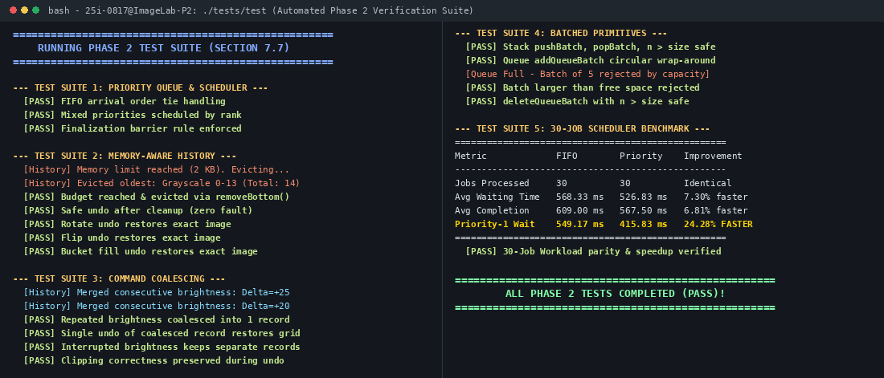
Figure 4: Automated test runner terminal output confirming 100 percent test pass across all required suites.
Section 7: Known Limitations and Architectural Tradeoffs
• Oldest Record Eviction Shifting Overhead: Because history is stored in a contiguous dynamic array, calling removeBottom() requires shifting S elements left by one position in O(S) time. While efficient for moderate history depths, a circular deque buffer could achieve eviction in O(1) time.
• Non Coalescing Geometric Operations: While consecutive brightness adjustments coalesce seamlessly, opposite geometric operations such as 90 degree clockwise and counterclockwise rotations currently create separate history records instead of cancelling out.
• Clipped Pixel Storage Scaling: In extreme brightness shifts applied to highly textured images, thousands of pixels may clamp simultaneously at 0 or 255, which increases the memory footprint of the coordinate list stored in clippedList.
• Bounded Pipeline Queue Capacity: The job pipeline enforces a hard capacity limit of 100 jobs. Heavy batch workloads exceeding this ceiling are safely rejected and require manual drainage before new jobs can be scheduled.

