### 

## Computer Science Department

COMP338

Project 2

**Name:** Ahmad Al Qatu 1193000

**Instructor:** mustafa jarrar

Introduction

One of the investment companies wants to know main source of energy used in heating water to invest with a source that used in there area with certain stations.

We had a given data that was collected about 8000 Palestinian Families, so the matter was studied well and machine learning using Decision tree was used to predict the source of energy used in heating water

I used some equations to calculate the accuracy and make the error rate as low as possible, which increases the efficiency of the program

Abstract

Assume we need to predict What is the main source of energy used in heating water, we used this 20 feature from given spss file

“SefSec_2014_HH_weight new.sav”

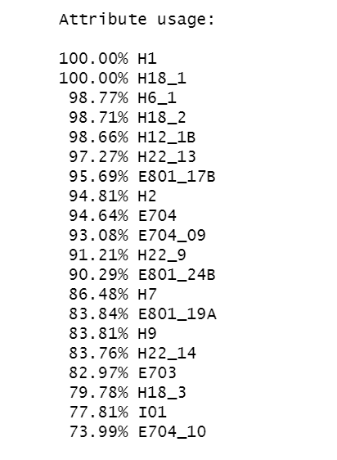Used Features like:























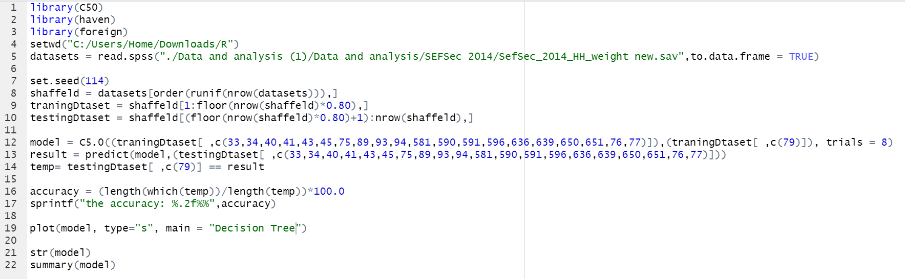code

summary

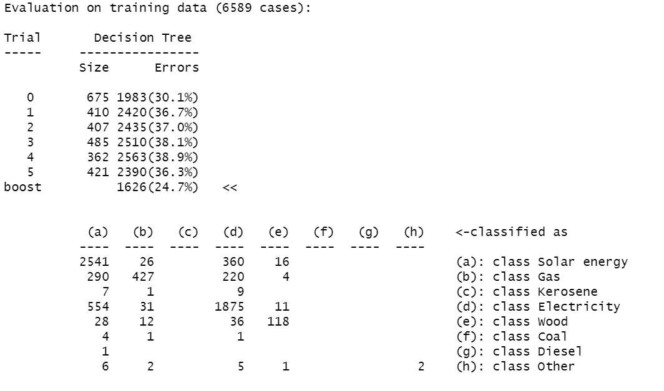Accuracy in training data 24.7 -100 = 76.3%

Accuracy in testing data



Confusion matrix

