

#### Orange Coding Academy

Master Project Documentation

###### MASHTAL-online

Prepared by:

SAMI ISMAEL MHMOUD ALNJADAT

##### Contents

Chapter 1: Introduction 3

* 1. Brief
  2. Technologies Used 3

Chapter 2: Requirements and Analysis 5

|  |  |
| --- | --- |
| 2.1 Functional Requirements | 5 |
| 2.1.1 User | 4 |
| 2.1.2 Admin |  |
|  |  |

Chapter 3: Design

3.1 Database Schema 5

Chapter 4: Conclusion & Future work 6

4.1 Conclusion 6

4.2 Future Work 6

Chapter 1: Introduction

* 1. Brief

Mashtal website is a one-stop destination for plant enthusiasts, offering a diverse range of indoor plants suitable for both homes and corporate spaces. With a carefully curated selection of greenery, your website caters to customers looking to enhance their living or working environments with the beauty of nature. Additionally, you provide a variety of accessories, from stylish planters to essential care products, ensuring that your customers have everything they need to nurture their plants. With a focus on quality, your website aims to make plant shopping a convenient and enjoyable experience for all.

* 1. Technologies Used

### Front-End

* + - * HTML (Hyper Text Markup Language).
      * CSS (Cascading Style Sheets).
      * JavaScript.
      * Bootstrap.

### Back-End

* + - * PHP (Hypertext Preprocessor).
      * LARAVEL.
      * MySQL.

Chapter 2: Requirements and Analysis

* 1. Functional Requirements

Functional requirements in software engineering help you to capture the intended behavior of the system. This behavior may be expressed as functions, services or tasks or which system is required to perform.

### User:

Home page. Register or Login.

The user can view categories.

The user can view All-Products.

The user can view CART and add and delete Product in CART.

The user can add coupon.

The user can add review.

The user must be logging to go to checkout page and payment.

The user can pay by PayPal and cash on delivery.

### Admin:

Login. Dashboard.

The admin can view, add and delete categories.

The admin can view, add and delete users.

The admin can view, add and delete Products.

The admin can view, the message from users.

Chapter 3: Design

## Database Schema

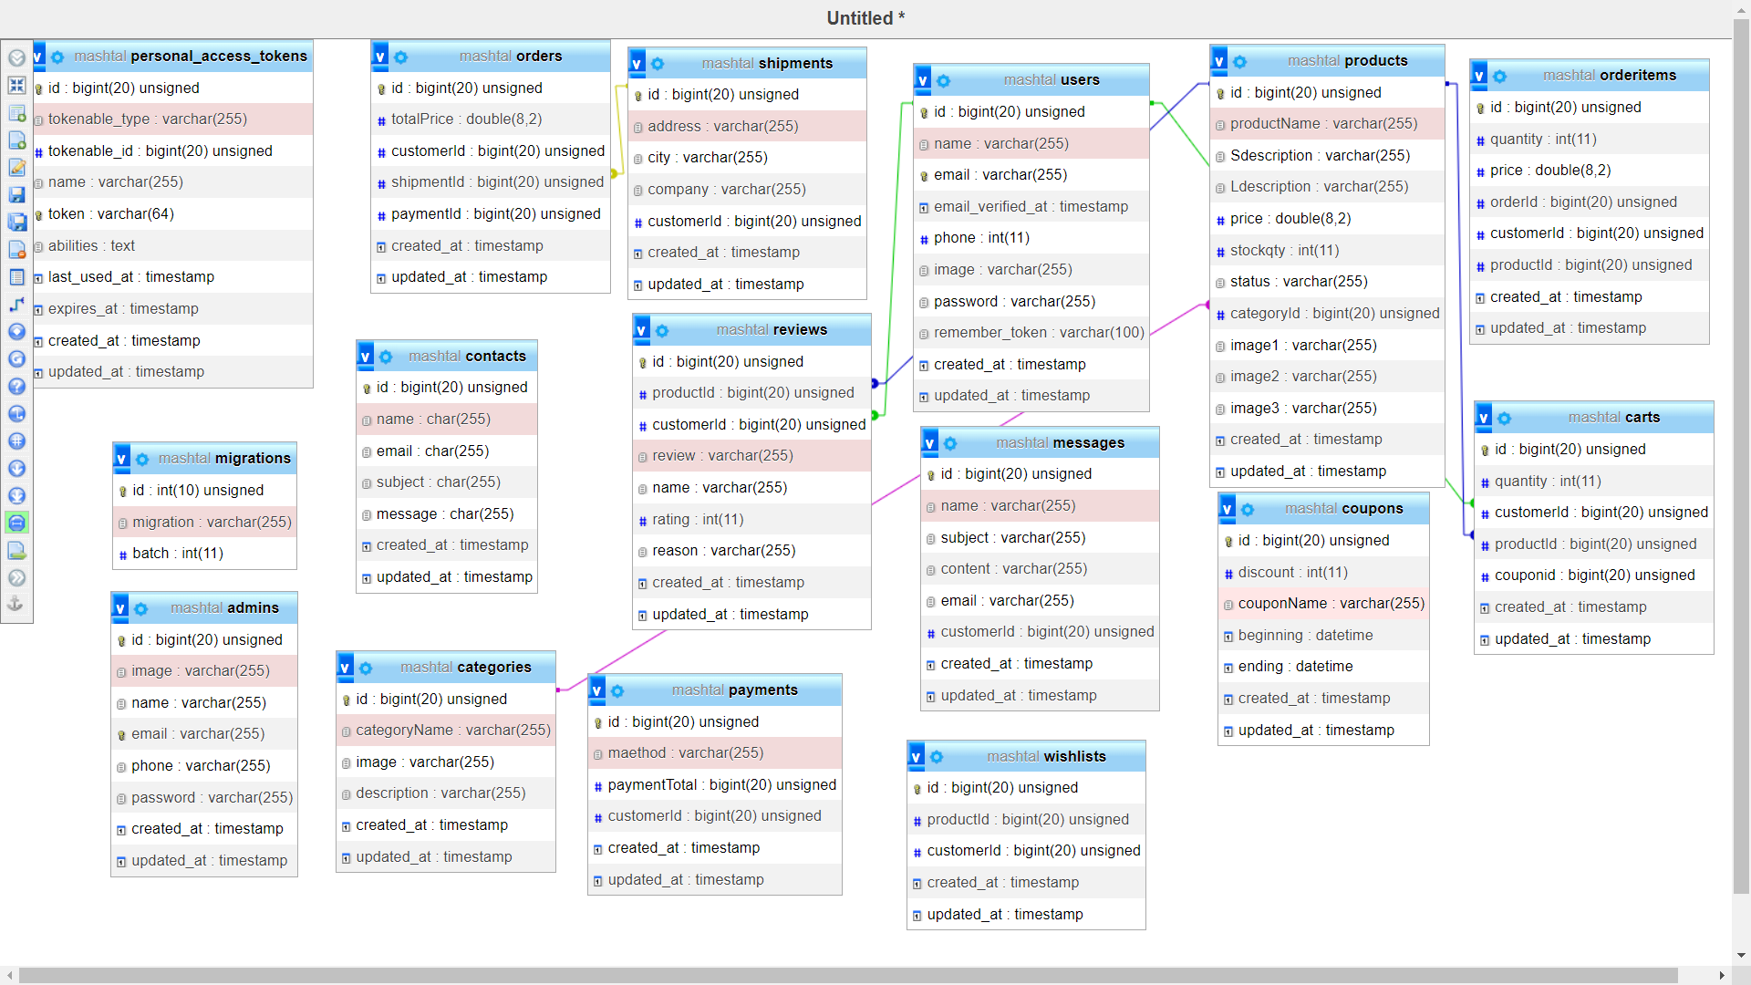

# Chapter 4: Conclusion & Future work

## Conclusion

This site was created to group the tourist places in Jordan, in addition to offering hotels in the cities in agreement with the owners, where people can book easily and comfortably.

## Future Work

* + - Recommend restaurants in cities.
    - Add booking form for restaurant.
    - Add payment and checkout for hotels and restaurants.
    - Multi language website.