TimeOff Microservice Syte,
Technical Requirements Document (TRD)
Repository: https://github.com/Ahmad-Aziz-2003/time-off-system
1. Objective
The TimeOff Microservice acts as a bridge between the employee application and an external HCM system like Workday or SAP. It manages the full lifecycle of leave requests while keeping leave balances consistent between both systems.
The main challenge is that both systems can update the same data independently, so the service must carefully control when to read, write, and sync data.

2. System Architecture
The system is divided into three main services.
Services and Ports
Service | Technology | Port | Responsibility
Frontend | Next.js + Zustand | 3000 | UI for employees and managers
Backend API | NestJS + TypeScript | 3002 | Business logic, validation, sync
Mock HCM Server | Express + TypeScript | 3001 | External source of truth simulation

The backend acts as the central controller. It handles all communication and ensures that the frontend never directly interacts with the HCM.

3. Data Model
Table | Key Fields | Purpose
Employees | id, email, role, locationId | Stores user identity
LeaveBalances | employeeId, availableDays, version | Local cache with locking
LeaveRequests | daysRequested, status, managerId | Tracks full lifecycle
SyncLogs | syncType, status, timestamp | Tracks sync operations
The version field is used for optimistic locking to prevent race conditions when multiple updates happen at the same time.
4. Sync Strategy
Real-time Balance Check : Whenever a balance is requested, the system checks if the data is older than 15 minutes. If it is stale, it fetches fresh data from HCM and updates the local cache before returning the result.

Approval and Deduction : When a manager approves a request, the system first verifies the latest balance from HCM. If sufficient, it deducts leave using HCM. If anything fails, the request stays pending and no local update happens.

Batch Synchronization : Every 10 minutes, a cron job fetches all balances from HCM. It updates local records but skips employees who have pending requests to avoid overwriting active changes.

5. Key Challenges
Balance Drift : HCM can update balances independently. This is handled using TTL-based refresh and periodic sync.
Unreliable HCM Errors : The system does not rely on HCM errors. It verifies balance locally and remotely before any deduction.
Race Conditions : Multiple requests at the same time can cause conflicts. Optimistic locking ensures only one request succeeds while others retry.
6. Edge Cases Handling
HCM Updates Balance Independently : Handled through real-time checks and scheduled sync.
Two Requests at Same Time : Second request fails due to version mismatch and must retry.
Batch Sync During Active Request : Employees with pending requests are skipped during sync to prevent overwriting.
Invalid Employee Location : System validates employee and location before making HCM calls.
Unauthorized Cancel Request : Only the request owner can cancel. Otherwise, access is denied.
HCM Downtime : If HCM is unreachable, the request remains pending and no data is changed.

7. API Overview
Method | Endpoint | Purpose
POST | /auth/login | User login
GET | /leave/balance/:id | Get balance
POST | /leave/request | Submit leave
POST | /leave/approve/:id | Approve request
DELETE | /leave/request/:id | Cancel request
POST | /sync/trigger | Manual sync
GET | /sync/logs | View logs

8. Test Summary
The system was tested using unit tests, integration tests, and end-to-end tests.
Unit tests verify core business logic like leave validation, approvals, and sync behavior.
Integration tests ensure complete workflows such as submitting and approving requests work correctly.
End-to-end tests simulate real user actions from login to final balance deduction.
Overall coverage is around 50 percent. Core logic is well tested while non-critical parts like mock servers are excluded.
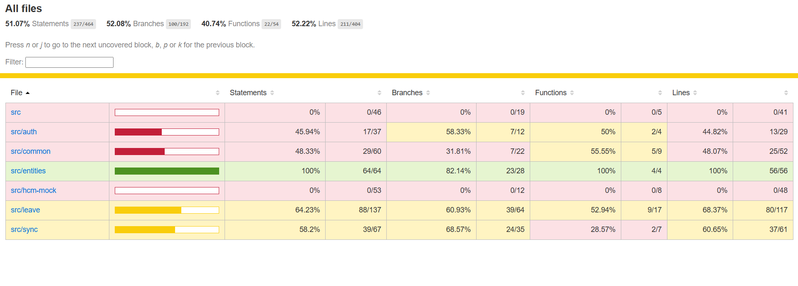
9. Seed Data
Name | Email | Password | Location | Role | Balance
Ali Khan | ali@readyon.com | pass1234 | LOC-1 | Employee | 15
Sara Ahmed | sara@readyon.com | pass1234 | LOC-1 | Employee | 12
Ahmed Raza | ahmed@readyon.com | pass1234 | LOC-2 | Employee | 10
Zara Manager | manager@readyon.com | pass1234 | LOC-1 | Manager | —

10. Frontend Explanation
The frontend is built using Next.js and provides a simple interface for users.
Zustand is used for state management because it is lightweight and easy to use compared to Redux.
Main parts of frontend:
auth store manages login session and user data
leave store manages balance and requests
sync store manages sync logs

Pages in the system:
login page for authentication
dashboard page showing balance and history
request page to submit leave
manager page to approve or reject requests
Middleware is used to protect routes so only authorized users can access certain pages.

11. Final Summary
This system solves a real-world distributed system problem where two systems manage the same data.
Instead of relying only on one system, it combines caching, real-time validation, and periodic synchronization.
This approach ensures the system remains fast, reliable, and consistent without unnecessary complexity.

