


Project-1 Documentation: Equipify Project

Supervised by: Dr. Hamad Alsawalqah
Student Id | Student Name
0214463 | Mohammed Mahmoud Ahmad Al-Khalilah
0214634 | Ahmad Samih Saadi Fahed
0214984 | Nour Mohammad Nemer Al-Zubaidi
0211082 | Linda Raid Ghazi Allafi

ABSTRACT
This project introduces an easy-to-use online platform designed to make tool rental simple and secure. Equipify connects tool owners and renters, allowing them to communicate and complete rentals effortlessly. The platform uses an OTP system to ensure safety and trust between users. By carefully planning and designing the system, Equipify solves the problem of expensive and unused tools by offering a cost-effective and sustainable solution. It helps people rent, share, and manage tools easily, saving resources and encouraging a collaborative community.

ACKNOWLEDGEMENT

We would like to express our heartfelt gratitude to everyone who contributed to the success of the Equipify project. Special thanks to our supervisor, Dr. Hamad Alsawalqah, for his constant support and invaluable guidance throughout this journey. We deeply appreciate the feedback from everyone who shared their insights, helping us refine and enhance Equipify’s features. A warm thank you goes out to our colleagues, friends, and families for their encouragement and belief in us, especially during the challenging moments. Equipify is a true reflection of the hard work, dedication, and collaboration of everyone involved, and we are truly grateful for each contribution to this achievement.

Table of Contents
ABSTRACT 3
ACKNOWLEDGEMENT 3
1.0 CHAPTER 1: INTRODUCTION 9
1.1 Motivation 9
1.2 Problem Statement 9
1.3 Project Aim and Objectives 9
1.4 Project Scope 12
1.5 Software and Hardware Requirements 14
1.6 Project Limitations 15
1.7 Project Expected Output 15
1.8 Project Schedule 16
1.9 Report Outline 18
2.0 CHAPTER TWO: RELATED EXISTING SYSTEMS 20
2.1 Existing Systems/Products 20
2.2 Problems/Weaknesses 20
2.3 Solutions in Our Product 21
3.0 CHAPTER THREE: SYSTEM REQUIREMENTS ENGINEERING AND ANALYSIS 22
3.1 Feasibility Study 22
3.3 Targeted Users 35
3.4 System stakeholders and Requirements Sources 35
3.5 Functional Requirements Definition and Specification 36
3.6 Non-Functional Requirements 41
3.7 Usability and User Experience Goals 42
4.0 CHAPTER FOUR: SYSTEM DESIGN 45
4.1 Context Diagram 45
4.2 Data Flow Diagram (DFD) 46
4.3 Entity Relationship Diagram (ERD) 47
4.4 UML Use Case diagram, Scenario and UML Sequence diagram 48
4.4.1 User Use Case 49
4.4.2 User Scenarios, Sequence Diagrams 50
4.4.3 Admin Use Case 81
4.4.4 Admin Scenarios, Sequence Diagrams 82
4.4.5 Customer Support Use Case 92
4.4.6 Customer Support, Sequence Diagrams 93
4.5 UML Class Diagram 101
4.6 Graphical User Interface / Low Fidelity Prototype 102

List of Figures
Figure: 1 PERT diagram 17
Figure: 2 Gantt Chart 18
Figure: 3 technologies and tools 22
Figure: 4 Context Diagram 45
Figure: 5 Data Flow Diagram (DFD) 46
Figure: 6 Entity Relationship Diagram (ERD) 47
Figure: 7 UML Use Case diagram 48
Figure: 8 User Use Case 49
Figure: 9 User Registration - Input Validation 51
Figure: 10 Login to System 52
Figure: 11 View User Profile 54
Figure: 12 Edit User Profile 55
Figure: 13 View User Ratings 56
Figure: 14 Access Navbar Options 57
Figure: 15 Search Listings 58
Figure: 16 View News Section 59
Figure: 17 Create Listing 60
Figure: 18 Add Listing Data 61
Figure: 19 Add Listing Cost 62
Figure: 20 View Categories 63
Figure: 21 Filter Listings by Category 64
Figure: 22 View Listings 65
Figure: 23 View Listing Details 66
Figure: 24 Submit Rental Request 67
Figure: 25 Access Footer Information 68
Figure: 26 Notify User of Rental Requests 69
Figure: 27 Notify Users of System Updates 70
Figure: 28 Access About Us Page 71
Figure: 29 Access FAQ Page 72
Figure: 30 View Rental Requests 73
Figure: 31 Process Rental Request 74
Figure: 32 View Accepted Rental Requests 75
Figure: 33 View Terms and Conditions 76
Figure: 34 Accept Terms and Conditions 77
Figure: 35 Verify Rental Agreement with OTP 78
Figure: 36 Report a Problem 79
Figure: 37 Submit Report Details 80
Figure: 38 Admin Use Case 81
Figure: 39 Admin Login 82
Figure: 40 Add News to System 83
Figure: 41 Update News Section 84
Figure: 42 Remove News Section 85
Figure: 43 View Listings 86
Figure: 44 Edit Listing Details 87
Figure: 45 Delete Listing 88
Figure: 46 Approve Listing 89
Figure: 47 Reject Listing 90
Figure: 48 Admin Logout 91
Figure: 49 Customer Support Use Case 92
Figure: 50 Customer Support Login 93
Figure: 51 Handle User Support Ticket 94
Figure: 52 Maintain FAQs and Tutorials 95
Figure: 53 Collect User Feedback 96
Figure: 54 Monitor Support Tickets 97
Figure: 55 Access Rental History 98
Figure: 56 Create Support Reports 99
Figure: 57 Customer Support Logout 100
Figure: 58 UML Class Diagram 101

List of Tables
Table 1 needed hardware and software 14
Table 2 estimated project schedule 16
Table 3 Development Costs 23
Table 4 Hardware and Software Cost 24
Table 5 Operational Cost 24
Table 6 Tangible Benefits 25
Table 7 Cost-Benefit Analysis 26
Table 8 Schedule feasibility 27
Table 9 System stakeholders 36
Table 10 Functional Requirements 36
Table 11 Non-Functional Requirements 41
Table 12 User Registration - Input Validation 50
Table 13 Login to System 52
Table 14 Reset Password 53
Table 15 View User Profile 54
Table 16 Edit User Profile 55
Table 17 View User Ratings 56
Table 18 Access Navbar Options 57
Table 19 Search Listings 58
Table 20 View News Section 59
Table 21 Create Listing 60
Table 22 Add Listing Data 61
Table 23 Add Listing Cost 62
Table 24 View Categories 63
Table 25 Filter Listings by Category 64
Table 26 View Listings 65
Table 27 View Listing Details 66
Table 28 Submit Rental Request 67
Table 29 Access Footer Information 68
Table 30 Notify User of Rental Requests 69
Table 31 Notify Users of System Updates 70
Table 32 Access About Us Page 71
Table 33 Access FAQ Page 72
Table 34 View Rental Requests 73
Table 35 Process Rental Request 74
Table 36 View Accepted Rental Requests 75
Table 37 View Terms and Conditions 76
Table 38 Accept Terms and Conditions 77
Table 39 Verify Rental Agreement with OTP 78
Table 40 Report a Problem 79
Table 41 Submit Report Details 80
Table 42 Admin Login 82
Table 43 Add News to System 83
Table 44 Update News Section 84
Table 45 Remove News Section 85
Table 46 View Listings 86
Table 47 Edit Listing Details 87
Table 48 Delete Listing 88
Table 49 Approve Listing 89
Table 50 Reject Listing 90
Table 51 Admin Logout 91
Table 52 Customer Support Login 93
Table 53 Handle User Support Ticket 94
Table 54 Maintain FAQs and Tutorials 95
Table 55 Collect User Feedback 96
Table 56 Monitor Support Tickets 97
Table 57 Access Rental History 98
Table 58 Create Support Reports 99
Table 59 Customer Support Logout 100

CHAPTER 1: INTRODUCTION

1.1 Motivation
- Renting tools through Equify allows renters to save money and ensures that tools are being used only when needed, making the most out of each item.
- By renting instead of buying, Equify helps reduce waste, contributing to more sustainable living and promoting eco-friendly habits.
- Renting gives you access to different tools you might not be able to afford or store at home, so you can do more things.

1.2 Problem Statement
- Many renters and the community are unaware of Equify and its ability to provide easy access to rented tools and equipment at affordable prices.
- If a tool is already reserved, other renters must wait until it becomes available, which can cause delays and frustration.
- If the rental process is difficult fewer people will use the service

1.3 Project Aim and Objectives
Project Aim:
The aim of this project is to enhance the renting of tools and equipment by creating a user-friendly online platform. Equipify aims to simplify the rental process, promote cost-effective and sustainable practices, optimize the usage of tools, and improve overall user satisfaction for individuals and organizations needing short-term equipment for various projects.
Objectives:
- Develop a User-Friendly Interface:
    - Create an intuitive and easy-to-use interface for the Equipfy platform, ensuring a seamless rental experience for users with varying levels of technological proficiency.
- Centralize Booking Information:
    - Implement a centralized platform that consolidates all tool and equipment rental details, providing users with a single point of access for availability, reservations, pricing, and related information.

- Real-Time Availability Updates:
  - Integrate a real-time availability system to provide accurate and up-to-date information on the status of tools and equipment, enabling users to make informed rental decisions.
- Categorize Equipment by Type and Purpose:
  - Categorize tools and equipment based on their type and intended use, allowing users to easily identify and choose the right items for their specific needs.
- Efficient Booking Process:
  - Streamline the rental process to minimize the time and steps required for users to reserve tools, encouraging increased utilization and making it more convenient for users to access the equipment they need..
- User Authentication and Authorization:
  - Incorporate a secure user authentication system with role-based authorization, ensuring that only registered users can make or manage tool rentals. This system will include OTP (One-Time Password) verification for added security during user sign-in and transactions
- Feedback Mechanism:
  - Integrate a feedback system to gather user input and suggestions, enabling continuous improvement of the rental process and platform based on real user experiences and needs.
- Reporting and Analytics:
  - Develop reporting and analytics features to track tool utilization, identify peak rental times, and generate insights that can help optimize tool availability, improve resource planning, and provide better service.

1.4 Project Scope

Need: The identified need is to simplify and secure the process of renting tools and equipment for individuals and organizations, providing an accessible and user-friendly platform for seamless short-term rentals while ensuring user security.

Scope: The project involves developing a comprehensive online platform for renting tools and equipment, where users can create accounts, browse available items, select rental durations, and complete reservations. The website will feature an intuitive user interface for easy navigation and a backend system for managing user profiles, tools, and rental transactions. After the user is assigned to a terms and conditions page, they must confirm their agreement before an OTP (One-Time Password) is sent to their phone number. This OTP will confirm that the renter has successfully reserved the tool. The platform will also integrate a secure payment system to facilitate smooth financial transactions. The platform aims to promote sustainability by offering an alternative to purchasing tools and improving overall resource utilization.

Objectives: The primary objectives are to create a user-friendly and secure platform that simplifies the rental process for tools and equipment. The system should ensure secure user authentication through the OTP process, promoting accessibility, sustainability, and efficiency. Business objectives may include increasing user engagement with the platform, optimizing tool availability, reducing the need for unnecessary purchases, and generating revenue through tool rentals. A portion of the revenue can be allocated to improving the platform and supporting its ongoing growth and maintenance.

Deliverables:
- User authentication system with OTP verification for secure reservations
- Front-end development with an intuitive user interface
- Back-end development for managing facilities, reservations, and user profiles.
- Testing documentation and procedures Assumptions:
- Assumption that user feedback will be gathered for iterative improvements to the platform.
- Assumption that tool owners and renters will have reliable internet access for platform interaction.

1.5 Software and Hardware Requirements
The estimated hardware and software costs are illustrated in Table 1.
Table 1 needed hardware and software
 | Description | Quantity | Unit Price (JD) | Total Price (JD) | Note
HD1 | Servers (rent) | 1 | 50/month | 50 | Price per month
HD2 | Networking/Internet | 1 subs | 34/month | 34 | Price per month
HD3 | Printers | 1 | 100 | 100
HD4 | PCs | 4 | 700 | 2800
SW1 | The Amazon Web Services | 1TB | 0.026 per GB per month | 26.6/month | Price per month
SW2 | DBMS | 1 | 100 | 100 | Price per month
SW5 | Security Software | 1 | 250 | 250
SW6 | Collaboration Tools | 3 | 25 | 75
SW7 | User Analytics and Monitoring Tools | 1 | 250 | 250
Total |  |  |  | 3,285.6JD’s

1.6 Project Limitations
- Budget constraints may impact the choice of technologies and development resources.
- Time constraints to ensure timely delivery of the project within the academic timeframe.
- Resource constraints, including the availability of developers and other necessary team members.
- Potential risks such as technical challenges or unforeseen issues during development.

1.7 Project Expected Output
project expected output is broader than the deliverables that we mentioned before in the scope section, so we expect the output of our project to be:
- Include a user-friendly reservation system.
- Increased engagement with the platform, resulting in more users renting tools for short-term projects.
- Greater demand for rental tools, improving the overall utilization of available equipment.
- Potentially increased revenue through paid reservations.
- Efficient and faster usage for both owners and renters.

1.8 Project Schedule
The estimated project schedule is illustrated in Table 2.
Table 2 estimated project schedule
TASK ID | TASK | ASSIGNED  START END  TO |  |  | Dependencies
Initiation
T1 | Gathering Information | All team  10/25/24 10/31/24  members |  |  | -
T2 | requirements analysis | All team  11/1/24  members |  | 11/6/24 | T1
T3 | Define Project Scope and Objectives | Linda, Noor 11/7/24 |  | 11/10/24 | T2
T4 | feasibility study | Ahmad, Moh 11/7/24 11/20/24 |  |  | T2
T5 | Initial plan | All members | 11/21/24 11/27/24 |  | T3
Planning and design
T6 | Create schedule | Moh, Noor | 12/1/24 12/5/24 |  | T5
T7 | Identify deliverables | Linda | 12/5/24 12/10/24 |  | T5
T8 | Identify Risks and mitigation strategies | Linda, Ahmad | 12/11/24 12/15/24 |  | T6
T9 | System modeling | All team members | 12/12/24 12/25/24 |  | T8, T10
T10 | Design (GUI, Database) | Mohammad, Ahmad | 12/26/24 1/10/25 |  | T4
implementation
T11 Execute tasks |  | All team members | 1/11/25 1/25/25 |  | T9
T12 Monitor progress |  | Mohammed | 1/26/25 2/5/25 |  | T11
T13 Manage resources |  | Ahmad | 2/6/25 2/20/25 |  | T11
T14 Testing and validation |  | Linda,noor 2/7/25 3/6/25 |  |  | T11

The PERT diagram for the project schedule is illustrated in Figure 1. A PERT diagram is a project management tool that uses nodes and arrows to show tasks, their dependencies, and time estimates. It helps plan projects by identifying critical tasks and the project's overall timeline.
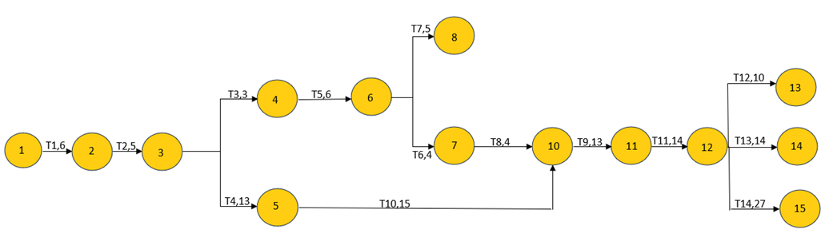
Figure: 1 PERT diagram

We can detect from the PERT diagram that the critical path is 93 working days, and the critical activities are T1, T2, T4, T10, T9, T11 and T14, meaning that any delay on one of these critical activities will cause the entire project to get delayed.

The Gantt Chart can be found in Figure 2. A Gantt chart is a visual project management tool that displays tasks, their durations, and their relationships over a timeline. It helps track project progress, allocate resources, and manage project schedules
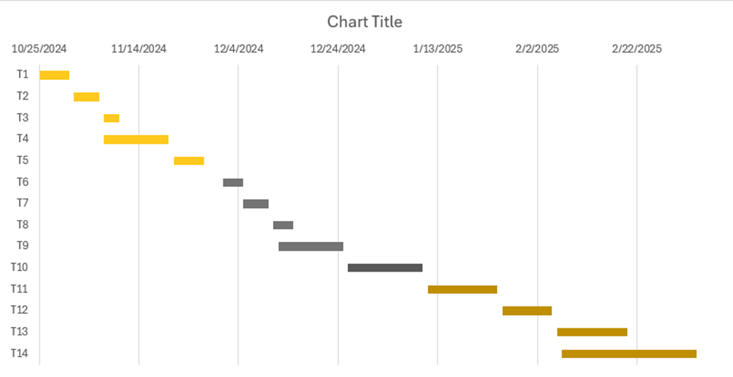
Figure: 2 Gantt Chart

1.9 Report Outline
- Chapter one Introduction: In this chapter, we have discussed the main idea of the project and our motivation to provide a convenient platform for renting tools, helping people save money and avoid unnecessary purchases. The project aims to simplify the rental process and make tools accessible for temporary use.
- Chapter two related the existing system: in this chapter we will discuss the existing system that is not fully computerized and from here our idea of Equipfy emerged to solve the inefficiencies, such as difficulty in finding tools and unclear rental terms, we seek in this project to solve these problems completely.
iii. Chapter three system requirements engineering and analysis: in this chapter we had calculate the overall budget for the project and done a survey to try to filter the requirements to get to our targeted users, and we will define the functional requirement and non-functional requirements.
- Chapter Four System Design: In this chapter, we will talk about designing the system, simplifying it and facilitating it as much as possible through models and figures to prepare it for programmers, and about preparing the initial design of the website screens to present it to customers.
- Chapter Five Implementing the system: In this chapter, we will apply what we wrote previously, such as designing and creating databases, implementing screens design using code.
- Chapter Six system testing and installation: In this chapter, we will test every part of the system to check if every functionality is working properly and fixing the bugs if found and doing the user manual to teach the user how to use the system.
- Chapter Seven project conclusions and future work: This chapter presents the project conclusions and future work including the overall weaknesses and strengths, and future directions.

2.0 CHAPTER TWO: RELATED EXISTING SYSTEMS

2.1 Existing Systems/Products
1. Fat llama: a website that protects owners against loss or damage to items rented through the platform. It outlines the steps and conditions owners need to follow to ensure they qualify for this protection, helping build trust and security within the rental process.
Fat llama link: https://fatllama.com/uk

- Big Rentz: is an online equipment rental platform that provides access to a wide range of construction tools and heavy machinery. It simplifies the rental process by connecting customers with local suppliers across the U.S.
Big Rentz Link: https://www.bigrentz.com/

2.2 Problems/Weaknesses
- User Interface Complexity: A complicated or unclear interface can make it hard for users to browse or rent tools, which may lead to frustration

- Lack of Confirmation and Trust: The platform doesn’t provide a secure way to confirm reservations or build trust between tool owners and renters.

2.3 Solutions in Our Product
In our product we had focused on:
- UI/UX and the ease of use in our interface so the first-time user will not find it difficult to use and reserve.
- Adding a secure OTP-based confirmation system and clear terms to build trust and improve reservation experience.

3.0 CHAPTER THREE: SYSTEM REQUIREMENTS ENGINEERING AND ANALYSIS

3.1 Feasibility Study

3.1.1 Technical Feasibility
Our project is a complete website. Resources that are required for this project include:
- Programming device.
- Hosting space.
- Programming tools.
- Programming individuals.
The main technologies and tools that are associated with this project are:

- HTML.
- CSS.
- JavaScript.
- Bootstrap
- Typescript
- Angular
- ASP.net
- C#
- MySQL
Figure: 3 technologies and tools

Each of the technologies is freely available and the technical skills required are manageable. The limitations of product development and the ease of implementing using these technologies are synchronized. Our system has enough flexibility for the users to easily handle it.

3.1.2 Operational Feasibility
The web-based platform for Equipify is operationally feasible due to its user-friendly design, compatibility with existing systems, and automated processes that reduce administrative workload.
3.1.3 Economic Feasibility
3.1.3.1 Development Costs
Table 3 Development Costs
Employee position | Cost per hour | Number of Hours | Total cost
Software Engineer | 25 | 70 | $1,750
System Analyst | 30 | 50 | $1,500
System Administrator | 20 | 20 | $400
GUI designer | 15 | 70 | $1,050
Database Administrator | 20 | 15 | $300
Project Manager | 30 | 70 | $2,100
Total |  |  | $7,100

3.1.3.2 Hardware and Software Cost

Table 4 Hardware and Software Cost
Name |  | Cost
Computers |  | $2,000
GUI Development Tools |  | $100
DBMS |  | $500
Virtual Private Server (VPS) |  | $800
Development environment |  | $300
Total |  | $3,700
Total Development Costs
Total |  | $10,800

3.1.3.3 Operational Cost
Table 5 Operational Cost
Name | Cost per year
Employee wages | $9000
Maintenance and Repair | $1300
Utility | $1500
Accounting and Legal fees | $600
Total | $12,400

- Tangible Benefits

Table 6 Tangible Benefits
Name | Benefit
Decrease the number of employees | $8400
Increased Flexibility | $3000
Ease of management and control | $3000
Total | $14400

- Intangible Benefits
  - Reducing the possibilities of error occurrences.
  - Enhancing the service.
  - Improved Customer Satisfaction
  - Time Savings

- Cost-Benefit Analysis
Table 7 Cost-Benefit Analysis
Year | 0 | 1 | 2 | 3 | 4 | 5
Estimated Cost | 26,800 | 1,300 | 1,900 | 2,800 | 3,100 | 3,700
Estimated benefits | 0 | 31,200 | 46,800 | 54,600 | 65,520 | 70,200
Discount (rate 10%) | 1 | 0.91 | 0.83 | 0.75 | 0.68 | 0.62
Accumulated Costs | 26,800 | 27,983 | 29,560 | 31,660 | 33,768 | 36,062
Accumulated benefits | 0 | 28,392 | 67,236 | 108,186 | 152,829 | 196,353
Accumulated benefits -  Accumulated Costs | -26,800 | 409 | 36,676 | 76,526 | 119,061 | 160,291

From the previous table we conclude that:
- Since the present value of accumulated benefits in the fifth year of operation (196,353 JD).
Exceeding the present value of the accumulated costs (36,062 JD), this project has a payback.
- Payback year = The first year.
- Lifetime ROI = (Estimated lifetime benefits - estimated lifetime costs) / estimated lifetime costs So, Lifetime ROI = (196,353- 36,062) / 36,062= 4.445
- The Annual ROI for the project is: 4.445 / 5 = 0.889
- Net Present Value = Total Present Value of Benefits – Total Present Value of Costs So, Net Present Value =196,353– 36,062= 160,291 JD.

3.1.4 Schedule Feasibility
Table 8 Schedule feasibility
Task | Description | Start time | End time | Duration | Dependency
T1 | Specifying project concepts, purpose, and scope | 12/7/2024 | 12/8/2024 | 2 Days | None
T2 | Project planning and structuring. | 12/9/2024 | 12/12/2024 | 5 Days | T1
T3 | Feasibility Study | 12/13/2024 | 12/15/2024 | 3 Days | T2
T4 | Software Requirements Specifications | 12/16/2024 | 12/18/2024 | 3 Days | T2
T5 | System Analysis | 12/19/2024 | 12/20/2024 | 2 Days | T4
T6 | System Design | 12/21/2024 | 12/25/2023 | 5 Days | T5
T7 | Implementation | 12/26/2024 | 12/30/2023 | 5 Days | T6
T8 | User Manual | 1/3/2025 | 1/5/2025 | 3 Days | T7

3.2 Requirements Gathering Techniques
3.2.1 Questioner
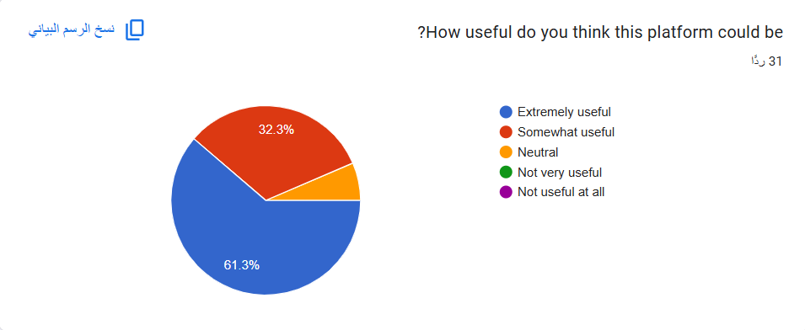

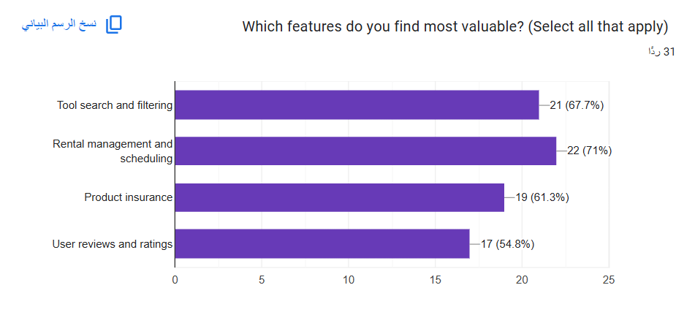
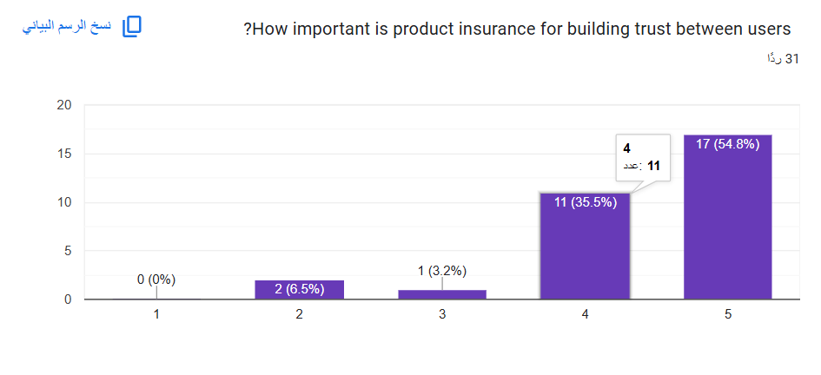
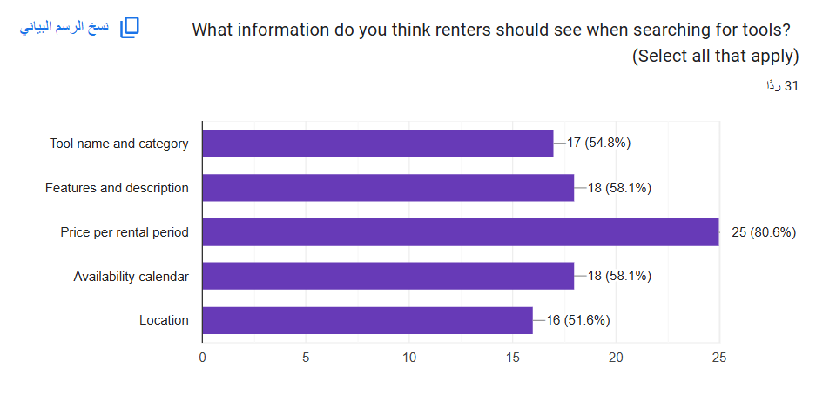

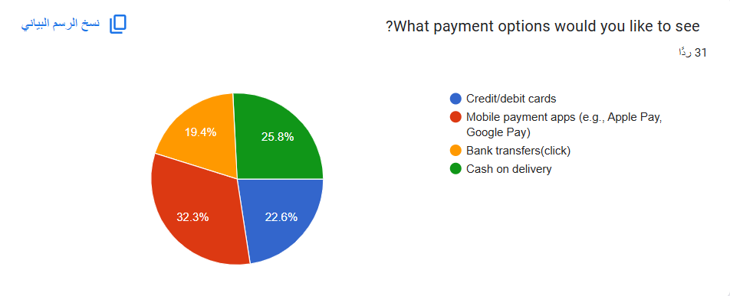

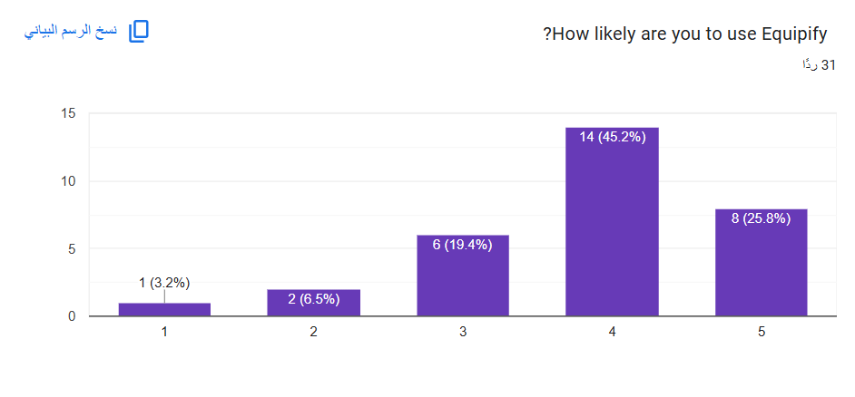

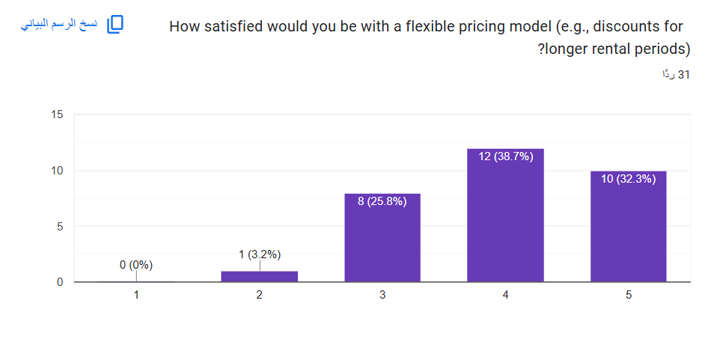

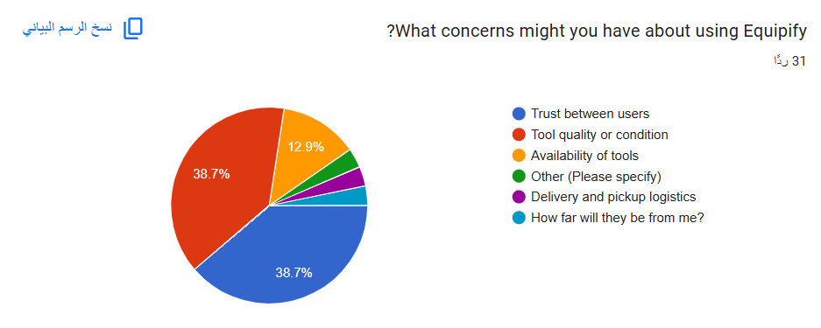

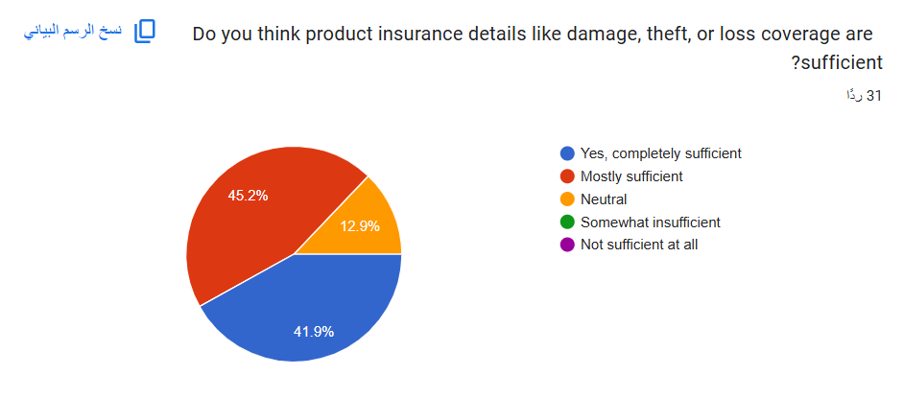

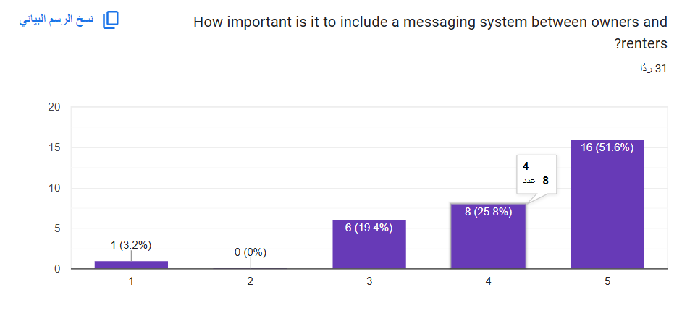

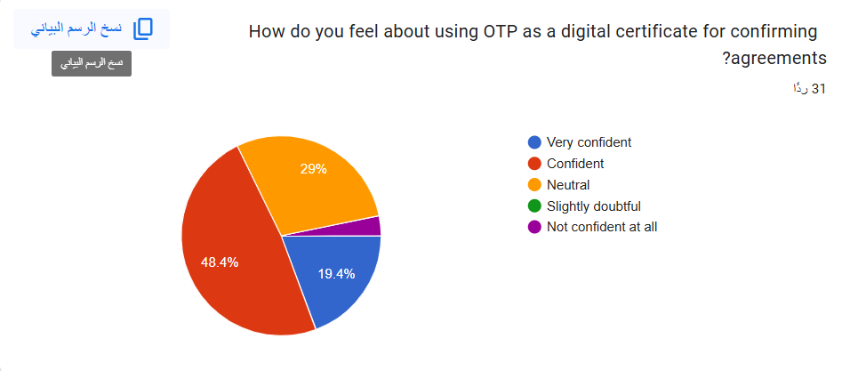

- Summary:
Thirty-one people completed the opinion survey that was conducted via Google Form the responses highlighted several challenges faced by individuals when it comes to accessing and renting tools. These include difficulties in finding available tools, concerns about trust between users, tool quality or condition. The need for all was to find an electronic solution, such as a user-friendly website or application, to simplify the tool-renting process, enhance trust, and address these concerns effectively.

3.2.2 Interview
interviewee name: Dr. Mohammed Abusharaiah
Closed-Ended Questions:
- Do you think Equipify's tool searching feature effectively meets the needs of users looking to rent tools?
  - [ ] Yes
  - [ ] No
  - [ ]Unsure
- Is the rental management system (including booking calendars and availability tracking) user-friendly and efficient?
  - [ ]Strongly Agree
  - [] Agree
  - [ ]Neutral
  - [ ]Disagree
  - [ ]Strongly Disagree
- Do you find the insurance feature using OTP verification to be a reliable method for ensuring secure rental agreements?
  - [] Yes
  - [ ]No
  - [ ]Maybe
- Should Equipify prioritize integrating additional security measures beyond OTP for rental agreements?
  - [ ]Yes
  - [] No
  - [ ] Not Sure
- Do you believe Equipify can be integrated into academic programs as a practical project for students?
  - []Yes
  - [ ]No
  - [ ] Maybe

Open-Ended Questions:
Based on my discussion with Linda, I believe that functionalities / services of “Equipify” system meet the expectations of renters and owners. Your Equipify project looks very essential, and I believe there is a need to develop this project in reality. Your idea of Equipify is scalable and can be a startup in future , Good luck !!

interviewee name: Dr. Huda Karajah
Closed-Ended Questions:
- Do you think Equipify's tool searching feature effectively meets the needs of users looking to rent tools?
  - [ ] Yes
  - [ ] No
  - [ ]Unsure
- Is the rental management system (including booking calendars and availability tracking) user-friendly and efficient?
  - [ ]Strongly Agree
  - [] Agree
  - [ ]Neutral
  - [ ]Disagree
  - [ ]Strongly Disagree
- Do you find the insurance feature using OTP verification to be a reliable method for ensuring secure rental agreements?
  - [ ] Yes
  - [ ]No
  - [ ]Maybe
- Should Equipify prioritize integrating additional security measures beyond OTP for rental agreements?
  - [ ]Yes
  - [ ] No
  - [ ] Not Sure
- Do you believe Equipify can be integrated into academic programs as a practical project for students?
  - []Yes
  - [ ]No
  - [ ] Maybe

Open-Ended Questions:
After discussing your Equipfy project, I believe its functionalities and services perfectly address the needs. This idea is innovative, practical, and has strong potential for real-world websites. I’m confident that Equipfy could evolve into a successful startup in the future. Best of luck!

- Summary:
Many interviews were conducted, but the most crucial ones were with Dr. Huda and Dr. Mohammed, according to the interviews, they face significant challenges in managing and tracking tool rentals efficiently. They emphasized the need for a website that simplifies the process.

3.3 Targeted Users
- Individuals who need tools for short-term use
- individuals want to rent out their tools to earn extra income.
- Individuals who cannot afford to buy tools

3.4 System stakeholders and Requirements Sources
The stakeholder refers to “a person, group or company that is directly or indirectly involved in the project and who may affect or get affected by the outcome of the project”
The stakeholders of this project will show in the table below: -

Table 9 System stakeholders
Stakeholders number | Stakeholders Name | Description
1 | End user | Individuals who use the platform for renting or offering tools
2 | Administrator | The person who will manage the platform operations
3 | Customer support | The customer support team will aid and support platform users.

3.5 Functional Requirements Definition and Specification
Table 10 Functional Requirements
FR-ID | FR-Title | Description | Stakeholder | Priority | Notes
FR-001 | User Registration - Input Validation | The system must validate user input for first name, last name, email, phone number, password, and birthdate during registration. | ST1 | High | Fields must not be empty, email must be valid, password must meet security requirements.
FR-003 | User Login | The system must allow users to log in using their email and password. | ST1 | High | Invalid credentials must trigger a clear error message.
FR-004 | Password Reset | The system must allow users to reset their password using a secure email-based link. | ST1 | High | Password reset link must expire after a specified duration.
FR-005 | View Profile | The system must allow users to view their profile details, including name, phone number, email, birthdate, location, and profile image. | ST1 | High
FR-006 | Edit Profile | The system must allow users to update their profile information (name, phone, birthdate, location, profile image). | ST1 | High
FR-007 | View User Ratings | The system should allow users to view their ratings as given by other users. | ST1 | Medium
FR-008 | Navbar Access | The system must allow users to access the navigation bar containing links to View Profile, About Us, FAQ, Notifications, and Sign Out. | ST1 | High
FR-009 | Search | The system must allow users to search for listings using keywords. | ST1 | High
FR-010 | News Section | The system should allow user to access news section on the home screen for system updates. | ST1 | Medium
FR-011 | Add New Listing - Data Input | The system must allow users to add a listing by providing a title, uploading photos/videos, and specifying a category, sub-category, and availability dates. | ST1 | High
FR-012 | Add New Listing - Cost Details | The system must allow users to define the rental cost based on the selected rental period and add a description, location, and contact information. | ST1 | High
FR-013 | View Categories | The system must allow user to access all available categories and sub-categories and show related listings when a category is clicked. | ST1 | High
FR-014 | Filter by Category | The system must allow users to filter listings by category or sub-category to refine search results. | ST1 | High
FR-015 | View User Listings | The system must allow user to access all listings, showing the title, category, thumbnail, and cost. | ST1 | High
FR-016 | View Listing Details | The system must allow users to view detailed information about a listing, including title, photos, description, location, and owner’s contact information. | ST1 | High | If the item is rented, the "Request to Rent" button must be disabled.
FR-017 | Request to Rent Button | The system must allow renters to submit a rental request by clicking "Request to Rent," which notifies the owner and records the request. | ST1 | High
FR-018 | Footer Information | The system must allow user to access system contact information on the footer of every page. | ST1 | High
FR-019 | Notifications - User Rental Requests | The system must notify owners when a rental request is submitted and notify renters of request acceptance or rejection. | ST1 | High | Notifications must be real-time or near real-time.
FR-020 | Notifications - General Updates | The system should send notifications to users about general updates, such as news or system alerts. | ST1 | Medium
FR-021 | About Us Page | The system should allow user to access "About Us" page from the navbar. | ST1 | Medium
FR-022 | FAQ Page | The system should allow user to access an FAQ page from the navbar. | ST1 | Medium
FR-023 | View Rental Requests | The system must allow owners to view all rental requests for their listings, displaying renter details, rental period, and total cost. | ST1 | High
FR-024 | Accept/Reject Rental Requests | The system must allow owners to accept or reject rental requests and notify the renter of the decision. | ST1 | High
FR-025 | Accepted Rental Requests Screen | The system must display accepted rental requests, showing details of the owner, listing, rental period, and cost. | ST1 | High
FR-026 | Terms and Conditions - Display | The system must allow user to access the terms and conditions for rental agreements. | ST1 | High
FR-027 | Terms and Conditions - Acceptance | The system must require renters to accept terms and conditions by checking a box before proceeding. | ST1 | High
FR-028 | OTP Verification | The system must send an OTP to the renter’s phone number and require entry from the OTP to confirm the rental agreement. | ST1 | High
FR-029 | Report Section - Problem Reporting | The system must allow users to report problems or non-compliance issues related to a listing to customer support. | ST1 | High
FR-030 | Report Section - Report Details | The system must require users to provide the listing ID, problem description, and their contact information when submitting a report. | ST1 | High | Reports must contain sufficient details for customer support to act on them.
FR-031 | Sign in | The system must allow admins to sign in to the system by entering the e-mail and password. | ST2 | High
FR-032 | Add to the news | The system must allow admins to add to the news slider by clicking on the "add news" button | ST2 | High
FR-033 | Update to the news | The system must allow admins to update to the existing news slider by clicking on the “update news" button | ST2 | High
FR-034 | Delete to the news | the system must allow admins to delete from the existing news slider by clicking on the “delete news" button | ST2 | High
FR-035 | Admin list view | The system must allow admin to view a list of all items on the website | ST2 | High
FR-036 | Admin list edition | the system should allow admin to edit an item detail | ST2 | Medium
FR-037 | Admin list deletion | The system must allow admins to delete listings that violate policies or are reported by users | ST2 | High
FR-038 | Admin approval for listings | the system must allow admins to approve item listing submitted by owners before it is posted on the website | ST2 | High
FR-039 | Admin rejection for listings | The system must allow admins to reject item listing submitted by owners before it is posted on the website | ST2 | High
FR-040 | Sign out | the system should allow admins to sign out of their accounts | ST2 | Medium
FR-041 | Sign in | The system must allow customer support agents to securely sign into their accounts to access the support system | ST3 | High
FR-042 | Responding to User Inquiries | The system must enable customer support to respond to user inquiries through a ticketing system | ST3 | High | The ticketing system should categorize inquiries by type (e.g., technical, rental issues, account problems)
FR-043 | Provide FAQs and Tutorials | The system should maintain an FAQ and tutorials section to assist users in resolving common issues independently | ST3 | Medium | The FAQ and tutorials should cover account setup, tool rentals and payments
FR-044 | Manage User Feedback | The system should collect and analyze user feedback to improve platform services | ST3 | Medium
FR-045 | Track Ticket Status | The system must allow customer support to track the status of support tickets, including open and resolved tickets | ST3 | High
FR-046 | View User Rental History | The system should allow customer support to view the rental history of users to assist with inquiries or disputes | ST3 | Medium | Rental history should include dates, tool details, and transaction status
FR-047 | Generate Support Reports | The system may provide tools to generate reports on support metrics, such as response time and resolution rate | ST3 | Low | Reports help evaluate the performance of the customer support team
FR-048 | Sign Out | The system must provide customer support team members with the ability to securely sign out of their accounts | ST3 | High

3.6 Non-Functional Requirements
Table 11 Non-Functional Requirements
NFR-ID | NFR-Title | Description | Priority | Notes
NFR-001 | Performance | The platform must handle at least 50 concurrent users without significant performance degradation. | High
NFR-003 | Response Time | Average response time for user actions should not exceed 3 seconds. | medium
NFR-004 | Usability | The UI must be intuitive and require minimal training for new users. | High
NFR-005 | Security | - User data must be securely encrypted in transmission (HTTPS).  - Users can access the system by email and password confirmed by the system. | High
FR-006 | Maintainability | The system should tolerate faults and errors as much as possible without failing. | High
FR-007 | Vulnerability Protection | The system must protect against SQL injections, XSS, and other vulnerabilities. | High

Usability and User Experience Goals

Usability Goal: The goal of usability is to ensure that the Equipify platform is intuitive, efficient, and easy to use for all stakeholders, including end users (owners and renters) and administrators.
- Efficiency:
- End users should be able to perform common tasks, such as posting or renting tools, in a few simple steps.
- Admins should efficiently manage listings, approve or reject items, and handle user reports.
- Intuitiveness:
- The interface should have a user-friendly layout, allowing users to navigate listings, profiles, and rental processes easily.
- Admin tools and customer support features should be logically organized to reduce complexity.
- Error Handling:
- Error messages should clearly explain issues, such as invalid input or unsuccessful actions, and guide users on how to resolve them.
- The system should minimize errors with features like input validation and disabled buttons for unavailable options for example disabled Request to Rent" for already rented items
- Consistency:
- Ensure a consistent design throughout the platform, including similar layouts for profiles, listings, and rental requests.
- Admin tools should follow a standardized layout to reduce complexity and improve usability.
User Experience Goal: The goal of user experience is to provide positive and seamless interaction for all users throughout their journey on Equipify.
- Engagement
- End users should find the platform engaging with features like notifications, personalized recommendations, and a news section.
- Admins and customer support should have efficient and rewarding tools to complete their tasks.
- Personalization
- Allow users to personalize their profiles, notifications, and preferences for a tailored experience.
- Enable admins to configure platform settings for streamlined operations.
- Satisfaction
- Users should feel satisfied with how smoothly they can find and rent tools or manage their listings.
- Admins and customer support should feel equipped to handle tasks effectively without confusion.
- Community Building
- Foster trust between renters and owners through features like ratings, reviews, and profiles.
- Encourage collaboration by making communication and feedback channels accessible
- Feedback Loop:
- Provide users with an easy way to submit feedback or report issues.
- Allow admins and support staff to gather and act on feedback to improve the platform.
- Learning Curve
- Minimize the learning curve for new users by providing FAQs, tutorials, and intuitive design.
- Ensure admins and support staff can quickly adapt to the system with clear documentation and training materials.

4.0 CHAPTER FOUR: SYSTEM DESIGN

4.1 Context Diagram
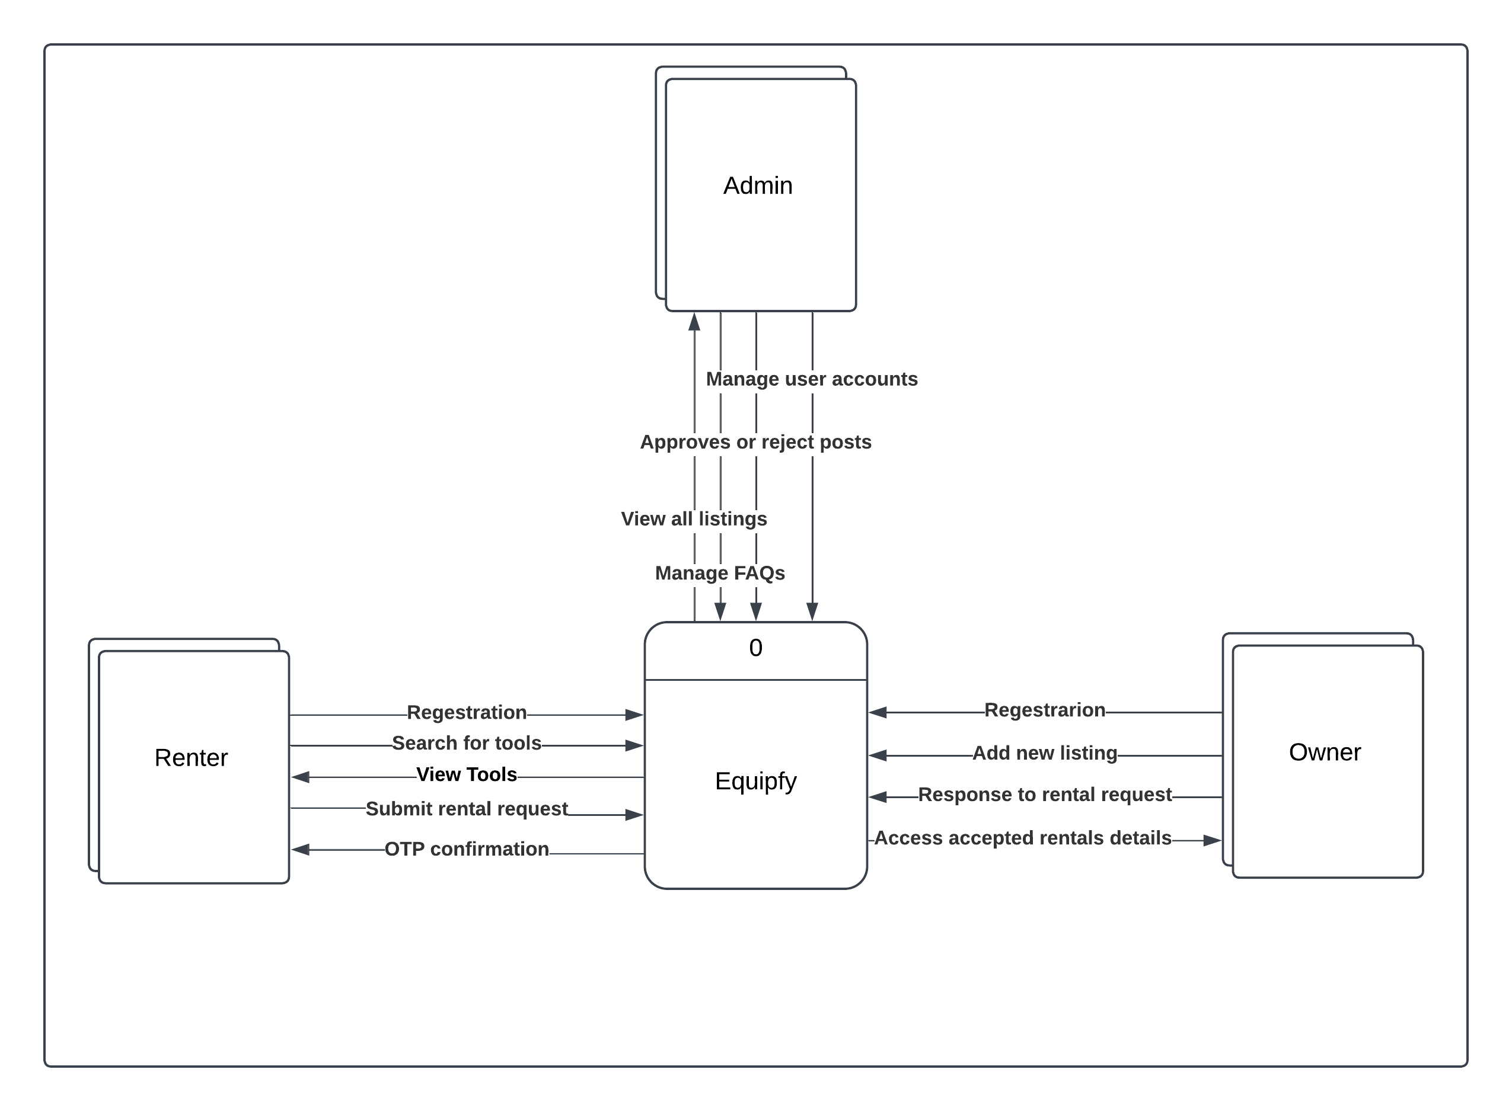
Figure: 4 Context Diagram

4.2 Data Flow Diagram (DFD)

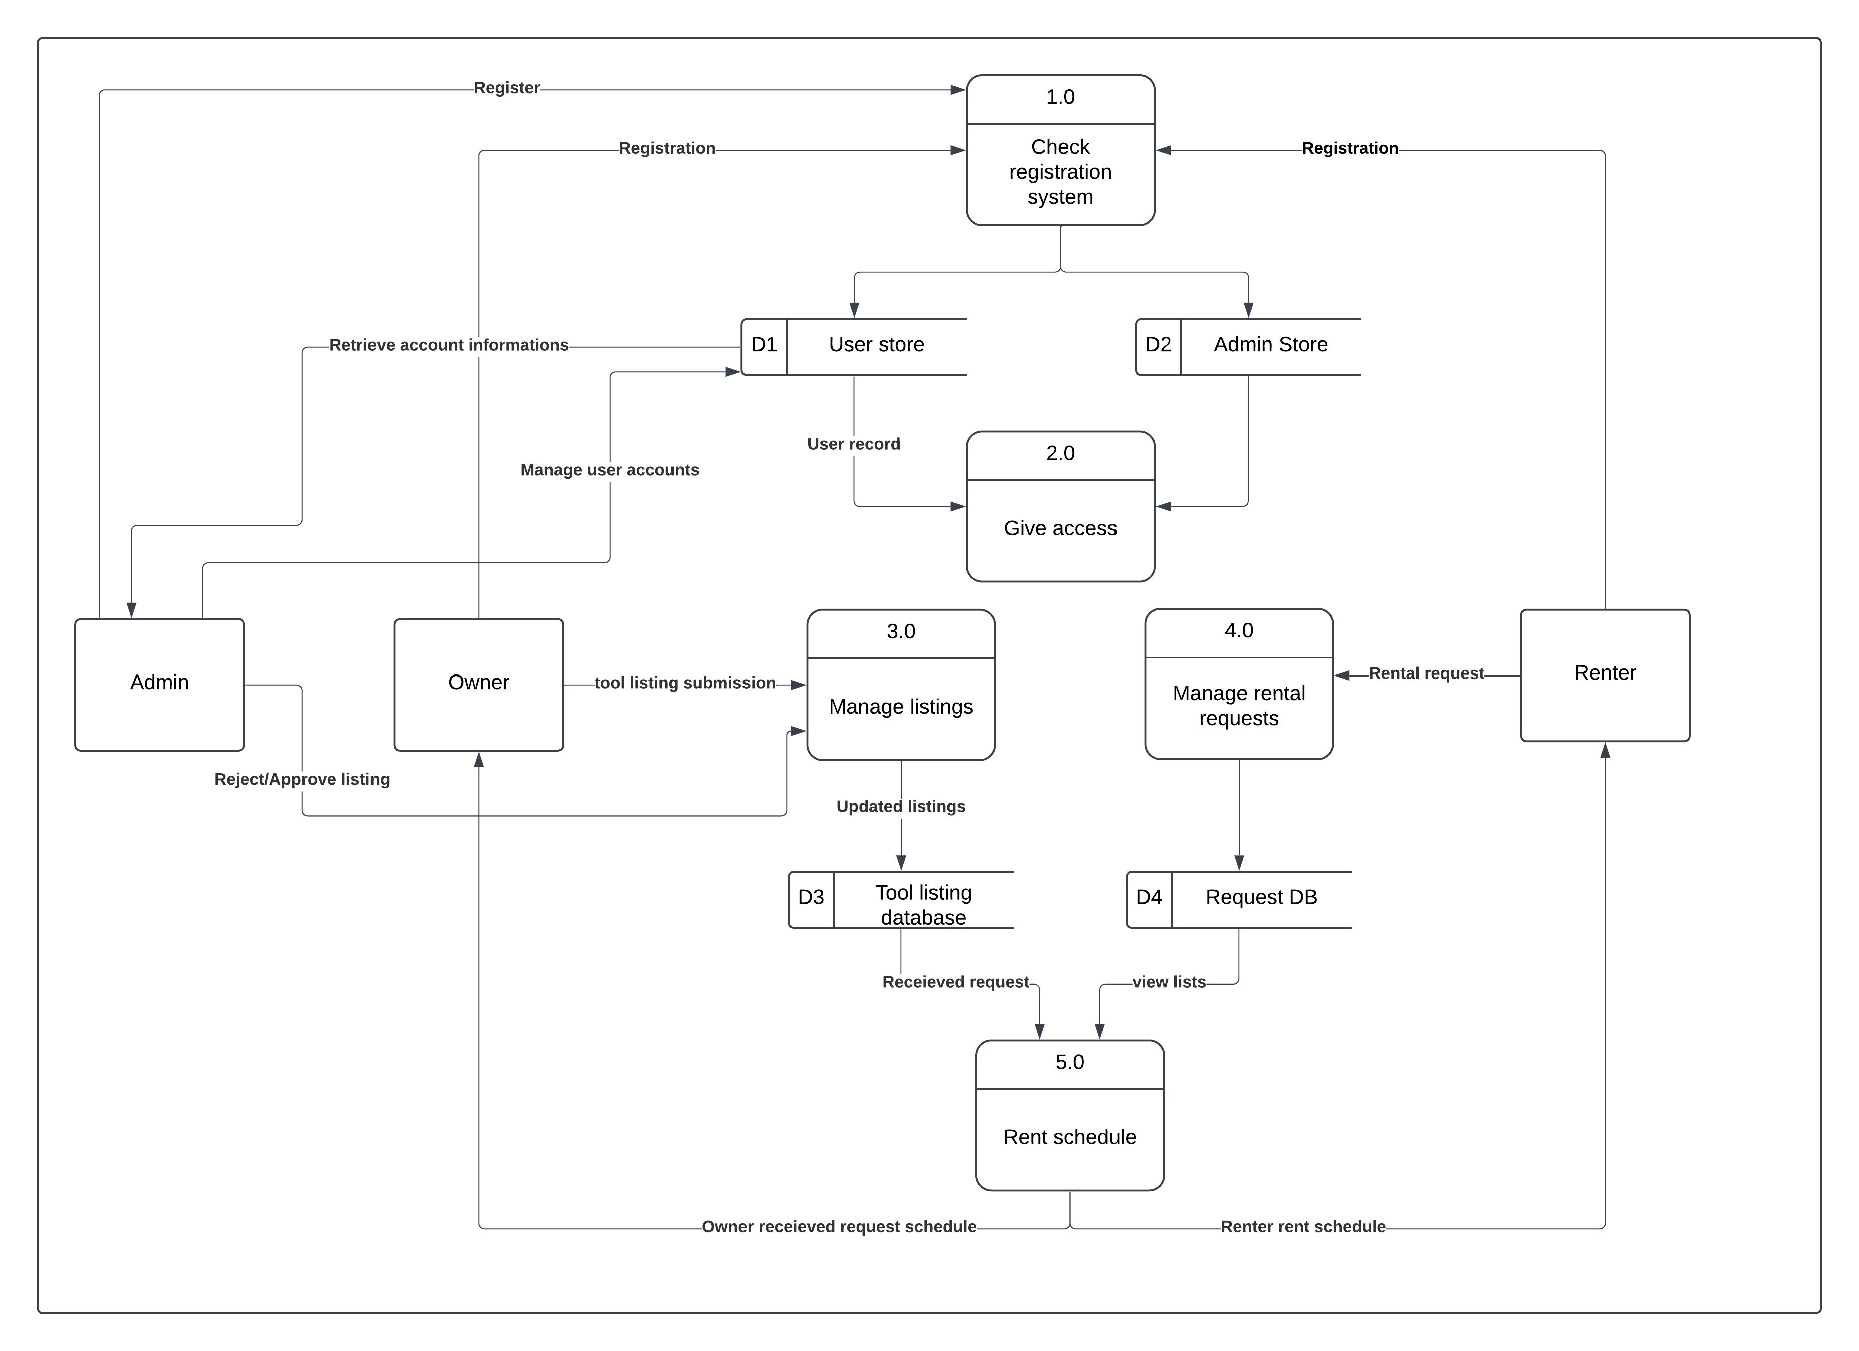

Figure: 5 Data Flow Diagram (DFD)

4.3 Entity Relationship Diagram (ERD)

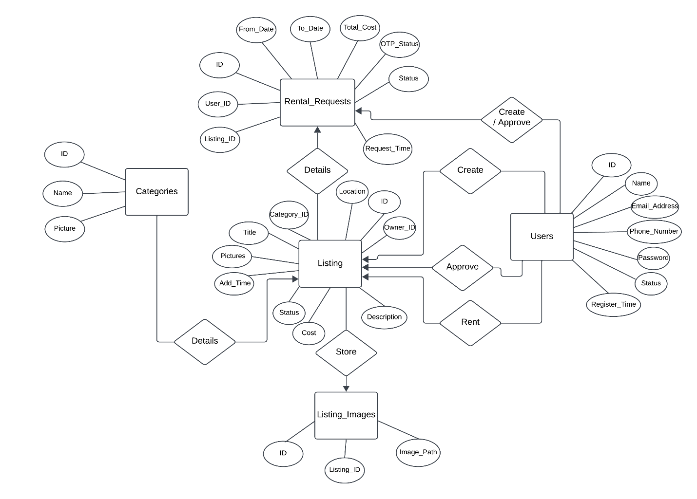

Figure: 6 Entity Relationship Diagram (ERD)

4.4 UML Use Case diagram, Scenario and UML Sequence diagram

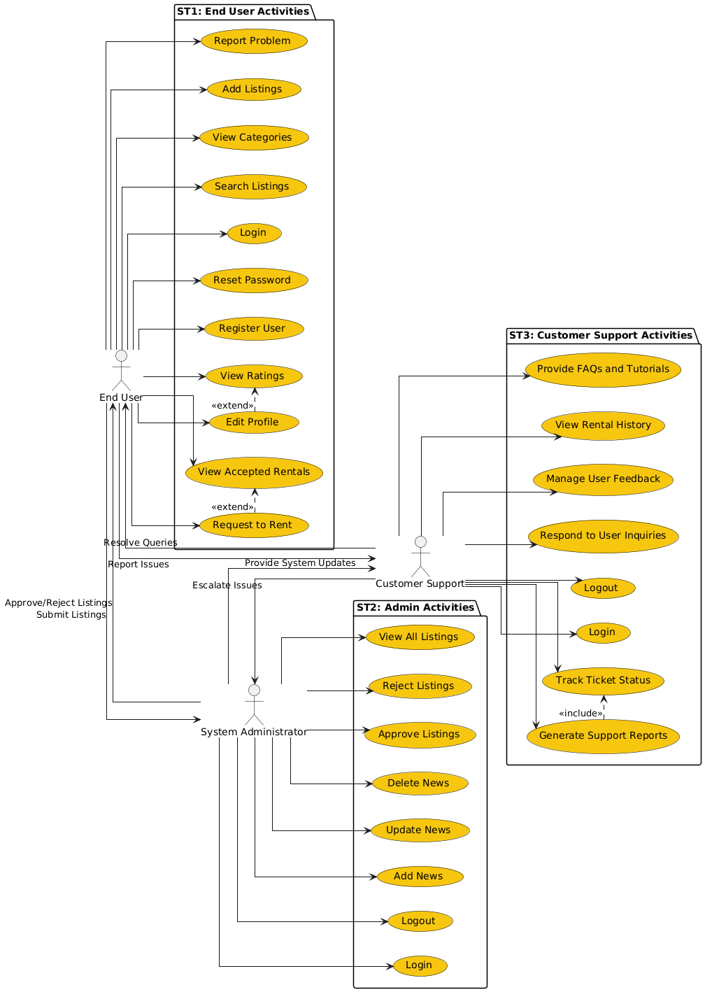

Figure: 7 UML Use Case diagram

4.4.1 User Use Case
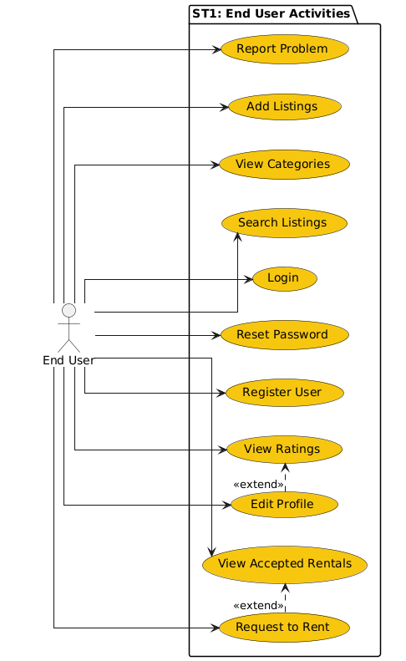

Figure: 8 User Use Case

4.4.2 User Scenarios, Sequence Diagrams

Table 12 User Registration - Input Validation

Use Case Name | Create User Account
Scenario | Validate user input during registration
Triggering Event | New user attempts to create an account
Brief Description | The system validates user input (name, email, phone, password) to ensure completeness and correctness before account creation
Actors | End User
Related Use Cases | None
Stakeholders | End User, System Administrator
Preconditions | All registration fields are accessible and functional
Postconditions | User accounts are created successfully, or error messages are displayed for invalid inputs
Flow of Activities | Actor | System
 | 1. User enters registration details (name, email, phone, password, birthdate) | 1.1 System checks if all fields are filled  1.2 System validates email format  1.3 System checks password strength  1.4 System validates phone number format  1.5 If all validations pass, the system saves user account details
Exception Conditions | 1.1 Missing required fields  1.2 Invalid email format  1.3 Invalid phone number

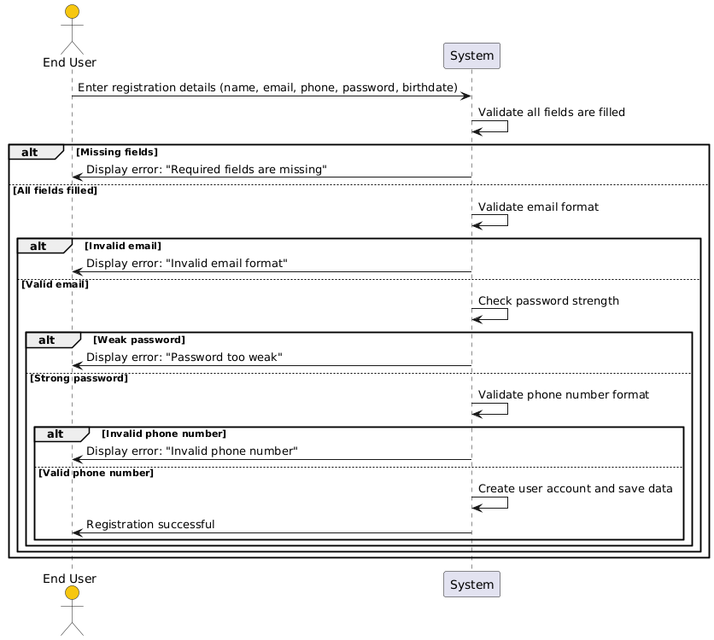
Figure: 9 User Registration - Input Validation

Table 13 Login to System
Use Case Name | Login to System
Scenario | Log in to the platform using email and password
Triggering Event | A user attempts to log in
Brief Description | The system verifies the user’s credentials and allows access if they are correct
Actors | End User
Related Use Cases | None
Stakeholders | End User, System Administrator
Preconditions | User account exists, and the login form is functional
Postconditions | User is logged in successfully, or error messages are displayed for invalid credentials
Flow of Activities | Actor | System
 | 1. User enters email and password | 1.1 System checks if the credentials are valid  1.2 If valid, the system grants access to the user account
Exception Conditions | 1.1 Incorrect email or password
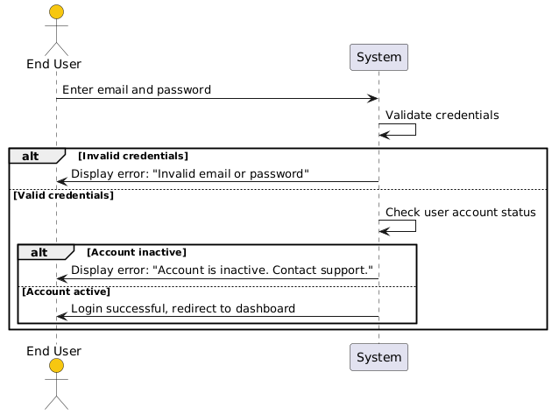
Figure: 10 Login to System
Table 14 Reset Password

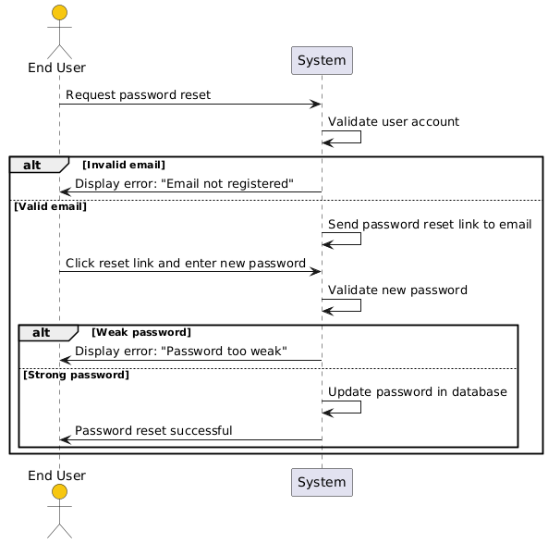

Use Case Name | Reset Password
Scenario | Reset password using a secure link
Triggering Event | User requests a password reset
Brief Description | The system sends a password reset link to the user’s registered email and updates the password if valid input is provided
Actors | End User
Related Use Cases | None
Stakeholders | End User, System Administrator
Preconditions | User account exists, and email service is functional
Postconditions | Password is successfully reset, or error messages are displayed for invalid inputs
Flow of Activities | Actor | System
 | 1. User requests password reset  2. User clicks the reset link and enters a new password | 1.1 System sends a password reset link to the user’s email  1.2 System validates the new password and updates the account
Exception Conditions | 1.1 Invalid email

Table 15 View User Profile
Use Case Name | View User Profile
Scenario | Access user profile details
Triggering Event | User selects the "View Profile" option
Brief Description | The system retrieves and displays user profile information, such as name, contact details, location, and profile picture
Actors | End User
Related Use Cases | Edit Profile
Stakeholders | End User
Preconditions | User must be logged in
Postconditions | Profile details are displayed correctly
Flow of Activities | Actor | System
 | 1. User selects "View Profile" | 1.1 System retrieves profile information from the database  1.2 System displays profile details to the user
Exception Conditions | 1.1 User is not logged in
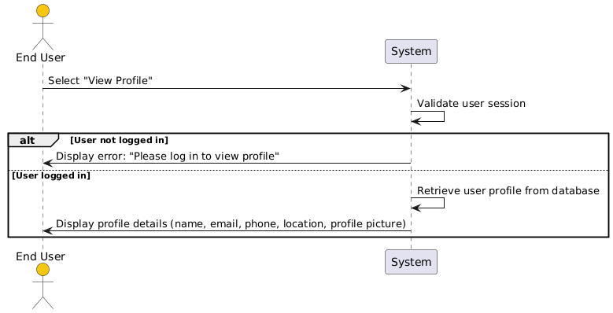
Figure: 11 View User Profile

Table 16 Edit User Profile
Use Case Name | Edit User Profile
Scenario | Modify user profile information
Triggering Event | User selects the "Edit Profile" option
Brief Description | The system allows users to update personal information, such as name, phone number
Actors | End User
Related Use Cases | View Profile
Stakeholders | End User
Preconditions | User must be logged in
Postconditions | Profile details are updated successfully
Flow of Activities | Actor | System
 | 1. User updates profile details (name, phone) | 1.1 System validates updated information  1.2 System saves the updated profile to the database
Exception Conditions | 1.1 Invalid input format
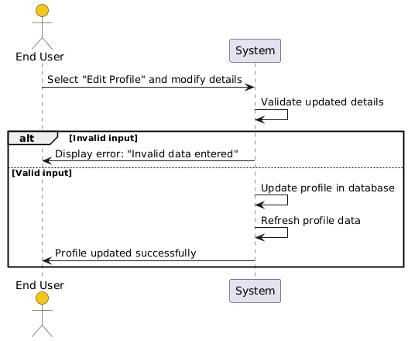
Figure: 12 Edit User Profile

Table 18 Access Navbar Options

Use Case Name | Access Navbar Options
Scenario | Navigate the platform using the navbar
Triggering Event | User clicks on a navbar option
Brief Description | The system loads the corresponding page (e.g., Profile, FAQ)
Actors | End User
Related Use Cases | View Profile, View FAQ
Stakeholders | End User
Preconditions | User must be logged in
Postconditions | The correct page is displayed
Flow of Activities | Actor | System
 | 1. User clicks on a navbar option | 1.1 System retrieves the selected page's content  1.2 System displays the selected page to the user
Exception Conditions | 1.1 User is not logged in
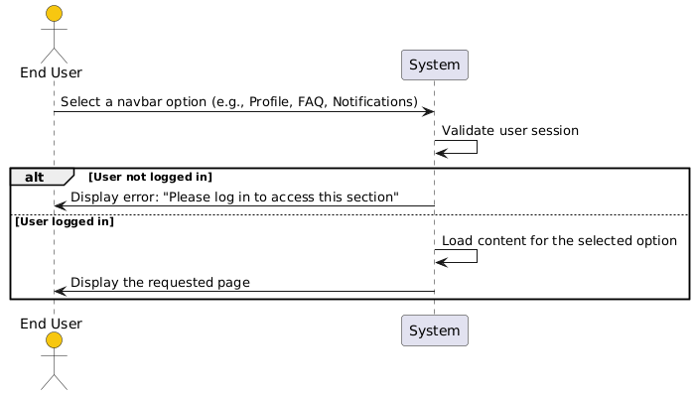
Figure: 14 Access Navbar Options

Table 19 Search Listings
Use Case Name | Search Listings
Scenario | Search for tools using keywords
Triggering Event | User enters a search query in the search bar
Brief Description | The system filters and displays listings matching the keywords
Actors | End User
Related Use Cases | Filter Listings
Stakeholders | End User
Preconditions | Search functionality must be available
Postconditions | Relevant listings are displayed
Flow of Activities | Actor | System
 | 1. User enters keywords in the search bar | 1.1 System filters listings based on the keywords  1.2 System displays the filtered results
Exception Conditions | 1.1 No matching results
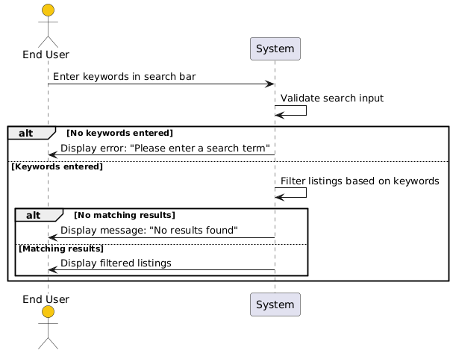
Figure: 15 Search Listings

Table 20 View News Section
Use Case Name | View News Section
Scenario | Access the news section for updates
Triggering Event | User clicks on the news section
Brief Description | The system displays recent updates and announcements
Actors | End User
Related Use Cases | None
Stakeholders | End User, System Administrator
Preconditions | The news section is populated with content
Postconditions | News items are displayed correctly
Flow of Activities | Actor | System
 | 1. User clicks on the news section | 1.1 System retrieves the latest news updates  1.2 System displays the news to the user
Exception Conditions | 1.1 No news content available
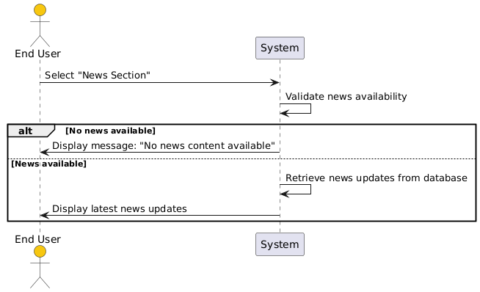
Figure: 16 View News Section

Table 21 Create Listing
Use Case Name | Create Listing
Scenario | Add a new tool listing
Triggering Event | User selects "Add Listing" and provides tool details
Brief Description | The system saves the listing with details like title, photos, and availability
Actors | End User (Owner)
Related Use Cases | View Listings
Stakeholders | End User, System Administrator
Preconditions | User must be logged in
Postconditions | Listing is created and saved successfully
Flow of Activities | Actor | System
 | 1. User enters listing details (title, photos, availability) | 1.1 System validates listing details  1.2 System saves the listing in the database
Exception Conditions | 1.1 Missing or invalid listing details
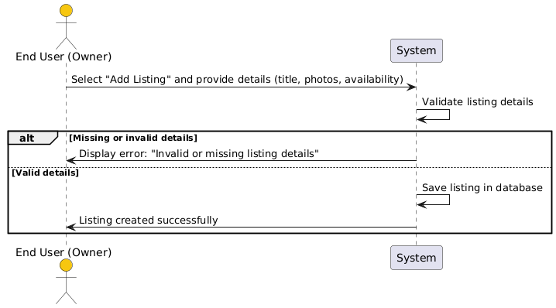
Figure: 17 Create Listing

Table 22 Add Listing Data
Use Case Name | Add Listing Data
Scenario | Provide listing data for a new tool
Triggering Event | User selects "Add Listing" and starts entering details
Brief Description | The system allows users to input a listing title, upload photos, and specify the category, and availability dates
Actors | End User (Owner)
Related Use Cases | Create Listing
Stakeholders | End User, System Administrator
Preconditions | User must be logged in
Postconditions | Listing data is entered successfully and saved
Flow of Activities | Actor | System
 | 1. User enters listing details (title, category, availability) | 1.1 System validates the inputs  1.2 System uploads and processes photos/videos  1.3 System saves the data temporarily
Exception Conditions | 1.1 Missing or invalid input fields
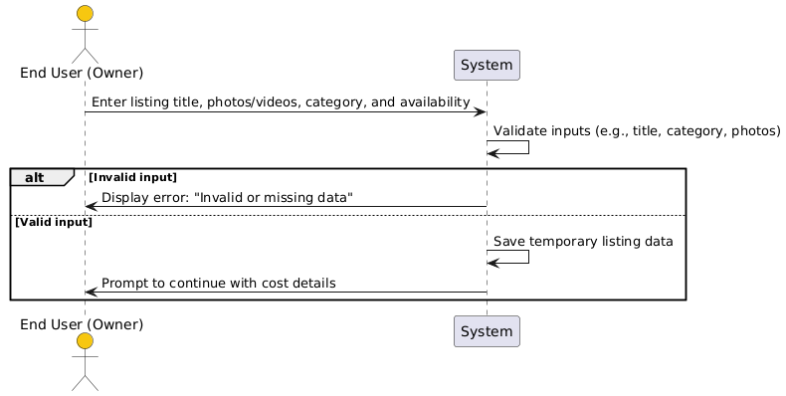
Figure: 18 Add Listing Data

Table 23 Add Listing Cost
Use Case Name | Add Listing Cost
Scenario | Define cost details for the new tool listing
Triggering Event | User enters the cost details for the listing
Brief Description | The system allows users to set rental cost, add a description, location, and contact information for the listing
Actors | End User (Owner)
Related Use Cases | Create Listing
Stakeholders | End User, System Administrator
Preconditions | Basic listing details have already been entered
Postconditions | Cost and additional details are saved successfully
Flow of Activities | Actor | System
 | 1. User enters cost, description, location, and contact info | 1.1 System validates all details  1.2 System updates the listing with additional details
Exception Conditions | 1.1 Missing or invalid cost or location data
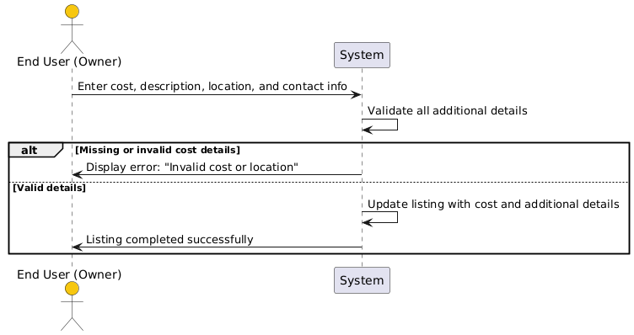
Figure: 19 Add Listing Cost

Table 24 View Categories
Use Case Name | View Categories
Scenario | Access available categories on the platform
Triggering Event | User clicks on the "Categories" section
Brief Description | The system displays all categories and their sub-categories to help users browse listings
Actors | End User
Related Use Cases | Filter by Category
Stakeholders | End User
Preconditions | Categories are already defined in the system
Postconditions | Categories and sub-categories are displayed successfully
Flow of Activities | Actor | System
 | 1. User clicks on "Categories" | 1.1 System retrieves all categories and sub-categories  1.2 System displays the list of categories
Exception Conditions | 1.1 No categories available
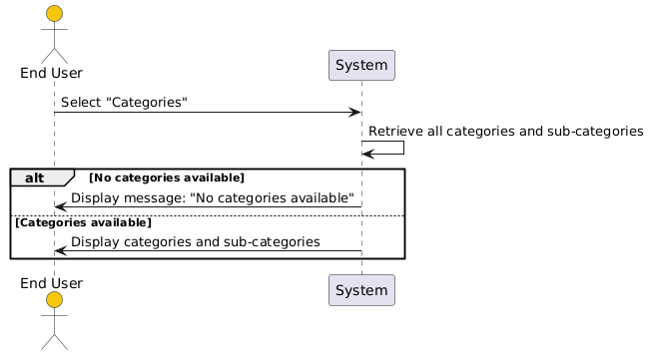
Figure: 20 View Categories

Table 25 Filter Listings by Category
Use Case Name | Filter Listings by Category
Scenario | Refine search results using categories
Triggering Event | User selects a category or sub-category to filter listings
Brief Description | The system filters and displays listings based on the selected category
Actors | End User
Related Use Cases | View Categories
Stakeholders | End User
Preconditions | Listings are available in the system
Postconditions | Filtered listings are displayed successfully
Flow of Activities | Actor | System
 | 1. User selects a category | 1.1 System filters listings based on the selected category  1.2 System displays filtered results to the user
Exception Conditions | 1.1 No listings available for the selected category
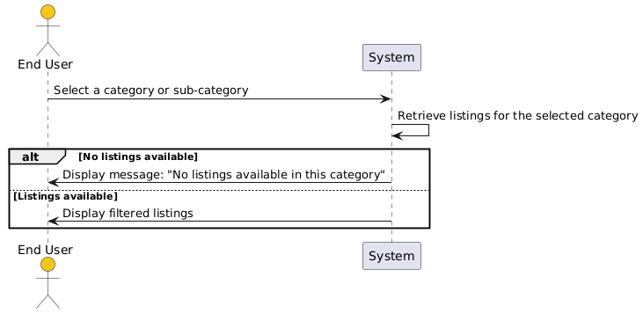
Figure: 21 Filter Listings by Category

Table 26 View Listings
Use Case Name | View Listings
Scenario | Access user-created listings
Triggering Event | User selects the "My Listings" section
Brief Description | The system displays all listings created by the user, including title, category, and cost
Actors | End User (Owner)
Related Use Cases | Edit Listing
Stakeholders | End User, System Administrator
Preconditions | Listings have been created by the user
Postconditions | User listings are displayed successfully
Flow of Activities | Actor | System
 | 1. User selects "My Listings" | 1.1 System retrieves all listings created by the user  1.2 System displays the listings in a grid or list format
Exception Conditions | 1.1 No listings available for the user
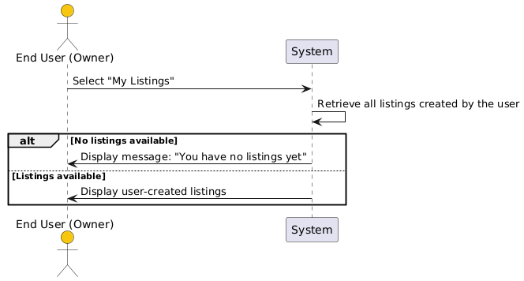
Figure: 22 View Listings

Table 27 View Listing Details
Use Case Name | View Listing Details
Scenario | Access detailed information about a specific listing
Triggering Event | User clicks on a listing from the search or category view
Brief Description | The system displays detailed information about the selected listing, such as photos, description, and contact information
Actors | End User
Related Use Cases | View Categories, Request to Rent
Stakeholders | End User
Preconditions | Listings are available in the system
Postconditions | Detailed information is displayed successfully
Flow of Activities | Actor | System
 | 1. User clicks on a listing | 1.1 System retrieves all details of the selected listing  1.2 System displays the listing details to the user
Exception Conditions | 1.1 Listing is unavailable
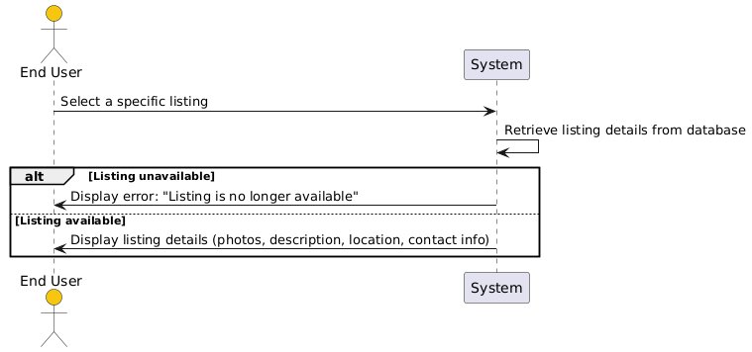
Figure: 23 View Listing Details

Table 28 Submit Rental Request
Use Case Name | Submit Rental Request
Scenario | Submit a rental request for a tool
Triggering Event | User clicks the "Request to Rent" button
Brief Description | The system sends a notification to the owner and records the rental request
Actors | End User (Renter)
Related Use Cases | View Listing Details
Stakeholders | End User (Owner, Renter)
Preconditions | Listing is available for rent
Postconditions | Rental request is sent successfully
Flow of Activities | Actor | System
 | 1. User clicks "Request to Rent" | 1.1 System records the rental request  1.2 System sends a notification to the listing owner
Exception Conditions | 1.1 Listing is already rented
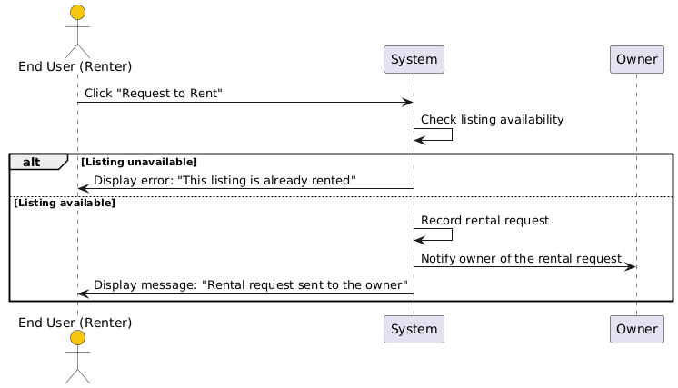
Figure: 24 Submit Rental Request

Table 29 Access Footer Information
Use Case Name | Access Footer Information
Scenario | Access contact information in the footer
Triggering Event | User scrolls to the footer section of a page
Brief Description | The system displays contact information and system links in the footer
Actors | End User
Related Use Cases | None
Stakeholders | End User, System Administrator
Preconditions | Footer is defined in the system
Postconditions | Footer information is displayed correctly
Flow of Activities | Actor | System
 | 1. User scrolls to the footer | 1.1 System retrieves and displays footer information
Exception Conditions | 1.1 Footer information is missing
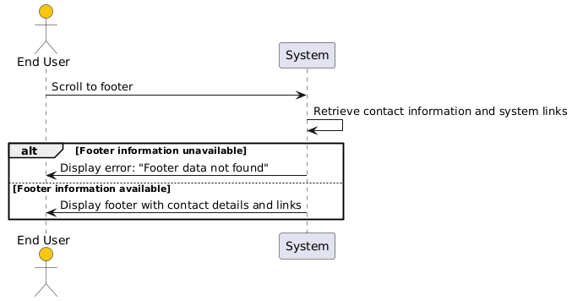
Figure: 25 Access Footer Information

Table 30 Notify User of Rental Requests
Use Case Name | Notify User of Rental Requests
Scenario | Notify owners of rental requests
Triggering Event | A rental request is submitted
Brief Description | The system notifies the owner about a new rental request and the renter about the request’s status
Actors | End User (Owner, Renter)
Related Use Cases | Submit Rental Request
Stakeholders | End User (Owner, Renter)
Preconditions | Notifications are configured in the system
Postconditions | Notifications are sent successfully
Flow of Activities | Actor | System
 | 1. Renter submits a rental request | 1.1 System notifies the owner of the request  1.2 System updates the request status for the renter
Exception Conditions | 1.1 Notification service is down
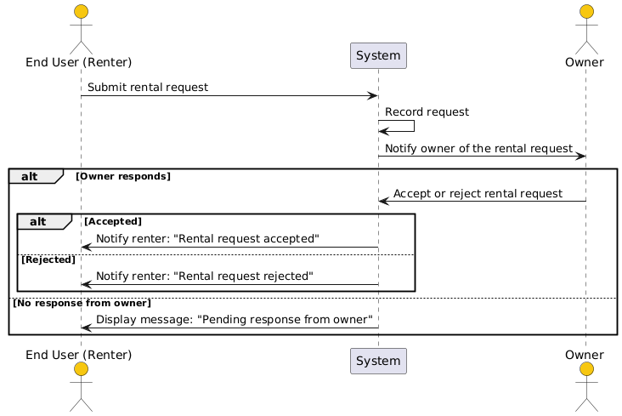
Figure: 26 Notify User of Rental Requests

Table 31 Notify Users of System Updates
Use Case Name | Notify Users of System Updates
Scenario | Notify users about system updates or alerts
Triggering Event | System sends an update notification
Brief Description | The system sends notifications to users about news, updates, or alerts
Actors | End User
Related Use Cases | View News Section
Stakeholders | End User, System Administrator
Preconditions | Notifications are configured in the system
Postconditions | Notifications are sent successfully
Flow of Activities | Actor | System
 | 1. System generates a notification | 1.1 System sends the notification to all users
Exception Conditions | 1.1 Notification service is down
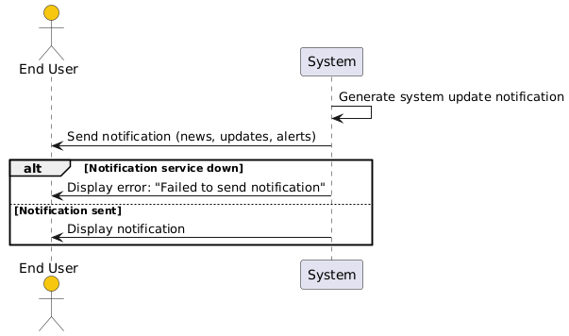
Figure: 27 Notify Users of System Updates

Table 32 Access About Us Page
Use Case Name | Access About Us Page
Scenario | View platform information
Triggering Event | User selects "About Us" from the navbar
Brief Description | The system displays the "About Us" page with details about the platform and its mission
Actors | End User
Related Use Cases | None
Stakeholders | End User, System Administrator
Preconditions | About Us page is pre-configured in the system
Postconditions | The About Us page is displayed successfully
Flow of Activities | Actor | System
 | 1. User selects "About Us" from the navbar | 1.1 System retrieves the About Us page content  1.2 System displays the About Us page
Exception Conditions | 1.1 About Us page content is missing
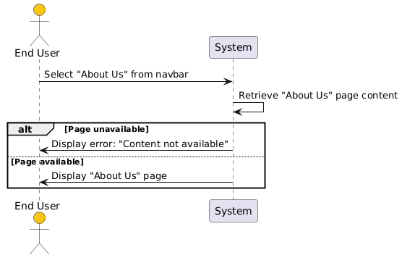
Figure: 28 Access About Us Page

Table 33 Access FAQ Page
Use Case Name | Access FAQ Page
Scenario | View frequently asked questions
Triggering Event | User selects "FAQ" from the navbar
Brief Description | The system displays an FAQ page with answers to common user queries
Actors | End User
Related Use Cases | None
Stakeholders | End User, System Administrator
Preconditions | FAQ page is pre-configured in the system
Postconditions | The FAQ page is displayed successfully
Flow of Activities | Actor | System
 | 1. User selects "FAQ" from the navbar | 1.1 System retrieves the FAQ page content  1.2 System displays the FAQ page
Exception Conditions | 1.1 FAQ page content is missing
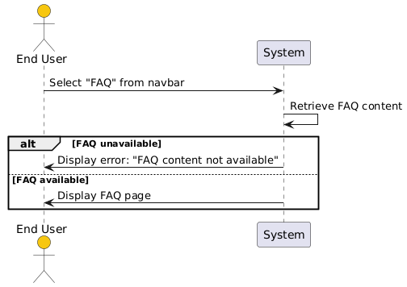
Figure: 29 Access FAQ Page

Table 34 View Rental Requests
Use Case Name | View Rental Requests
Scenario | View rental requests for user listings
Triggering Event | Owner selects "Rental Requests" for their listings
Brief Description | The system displays a list of rental requests, including renter details, rental period, and total cost
Actors | End User (Owner)
Related Use Cases | Accept/Reject Rental Request
Stakeholders | End User (Owner, Renter)
Preconditions | Rental requests exist for the owner’s listings
Postconditions | Rental requests are displayed successfully
Flow of Activities | Actor | System
 | 1. Owner selects "Rental Requests" for a listing | 1.1 System retrieves all rental requests for the selected listing  1.2 System displays the rental requests
Exception Conditions | 1.1 No rental requests available for the listing
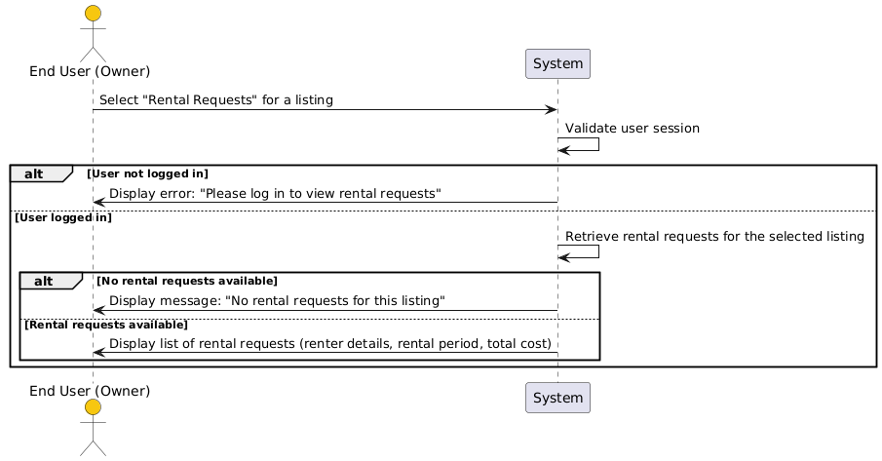
Figure: 30 View Rental Requests

Table 35 Process Rental Request
Use Case Name | Process Rental Request
Scenario | Accept or reject a rental request
Triggering Event | Owner reviews a rental request and decides to accept or reject it
Brief Description | The system processes the owner’s decision and notifies the renter accordingly.
Actors | End User (Owner)
Related Use Cases | View Rental Requests
Stakeholders | End User (Owner, Renter)
Preconditions | Rental requests exist for the owner’s listings
Postconditions | Rental requests are accepted or rejected, and notifications are sent
Flow of Activities | Actor | System
 | 1. Owner selects a rental request  2. Owner accepts/rejects the request | 1.1 System displays request details  1.2 System updates the request status  1.3 System notifies the renter of the decision
Exception Conditions | 1.1 Request details are unavailable
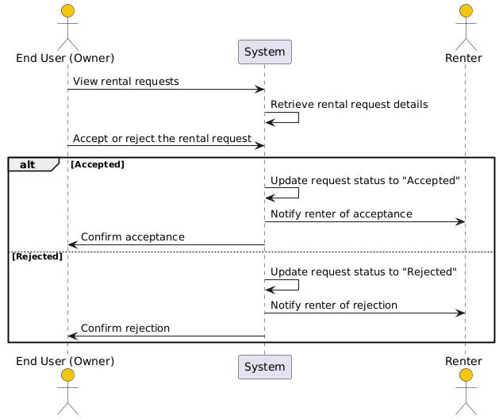
Figure: 31 Process Rental Request

Table 36 View Accepted Rental Requests
Use Case Name | View Accepted Rental Requests
Scenario | Access a list of accepted rental requests
Triggering Event | Renter or owner selects "Accepted Requests."
Brief Description | The system displays details of all accepted rental requests, including owner/renter information, listing details, and rental period
Actors | End User (Owner, Renter)
Related Use Cases | Process Rental Request
Stakeholders | End User (Owner, Renter)
Preconditions | Accepted rental requests exist
Postconditions | Accepted requests are displayed successfully
Flow of Activities | Actor | System
 | 1. User selects "Accepted Requests" | 1.1 System retrieves all accepted requests for the user  1.2 System displays the accepted requests
Exception Conditions | 1.1 No accepted requests available
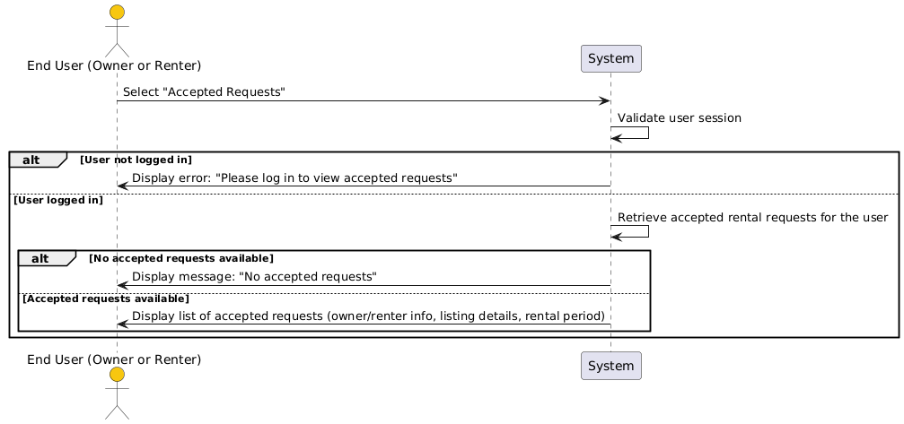
Figure: 32 View Accepted Rental Requests

Table 37 View Terms and Conditions
Use Case Name | View Terms and Conditions
Scenario | Display rental agreement terms
Triggering Event | Renter proceeds to accept the rental request
Brief Description | The system displays terms and conditions for the rental agreement
Actors | End User (Renter)
Related Use Cases | None
Stakeholders | End User (Renter)
Preconditions | Terms and conditions are pre-configured in the system
Postconditions | Terms and conditions are displayed successfully
Flow of Activities | Actor | System
 | 1. Renter proceeds to rental agreement | 1.1 System retrieves and displays the terms and conditions
Exception Conditions | 1.1 Terms and conditions are unavailable
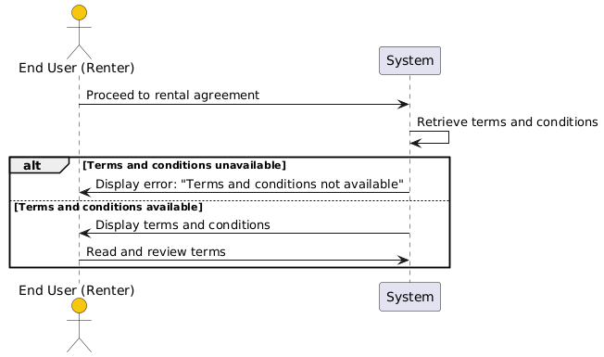
Figure: 33 View Terms and Conditions

Table 38 Accept Terms and Conditions
Use Case Name | Accept Terms and Conditions
Scenario | Confirm agreement to terms and conditions
Triggering Event | Renter checks the acceptance box for the terms and conditions
Brief Description | The system allows the renter to proceed only after accepting the terms
Actors | End User (Renter)
Related Use Cases | View Terms and Conditions
Stakeholders | End User (Renter)
Preconditions | Terms and conditions are displayed
Postconditions | Acceptance is recorded, and the user is allowed to proceed
Flow of Activities | Actor | System
 | 1. Renter checks the acceptance box  2. Renter clicks "Proceed" | 1.1 System enables the "Proceed" button  1.2 System records acceptance and navigates to the next screen
Exception Conditions | 1.1 Acceptance is not recorded
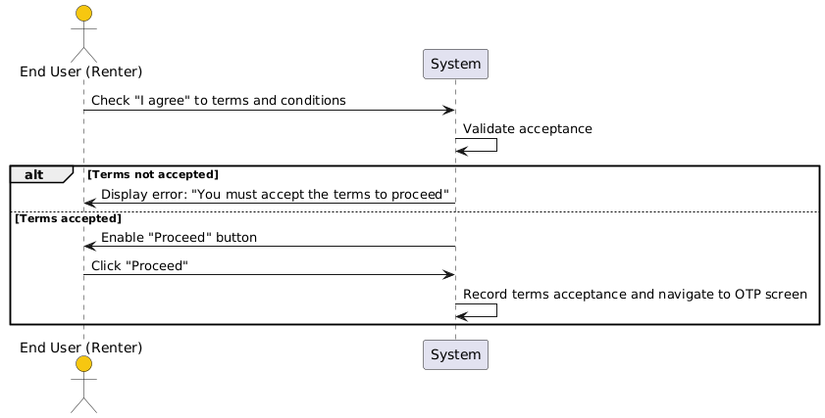
Figure: 34 Accept Terms and Conditions

Table 39 Verify Rental Agreement with OTP
Use Case Name | Verify Rental Agreement with OTP
Scenario | Complete rental agreement using an OTP
Triggering Event | Renter clicks "Get OTP" after accepting terms
Brief Description | The system sends an OTP to the renter’s phone, which must be entered to confirm the agreement
Actors | End User (Renter)
Related Use Cases | Accept Terms and Conditions
Stakeholders | End User (Renter)
Preconditions | Renter has accepted the terms and conditions
Postconditions | Rental agreement is confirmed after successful OTP verification
Flow of Activities | Actor | System
 | 1. Renter clicks "Get OTP"  2. Renter enters the OTP | 1.1 System sends OTP to the renter’s phone  1.2 System validates the OTP  1.3 System confirms the rental agreement
Exception Conditions | 1.1 OTP is invalid or expired
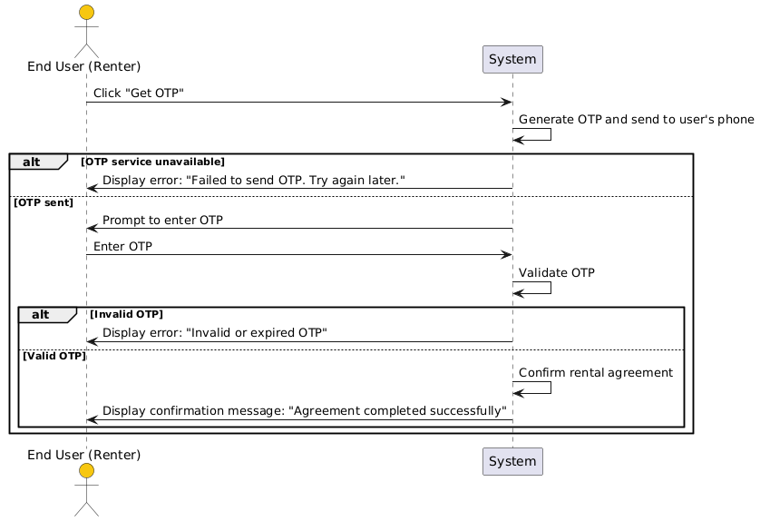
Figure: 35 Verify Rental Agreement with OTP

Table 40 Report a Problem
Use Case Name | Report a Problem
Scenario | Report a problem or non-compliance issue
Triggering Event | User selects "Report" and submits a problem description
Brief Description | The system allows users to report listing issues to customer support
Actors | End User
Related Use Cases | None
Stakeholders | End User, Customer Support
Preconditions | Reporting functionality is enabled
Postconditions | Report is submitted successfully
Flow of Activities | Actor | System
 | 1. User selects "Report" and fills in problem details | 1.1 System validates and records the report  1.2 System notifies customer support
Exception Conditions | 1.1 Problem details are incomplete
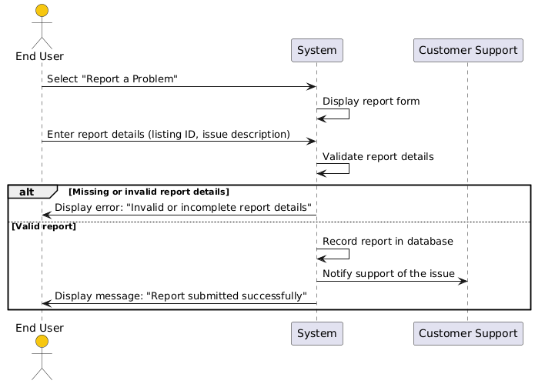
Figure: 36 Report a Problem

Table 41 Submit Report Details
Use Case Name | Submit Report Details
Scenario | Provide details for a reported issue
Triggering Event | User submits a report with details like listing ID and description
Brief Description | The system captures detailed information about the reported issue and forwards it to customer support
Actors | End User
Related Use Cases | Report a Problem
Stakeholders | End User, Customer Support
Preconditions | Reporting functionality is enabled
Postconditions | Report details are submitted successfully
Flow of Activities | Actor | System
 | 1. User enters report details (listing ID, problem description) | 1.1 System validates the inputs  1.2 System forwards the report to customer support
Exception Conditions | 1.1 Details are missing or invalid
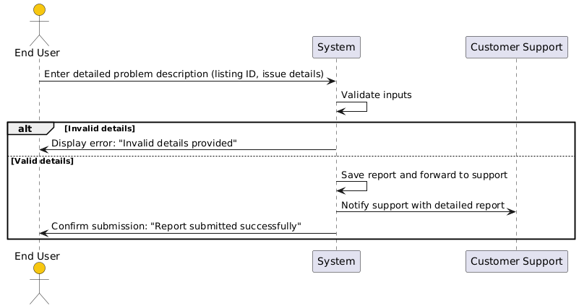
Figure: 37 Submit Report Details

4.4.3 Admin Use Case

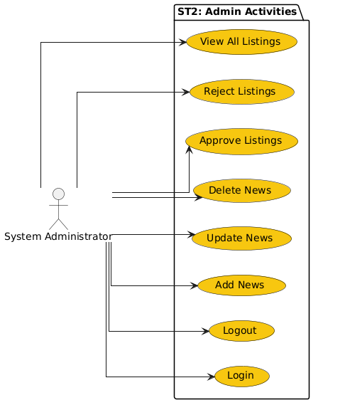
Figure: 38 Admin Use Case

4.4.4 Admin Scenarios, Sequence Diagrams

Table 42 Admin Login
Use Case Name | Admin Login
Scenario | Admin logs into the system
Triggering Event | Admin provides email and passwords to access the system
Brief Description | The system authenticates admin credentials and allows access to administrative functions
Actors | System Administrator
Related Use Cases | None
Stakeholders | System Administrator
Preconditions | Admin account exists, and login functionality is enabled
Postconditions | Admin is logged in successfully or an error message is displayed
Flow of Activities | Actor | System
 | 1. Admin enters email and password | 1.1 System validates credentials  1.2 System grants access to admin dashboard upon validation
Exception Conditions | 1.1 Incorrect email or password

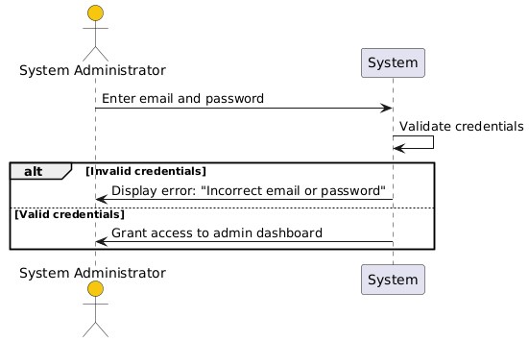
Figure: 39 Admin Login
Table 43 Add News to System
Use Case Name | Add News to System
Scenario | Admin adds a new item to the news section
Triggering Event | Admin selects "Add News" and provides details
Brief Description | The system adds the news to the news section, making it visible to users
Actors | System Administrator
Related Use Cases | Update News, Delete News
Stakeholders | System Administrator, End User
Preconditions | Admin must be logged in
Postconditions | News is added successfully
Flow of Activities | Actor | System
 | 1. Admin clicks "Add News" and provides news details | 1.1 System validates the news content  1.2 System saves and publishes the news
Exception Conditions | 1.1 News content is invalid or incomplete

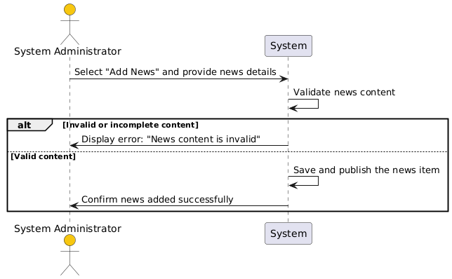
Figure: 40 Add News to System

Table 44 Update News Section
Use Case Name | Update News Section
Scenario | Admin modifies an existing news item
Triggering Event | Admin selects "Update News" for an item
Brief Description | The system allows the admin to modify the content of an existing news item
Actors | System Administrator
Related Use Cases | Add News, Delete News
Stakeholders | System Administrator, End User
Preconditions | Admin must be logged in, and the news item must exist
Postconditions | News is updated successfully
Flow of Activities | Actor | System
 | 1. Admin selects a news item and updates its content | 1.1 System validates the updated content  1.2 System saves the changes to the news
Exception Conditions | 1.1 Updated content is invalid or missing

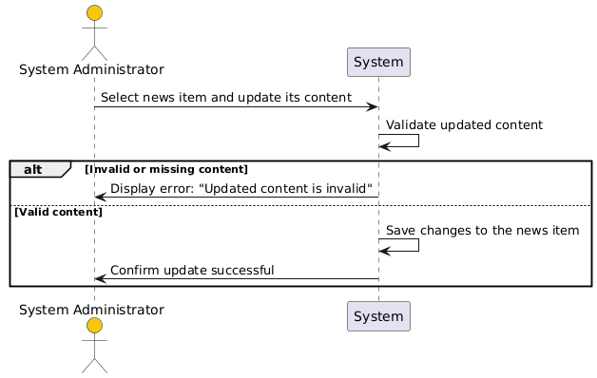
Figure: 41 Update News Section

Table 45 Remove News Section
Use Case Name | Remove News Section
Scenario | Admin deletes an existing news item
Triggering Event | Admin selects "Delete News" for an item
Brief Description | The system removes the selected news item from the news section
Actors | System Administrator
Related Use Cases | Add News, Update News
Stakeholders | System Administrator, End User
Preconditions | Admin must be logged in, and the news item must exist
Postconditions | News item is deleted successfully
Flow of Activities | Actor | System
 | 1. Admin selects a news item and clicks "Delete News" | 1.1 System confirms deletion request  1.2 System removes the news item from the database
Exception Conditions | 1.1 News item does not exist

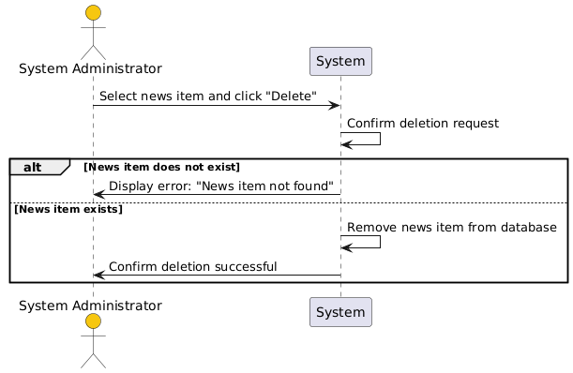
Figure: 42 Remove News Section

Table 46 View Listings
Use Case Name | View Listings
Scenario | Admin views all listings on the platform
Triggering Event | Admin selects "View Listings" from the admin dashboard
Brief Description | The system displays a list of all listings available on the platform
Actors | System Administrator
Related Use Cases | Edit Listings, Approve Listings
Stakeholders | System Administrator
Preconditions | Listings exist in the system
Postconditions | Listings are displayed successfully
Flow of Activities | Actor | System
 | 1. Admin selects "View Listings" | 1.1 System retrieves all listings from the database  1.2 System displays the listings in a grid or list format
Exception Conditions | 1.1 No listings are available
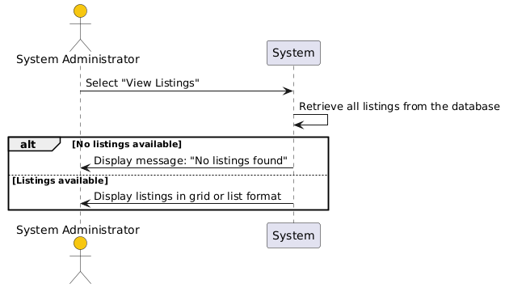
Figure: 43 View Listings

Table 47 Edit Listing Details
Use Case Name | Edit Listing Details
Scenario | Admin modifies the details of an existing listing
Triggering Event | Admin selects "Edit Listing" for a specific item
Brief Description | The system allows the admin to update the listing details, such as title, description, or category
Actors | System Administrator
Related Use Cases | View Listings
Stakeholders | System Administrator
Preconditions | Listings exist, and admin has edit permissions
Postconditions | Listing details are updated successfully
Flow of Activities | Actor | System
 | 1. Admin selects a listing and updates its details | 1.1 System validates the updated details  1.2 System saves the changes to the listing
Exception Conditions | 1.1 Updated details are invalid or missing
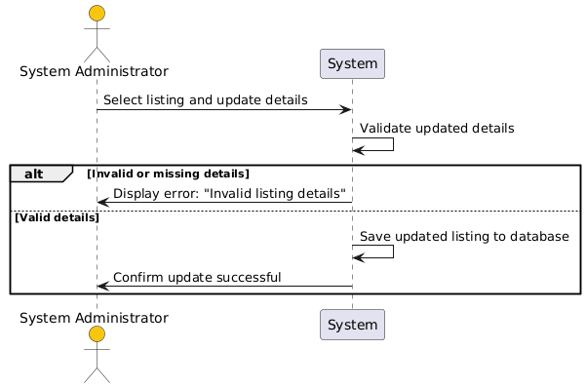
Figure: 44 Edit Listing Details

Table 48 Delete Listing
Use Case Name | Delete Listing
Scenario | Admin removes a listing from the platform
Triggering Event | Admin selects "Delete Listing" for a specific item
Brief Description | The system removes the listing from the database
Actors | System Administrator
Related Use Cases | View Listings
Stakeholders | System Administrator, End User
Preconditions | Listing exists, and admin has delete permissions
Postconditions | Listing is deleted successfully
Flow of Activities | Actor | System
 | 1. Admin selects a listing and clicks "Delete Listing" | 1.1 System confirms deletion request  1.2 System removes the listing from the database
Exception Conditions | 1.1 Listing does not exist
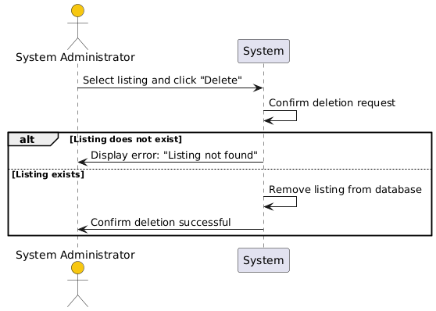
Figure: 45 Delete Listing

Table 49 Approve Listing
Use Case Name | Approve Listing
Scenario | Admin approves a submitted listing
Triggering Event | Admin selects "Approve Listing" for a specific item
Brief Description | The system marks the listing as approved, making it visible to users
Actors | System Administrator
Related Use Cases | View Listings, Reject Listing
Stakeholders | System Administrator, End User
Preconditions | Listing exists and is pending approval
Postconditions | Listing is approved and made visible to users
Flow of Activities | Actor | System
 | 1. Admin selects a pending listing and clicks "Approve" | 1.1 System updates the listing status to approved  1.2 System notifies the listing owner of approval
Exception Conditions | 1.1 Listing does not exist
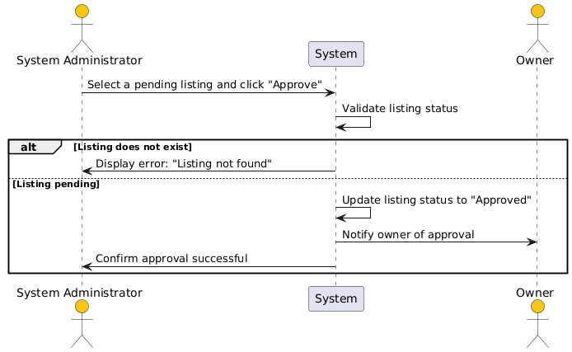
Figure: 46 Approve Listing

Table 50 Reject Listing
Use Case Name | Reject Listing
Scenario | Admin rejects a submitted listing
Triggering Event | Admin selects "Reject Listing" for a specific item
Brief Description | The system marks the listing as rejected and notifies the owner
Actors | System Administrator
Related Use Cases | View Listings, Approve Listing
Stakeholders | System Administrator, End User
Preconditions | Listing exists and is pending approval
Postconditions | Listing is rejected, and the owner is notified
Flow of Activities | Actor | System
 | 1. Admin selects a pending listing and clicks "Reject" | 1.1 System updates the listing status to rejected  1.2 System notifies the listing owner of rejection
Exception Conditions | 1.1 Listing does not exist
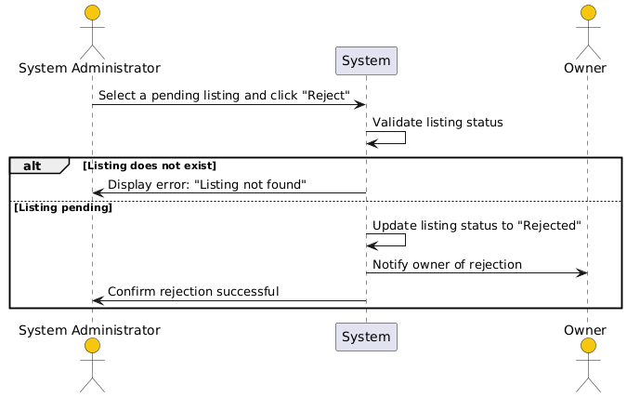
Figure: 47 Reject Listing

Table 51 Admin Logout
Use Case Name | Admin Logout
Scenario | Admin logs out of the system
Triggering Event | Admin clicks the "Sign Out" button
Brief Description | The system logs the admin out and redirects to the login screen
Actors | System Administrator
Related Use Cases | Admin Login
Stakeholders | System Administrator
Preconditions | Admin must be logged in
Postconditions | Admin is logged out successfully
Flow of Activities | Actor | System
 | 1. Admin clicks "Sign Out" | 1.1 System terminates the admin session  1.2 System redirects to the login screen
Exception Conditions | - System fails to terminate the session
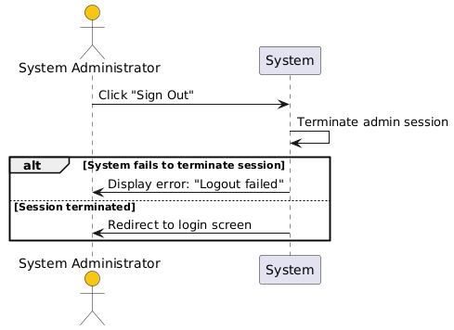
Figure: 48 Admin Logout

4.5 UML Class Diagram

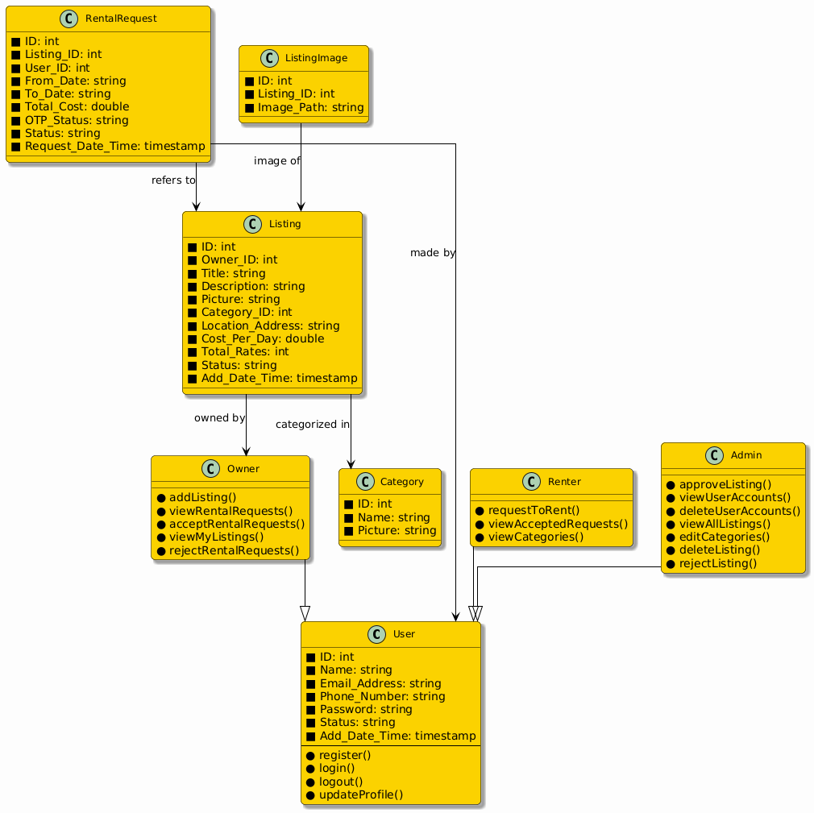

Figure: 58 UML Class Diagram

4.6 Graphical User Interface / Low Fidelity Prototype
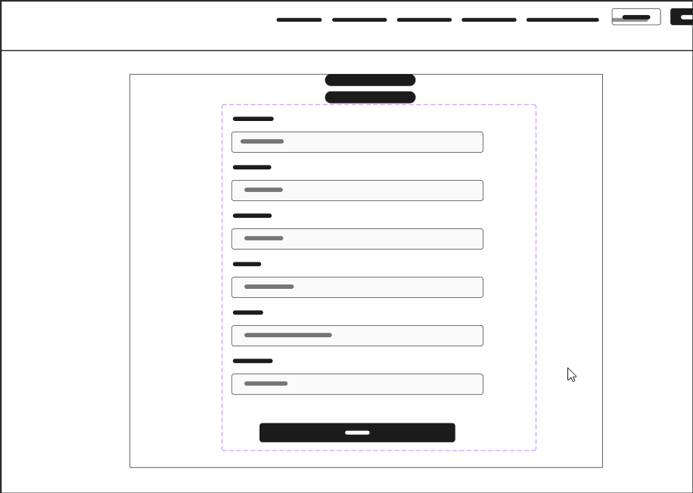

Figure: 59

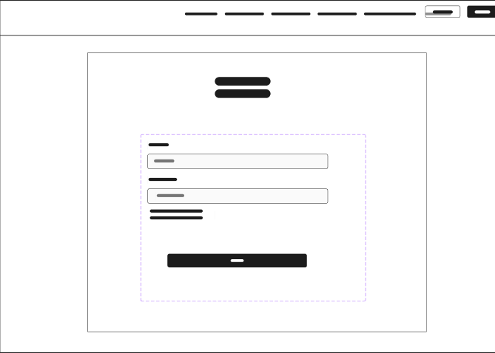
Figure: 60 login screen
Figure: 61 signup screen

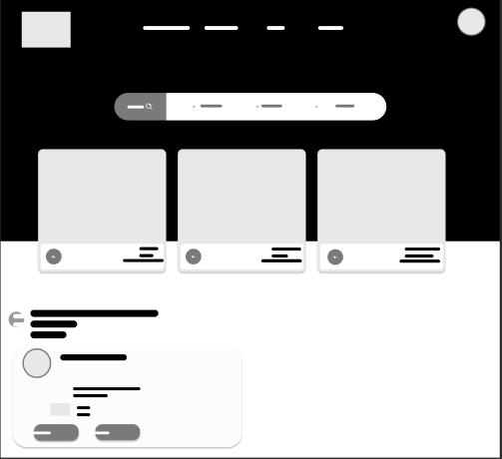

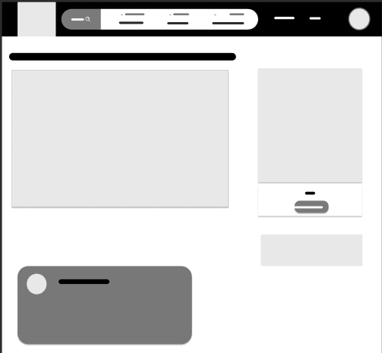
Figure: 62 listing screen
Figure: 63 homepage screen

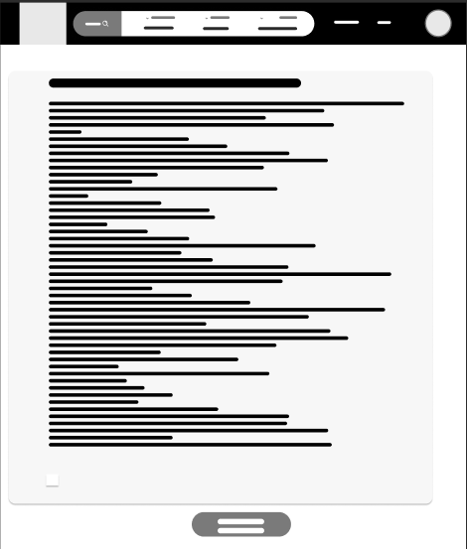
Figure: 64 terms and conditions screen

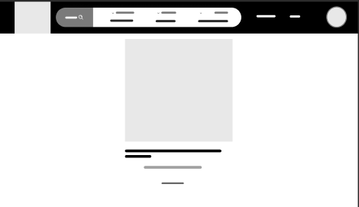
Figure: 65 OTP screen

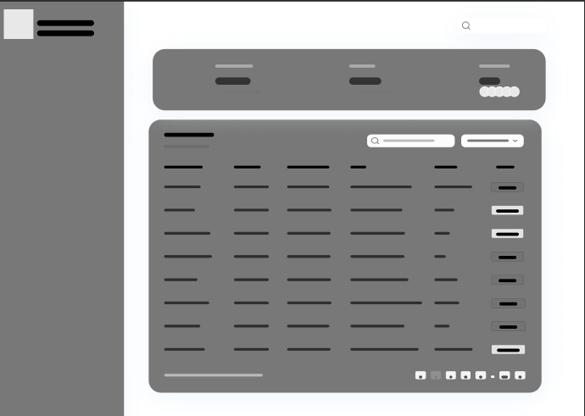

Figure: 66 admin dashboard



