

National Textile University
Department of Computer Science
Subject

Operating System

Submitted to:
Sir Nasir Mahmood

Submitted by:

Ahmad Farooq

Registration Number
23-NTU-CS-1128

Lab No.
01

Semester
5th

Connecting VS code with WSL :
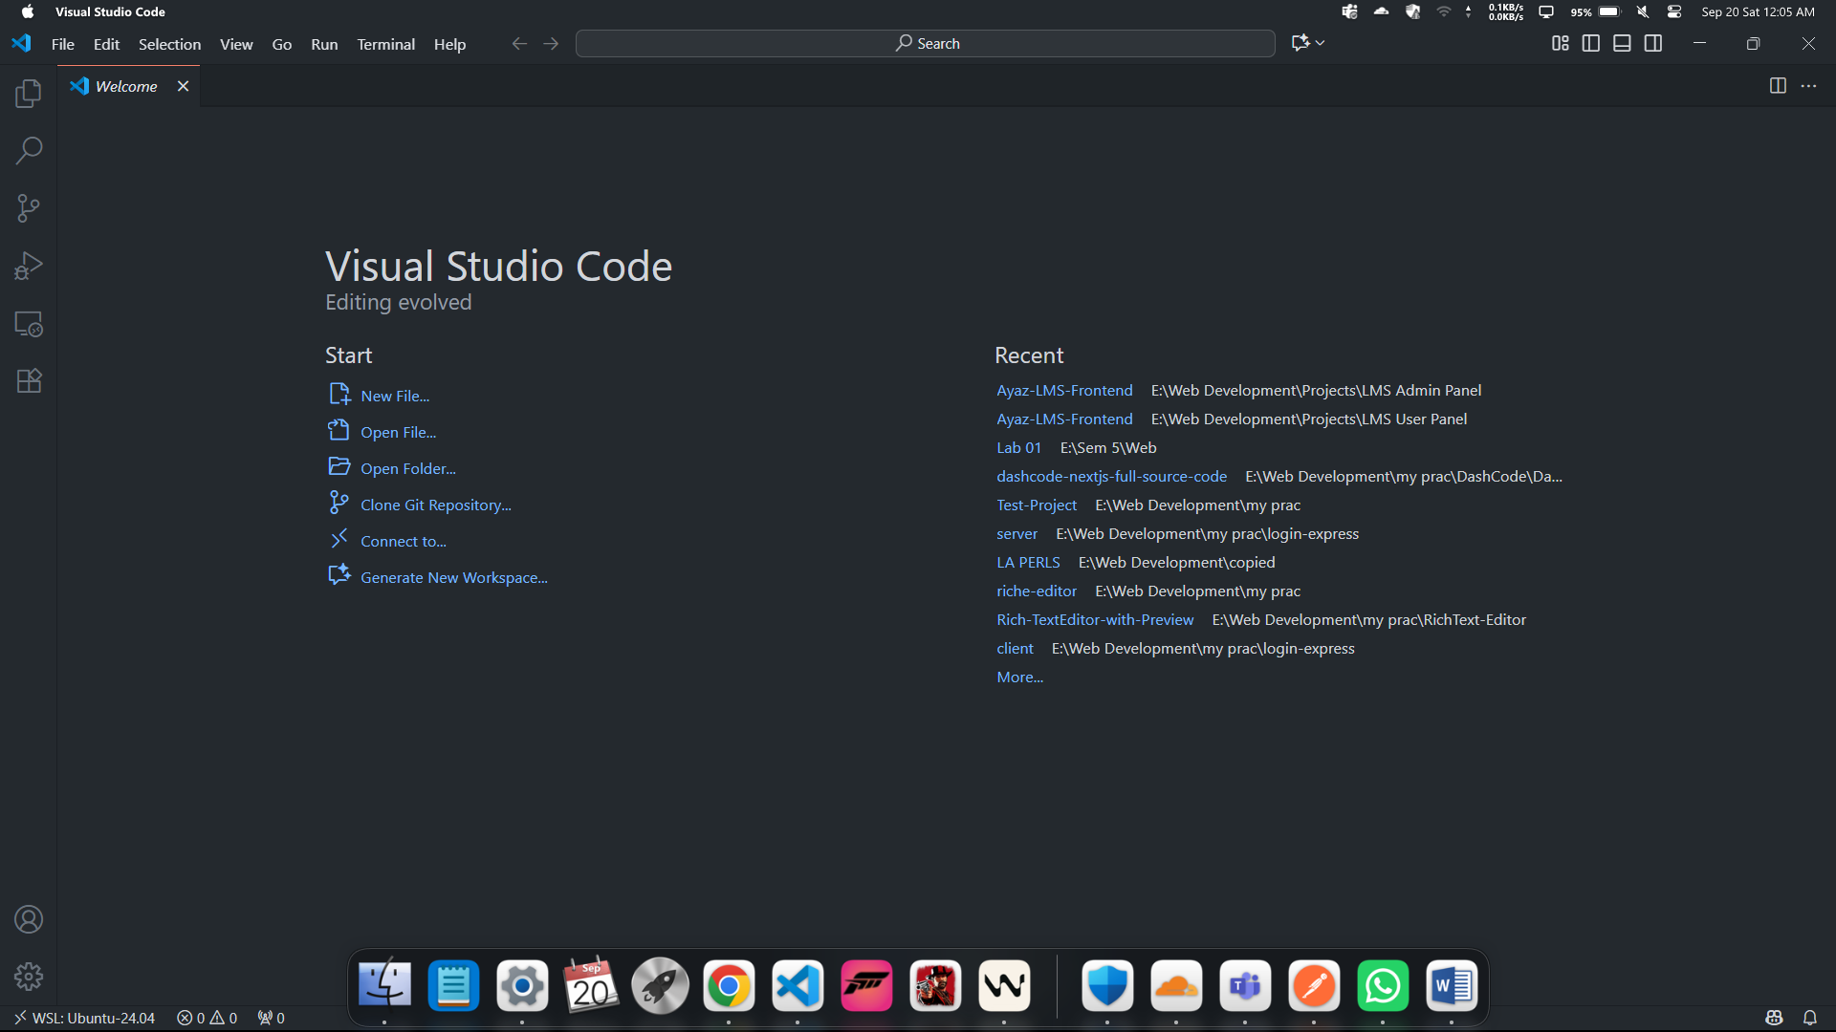

WSL version and Ubuntu runing:
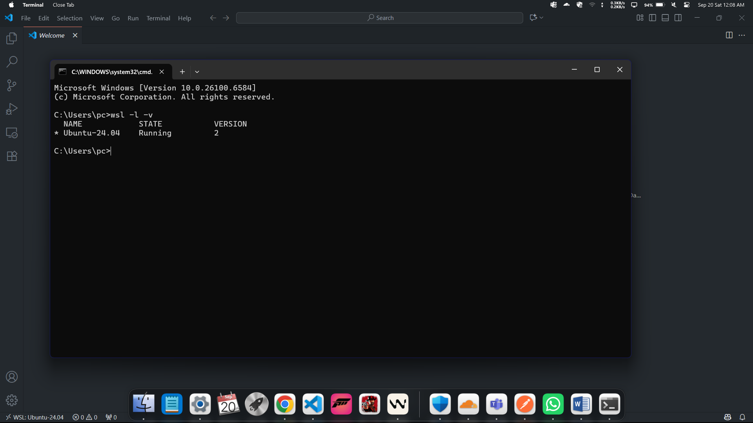

APT Update:
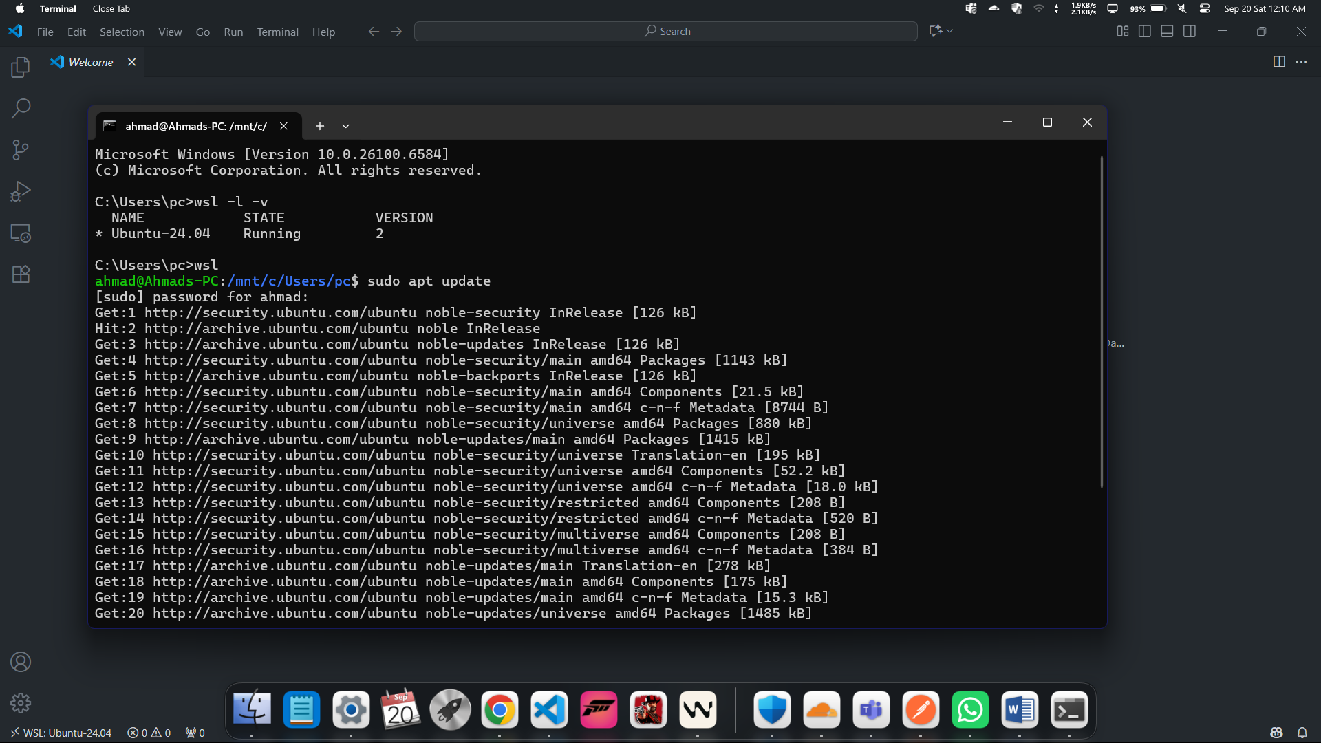

Gcc Install:
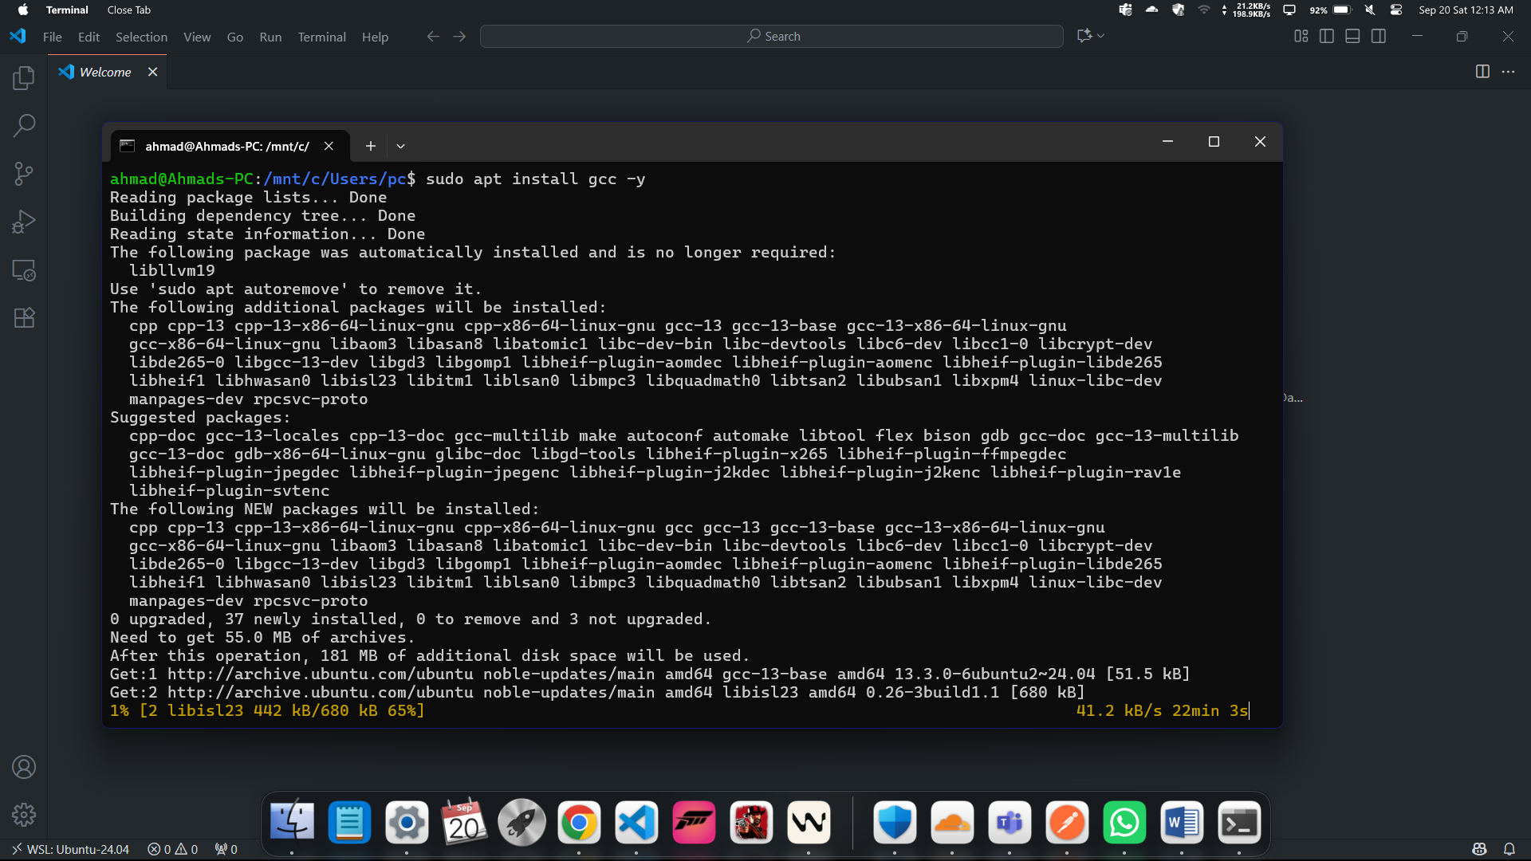

Gcc version:
