

National Textile University
Department of Computer Science
Subject

Operating System

Submitted to:
Sir Nasir Mahmood

Submitted by:

Ahmad Farooq

Registration Number
23-NTU-CS-1128

Lab No.
04

Semester
5th

Thread 1:
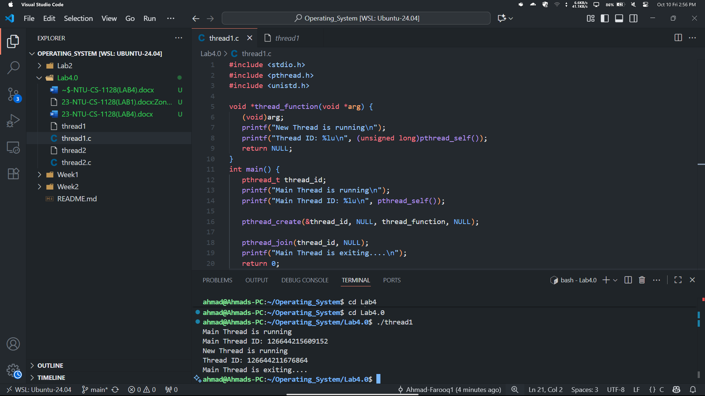
Thread 2:
