

National Textile University
Department of Computer Science
Subject

Operating System

Submitted to:
Sir Nasir Mahmood

Submitted by:

Ahmad Farooq

Registration Number
23-NTU-CS-1128

Lab No.
10

Semester
5th

Task 2:
#include <stdio.h>
#include <pthread.h>
#include <semaphore.h>
#include <unistd.h>
#define BUFFER_SIZE 5
int buffer[BUFFER_SIZE];
int in = 0; // Producer index
int out = 0; // Consumer index
sem_t empty; // Counts empty slots
sem_t full; // Counts full slots
pthread_mutex_t mutex;
void *producer(void *arg)
{
int id = *(int *)arg;
for (int i = 0; i < 3; i++)
{ // Each producer makes 3 items
int item = id * 100 + i;
// TODO: Wait for empty slot
sem_wait(&empty);
// TODO: Lock the buffer
pthread_mutex_lock(&mutex);
// Add item to buffer
buffer[in] = item;
printf("Producer %d produced item %d at position %d\n",
id, item, in);
in = (in + 1) % BUFFER_SIZE;
// TODO: Unlock the buffer
pthread_mutex_unlock(&mutex);
// TODO: Signal that buffer has a full slot
sem_post(&full);
sleep(1);
}
return NULL;
}
void *consumer(void *arg)
{
int id = *(int *)arg;
for (int i = 0; i < 3; i++)
{
// TODO: Students complete this similar to producer
sem_wait(&full);
pthread_mutex_lock(&mutex);
int item = buffer[out];
printf("Consumer %d consumed item %d from position %d\n",
id, item, out);
out = (out + 1) % BUFFER_SIZE;
pthread_mutex_unlock(&mutex);
sem_post(&empty);
sleep(2); // Consumers are slower
}
return NULL;
}
int main()
{
pthread_t prod[2], cons[2];
int ids[2] = {1, 2};
// Initialize semaphores
sem_init(&empty, 0, BUFFER_SIZE); // All slots empty initially
sem_init(&full, 0, 0); // No slots full initially
pthread_mutex_init(&mutex, NULL);
// Create producers and consumers
for (int i = 0; i < 2; i++)
{
pthread_create(&prod[i], NULL, producer, &ids[i]);
pthread_create(&cons[i], NULL, consumer, &ids[i]);
}
// Wait for completion
for (int i = 0; i < 2; i++)
{
pthread_join(prod[i], NULL);
pthread_join(cons[i], NULL);
}
// Cleanup
sem_destroy(&empty);
sem_destroy(&full);
pthread_mutex_destroy(&mutex);
return 0;
}
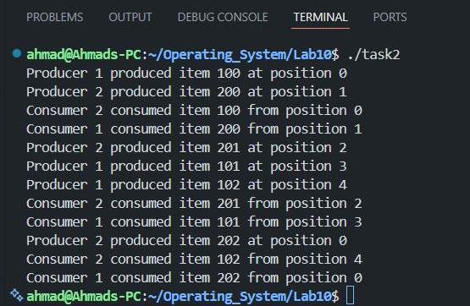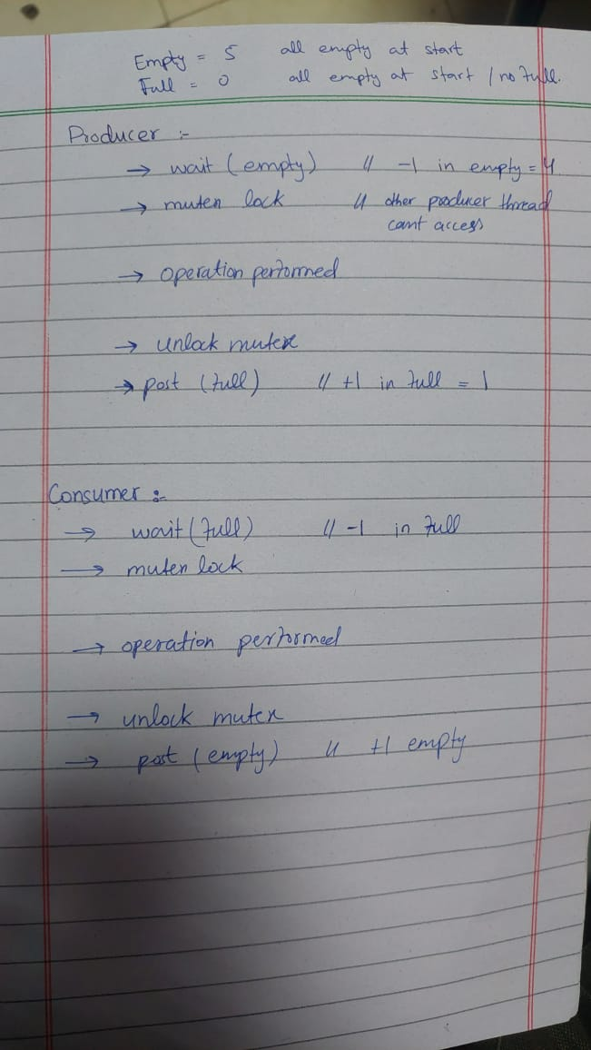
In this task we have a bufferSize of 5, two counting Semaphores (one checks empty slots and it is initialized to 5{bufferSize} the other checks the full slots it is initialized to 0 because no slot is full in start) and a Mutex. Now total no of threads is 4 (two producers and two consumers).
When the process starts all the slots are empty so we cannot consume. Consumer threads are blocked until producer produces any resource. When producer thread enters the producer function it enters the loop in which it creates 3 resources (1 producer thread creates 3 resource only). So total no of resources produced by 2 threads or producers is 6. Same total no of resources consumed by 2 threads of consumer is 6(3 resources consumed by each consumer thread).
All these processes happens concurrently. But simple is that when Producer performs action it call wait(empty) which decrements it by 1. And it calls the mutex lock so that not even the other producer thread can access the critical section then it calls the post(full) which increments in the semaphore of full.
Almost same thing happens in the function of consumer but it calls wait(full) and post(empty).

