

National Textile University
Department of Computer Science
Subject

Operating System

Submitted to:
Sir Nasir Mahmood

Submitted by:

Ahmad Farooq

Registration Number
23-NTU-CS-1128

Lab No.
06

Semester
5th

Comparison between Peterson’s Method AND Mutex Method:

The actual difference between the Peterson’s and Mutex method is that mutex is using a lock that single lock can be checked by multiple processes and thus it is less complex but in Peterson’s Method the loop condition can be tricky if we increase number of processes from 2,3 because there will be too much long condition to check if the critical function is in use. This makes Peterson not scalable.

Task1:
#include <stdio.h>
#include <pthread.h>

#define NUM_THREADS 4
int varg=0;

void *thread_function(void *arg) {
int thread_id = *(int *)arg;

int varl=0;
varg++;
varl++;
printf("Thread %d is executing the global value is %d: local vale is %d: process id %d: \n", thread_id,varg,varl,getpid());
return NULL;
}

int main() {
pthread_t threads[NUM_THREADS];
int thread_args[NUM_THREADS];

for (int i = 0; i < NUM_THREADS; ++i) {
thread_args[i] = i;
pthread_create(&threads[i], NULL, thread_function, &thread_args[i]);
}

for (int i = 0; i < NUM_THREADS; ++i) {
pthread_join(threads[i], NULL);
}
printf("Main is executing the global value is %d:: Process ID %d: \n",varg,getpid());

return 0;
}

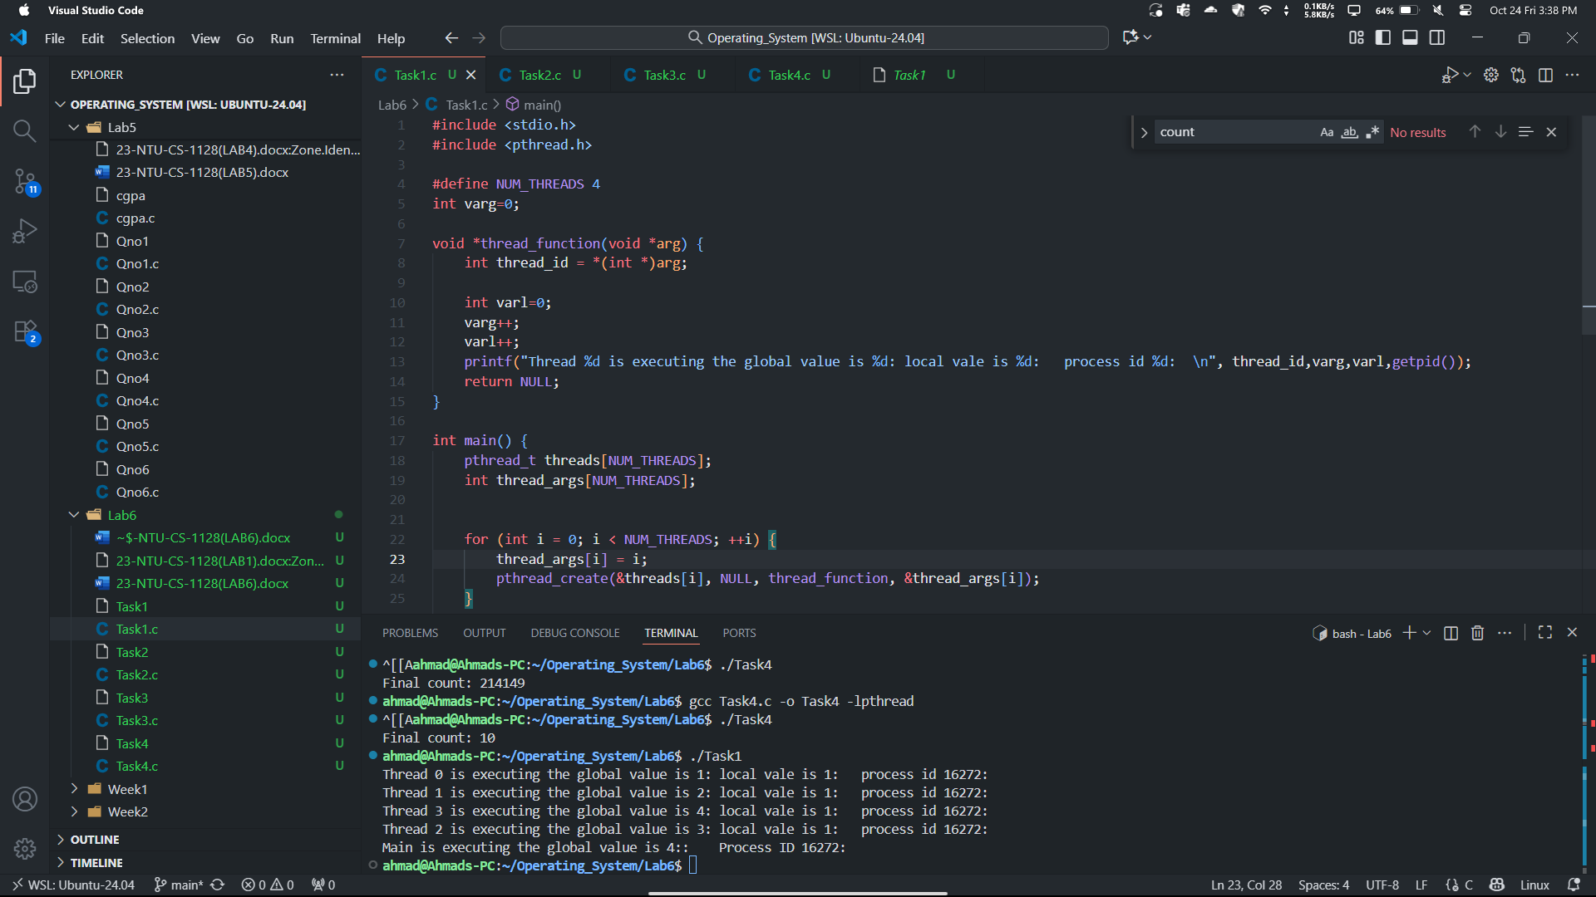
Task2:
#include <stdio.h>
#include <pthread.h>
#include <unistd.h>
#define NUM_ITERATIONS 1000000

int count=10;
// Critical section function
void critical_section(int process) {
//printf("Process %d is in the critical section\n", process);
//sleep(1); // Simulate some work in the critical section
if(process==0){

for (int i = 0; i < NUM_ITERATIONS; i++)
count--;
}
else
{
for (int i = 0; i < NUM_ITERATIONS; i++)
count++;
}

}

void *process0(void *arg) {
// Critical section
critical_section(0);
// Exit section
return NULL;
}
void *process1(void *arg) {
// Critical section
critical_section(1);
// Exit section
return NULL;
}

int main() {
pthread_t thread0, thread1, thread2, thread3;
// Create threads
pthread_create(&thread0, NULL, process0, NULL);
pthread_create(&thread1, NULL, process1, NULL);
pthread_create(&thread2, NULL, process0, NULL);
pthread_create(&thread3, NULL, process1, NULL);
// Wait for threads to finish
pthread_join(thread0, NULL);
pthread_join(thread1, NULL);
pthread_join(thread2, NULL);
pthread_join(thread3, NULL);
printf("Final count: %d\n", count);
return 0;
}
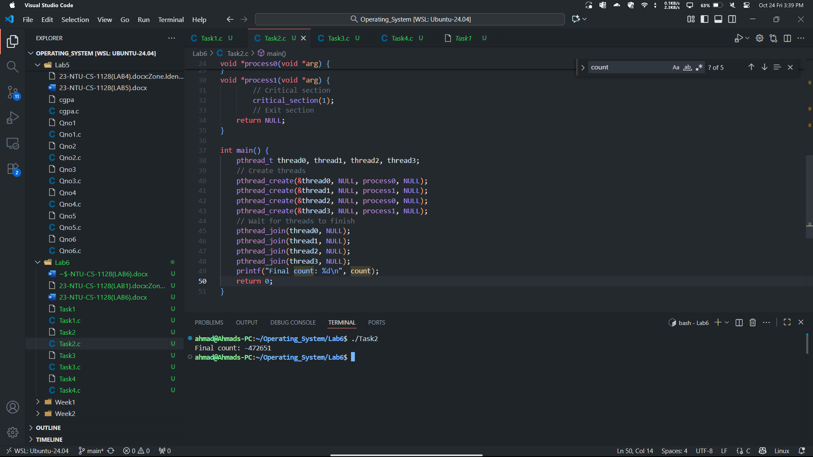
Task3:
#include <stdio.h>
#include <pthread.h>
#include <unistd.h>
#define NUM_ITERATIONS 100000
// Shared variables
int turn;
int flag[2];
int count=0;

// Critical section function
void critical_section(int process) {
//printf("Process %d is in the critical section\n", process);
//sleep(1); // Simulate some work in the critical section
if(process==0){

for (int i = 0; i < NUM_ITERATIONS; i++)
count--;
}
else
{
for (int i = 0; i < NUM_ITERATIONS; i++)
count++;

}
// printf("Process %d has updated count to %d\n", process, count);
//printf("Process %d is leaving the critical section\n", process);
}

// Peterson's Algorithm function for process 0
void *process0(void *arg) {

flag[0] = 1;
turn = 1;
while (flag[1]==1 && turn == 1) {
// Busy wait
}
// Critical section
critical_section(0);
// Exit section
flag[0] = 0;
//sleep(1);

pthread_exit(NULL);

}

// Peterson's Algorithm function for process 1
void *process1(void *arg) {

flag[1] = 1;
turn = 0;
while (flag[0] ==1 && turn == 0) {
// Busy wait
}
// Critical section
critical_section(1);
// Exit section
flag[1] = 0;
//sleep(1);

pthread_exit(NULL);
}

int main() {
pthread_t thread0, thread1;

// Initialize shared variables
flag[0] = 0;
flag[1] = 0;
turn = 0;

// Create threads
pthread_create(&thread0, NULL, process0, NULL);
pthread_create(&thread1, NULL, process1, NULL);

// Wait for threads to finish
pthread_join(thread0, NULL);
pthread_join(thread1, NULL);

printf("Final count: %d\n", count);

return 0;
}
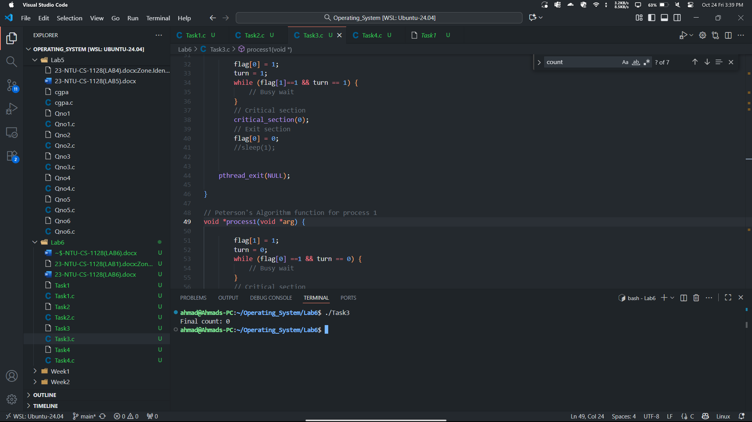
Task4:
#include <stdio.h>
#include <pthread.h>
#include <unistd.h>
#define NUM_ITERATIONS 1000000

int count=10;

pthread_mutex_t mutex; // mutex object

// Critical section function
void critical_section(int process) {
//printf("Process %d is in the critical section\n", process);
//sleep(1); // Simulate some work in the critical section
if(process==0){

for (int i = 0; i < NUM_ITERATIONS; i++)
count--;
}
else if(process==1)
{
for (int i = 0; i < NUM_ITERATIONS; i++)
count++;
}
else{

for (int i = 0; i < NUM_ITERATIONS; i++)
count++;
}
//printf("Process %d has updated count to %d\n", process, count);
//printf("Process %d is leaving the critical section\n", process);
}

// Peterson's Algorithm function for process 0
void *process0(void *arg) {

pthread_mutex_lock(&mutex); // lock

// Critical section
critical_section(0);
// Exit section

pthread_mutex_unlock(&mutex); // unlock

return NULL;
}

// Peterson's Algorithm function for process 1
void *process1(void *arg) {

pthread_mutex_lock(&mutex); // lock

// Critical section
critical_section(1);
// Exit section

pthread_mutex_unlock(&mutex); // unlock

return NULL;
}
// Peterson's Algorithm function for process 2
void *process2(void *arg) {

pthread_mutex_lock(&mutex); // lock

// Critical section
critical_section(2);
// Exit section

pthread_mutex_unlock(&mutex); // unlock

return NULL;
}

int main() {
pthread_t thread0, thread1, thread2, thread3;

pthread_mutex_init(&mutex,NULL); // initialize mutex

// Create threads
pthread_create(&thread0, NULL, process0, NULL);
pthread_create(&thread1, NULL, process1, NULL);
pthread_create(&thread2, NULL, process2, NULL);
pthread_create(&thread3, NULL, process0, NULL);

// Wait for threads to finish
pthread_join(thread0, NULL);
pthread_join(thread1, NULL);
pthread_join(thread2, NULL);
pthread_join(thread3, NULL);

pthread_mutex_destroy(&mutex); // destroy mutex

printf("Final count: %d\n", count);

return 0;
}
