

National Textile University
Department of Computer Science
Subject

Operating System

Submitted to:
Sir Nasir Mahmood

Submitted by:

Ahmad Farooq

Registration Number
23-NTU-CS-1128

Lab No.
09

Semester
5th

Task 1:
This was simple task using semaphore and in this we accessed a critical section and the execution is synchronized.
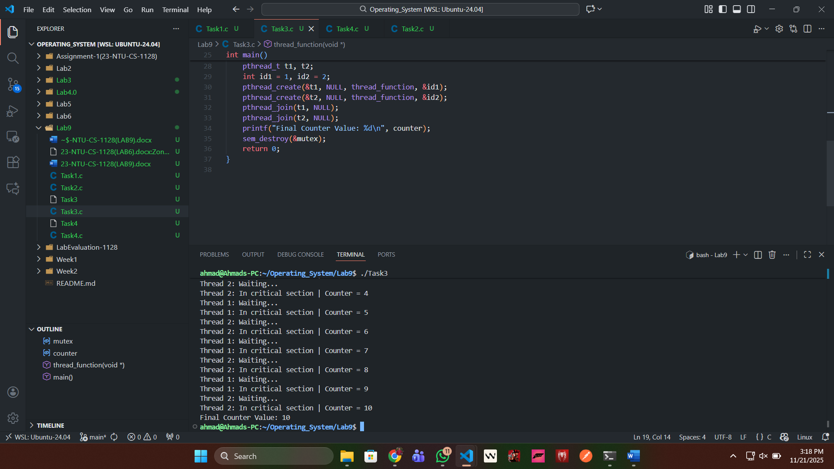

First Mutation:
I set the S in semaphore as 0 so both will keep waiting.
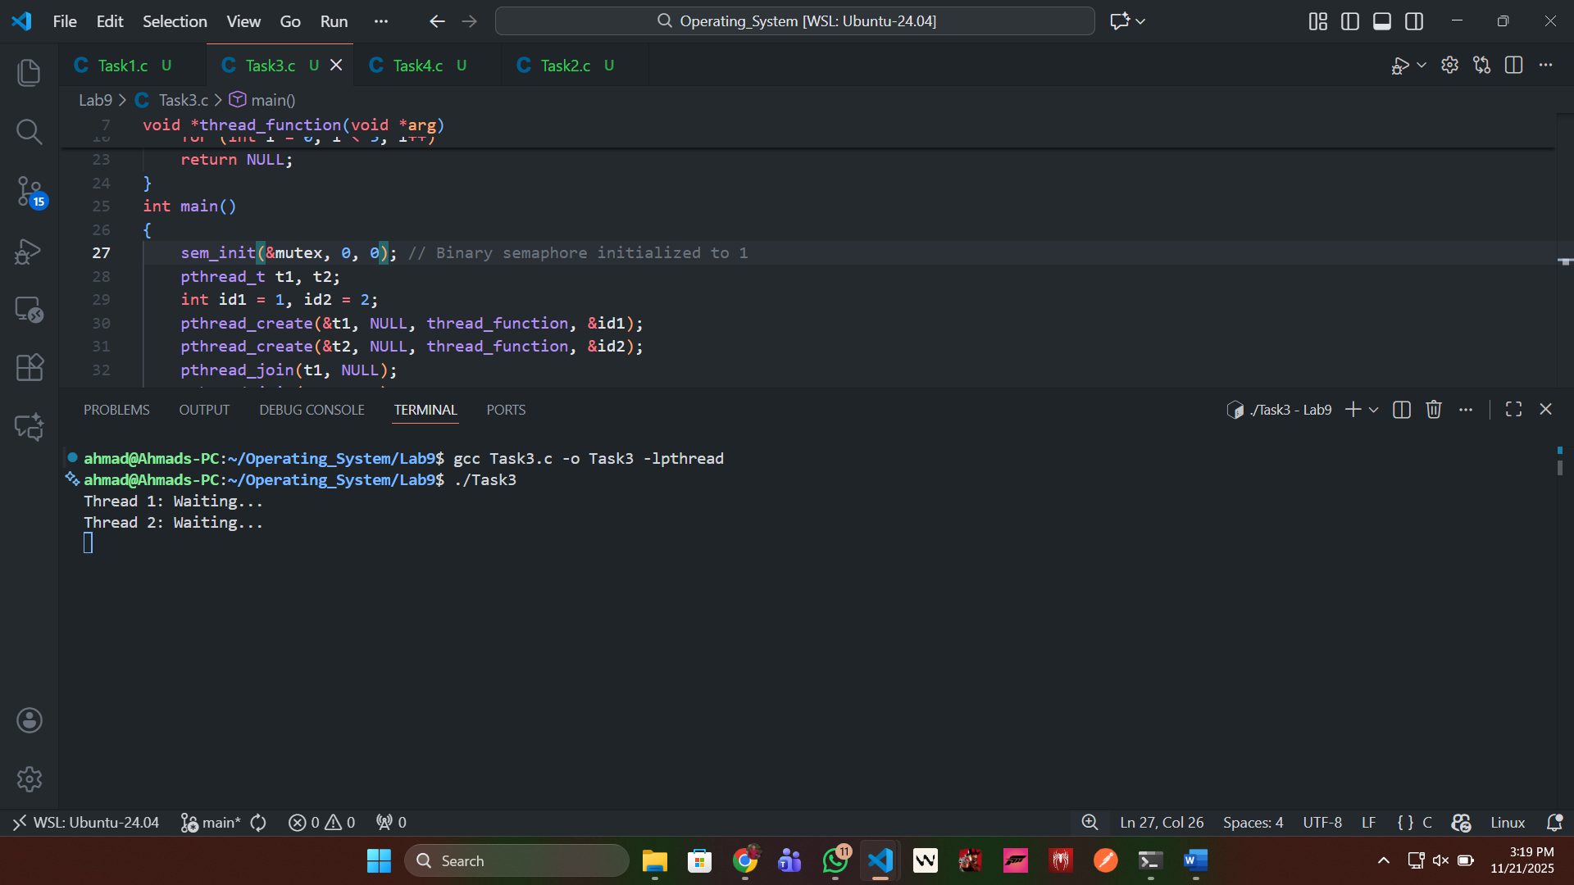

Second Mutation:
I commented the wait() so that all the threads can access the critical section altogether.
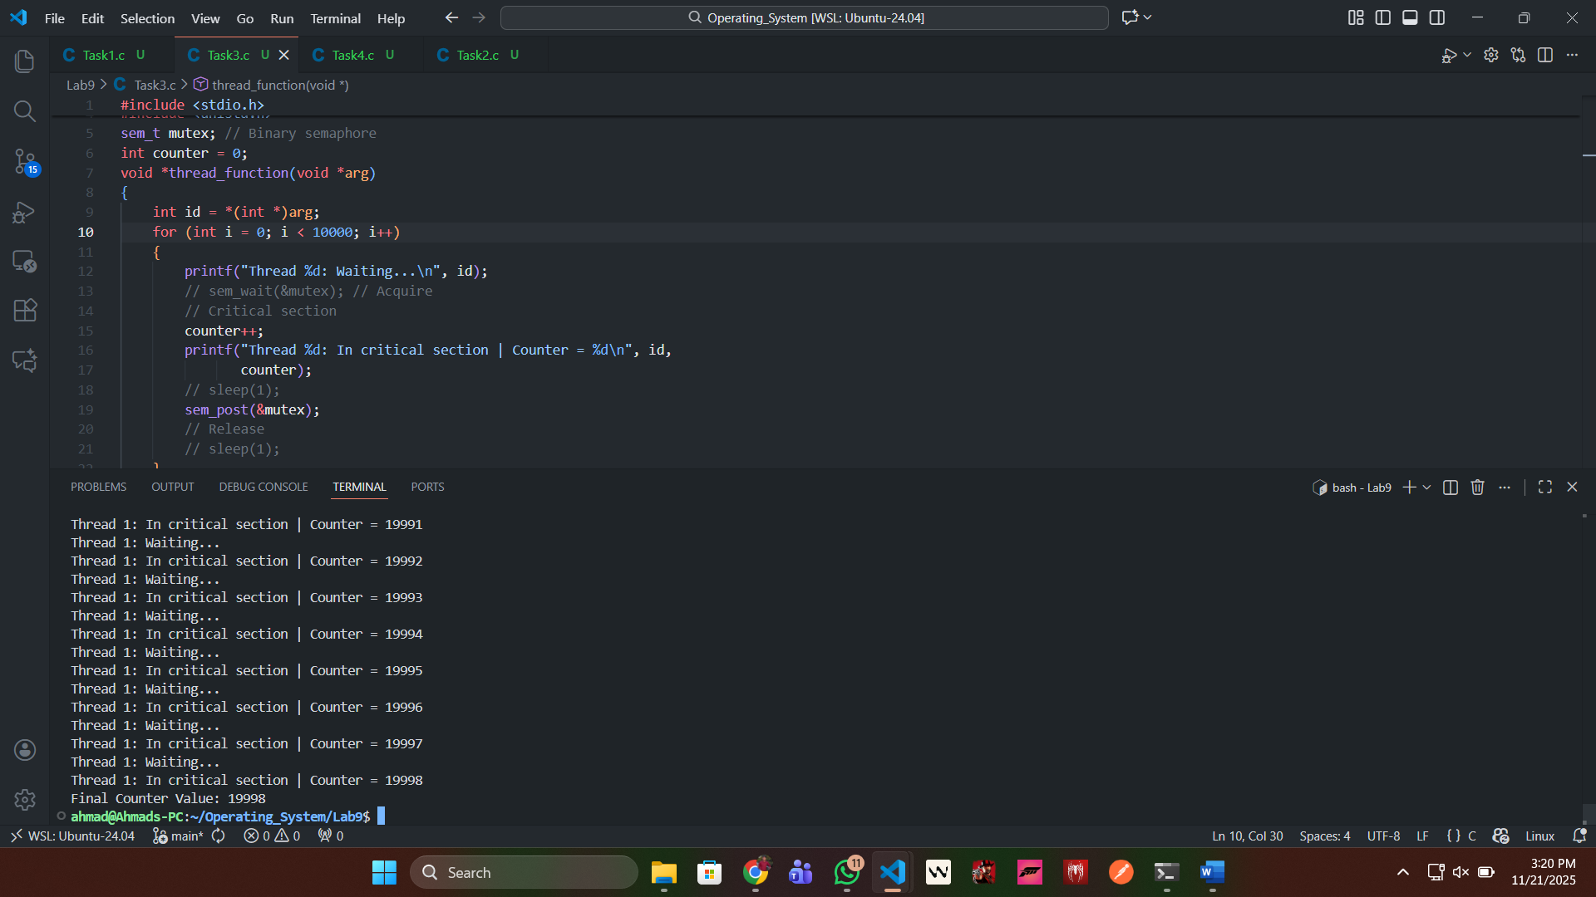
Third Mutation:
I commented the post() so that after executing the first thread it is blocked in waiting.
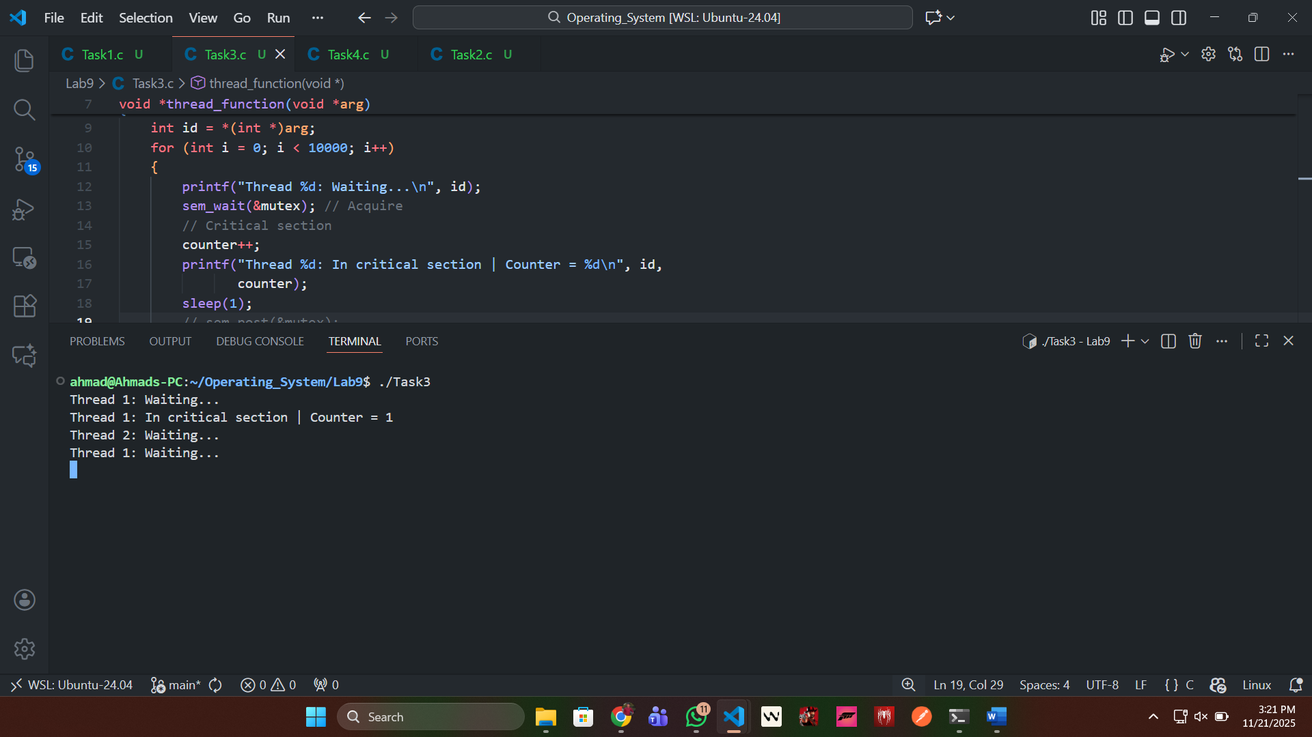

Task 2:
I created two functions one is incrementing the counter and the other is decrementing the counter and all the four threads are synchronized.
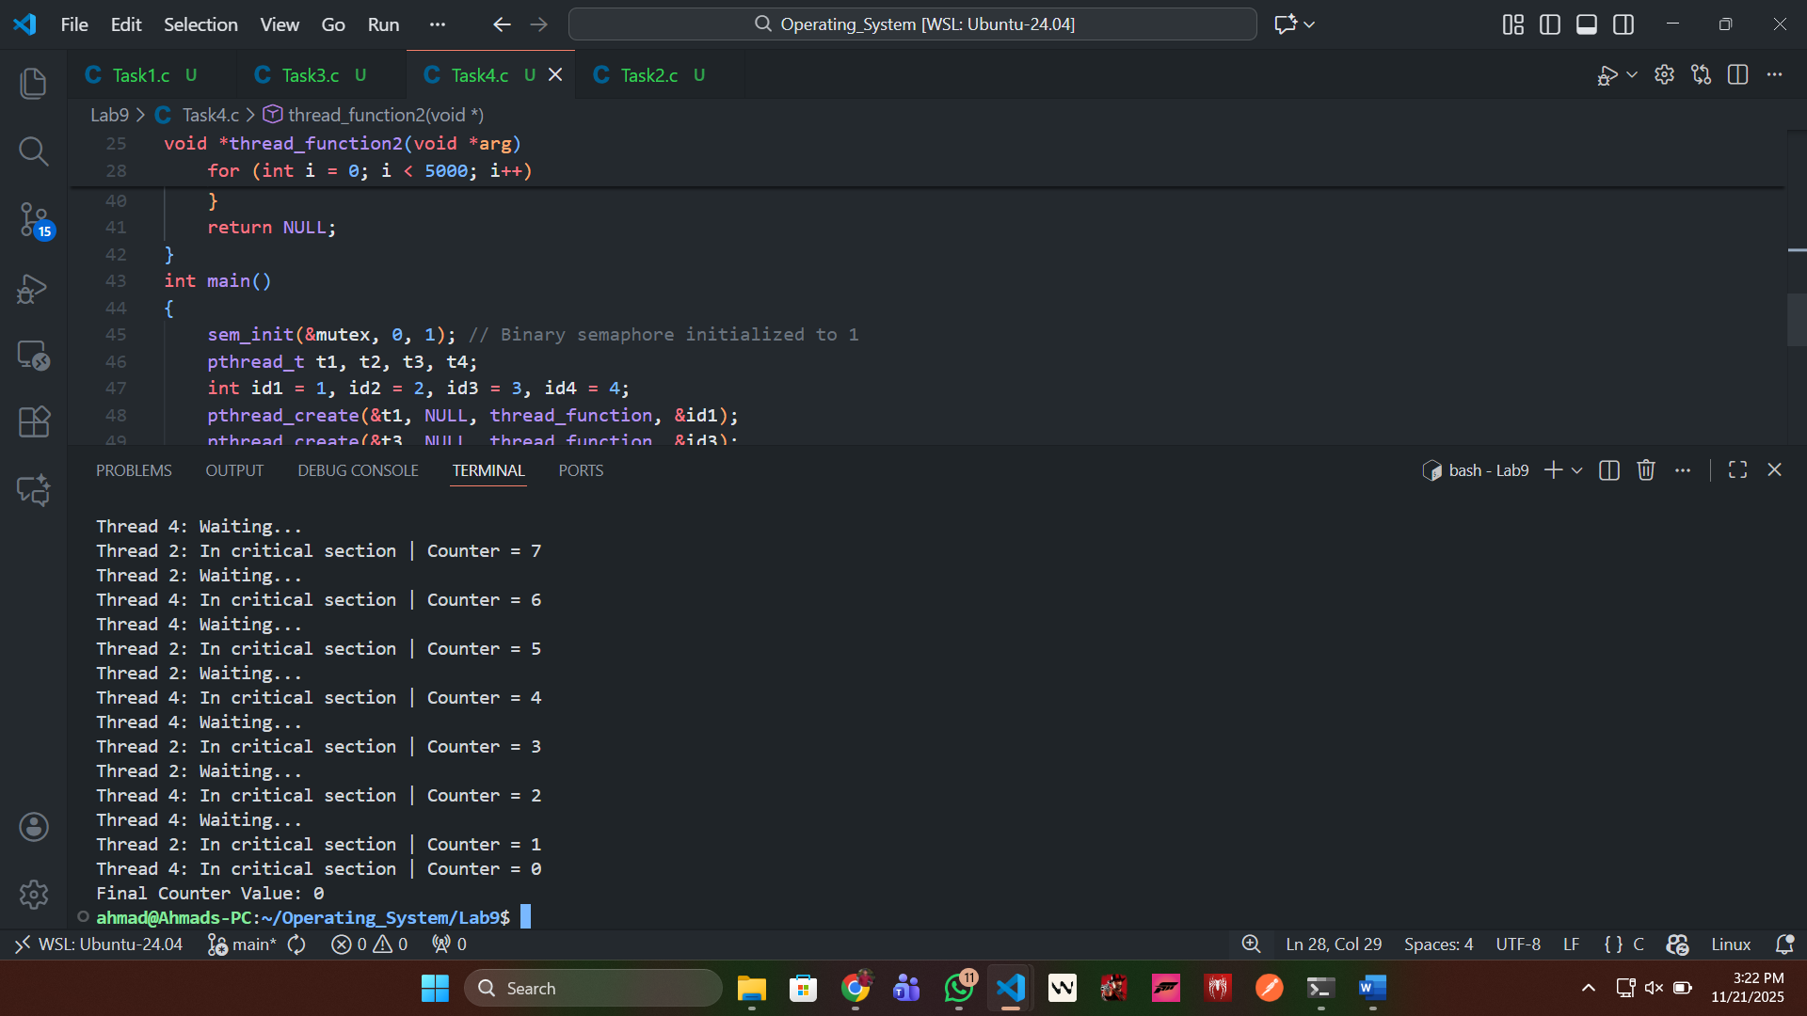
First Mutation:
In first mutation I commented the wait() so that it created the race condition.
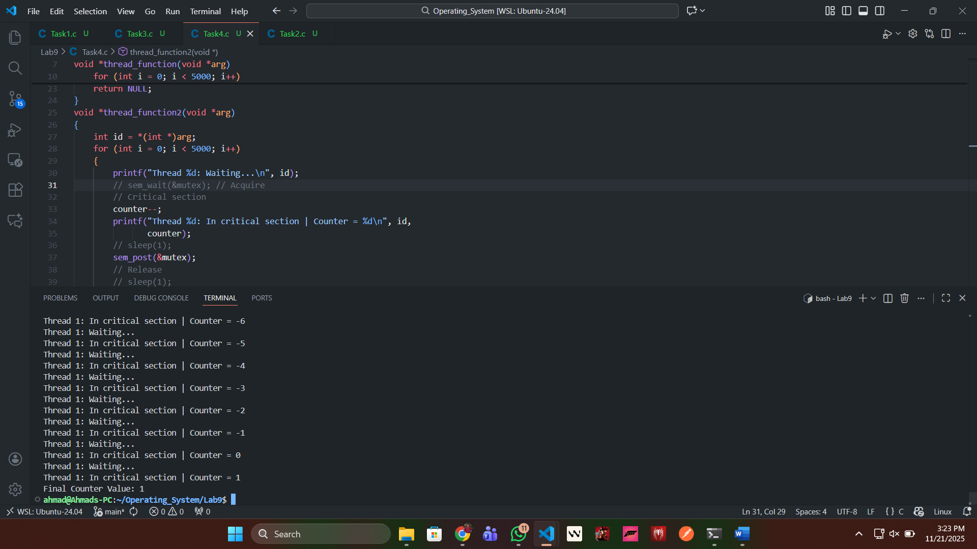

Second Mutation:
I commented the post() so that after executing the first thread it is blocked.
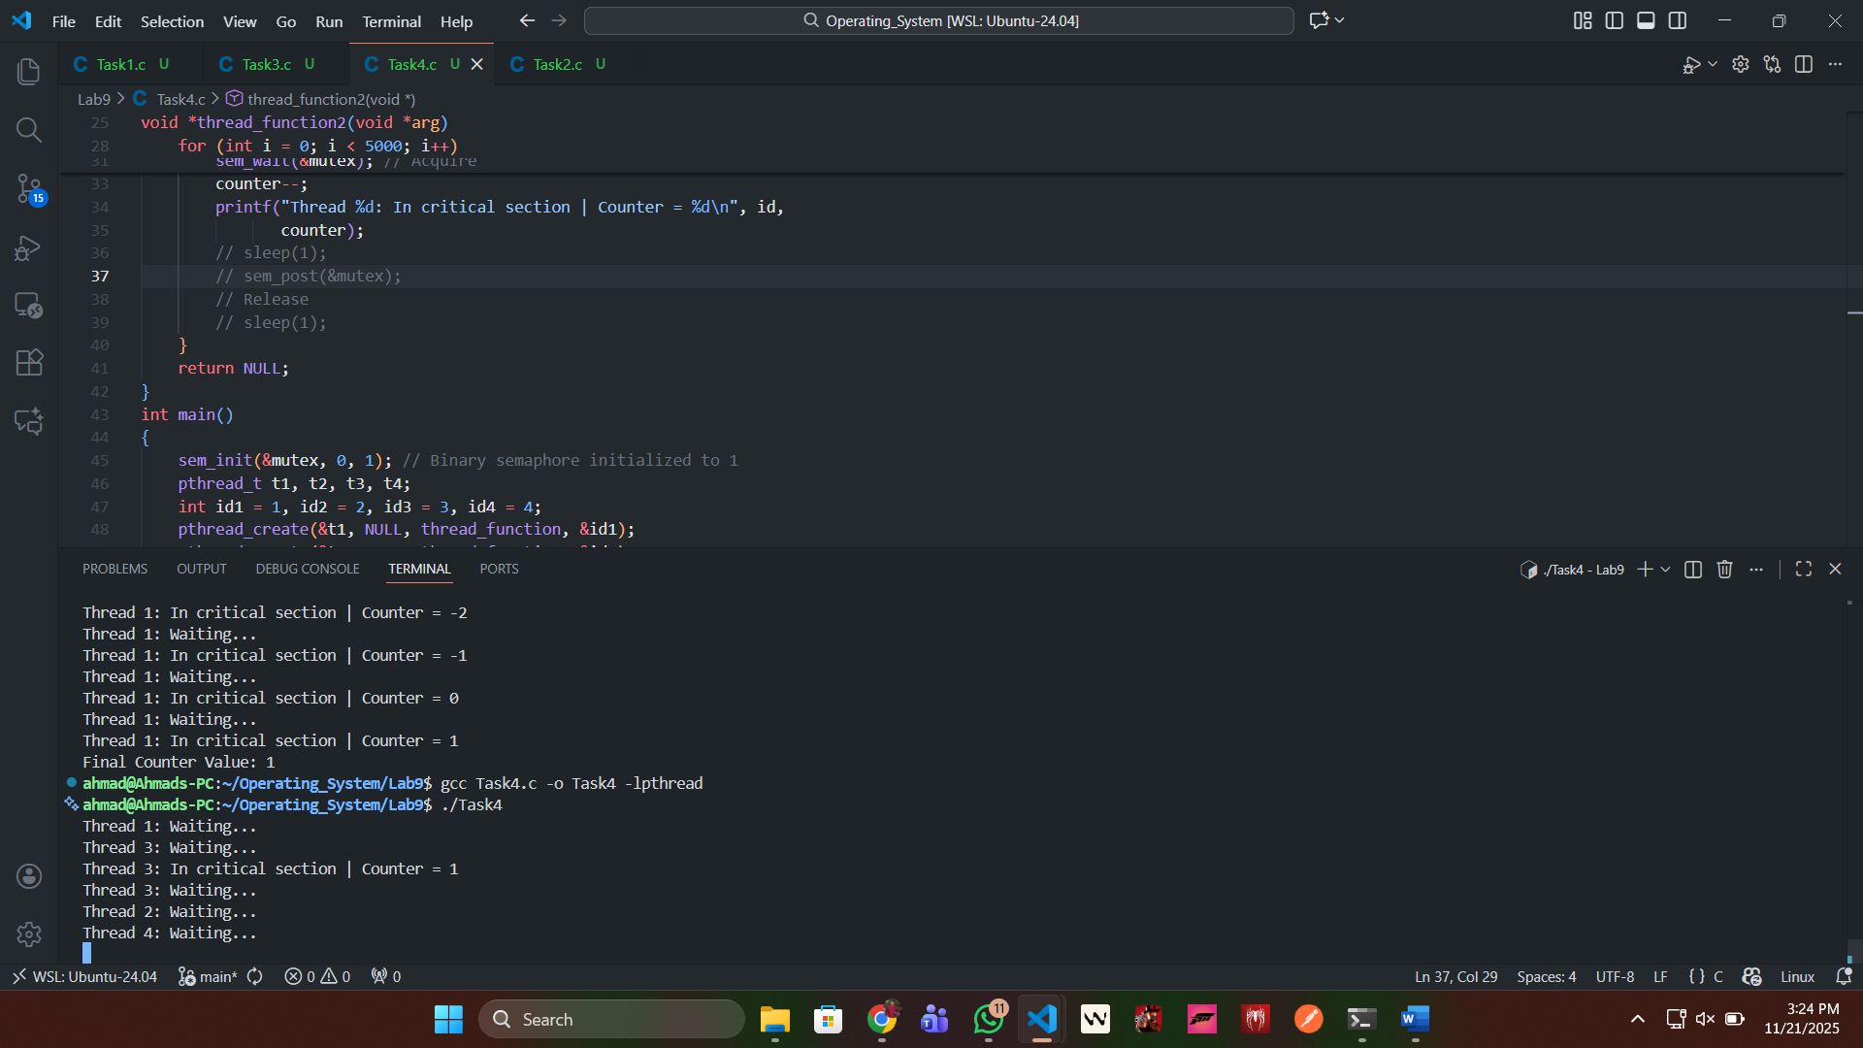
Third Mutation:
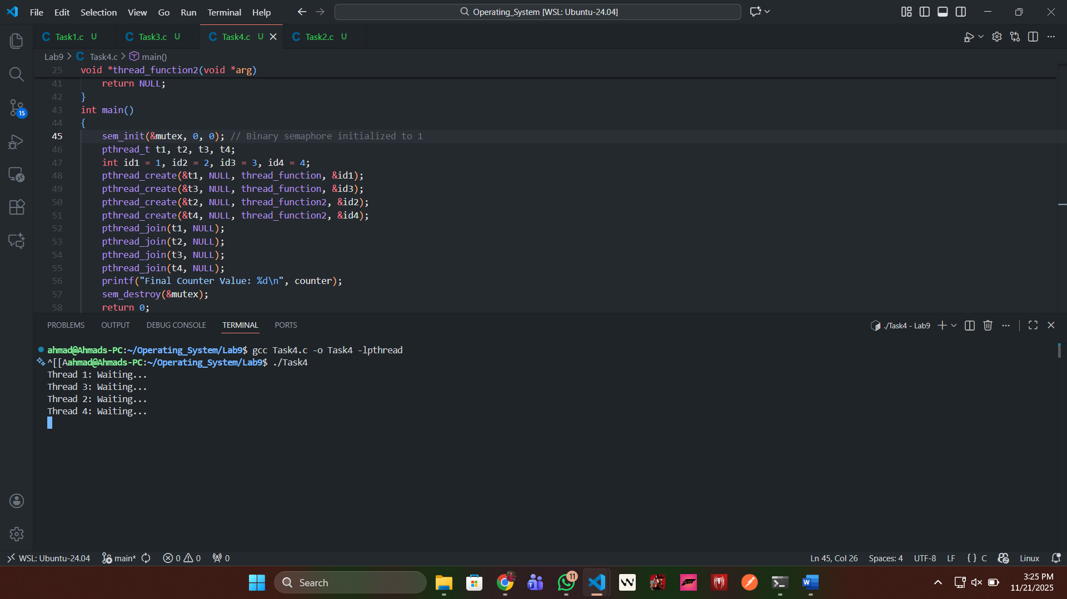

Task 3: Difference between Semaphore and Mutex:
The Mutex is a lock and unlock system which prevents from one thread to access shared critical section while the other thread is working on it.
DataType:
- The main difference between both of them is Semaphore is an integer while the Mutex is just a lock both have completely different datatypes.
OwnerShip:
- In a mutex, the lock is owned and released by the thread that acquires it, whereas in a semaphore there is no ownership; any thread can perform wait() (decrement) or signal() (increment) on the semaphore.

