

National Textile University
Department of Computer Science
Subject

Operating System

Submitted to:
Sir Nasir Mahmood

Submitted by:

Ahmad Farooq

Registration Number
23-NTU-CS-1128

Lab No.
01

Semester
5th

1.1: Basic Commands:
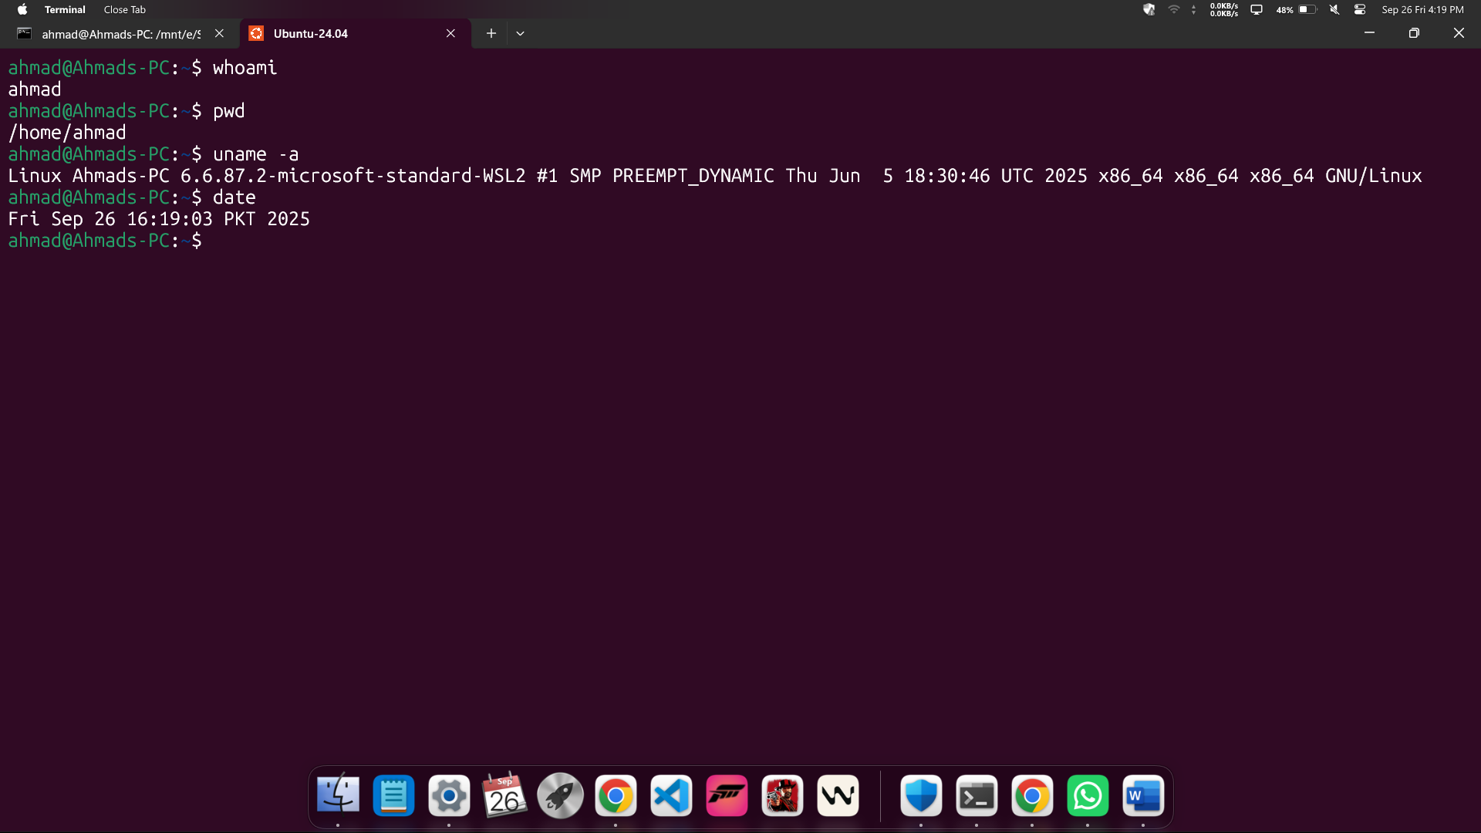
1.2: Getting Help in Linux:
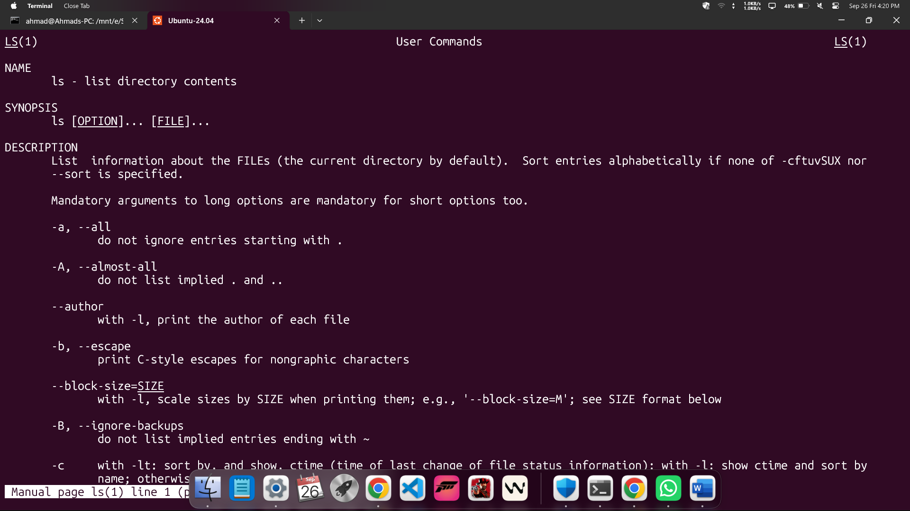

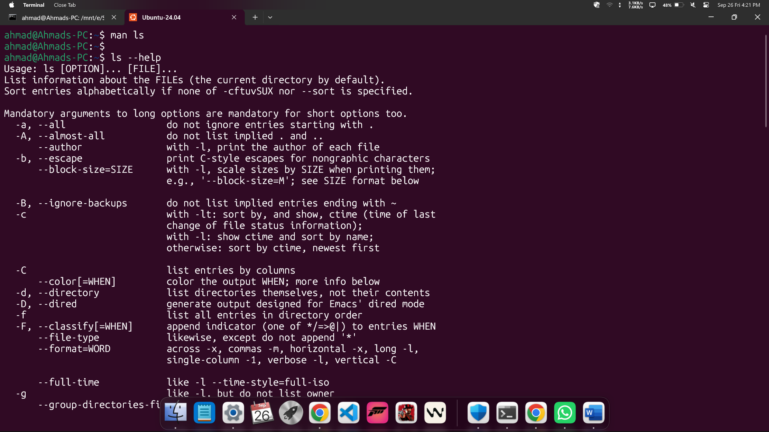
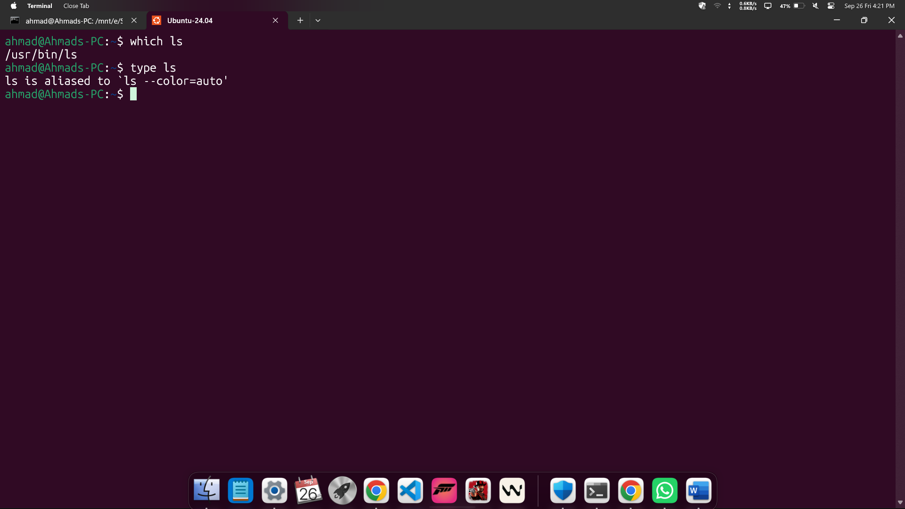

2.1: Linux directory Structure:
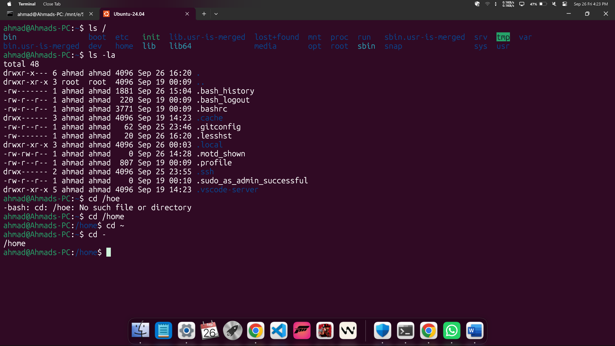
2.2: Basic Navigation:
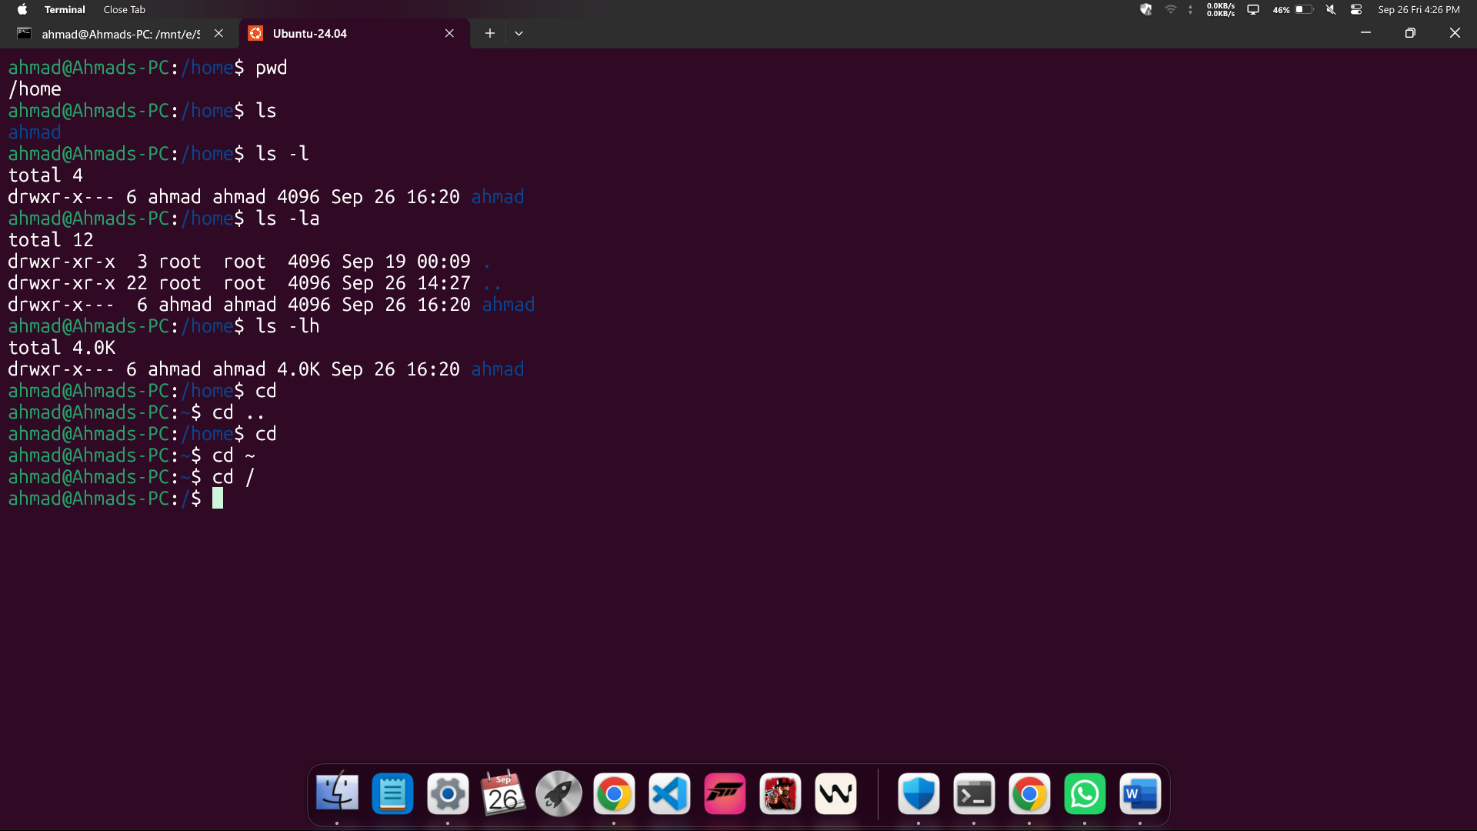

3.1: Linux Directory Operations:
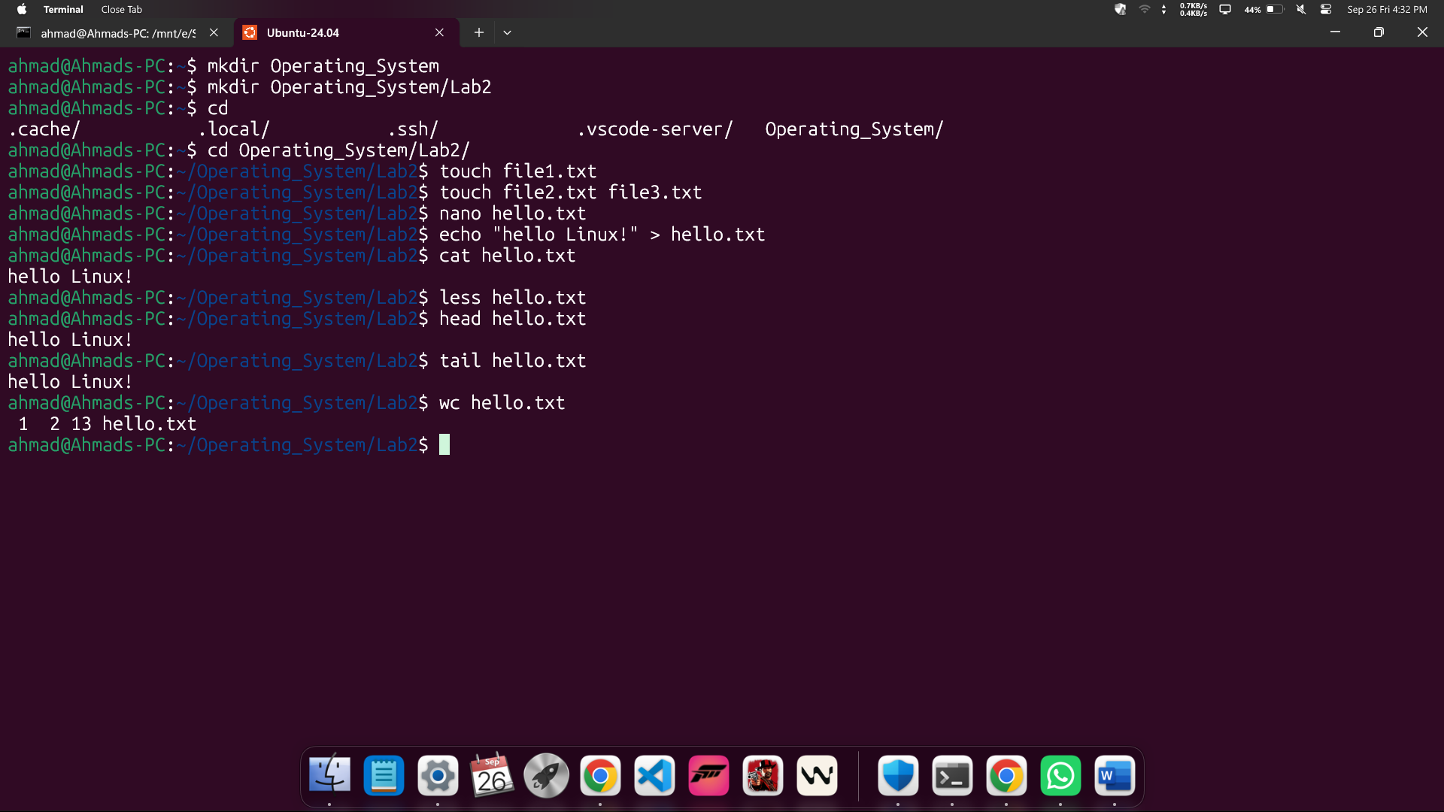
3.2: Copying , Moving and Deleting:
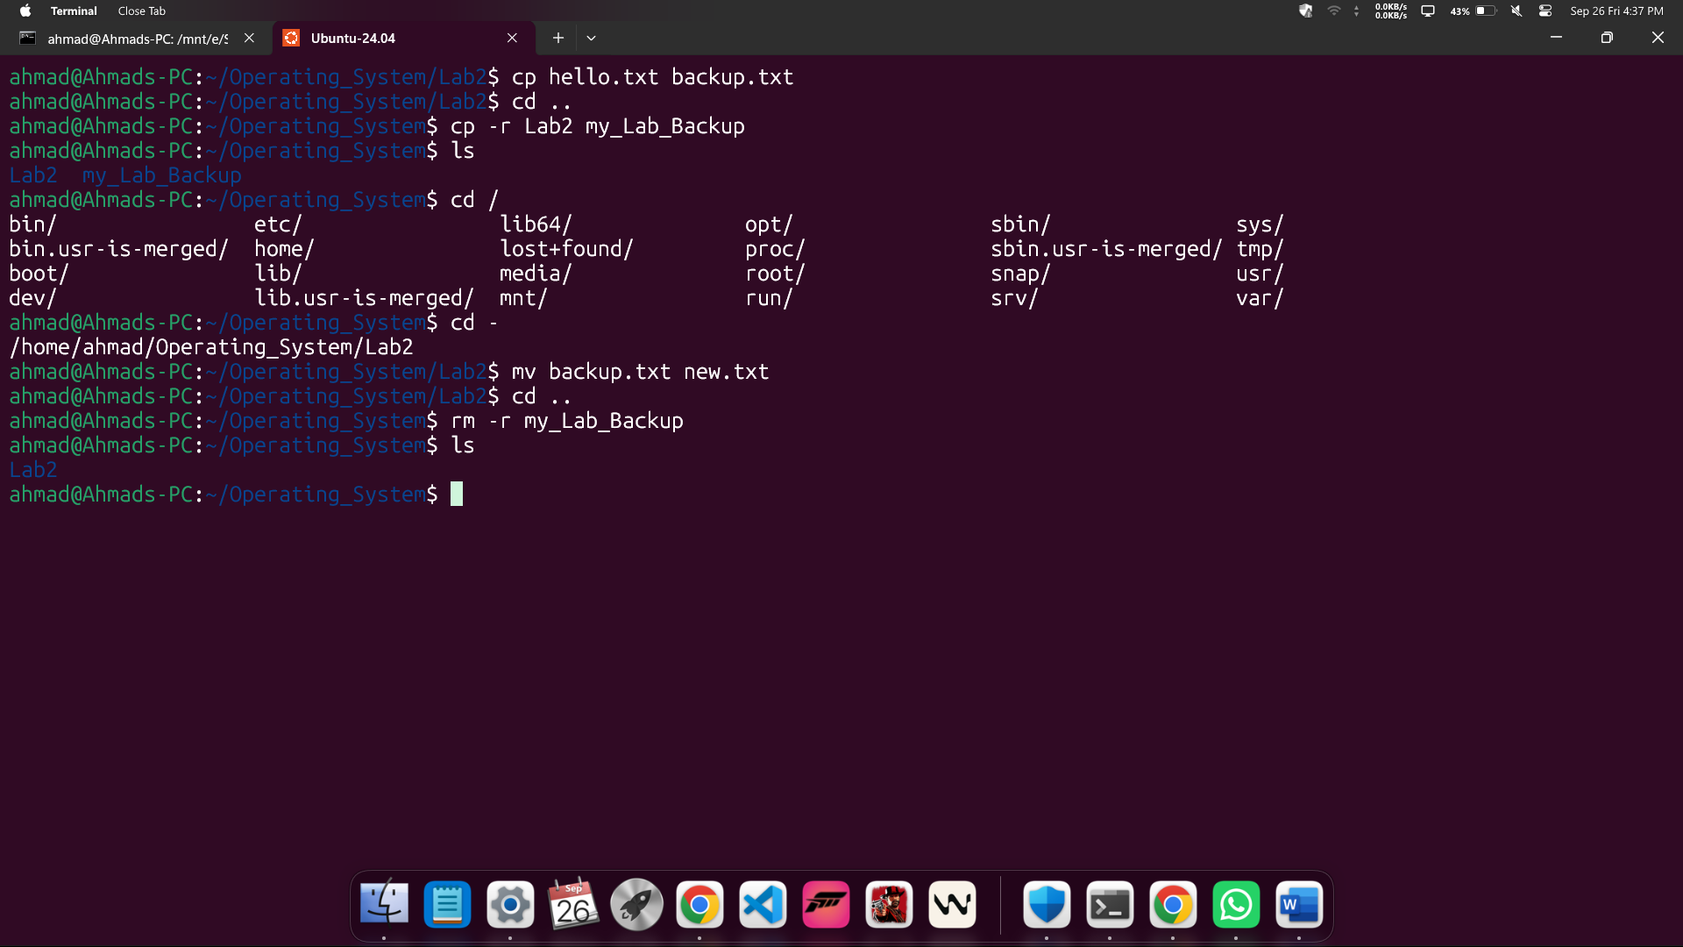

4.1: Understanding File Permissions:
