Storage Microservice
Solution Architecture — Executive Summary
.NET 10 · Angular · Azure · Ports & Adapters
This document answers the four questions in the task statement. The full design document covers the same material in greater depth across 21 sections.

Task Statement
Design a storage microservice that can store files of any extension and act as a storage hub for all other microservices. The design must indicate:
- The functional and non-functional requirements for this microservice.
- The high-level and low-level design for the microservice.
- The type of the storage that will be used and why, and how files will be saved and retrieved.
- How the other microservices will communicate with the newly designed one.
Each of the four sections below answers one of these points in order.

1. Functional and Non-Functional Requirements

1.1 Functional Requirements
The service supports the full lifecycle of a file: upload, store, retrieve, manage metadata, control access, scan, and dispose.

Upload
- Single-shot upload for small files via pre-signed URL or service proxy.
- Multipart, chunked, resumable upload for large files up to 5 TB.
- Accepts any MIME type and any extension. Constraints are enforced per FileCategory (see §2.2), not at the endpoint level.
- Idempotency-Key support on upload initiation for safe retries.

Download
- Direct streaming download via short-lived pre-signed URL.
- HTTP Range requests for partial reads (resumable downloads, media seeking).
- CDN-fronted delivery for hot or public files.
- Optional server-mediated proxy download for audited internal flows.

Metadata, Versioning, Deletion
- Rich metadata: filename, MIME type, size, checksum, owner service, tenant, owner user, category, custom tags, status, timestamps.
- Versioning preserves prior versions under the same logical file ID; list and roll back are supported.
- Soft delete with configurable grace period; hard delete by policy; bulk deletion for tenant offboarding or compliance erasure.

Search, Access Control, Integrity, Lifecycle
- Paginated listing filtered by tenant, owner, category, MIME type, tags, date range, with full-text search on filename.
- Three-layer access control: authenticated identity, per-service permissions, per-file ACL for end users. Pre-signed URLs with caller-bound TTL.
- SHA-256 checksum verified on upload and download. Antivirus scan on every uploaded file before status becomes ready.
- Automatic tiering (hot → cool → archive). Automatic deletion after a retention window. Orphaned pending uploads cleaned after 24 hours.

Audit and Multi-Tenancy
- Every mutation recorded with actor, action, source IP, user agent, timestamp.
- Strict tenant isolation at metadata and storage-key levels. Per-tenant quotas on volume, request rate, max object size.

1.2 Non-Functional Requirements
Attribute | Target
Availability | 99.95% SLA. Multi-AZ deployment. Optional multi-region active/passive.
Durability | 99.999999999% (11 nines) for stored bytes via S3-class object storage.
Scalability | Stateless API on Kubernetes with HPA. 10,000+ RPS, petabyte-scale data.
Performance | P95 metadata operations under 100 ms. Upload initiation under 200 ms. Download throughput limited only by object store and CDN bandwidth.
Security | TLS 1.3 in transit. AES-256 at rest via SSE-KMS. mTLS or signed JWT for service-to-service. Signed/expiring URLs. Per-tenant key isolation option.
Resiliency | Circuit breakers on downstream calls. Retries with exponential backoff and jitter. Idempotency keys. DLQs for failed async work.
Cost efficiency | Tiered storage classes with lifecycle rules. CDN offload. Pre-signed URLs remove the service from the bandwidth path.
Disaster recovery | Cross-region replication. PITR for SQL. RPO under 15 min; RTO under 1 hour. Quarterly DR drills.
Observability | Structured logs (Serilog). OpenTelemetry tracing and metrics. RED metrics per endpoint and tenant.
Maintainability | Versioned API. Backward-compatible contracts. Infrastructure as code (Terraform). CI/CD with automated tests.
Compliance | GDPR right to erasure. Configurable region pinning. PDPL, NCA ECC/CCC, SAMA frameworks addressed for KSA tenants.

2. High-Level and Low-Level Design

2.1 High-Level Design
A single, opinionated platform service owns all files across the platform. No other microservice owns file bytes directly. Every file is registered with the Storage Service, which owns the metadata, governs access, and brokers byte transfer through an object storage backend.
The architecture follows the Ports and Adapters (Hexagonal) pattern. The application core depends only on abstractions for storage, cache, messaging, and persistence. Concrete adapters wire these to specific technologies, selected at startup by configuration. The same codebase runs in Azure production and in a Docker-Compose demo with zero code changes.
Bytes never flow through the service in the common case. Clients receive a pre-signed URL and upload or download directly to the object store. The service handles authorisation and metadata; the object store handles bandwidth. Uploading a 10 GB file costs the service the same as uploading a 10 KB file.
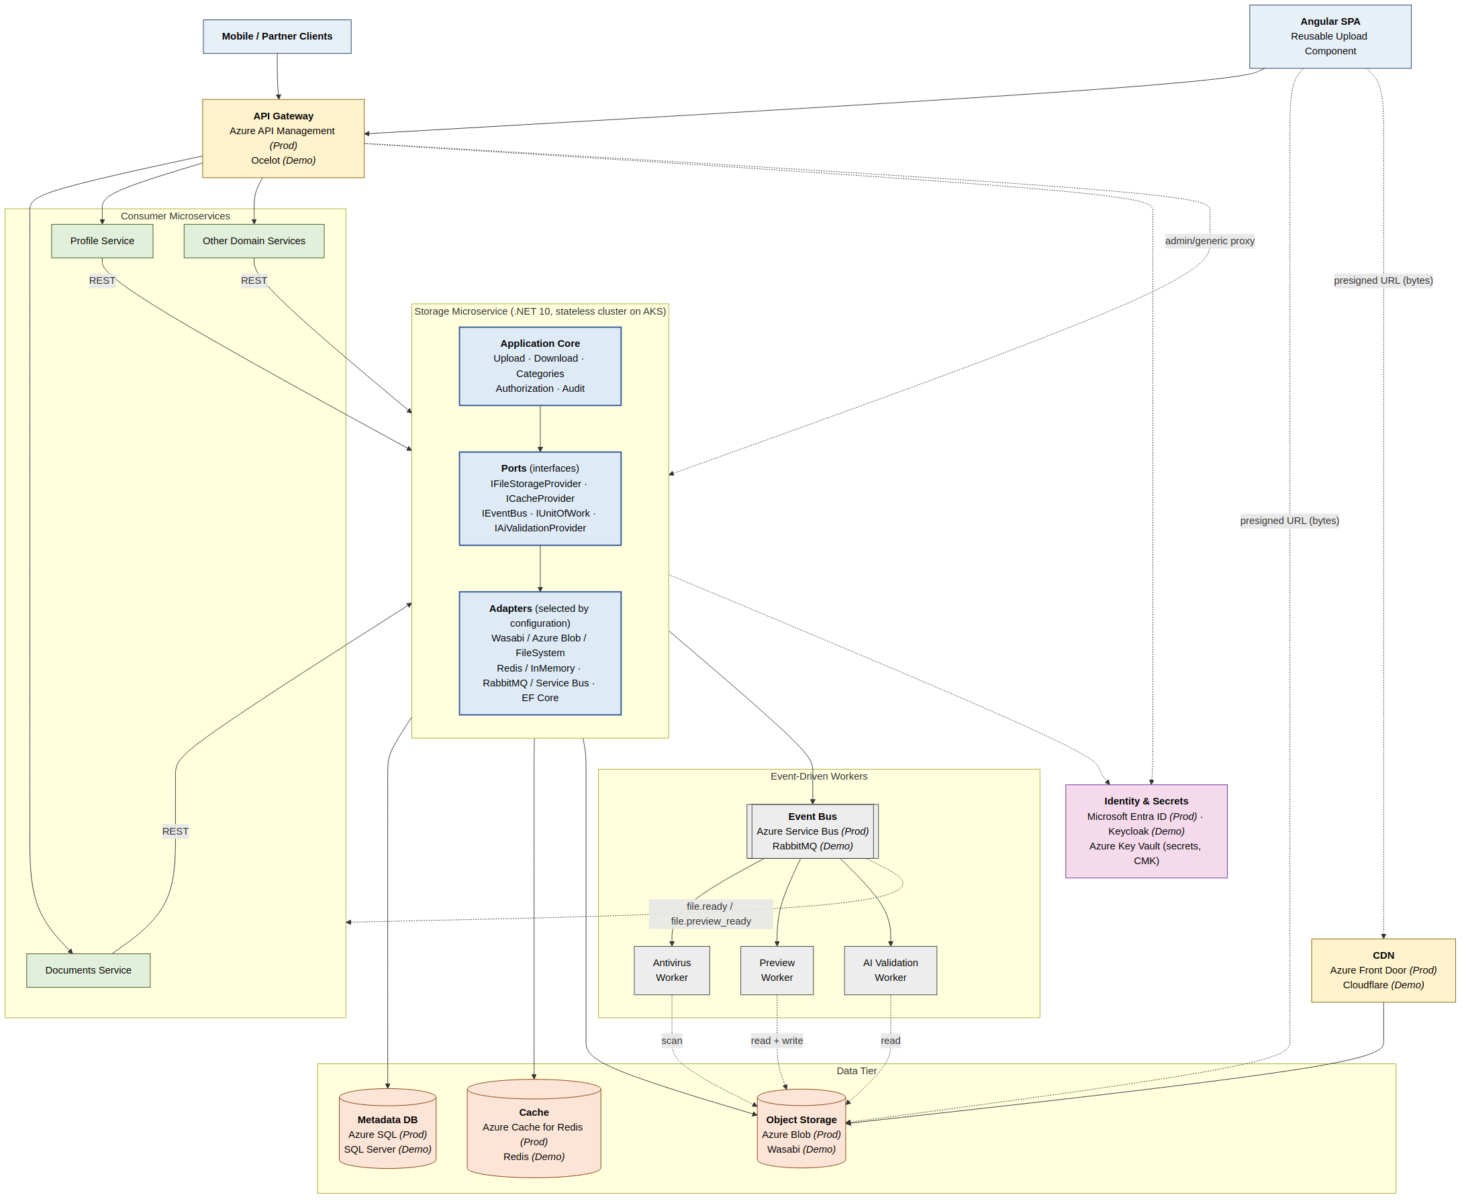
Figure 1. End-to-end system architecture. Production components labelled (Prod); demo equivalents labelled (Demo). The same application code runs against either set of adapters.

Component Responsibilities
- API Gateway — terminates TLS, performs coarse authentication, applies rate limits, forwards calls. Azure API Management in production, Ocelot in demo.
- Storage Microservice — stateless .NET 10 cluster on Kubernetes. Three responsibilities: authorise the operation, manage metadata in SQL Server, broker byte transfer via pre-signed URLs.
- SQL Server (Metadata Store) — files, permissions, versions, tags, audit. EF Core 10. Azure SQL in production, SQL Server in Docker for demo.
- Redis (Distributed Cache) — hot metadata, idempotency keys, rate-limit counters, short-lived pre-signed URL cache.
- Object Storage — file bytes with versioning, server-side encryption, lifecycle rules, event notifications. Azure Blob in production, Wasabi in demo, file system for local dev.
- Event Bus — carries domain events. Azure Service Bus in production, RabbitMQ in demo. MassTransit abstracts both behind a single API.
- CDN — edge caching for public reads. Azure Front Door in production, Cloudflare in demo.
- Antivirus Scanner — consumes file.uploaded, scans, publishes file.scanned. ClamAV or Microsoft Defender for Cloud.

2.2 Low-Level Design

File Categories — the Policy Holder
Validation rules (max size, allowed MIME types, allowed extensions, large-file flag, preview support) are properties of a FileCategory, not of the upload endpoint. Consumer microservices pass a category identifier; the Storage Service enforces the policy. This centralises validation, makes it auditable, and turns policy changes into a single-table update rather than a code change across every consumer.
Starter category set:
Category | Max size | Allowed types | Large? | Preview
avatar | 5 MB | jpeg, png, webp | No | Image thumbnails (64, 256)
company-logo | 2 MB | svg, png | No | Direct image
document | 100 MB | pdf, docx, xlsx, pptx | No | PDF first-page render
deliverable | 1 GB | broad allow-list | Yes | None
project-archive | 5 TB | zip, tar, 7z | Yes | None
video | 5 GB | mp4, mov, webm | Yes | Poster frame
signed-contract | 50 MB | pdf | No | PDF first-page render

Domain Class Model
File is the aggregate root. It belongs to a FileCategory (the policy holder), has many versions, permissions, tags, and audit entries, and references value objects (StorageKey, Checksum) and enums (FileStatus, Visibility, Permission).
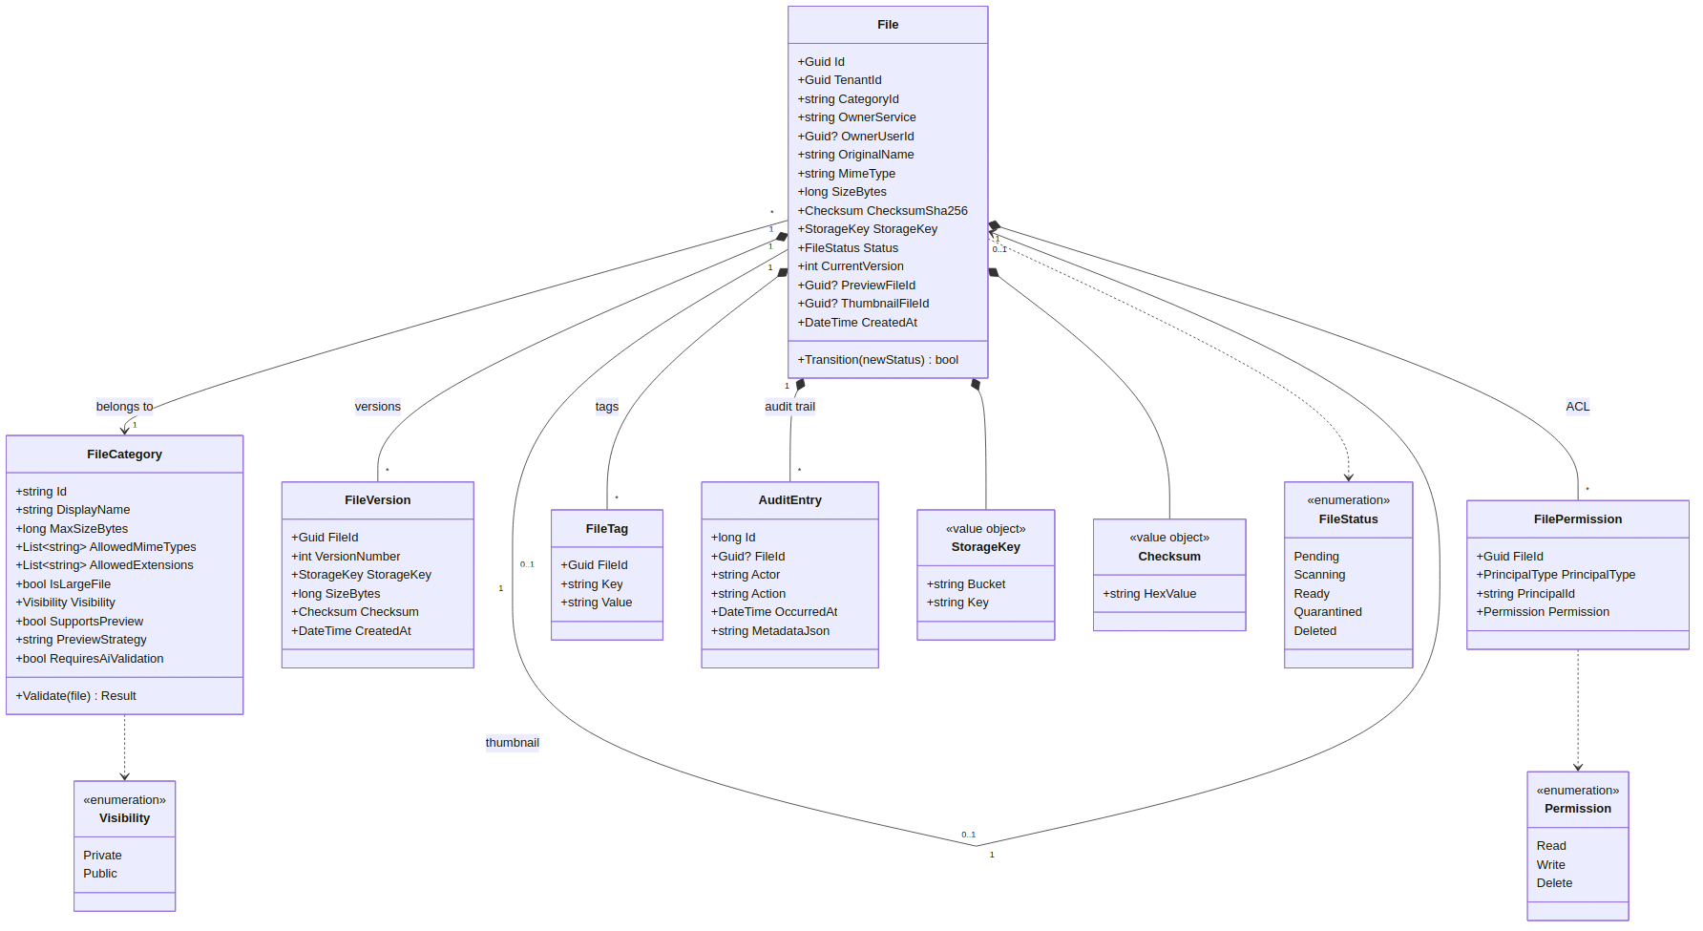
Figure 2. Domain class model. File is the aggregate root; FileCategory holds the policy.

Ports and Adapters Layering
Five interfaces define the seams of the architecture. Each has multiple concrete adapters selected by configuration. UploadService and DownloadService are the primary application use cases; they depend only on the ports, never on concrete adapters.
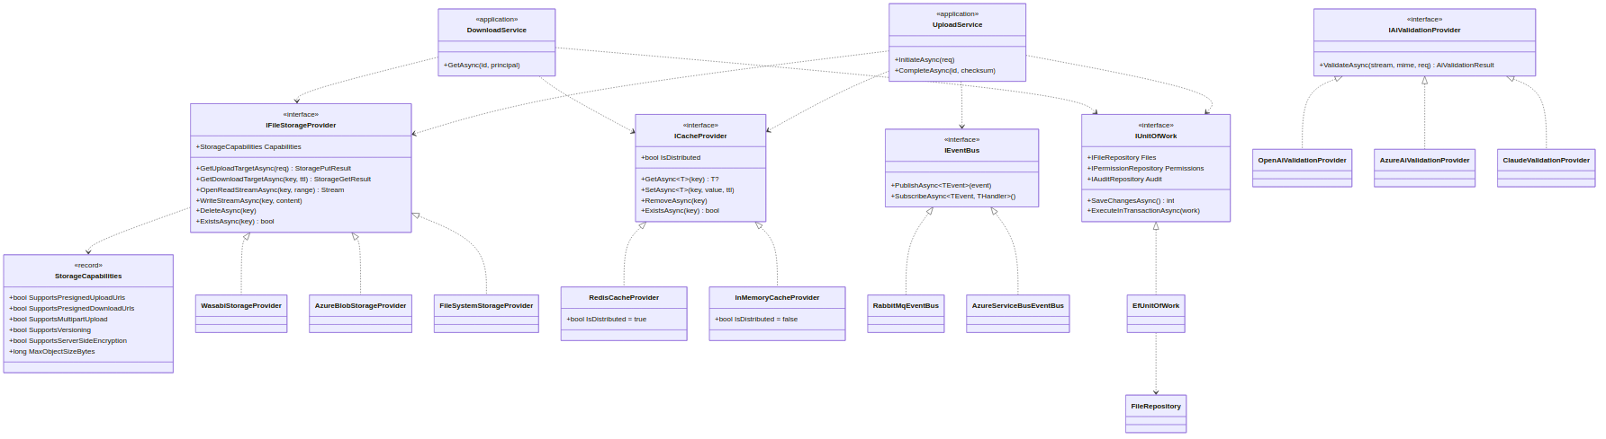
Figure 3. Ports (interfaces) above, adapters (concrete implementations) below.

Upload Sequence
From client request to file ready for consumption:
- Client POSTs to /v1/files with category, file name, MIME type, declared size, tenant, Idempotency-Key.
- Service resolves the FileCategory, validates OwnerService, MIME type, extension, size against the category. Returns precise 4xx errors (400 / 403 / 413 / 415) before any storage operation.
- Service generates a UUID and a date-prefixed storage key (<tenantId>/<yyyy>/<mm>/<dd>/<uuid>) to prevent hotspots in the object store.
- Service inserts a Files row with Status=pending and the resolved CategoryId. For IsLargeFile categories, initiates a multipart upload immediately.
- Service returns a pre-signed PUT URL (TTL 15 min, SSE-KMS headers) or multipart upload ID.
- Client uploads bytes directly to the object store. The service never sees them.
- Client confirms completion via POST /v1/files/{id}/complete with checksum.
- Service verifies the checksum, flips Status=scanning, publishes file.uploaded.
- Antivirus worker scans the file and publishes file.scanned.
- If SupportsPreview is true, preview worker generates preview/thumbnail and publishes file.preview_ready.
- Service flips Status to ready (or quarantined) and publishes file.ready. Subscribed consumer microservices update their own state.

3. Storage Type and Save / Retrieve Mechanics

3.1 Choice: S3-Compatible Object Storage for Bytes, SQL Server for Metadata
The design rests on a clear separation. SQL Server holds structured transactional metadata. Object storage holds the binary content. The two layers have different access patterns, different durability profiles, and different cost economics — pairing them is the architecturally correct choice.

3.2 Why Object Storage Wins (Alternatives Considered)
Option | Why rejected
Files inside SQL Server (FILESTREAM or varbinary) | Bloats transaction log, breaks backup windows, ruins buffer-pool cache hit ratios, caps file size at row limits, saturates DB I/O with bandwidth-heavy traffic.
Block storage (Azure Disk, EBS) | Single-attach by design. Does not scale across nodes without significant engineering. Expensive per GB. No native HTTP access.
Network file system (NFS, EFS, Azure Files) | Expensive per GB. Slower than object storage at scale. Suffers under millions of small objects. Operationally heavy.
Self-hosted file server | Single point of failure. Operational liability. No durability guarantees. No native versioning or lifecycle.
Object storage wins on every dimension that matters here:
- Designed for arbitrary file types and sizes up to terabyte-class objects.
- Horizontal scalability across billions of objects per bucket.
- Durability of 11 nines via cross-AZ replication or erasure coding.
- Order of magnitude cheaper per GB than block storage. Tiered classes for lifecycle savings.
- HTTP-native: pre-signed URLs remove the Storage Microservice from the byte path.
- Built-in: SSE, versioning, lifecycle, event notifications, cross-region replication, object lock.
- Vendor-portable: S3 API supported by Wasabi, AWS, MinIO; Azure Blob has a first-class native adapter.

Provider Strategy by Environment
- Production: Azure Blob Storage. Hot/cool/archive tiers, Azure Front Door integration, Entra ID RBAC, customer-managed keys via Azure Key Vault. ZRS by default, GRS available for compliance tenants.
- Demo: Wasabi. S3-compatible, generous free tier, no egress fees. Same capability profile as Azure Blob.
- Development: File system. Files written to a configured root, served through the service's proxy endpoint. Capability flag SupportsPresignedUploadUrls=false; application transparently switches to proxy upload.

3.3 How Files Are Saved
- Client initiates upload with POST /v1/files (category, filename, MIME type, declared size, intended permissions).
- Service generates a UUID and the deterministic storage key (<tenantId>/<yyyy>/<mm>/<dd>/<uuid>). The date prefix prevents hot partitions in the object store.
- Service requests a pre-signed PUT URL from the object store (15-min TTL, SSE-KMS headers baked into the signed URL).
- For files larger than 100 MB or categories flagged IsLargeFile, the service initiates a multipart upload and returns per-part pre-signed URLs (5–100 MB per part).
- Client uploads bytes directly to the object store. Service never sees them.
- On completion, SHA-256 checksum verified against object store metadata. Files row marked scanning; antivirus pipeline runs.
- Versioning enabled at the bucket level; the service tracks version IDs in FileVersions.

3.4 How Files Are Retrieved
- Client calls GET /v1/files/{id}.
- Service returns metadata plus a pre-signed GET URL (default 15-min TTL).
- Client requests bytes directly from the object store. HTTP Range supported for partial reads.
- For hot or public content, the service returns a CDN-signed URL. CDN caches at the edge after the first miss.
- For audited internal streams, GET /v1/files/{id}/content proxies through the service. This is the exception, not the default.

4. How Other Microservices Communicate
A blend of synchronous and asynchronous channels, each used for what it does best, plus pre-signed URLs as a third channel that handles the bandwidth-heavy parts.

4.1 Synchronous: REST over HTTPS
Consumer microservices call the Storage Microservice for all CRUD-style operations. REST is the default; gRPC is acceptable for chatty service-to-service paths. Ground rules:
- Clients never proxy file bytes through the Storage Service. They receive a pre-signed URL and talk to the object store directly.
- Every call carries a service token (signed JWT) or mTLS-authenticated transport identity.
- Standard headers: Authorization, Idempotency-Key, X-Tenant-Id, traceparent.

4.2 Asynchronous: Event-Driven
Domain events are published over RabbitMQ (demo) or Azure Service Bus (production), abstracted through MassTransit. Each event carries the file ID, tenant ID, owner service, timestamp, and just enough metadata for routing — no payload bytes.
Event | Description
file.created | A new file metadata record was created. Status is pending.
file.uploaded | Bytes uploaded and checksum verified. Status is scanning.
file.scanned | Antivirus scan completed. Payload includes the verdict.
file.preview_ready | Preview or thumbnail generated. Payload includes PreviewFileId / ThumbnailFileId.
file.ready | File is fully available for consumption. Status is ready.
file.deleted | File has been deleted (soft or hard).
file.permission_changed | File ACL was modified.

4.3 Pre-Signed URLs — the Third Channel
Pre-signed URLs let the Storage Microservice hand off bandwidth-intensive operations to the object store while controlling who can do what for how long. This pattern is what makes the service horizontally cheap regardless of file sizes. The service generates the URL after authorising the request; the client uses the URL directly against the object store within the TTL.

4.4 Client SDK and Reliability Primitives
A thin client SDK (.NET, TypeScript) encapsulates the common patterns and removes per-team toil:
- Authentication, retry-with-jitter, multipart chunking, idempotency-key handling, checksum verification, event subscription.
- Consumers send Idempotency-Key on POSTs, honour Retry-After on 429s, use exponential backoff with jitter.
- Consumers treat the service as eventually consistent for newly uploaded files — subscribe to file.ready instead of polling.

4.5 Authentication Between Services
Two acceptable patterns, both supported:
- mTLS via service mesh (Linkerd, Istio, Dapr) — stronger guarantees, heavier operations.
- Signed JWTs issued by central identity (Keycloak in demo, Microsoft Entra ID in production) — easier to roll out incrementally.
For end-user-initiated operations, the user's JWT is forwarded so the Storage Service can apply user-level permissions on top of service-level ones.

4.6 Sample Integration: Documents Service Uploading a Project Deliverable
A walk-through of how a consumer microservice integrates end-to-end:
- Angular client calls POST /api/documents on the Documents Service with file metadata.
- Documents Service calls POST /v1/files on the Storage Service with category="deliverable", OwnerService="documents-service", tags { projectId, type }.
- Storage Service returns { fileId, uploadUrl, expiresAt }.
- Documents Service inserts a Documents row with Status=uploading, StorageFileId=fileId; returns { documentId, uploadUrl } to the client.
- Angular client uploads bytes directly to the object store via the pre-signed URL.
- Client calls POST /api/documents/{id}/confirm; Documents Service calls Storage Service's complete endpoint.
- Storage Service runs antivirus, eventually publishes file.ready.
- Documents Service's event handler receives file.ready and updates Documents.Status=ready.
The same pattern works for every consumer microservice. The Storage Service is the single hub; the consumer owns its own business entity and metadata; events keep the two in sync without tight coupling.

Closing Note
This summary answers the four points of the task directly. The full design document covers the same material in greater depth across 21 sections: complete REST API contract, full SQL DDL, Ports and Adapters code samples, configuration-driven wiring, Azure deployment topology, DevOps and Terraform, testing strategy across the test pyramid, security architecture (STRIDE and OWASP API Top 10), observability with SLOs and runbooks, and KSA-specific localisation and regulatory compliance (PDPL, NCA, SAMA, ZATCA).

