Survey Configurator Application

Administrator Documentation
Version: 1.0
Document Type: Administrator
Application Type: Desktop Application (.NET)
Prepared By: Ahmad Jaber

Contents
Survey Configurator Application 1
Administrator Documentation 1
1. Introduction 3
2. System Requirements 3
2.1 Software Requirements 3
3. Installation Guide 3
3.1 Unzip Application Files 3
3.2 Database Setup 4
3.2.1 Running the Database Script 4
3.3 Application Configuration 5
4 Handling Errors 7
4.1 Error Handling and Logs 7
4.1.1 Database Errors 7
4.1.2 Application Logs 7
4.1.3 Support 7

1. Introduction
The Survey Configurator Application – Administrator Documentation is designed to guide system administrators through the installation, configuration, and maintenance of the Survey Configurator Application.
This manual is intended for administrators responsible for setting up the application on user PCs, ensuring proper database connectivity, managing configuration files, and troubleshooting any issues that may arise.
By following this guide, administrators will be able to:
- Successfully install the application and its dependencies.
- Configure the application to connect to the database.
- Ensure multi-instance support on the same or multiple PCs.
- Monitor and maintain the system to ensure smooth operation for end users.

2. System Requirements
To successfully install and run the Survey Configurator Application, the following system requirements must be met.

2.1 Software Requirements
- Operating System: Windows 10 or later
- .NET Runtime: .NET 10 Runtime installed
- Database: Microsoft SQL Server (any supported edition)
- Database Management Tool:
  - SQL Server Management Studio (SSMS) – required to run the database creation script and manage the database

3. Installation Guide
This section describes the steps required to install the Survey Configurator Application and prepare the database.

3.1 Unzip Application Files
- Locate the provided ZIP package.
- Extract the contents to a desired directory (for example: C:\SurveyConfigurator).

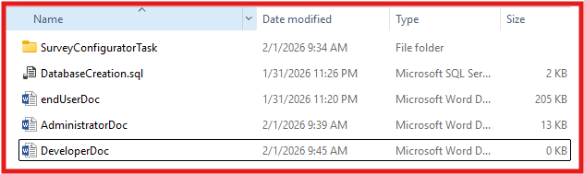
Figure 1

3.2 Database Setup
The application requires a SQL Server database. A SQL script is provided to create the database and all required tables.

3.2.1 Running the Database Script
- Open SQL Server Management Studio (SSMS).
- Connect to the target SQL Server instance.
- From the menu, select File → Open → File and open DatabaseCreation.sql. As shown in figure 2 .
- Click Execute (or press F5) to run the script.
- Verify that the following database and tables are created successfully:
  - SurveyConfigurator
  - Questions
  - SliderQuestion
  - SmileyFacesQuestion
  - StarsQuestion
  - DatabaseChangeTracker
As shown in figure 3.

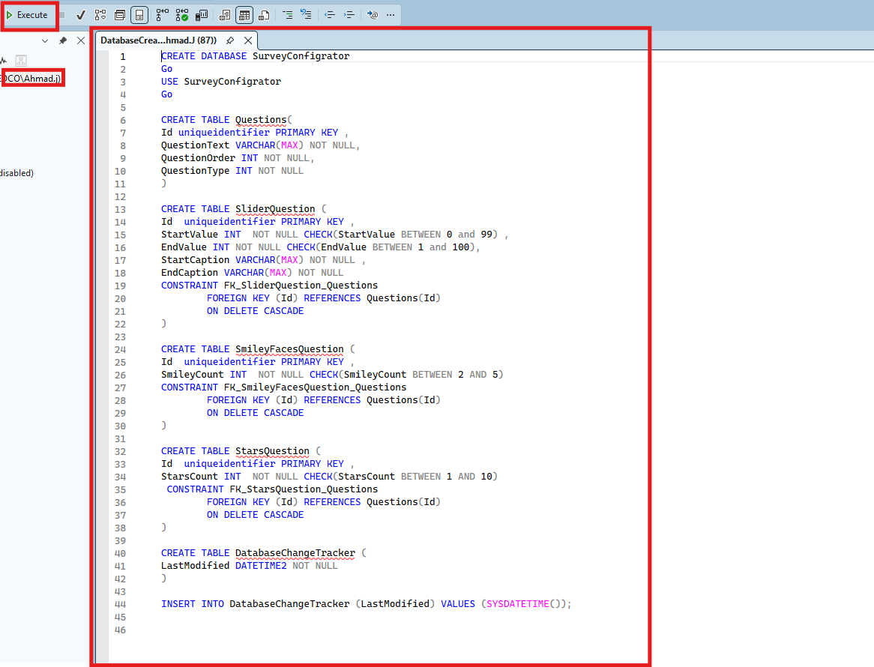
Figure 2

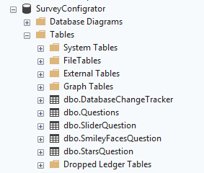
Figure 3

3.3 Application Configuration
- Locate the configuration file SurveyConfiguratorTask.dll.config in the application folder.
- Open the file using a text editor.
- Update the SQL Server connection settings:
  - Server name or IP address
  - Database name (SurveyConfigurator)
  - Authentication type (Windows or SQL Server authentication)
  - Username and password (if SQL authentication is used)
- Save the file.
After completing this step, the application is ready to run.

4 Handling Errors

4.1 Error Handling and Logs

4.1.1 Database Errors
- If a database-related issue occurs, an error message will be displayed.
Carefully read the message, as it often indicates the cause of the problem.

4.1.2 Application Logs
- For detailed error information, open the logs folder inside the application directory.
- Locate the file app_log.txt.
- This file contains:
  - A detailed error description
  - The exact location in the application where the error occurred
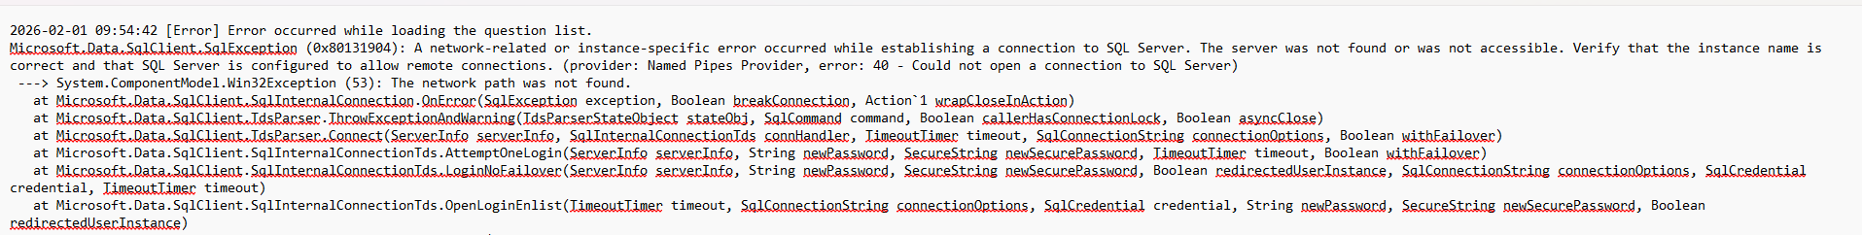
Figure 4

4.1.3 Support
- If the issue cannot be resolved using the error message or log file, contact the application developer or system support for assistance.

