Survey Configurator Application

Developer Documentation
Version: 1.0
Document Type: Developer
Application Type: Desktop Application (.NET)
Prepared By: Ahmad Jaber

Contents
Survey Configurator Application 1
Developer Documentation 1
1. Developer Documentation Introduction 3
1.1 Target Audience 3
2. Application Architecture and Layers 4
2.1 Model Layer 4
2.2 Repository Layer 5
2.3 Service Layer 5
2.4 UI Layer (WinForms) 5
5
3. Database Design 6
3.1 Questions Table 6
3.2 Type-Specific Tables 6
3.2.1 SliderQuestion Table 6
3.2.2 SmileyFacesQuestion Table 7
3.2.3 StarsQuestion Table 7
3.3 DatabaseChangeTracker Table 7
4. Repository Layer 9
4.1 Purpose 9
4.2 Properties 9
4.3 Methods Overview 9
4.3.1 Loading Questions 9
4.3.2 Adding Questions 9
4.3.3 Editing Questions 9
4.3.4 Deleting Questions 10
4.3.5 Retrieving a Single Question 10
4.3.6 Counting Questions 10
4.3.7 Multi-Instance Support 10
4.4 Database Connection Handling 10
4.5 Error Handling 11
4.6 Notes 11
5. Service Layer 12
5.1 Purpose 12
5.2 Properties 12
5.3 Methods Overview 12
5.3.1 Loading Questions 12
5.3.2 Adding Questions 12
5.3.3 Editing Questions 12
5.3.4 Deleting Questions 12
5.3.5 Managing Question Order 13
5.3.6 Retrieving Questions 13
5.3.7 Counting Questions 13
5.3.8 Multi-Instance Support 13
5.4 Error Handling 14
5.5 Notes 14
6. UI Layer 15
6.1 Purpose 15
6.2 MainForm Overview 15
6.3 MainForm Methods 15
6.3.1 Loading and Reloading 15
6.3.2 Adding a Question 15
6.3.3 Editing a Question 15
6.3.4 Deleting a Question 15
6.3.5 Selecting a Question 16
6.4 Multi-Instance Support 16
6.5 Error Handling 16
6.6 Notes 17
7. Survey Configurator - UI Dialogs 18
7.1 AddDialog 18
Purpose 18
Key Features 18
Error Handling 18
7.2 EditDialog 18
Purpose 18
Key Features 18
Error Handling 18
7.3 Notes 18

1. Developer Documentation Introduction
This document provides a technical overview and detailed explanation of the Survey Configurator Application for developers who will maintain, extend, or review the system.

1.1 Target Audience
- Developers who will continue development or add new features.
- Reviewers who need to evaluate code quality, architecture, and non-functional requirements.
- Technical stakeholders who want to understand the internal design of the application.
The Survey Configurator Application is a .NET desktop application that allows administrators or users to create, edit, delete, and order different types of survey questions. All application state and configuration are persisted in a SQL Server database, ensuring consistency across application restarts and multi-instance usage.

2. Application Architecture and Layers
The Survey Configurator Application is designed using a layered architecture to promote separation of concerns, maintainability, and ease of adding new features. Each layer has a specific responsibility, ensuring clear communication between components.
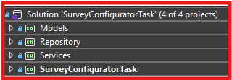
Figure 1

2.1 Model Layer
- Contains classes representing the domain entities of the application.
- Examples include:
  - Question
  - SliderQuestion
  - StarsQuestion
  - SmileyFacesQuestion
- Responsibilities:
  - Define properties for each entity.
  - Provide validation rules for entity data.
  - Serve as the data structure passed between other layers.

Additionally, The AddQuestionDto and EditContext classes contain all properties for all question types in a single structure. This design avoids duplicating DTOs for each type. The application uses the TypeQuestionEnum to determine the question type, and only the relevant fields for that type are read and used from the DTO or context when adding or editing a question.

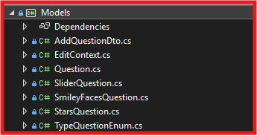
Figure 2

2.2 Repository Layer
- Responsible for direct communication with the SQL Server database.
- Contains methods to:
  - Insert, update, delete, and retrieve data.
  - Handle database-specific operations such as transactions or queries.
- Ensures that database access logic is centralized and reusable.

2.3 Service Layer
- Implements the business logic of the application.
- Uses the Repository Layer to interact with the database.
- Responsibilities:
  - Validate and process user input.
  - Enforce rules related to question types, ordering, and constraints.
  - Handle any operations that combine multiple repository actions.
  - Manage logging of errors.
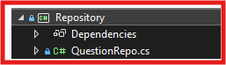
Figure 3

2.4 UI Layer (WinForms)
- Provides the interface that the end user interacts with.
- Responsibilities:
  - Display lists of questions and details.
  - Capture user input for adding, editing, or deleting questions.
  - Communicate with the Service Layer to perform operations.
  - Display messages and error notifications in a user-friendly manner.
This layered design ensures modularity, making it easier to maintain, extend, and test the application.

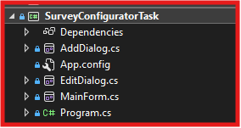
Figure 4

3. Database Design

3.1 Questions Table
- Table Name: Questions
- Purpose: Stores general information shared by all question types.
- Columns:
  - Id (Primary Key, uniqueidentifier)
  - QuestionText (VARCHAR(MAX))
  - QuestionType (INT)
  - QuestionOrder (INT)
All general question information is centralized here.
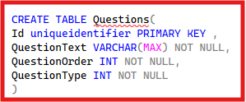
Figure 5

3.2 Type-Specific Tables
Each question type has a dedicated table storing additional properties. The Id column in these tables serves as both the Primary Key and a Foreign Key referencing Questions.Id.
- ON DELETE CASCADE ensures deleting a question from Questions removes the type-specific entry.
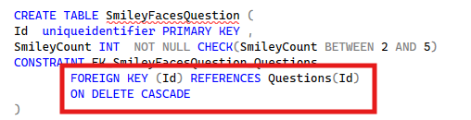
Figure 6

3.2.1 SliderQuestion Table
- Columns:
  - Id (PK, FK to Questions.Id)
  - StartValue (INT)
  - EndValue (INT)
  - StartCaption (VARCHAR(MAX))
  - EndCaption (VARCHAR(MAX))

3.2.2 SmileyFacesQuestion Table
- Columns:
  - Id (PK, FK)
  - SmileyCount (INT) (range: 2–5)

3.2.3 StarsQuestion Table
- Columns:
  - Id (PK, FK)
  - StarsCount (INT) (range: 1–10)

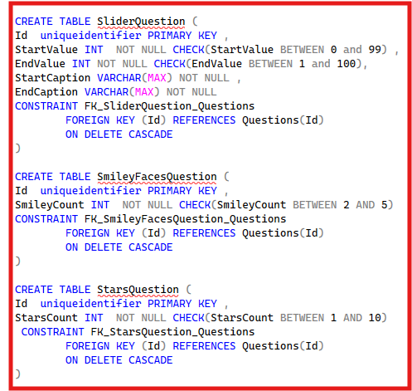

Figure 7

3.3 DatabaseChangeTracker Table
- Purpose: Tracks last modification time for multi-instance support.
- Columns:
  - LastModified (DATETIME2)
- Initial Value: Database creation time.
Any modification updates this value for other instances to detect changes.
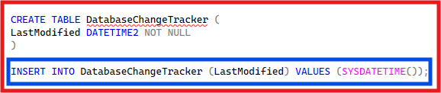
Figure 8

4. Repository Layer
The QuestionRepo class encapsulates all database operations using ADO.NET (Microsoft.Data.SqlClient).

4.1 Purpose
- Encapsulate all CRUD operations for questions.
- Load all question types.
- Maintain question order.
- Track last modification for multi-instance support.
- Ensure transactional integrity.

4.2 Properties
- Questions (List<Question>): In-memory list of loaded questions.

4.3 Methods Overview

4.3.1 Loading Questions
Method: QuestionsLoad()
- Loads all questions, including type-specific properties.
- Joins Questions with type-specific tables.
- Returns a List<Question> with derived types.

4.3.2 Adding Questions
Method: AddQuestion(Question question)
- Inserts into Questions and type-specific tables.
- Operations wrapped in a transaction.
- Uses parameterized queries.

4.3.3 Editing Questions
Method: EditQuestion(Question question)
- Updates general and type-specific tables.
- Transactional.
Method: EditOrder(List<Guid> ids, List<int> orders)
- Updates multiple question orders in one batch using dynamic SQL.

4.3.4 Deleting Questions
Method: DeleteQuestion(Guid Id)
- Deletes from Questions table.
- Cascading deletes handle type-specific rows.

4.3.5 Retrieving a Single Question
Method: GetQuestion(Guid id)
- Retrieves question and type-specific properties.

4.3.6 Counting Questions
Method: GetCount()
- Returns total number of questions.

4.3.7 Multi-Instance Support
Methods:
- GetLastModified(): Returns last modification timestamp.
- UpdateLastModified(): Updates timestamp after changes.
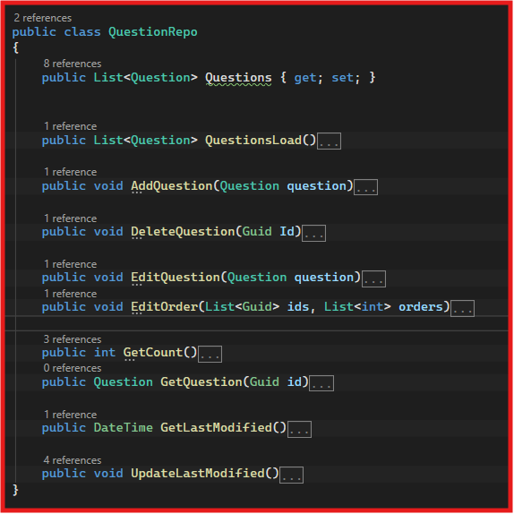
Figure 9

4.4 Database Connection Handling
- Connection string retrieved from App.config, As shown in figure 10 .
- Connections opened just-in-time and closed after operation.
- Transactions used for multi-command operations.
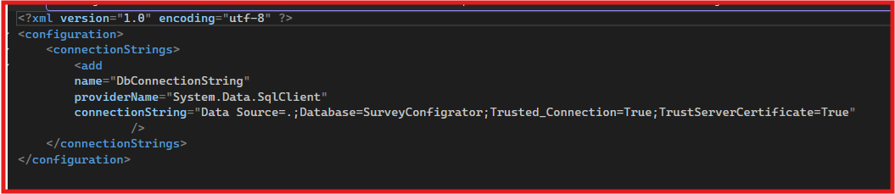
Figure 10

4.5 Error Handling
- Exceptions propagated to Service Layer.
- Transactions rolled back on failure.
- Errors logged by higher layers.

4.6 Notes
- Refresh Questions list after modifications.
- Use parameterized queries to prevent SQL injection.
- Always call UpdateLastModified() for multi-instance support.

5. Service Layer
The QuestionService class implements business logic and interacts with QuestionRepo.

5.1 Purpose
- Acts as a bridge between UI and Repository layers.
- Performs validation, error handling, and logging.
- Maintains in-memory question list for performance.
- Updates DatabaseChangeTracker for multi-instance support.

5.2 Properties
- repo (QuestionRepo): Repository object.
- questions (List<Question>): In-memory list sorted by QuestionOrder.

5.3 Methods Overview

5.3.1 Loading Questions
Method: QuestionsLoadService()
- Loads from repository and sorts by order.

5.3.2 Adding Questions
Method: AddQuestionService(TypeQuestionEnum type, AddQuestionDto questionDto)
- Validates input.
- Creates appropriate Question object.
- Updates in-memory list and repository.
- Updates DatabaseChangeTracker.

5.3.3 Editing Questions
Method: EditQuestionService(Guid id, EditContext editContext)
- Retrieves question from memory.
- Validates editContext.
- Updates in-memory and repository.
- Updates order if changed.
- Updates DatabaseChangeTracker.

5.3.4 Deleting Questions
Method: DeleteQuestionService(Guid id)
- Removes question from memory.
- Calls repository to delete.
- Reorders remaining questions.
- Updates DatabaseChangeTracker.

5.3.5 Managing Question Order
Method: EditOrder()
- Sorts in-memory list.
- Updates QuestionOrder.
- Persists to repository.
- Updates DatabaseChangeTracker.

5.3.6 Retrieving Questions
Methods:
- GetQuestionsList(): Returns in-memory list.
- GetQuestionService(Guid id): Returns single question by ID.

5.3.7 Counting Questions
Method: GetCountService()
- Retrieves count from repository.

5.3.8 Multi-Instance Support
Method: GetLastModifiedService()
- Returns last modification timestamp.

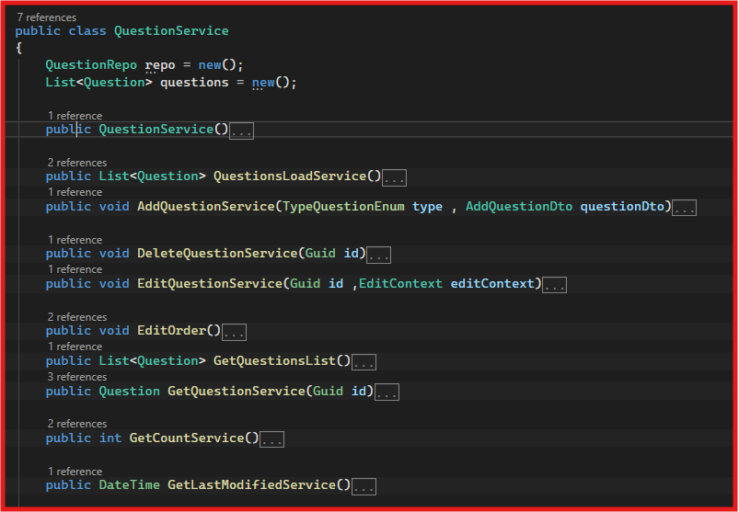
Figure 11

5.4 Error Handling
- Uses try-catch blocks.
- Logs with Serilog.
- Exceptions re-thrown for UI handling.

5.5 Notes
- Maintain in-memory list for performance.
- Always update DatabaseChangeTracker.
- Validate inputs before repository calls.

6. UI Layer
The UI Layer is implemented with WinForms.

6.1 Purpose
- Manage survey questions through a graphical interface.
- Handle add, edit, delete, and selection.
- Support multi-instance consistency.

6.2 MainForm Overview
- Question List: Displays questions.
- Buttons: AddButton, EditButton, DeleteButton.
- Panels: sliderPanel, smileyPanel, starsPanel, generalPanel.
- Labels/TextFields: Show question details.

6.3 MainForm Methods

6.3.1 Loading and Reloading
Method: ReloadMainForm()
- Retrieves list from service layer and binds to UI.

6.3.2 Adding a Question
Event Handler: addButton_Click()
- Opens AddDialog.
- Reloads form after success.

6.3.3 Editing a Question
Event Handler: editButton_Click()
- Opens EditDialog.
- Reloads form after success.

6.3.4 Deleting a Question
Event Handler: deleteButton_Click()
- Confirms deletion.
- Calls DeleteQuestionService().
- Rebinds UI.

6.3.5 Selecting a Question
Event Handler: QuestionList_SelectedIndexChanged()
- Displays relevant panel and details.
- Handles exceptions.
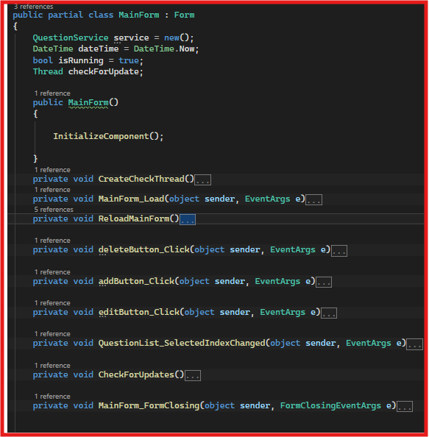
Figure 12

6.4 Multi-Instance Support
- Background thread checks DatabaseChangeTracker.LastModified every 3 seconds.
- Reloads question list if database changed.
- Thread stopped on form closing.
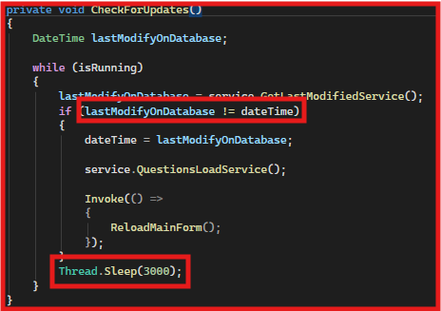
Figure 13

6.5 Error Handling
- Try-catch blocks for all operations.
- Specific exceptions handled with messages.
- Prevents crashes from user actions or inconsistencies.

6.6 Notes
- Always use Service Layer, not direct database access.
- Call ReloadMainForm() after changes.
- Stop background threads on form closing.
- Control visibility dynamically based on question type.

7. Survey Configurator - UI Dialogs

7.1 AddDialog

Purpose
- Create new questions (Slider, Smiley Faces, Stars).

Key Features
- Radio buttons for type selection.
- Enable/disable panels based on type.
- Collect input into AddQuestionDto.
- Call AddQuestionService().

Error Handling
- Handles ArgumentNullException, ArgumentOutOfRangeException, ArgumentException, and others.

7.2 EditDialog

Purpose
- Edit existing question.

Key Features
- Preload values.
- Type selection disabled.
- Input collected into EditContext.
- Call EditQuestionService().
- Validate order value.

Error Handling
- Handles KeyNotFoundException, ArgumentNullException, ArgumentOutOfRangeException, ArgumentException, others.
- Shows message boxes.

7.3 Notes
- Dialogs communicate only with Service Layer.
- Enable only active question type panel.
- Always close dialogs with appropriate DialogResult.

