Survey Configurator Application

End User Documentation
Version: 1.0
Document Type: User Manual
Application Type: Desktop Application (.NET)
Prepared By: Ahmad Jaber

Contents
Survey Configurator Application 1
End User Documentation 1
1. Introduction 3
Key Features 3
2. Getting Started 4
4
3. Main Page Overview 5
3.1 Questions List (Top Half of the Screen) 5
3.2 Question Details (Bottom Half of the Screen) 5
3.3 Action Buttons 6
6
4. Adding a New Question 7
4.1 Question Type Selection 7
4.2 Question Text 8
4.3 Question Properties 8
4.4 Action Buttons 8
5. Editing an Existing Question 9
5.1 Edit Dialog Overview 9
5.2 Modifying Question Data 9
5.3 Question Type Restriction 9
5.4 Question Order 9
5.5 Saving or Canceling Changes 10
6. Deleting a Question 11
6.1 Delete Confirmation 11
6.2 Deletion Behavior 11
7. Question Types and Validation Rules 12
7.1 General Rules 12
7.2 Slider Question 12
Properties 12
7.3 Smiley Faces Question 12
7.4 Stars Question 12
8. Error Messages and Handling 13
8.1 Validation Errors 13
8.2 Database Errors 13
8.3 Unexpected Errors 13

1. Introduction
The Survey Configurator Application is a desktop application designed to help users easily create and manage survey questions. It allows users to define the text, type, and order of each question, as well as configure specific properties based on the selected question type.
With this application, users can efficiently design surveys, customize questions to meet their requirements, and ensure that all configurations are stored and reflected directly in the database. This makes it simple to build, modify, and maintain surveys without the need for manual database handling, providing a clear and user-friendly experience.

Key Features
• Multiple Question Types: Supports Smiley Faces, Slider, and Stars questions.
• Customizable Question Properties: Configure question text, order, and type-specific details.
• Direct Database Updates: All changes are saved immediately to the database.
• Question Management: Add, edit, delete, and reorder questions easily.
• User-Friendly Interface: Designed to match standard Windows and Office application conventions.
• Multi-Instance Support: The application can run on the same or different PCs using a shared database configuration.

2. Getting Started
Before using the Survey Configurator Application, the administrator must install the application on the PC and configure it to connect to the database. Once this setup is completed, no further technical action is required from the user.
After launching the application, the Main Page appears. As shown in Figure 1, From this page, you can view, create, edit, and manage all survey questions.

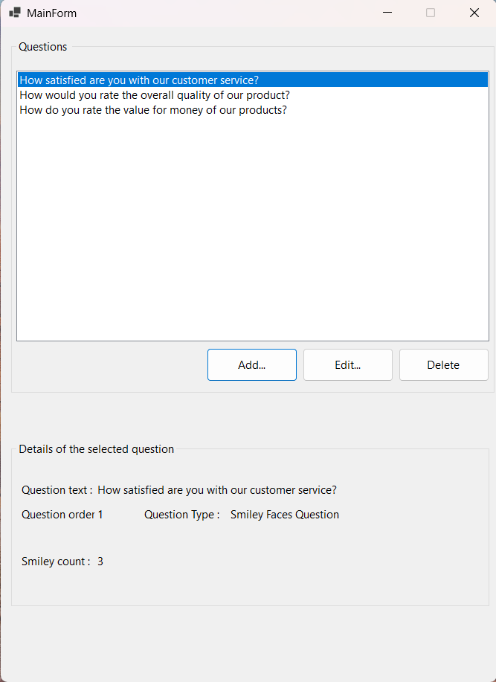
Figure 1

3. Main Page Overview
The Main Page is the central workspace of the Survey Configurator Application.

3.1 Questions List (Top Half of the Screen)
The top half of the screen displays a list of all questions saved in the database. Each item shows the question text, and questions are displayed according to their defined order , As shown in Figure 2.

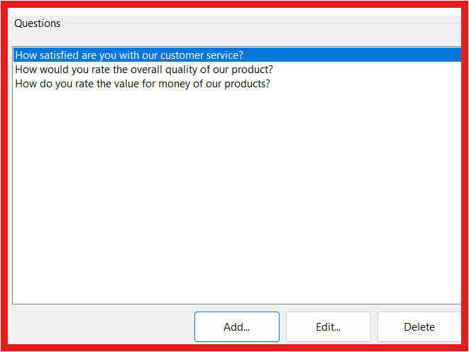
Figure 2

3.2 Question Details (Bottom Half of the Screen)
The bottom half of the screen displays details of the selected question, including:
• Question text
• Question order
• Question type
• Type-specific properties (depending on the question type)
This section allows you to review the configuration of the selected question. As shown in Figure 3.
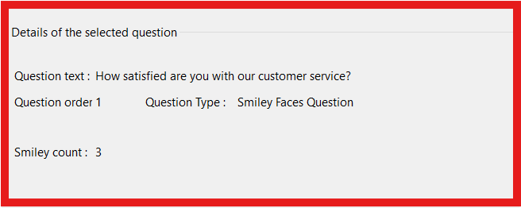
Figure 3

3.3 Action Buttons
Below the questions list, the following buttons are available:
• Add: Opens a dialog to create a new question.
• Edit: Opens a dialog to modify the selected question.
• Delete: Deletes the selected question after confirmation.

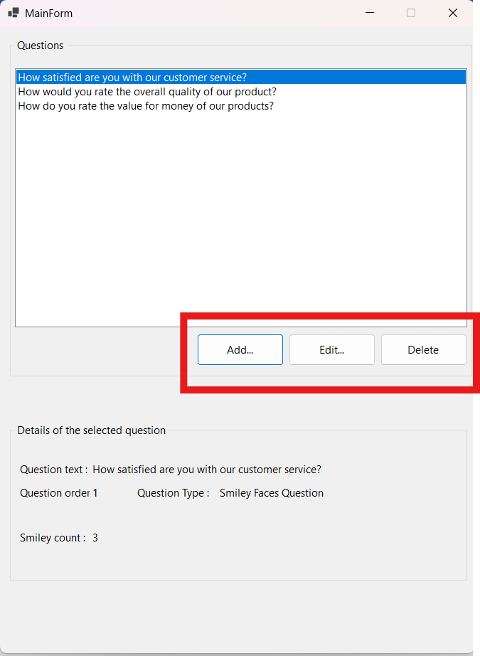
Figure 4

4. Adding a New Question
Clicking the Add button opens a dialog that allows you to create a new question.
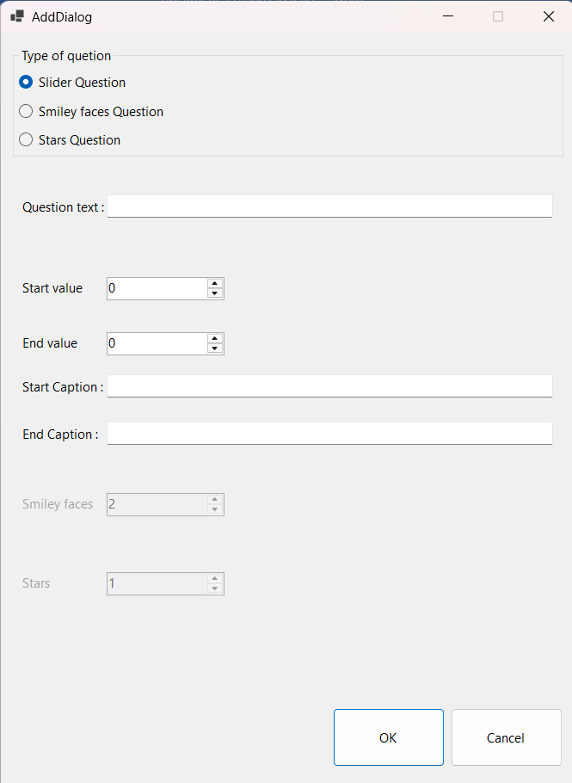
Figure 5

4.1 Question Type Selection
At the top of the dialog, three question types are available:
• Smiley Faces
• Slider
• Stars
You must select one question type before continuing. As shown in Figure 6.
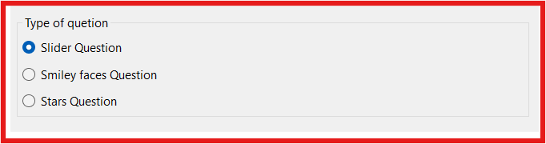
Figure 6

4.2 Question Text
Below the question type selection, enter the question text. This text represents the question shown in the survey.
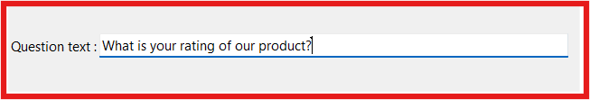
Figure 7

4.3 Question Properties
All possible properties for all question types are displayed in the dialog.
• Only properties related to the selected question type are enabled.
• Properties related to other question types are shown but disabled.
This ensures that only relevant data can be entered. As shown in Figure 8.
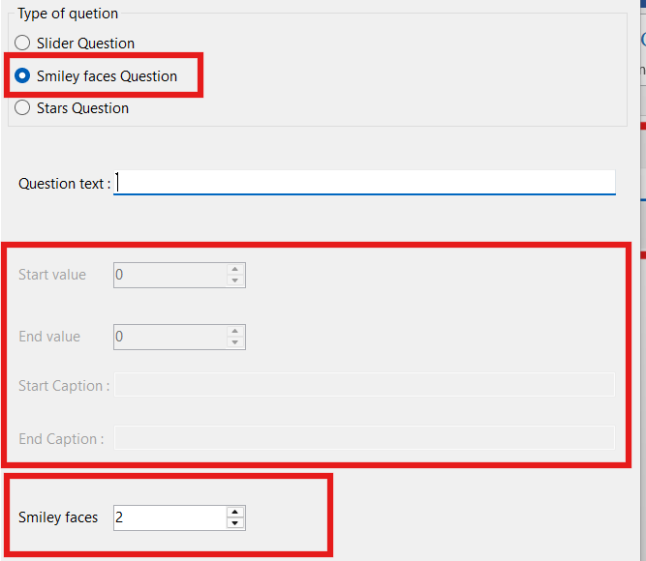
Figure 8

4.4 Action Buttons
• OK: Validates the entered data and saves the question to the database if all values are valid.
• Cancel: Closes the dialog without saving any data.
If validation fails, a clear message is displayed describing the issue.

5. Editing an Existing Question
To edit a question, select it from the list and click the Edit button.
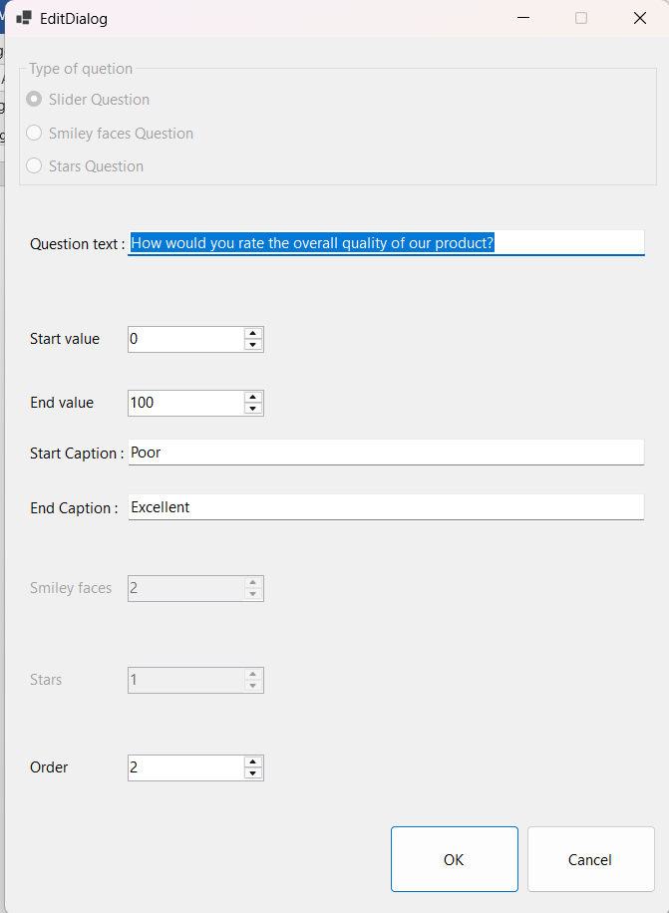
Figure 9

5.1 Edit Dialog Overview
The Edit dialog has the same layout and structure as the Add dialog to maintain consistency .All fields are pre-filled with the selected question’s data loaded from the database.
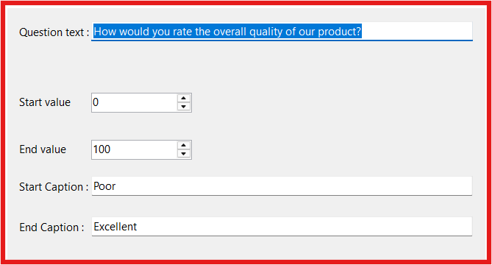
Figure 10

5.2 Modifying Question Data
• You may modify any field or leave it unchanged.
• Only properties related to the question’s type are editable.

5.3 Question Type Restriction
• The question type cannot be changed during editing.
• The type selection is visible but disabled to preserve data integrity.

5.4 Question Order
• The question order field is available only in the Edit dialog.
• You may change the order to reposition the question in the list. As shown in Figure 9.
When adding a new question, the order is automatically assigned to the last position, which is why it does not appear in the Add dialog.

5.5 Saving or Canceling Changes
• OK: Validates and saves the updated data.
• Cancel: Closes the dialog without saving.
Validation errors are shown with clear explanations.

6. Deleting a Question
To delete a question, select it from the list and click Delete.

6.1 Delete Confirmation
A warning message appears to confirm the deletion and prevent accidental data loss.
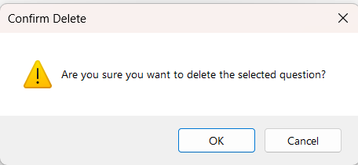
Figure 11

6.2 Deletion Behavior
• Confirming the action permanently removes the question from the list and database.
• This action cannot be undone.
• Remaining questions are automatically reordered to maintain consistent ordering.
Selecting Cancel closes the message without making any changes.

7. Question Types and Validation Rules
This section explains the available question types and their validation rules.

7.1 General Rules
• Question Text: Must not be empty.
• Question Order (Edit only): Must not exceed the total number of questions.

7.2 Slider Question

Properties
Property | Description | Required / Range
Start Value | Minimum slider value | 0–99
End Value | Maximum slider value | 1–100
Start Caption | Label for start value | Required, not empty
End Caption | Label for end value | Required, not empty

7.3 Smiley Faces Question
Property | Description | Required / Range
Number of Smiley Faces | Number of smiley icons in the question | 2–5

7.4 Stars Question
Property | Description | Required / Range
Number of Stars | Number of stars in the question | 1–10

8. Error Messages and Handling
The application may display error messages in the following cases:

8.1 Validation Errors
These errors occur when entered data violates validation rules (such as empty fields or invalid ranges).The application displays a clear and specific message explaining what needs to be corrected.

8.2 Database Errors
These errors occur due to database configuration or connection issues .If this happens, please inform the administrator, as technical intervention may be required.

8.3 Unexpected Errors
Unexpected errors are rare and not caused by user actions .If one occurs, do not worry—please inform the administrator so the issue can be investigated and resolved.

