Ip address

**Router d30-2**

Router>en

Router#conf t

Router(config)#interface FastEthernet2/0

Router(config-if)#ip address 76.0.0.9 255.255.255.252

Router(config-if)#no shutdown

Router(config)#interface FastEthernet0/0

Router(config-if)#ip address 76.0.0.13 255.255.255.252

Router(config-if)#no shutdown

Router(config)#interface FastEthernet1/0

Router(config-if)#ip address 76.0.0.6 255.255.255.252

Router(config-if)#no shutdown

Router(config)#interface GigabitEthernet6/0

Router(config-if)#ip address 76.0.0.81 255.255.255.252

Router(config-if)#no shutdown

Router(config)#interface GigabitEthernet70

Router(config-if)#ip address 76.0.0.77 255.255.255.252

Router(config-if)#no shutdown

**Router d30-1**

Router>en

Router#conf t

Router(config)#interface FastEthernet2/0

Router(config-if)#ip address 76.0.0.10 255.255.255.252

Router(config-if)#no shutdown

Router(config)#interface FastEthernet0/0

Router(config-if)#ip address 76.0.0.17 255.255.255.252

Router(config-if)#no shutdown

Router(config)#interface FastEthernet1/0

Router(config-if)#ip address 76.0.0.2 255.255.255.252

Router(config-if)#no shutdown

Router(config)#interface GigabitEthernet6/0

Router(config-if)#ip address 76.0.0.89 255.255.255.252

Router(config-if)#no shutdown

Router(config)#interface GigabitEthernet70

Router(config-if)#ip address 76.0.0.86 255.255.255.252

Router(config-if)#no shutdown

**Router d20-2**

Router>en

Router#conf t

Router(config)#interface FastEthernet2/0

Router(config-if)#ip address 76.0.0.21 255.255.255.252

Router(config-if)#no shutdown

Router(config)#interface FastEthernet0/0

Router(config-if)#ip address 76.0.0.25 255.255.255.252

Router(config-if)#no shutdown

Router(config)#interface FastEthernet1/0

Router(config-if)#ip address 76.0.0.29 255.255.255.252

Router(config-if)#no shutdown

Router(config)#interface GigabitEthernet6/0

Router(config-if)#ip address 76.0.0.97 255.255.255.252

Router(config-if)#no shutdown

Router(config)#interface GigabitEthernet70

Router(config-if)#ip address 76.0.0.93 255.255.255.252

Router(config-if)#no shutdown

**Router d20-1**

Router>en

Router#conf t

Router(config)#interface FastEthernet2/0

Router(config-if)#ip address 76.0.0.33 255.255.255.252

Router(config-if)#no shutdown

Router(config)#interface FastEthernet0/0

Router(config-if)#ip address 76.0.0.37 255.255.255.252

Router(config-if)#no shutdown

Router(config)#interface FastEthernet1/0

Router(config-if)#ip address 76.0.0.30 255.255.255.252

Router(config-if)#no shutdown

Router(config)#interface GigabitEthernet6/0

Router(config-if)#ip address 76.0.0.105 255.255.255.252

Router(config-if)#no shutdown

Router(config)#interface GigabitEthernet70

Router(config-if)#ip address 76.0.0.102 255.255.255.252

Router(config-if)#no shutdown

**Router d10-2**

Router>en

Router#conf t

Router(config)#interface FastEthernet2/0

Router(config-if)#ip address 76.0.0.49 255.255.255.252

Router(config-if)#no shutdown

Router(config)#interface FastEthernet0/0

Router(config-if)#ip address 76.0.0.45 255.255.255.252

Router(config-if)#no shutdown

Router(config)#interface FastEthernet5/0

Router(config-if)#ip address 76.0.0.41 255.255.255.252

Router(config-if)#no shutdown

Router(config)#interface GigabitEthernet6/0

Router(config-if)#ip address 76.0.0.118 255.255.255.252

Router(config-if)#no shutdown

Router(config)#interface GigabitEthernet70

Router(config-if)#ip address 76.0.0.109 255.255.255.252

Router(config-if)#no shutdown

**Router d10-1**

Router>en

Router#conf t

Router(config)#interface FastEthernet2/0

Router(config-if)#ip address 76.0.0.50 255.255.255.252

Router(config-if)#no shutdown

Router(config)#interface FastEthernet0/0

Router(config-if)#ip address 76.0.0.53 255.255.255.252

Router(config-if)#no shutdown

Router(config)#interface FastEthernet1/0

Router(config-if)#ip address 76.0.0.57 255.255.255.252

Router(config-if)#no shutdown

Router(config)#interface GigabitEthernet6/0

Router(config-if)#ip address 76.0.0.122 255.255.255.252

Router(config-if)#no shutdown

Router(config)#interface GigabitEthernet70

Router(config-if)#ip address 76.0.0.114 255.255.255.252

Router(config-if)#no shutdown

**Core0**

Router>en

Router#conf t

Router(config)#interface FastEthernet0/0

Router(config-if)#ip address 76.0.0.54 255.255.255.252

Router(config-if)#no shutdown

Router(config)#interface FastEthernet1/0

Router(config-if)#ip address 76.0.0.46 255.255.255.252

Router(config-if)#no shutdown

Router(config)#interface FastEthernet2/0

Router(config-if)#ip address 76.0.0.38 255.255.255.252

Router(config-if)#no shutdown

Router(config)#interface FastEthernet3/0

Router(config-if)#ip address 76.0.0.26 255.255.255.252

Router(config-if)#no shutdown

Router(config)#interface FastEthernet4/0

Router(config-if)#ip address 76.0.0.18 255.255.255.252

Router(config-if)#no shutdown

Router(config)#interface FastEthernet5/0

Router(config-if)#ip address 76.0.0.14 255.255.255.252

Router(config-if)#no shutdown

Router(config)#interface GigabitEthernet6/0

Router(config-if)#ip address 76.0.0.73 255.255.255.252

Router(config-if)#no shutdown

Router(config)#interface GigabitEthernet70

Router(config-if)#ip address 76.0.0.69 255.255.255.252

Router(config-if)#no shutdown

**Core 1**

Router>en

Router#conf t

Router(config)#interface FastEthernet0/0

Router(config-if)#ip address 76.0.0.22 255.255.255.252

Router(config-if)#no shutdown

Router(config)#interface FastEthernet1/0

Router(config-if)#ip address 76.0.0.58 255.255.255.252

Router(config-if)#no shutdown

Router(config)#interface FastEthernet2/0

Router(config-if)#ip address 76.0.0.34 255.255.255.252

Router(config-if)#no shutdown

Router(config)#interface FastEthernet3/0

Router(config-if)#ip address 76.0.0.1 255.255.255.252

Router(config-if)#no shutdown

Router(config)#interface FastEthernet4/0

Router(config-if)#ip address 76.0.0.5 255.255.255.252

Router(config-if)#no shutdown

Router(config)#interface FastEthernet5/0

Router(config-if)#ip address 76.0.0.42 255.255.255.252

Router(config-if)#no shutdown

Router(config)#interface GigabitEthernet6/0

Router(config-if)#ip address 76.0.0.65 255.255.255.252

Router(config-if)#no shutdown

Router(config)#interface GigabitEthernet70

Router(config-if)#ip address 76.0.0.61 255.255.255.252

Router(config-if)#no shutdown

MLS

A100-2

Switch>en

Switch#conf t

Enter configuration commands, one per line. End with CNTL/Z.

Switch(config)#int g0/1

Switch(config-if)#no switchport

Switch(config-if)#ip address 76.0.0.70 255.255.255.252

Switch(config-if)#no shutdown

Switch(config)#int g0/2

Switch(config-if)#no switchport

Switch(config-if)#ip address 76.0.0.62 255.255.255.252

Switch(config-if)#no shutdown

A100-1

Switch>en

Switch#conf t

Enter configuration commands, one per line. End with CNTL/Z.

Switch(config)#int g0/1

Switch(config-if)#no switchport

Switch(config-if)#ip address 76.0.0.74 255.255.255.252

Switch(config-if)#no shutdown

Switch(config)#int g0/2

Switch(config-if)#no switchport

Switch(config-if)#ip address 76.0.0.66 255.255.255.252

Switch(config-if)#no shutdown

A30-2

Switch>en

Switch#conf t

Enter configuration commands, one per line. End with CNTL/Z.

Switch(config)#int g0/1

Switch(config-if)#no switchport

Switch(config-if)#ip address 76.0.0.85 255.255.255.252

Switch(config-if)#no shutdown

Switch(config)#int g0/2

Switch(config-if)#no switchport

Switch(config-if)#ip address 76.0.0.78 255.255.255.252

Switch(config-if)#no shutdown

A30-1

Switch>en

Switch#conf t

Enter configuration commands, one per line. End with CNTL/Z.

Switch(config)#int g0/1

Switch(config-if)#no switchport

Switch(config-if)#ip address 76.0.0.90 255.255.255.252

Switch(config-if)#no shutdown

Switch(config)#int g0/2

Switch(config-if)#no switchport

Switch(config-if)#ip address 76.0.0.82 255.255.255.252

Switch(config-if)#no shutdown

A20-2

Switch>en

Switch#conf t

Enter configuration commands, one per line. End with CNTL/Z.

Switch(config)#int g0/1

Switch(config-if)#no switchport

Switch(config-if)#ip address 76.0.0.94 255.255.255.252

Switch(config-if)#no shutdown

Switch(config)#int g0/2

Switch(config-if)#no switchport

Switch(config-if)#ip address 76.0.0.101 255.255.255.252

Switch(config-if)#no shutdown

A20-1

Switch>en

Switch#conf t

Enter configuration commands, one per line. End with CNTL/Z.

Switch(config)#int g0/1

Switch(config-if)#no switchport

Switch(config-if)#ip address 76.0.0.106 255.255.255.252

Switch(config-if)#no shutdown

Switch(config)#int g0/2

Switch(config-if)#no switchport

Switch(config-if)#ip address 76.0.0.98 255.255.255.252

Switch(config-if)#no shutdown

A10-2

Switch>en

Switch#conf t

Enter configuration commands, one per line. End with CNTL/Z.

Switch(config)#int g0/1

Switch(config-if)#no switchport

Switch(config-if)#ip address 76.0.0.113 255.255.255.252

Switch(config-if)#no shutdown

Switch(config)#int g0/2

Switch(config-if)#no switchport

Switch(config-if)#ip address 76.0.0.110 255.255.255.252

Switch(config-if)#no shutdown

A10-1

Switch>en

Switch#conf t

Enter configuration commands, one per line. End with CNTL/Z.

Switch(config)#int g0/1

Switch(config-if)#no switchport

Switch(config-if)#ip address 76.0.0.121 255.255.255.252

Switch(config-if)#no shutdown

Switch(config)#int g0/2

Switch(config-if)#no switchport

Switch(config-if)#ip address 76.0.0.117 255.255.255.252

Switch(config-if)#no shutdown

Change device name

**Core0**

Router(config)#hostname core0

**Core1**

Router(config)#hostname core1

**Router d30-2**

Router(config)#hostname d30_2

**Router d30-1**

Router(config)#hostname d30_1

**Router d20-2**

Router(config)#hostname d20_2

**Router d20-1**

Router(config)#hostname d20_1

**Router d10-2**

Router(config)#hostname d10_2

**Router d10-1**

Router(config)#hostname d10_1

A100-2

Switch(config)#hostname A100-2

A100-1

Switch(config)#hostname A100-1

A 30-2

Switch(config)#hostname A30-2

A 30-1

Switch(config)#hostname A30-1

A 20-2

Switch(config)#hostname A20-2

A 20-1

Switch(config)#hostname A20-1

A 10-2

Switch(config)#hostname A10-2

A 10-1

Switch(config)#hostname A10-1

Switch

A100-3

Switch(config)#hostname A100-3

A100-4

Switch(config)#hostname A100-4

A100-5

Switch(config)#hostname A100-5

A30-3

Switch(config)#hostname A30-3

A30-4

Switch(config)#hostname A30-4

A30-5

Switch(config)#hostname A30-5

A20-3

Switch(config)#hostname A20-3

A20-4

Switch(config)#hostname A20-4

A20-5

Switch(config)#hostname A20-5

A10-3

Switch(config)#hostname A10-3

A10-4

Switch(config)#hostname A10-4

A10-5

Switch(config)#hostname A10-5

**Vlan**

Infra: VLAN ID is 100, name infra.

oStaff: VLAN ID is 10, name Staff.

students1 id 20, students2 id 30, and students3 id 40

**A30-2**

A30-2(config)#vlan 10

A30-2(config-vlan)#name staff

A30-2(config-vlan)#exit

A30-2(config)#vlan 20

A30-2(config-vlan)#name student1

A30-2(config-vlan)#exit

A30-2(config)#vlan 30

A30-2(config-vlan)#name student2

A30-2(config-vlan)#exit

A30-2(config)#vlan 40

A30-2(config-vlan)#name student3

A30-2(config)#int range f0/1-4

A30-2(config-if-range)#switchport trunk encapsulation dot1q

A30-2(config-if-range)#switchport mode trunk

**A30-1**

A30-1(config)#vlan 10

A30-1(config-vlan)#name staff

A30-1(config-vlan)#exit

A30-1(config)#vlan 20

A30-1(config-vlan)#name student1

A30-1(config-vlan)#exit

A30-1(config)#vlan 30

A30-1(config-vlan)#name student2

A30-1(config-vlan)#exit

A30-1(config)#vlan 40

A30-1(config-vlan)#name student3

A30-1(config)#int range f0/1-4

A30-1(config-if-range)#switchport trunk encapsulation dot1q

A30-1(config-if-range)#switchport mode trunk

**A30-3**

A30-3(config)#vlan 10

A30-3(config-vlan)#name staff

A30-3(config-vlan)#exit

A30-3(config)#vlan 20

A30-3(config-vlan)#name student1

A30-3(config-vlan)#exit

A30-3(config)#vlan 30

A30-3(config-vlan)#name student2

A30-3(config-vlan)#exit

A30-3(config)#vlan 40

A30-3(config-vlan)#name student3

A30-3(config)#int range f0/1,f1/1

A30-3(config-if-range)#switchport trunk encapsulation dot1q

A30-3(config-if-range)#switchport mode trunk

A30-3(config)#int f2/1

A30-3(config-if)#switchport mode access

A30-3(config-if)#switchport access vlan 40

A30-3(config)#int f3/1

A30-3(config-if)#switchport mode access

A30-3(config-if)#switchport access vlan 10

**A30-4**

A30-4(config)#vlan 10

A30-4(config-vlan)#name staff

A30-4(config-vlan)#exit

A30-4(config)#vlan 20

A30-4(config-vlan)#name student1

A30-4(config-vlan)#exit

A30-4(config)#vlan 30

A30-4(config-vlan)#name student2

A30-4(config-vlan)#exit

A30-4(config)#vlan 40

A30-4(config-vlan)#name student3

A30-4(config)#int range f0/1,f1/1

A30-4(config-if-range)#switchport trunk encapsulation dot1q

A30-4(config-if-range)#switchport mode trunk

A30-4(config)#int f2/1

A30-4(config-if)#switchport mode access

A30-4(config-if)#switchport access vlan 40

A30-4(config)#int f3/1

A30-4(config-if)#switchport mode access

A30-4(config-if)#switchport access vlan 10

**A30-5**

A30-5(config)#vlan 10

A30-5(config-vlan)#name staff

A30-5(config-vlan)#exit

A30-5(config)#vlan 20

A30-5(config-vlan)#name student1

A30-5(config-vlan)#exit

A30-5(config)#vlan 30

A30-5(config-vlan)#name student2

A30-5(config-vlan)#exit

A30-5(config)#vlan 40

A30-5(config-vlan)#name student3

A30-5(config)#int range f0/1,f1/1

A30-5(config-if-range)#switchport trunk encapsulation dot1q

A30-5(config-if-range)#switchport mode trunk

A30-5(config)#int f2/1

A30-5(config-if)#switchport mode access

A30-5(config-if)#switchport access vlan 40

A30-5(config)#int f3/1

A30-5(config-if)#switchport mode access

A30-5(config-if)#switchport access vlan 10

**A20-2**

A20-2(config)#vlan 10

A20-2(config-vlan)#name staff

A20-2(config-vlan)#exit

A20-2(config)#vlan 20

A20-2(config-vlan)#name student1

A20-2(config-vlan)#exit

A20-2(config)#vlan 30

A20-2(config-vlan)#name student2

A20-2(config-vlan)#exit

A20-2(config)#vlan 40

A20-2(config-vlan)#name student3

A20-2(config)#int range f0/1-4

A20-2(config-if-range)#switchport trunk encapsulation dot1q

A20-2(config-if-range)#switchport mode trunk

**A20-1**

A20-1(config)#vlan 10

A20-1(config-vlan)#name staff

A20-1(config-vlan)#exit

A20-1(config)#vlan 20

A20-1(config-vlan)#name student1

A20-1(config-vlan)#exit

A20-1(config)#vlan 30

A20-1(config-vlan)#name student2

A20-1(config-vlan)#exit

A20-1(config)#vlan 40

A20-1(config-vlan)#name student3

A20-1(config)#int range f0/1-4

A20-1(config-if-range)#switchport trunk encapsulation dot1q

A20-1(config-if-range)#switchport mode trunk

**A20-3**

A20-3(config)#vlan 10

A20-3(config-vlan)#name staff

A20-3(config-vlan)#exit

A20-3(config)#vlan 20

A20-3(config-vlan)#name student1

A20-3(config-vlan)#exit

A20-3(config)#vlan 30

A20-3(config-vlan)#name student2

A20-3(config-vlan)#exit

A20-3(config)#vlan 40

A20-3(config-vlan)#name student3

A20-3(config)#int range f0/1,f1/1

A20-3(config-if-range)#switchport trunk encapsulation dot1q

A20-3(config-if-range)#switchport mode trunk

A20-3(config)#int f2/1

A20-3(config-if)#switchport mode access

A20-3(config-if)#switchport access vlan 40

A20-3(config)#int f3/1

A20-3(config-if)#switchport mode access

A20-3(config-if)#switchport access vlan 10

**A20-4**

A20-4(config)#vlan 10

A20-4(config-vlan)#name staff

A20-4(config-vlan)#exit

A20-4(config)#vlan 20

A20-4(config-vlan)#name student1

A20-4(config-vlan)#exit

A20-4(config)#vlan 30

A20-4(config-vlan)#name student2

A20-4(config-vlan)#exit

A20-4(config)#vlan 40

A20-4(config-vlan)#name student3

A20-4(config)#int range f0/1,f1/1

A20-4(config-if-range)#switchport trunk encapsulation dot1q

A20-4(config-if-range)#switchport mode trunk

A20-4(config)#int f2/1

A20-4(config-if)#switchport mode access

A20-4(config-if)#switchport access vlan 40

A20-4(config)#int f3/1

A20-4(config-if)#switchport mode access

A20-4(config-if)#switchport access vlan 10

**A20-5**

A20-5(config)#vlan 10

A20-5(config-vlan)#name staff

A20-5(config-vlan)#exit

A20-5(config)#vlan 20

A20-5(config-vlan)#name student1

A20-5(config-vlan)#exit

A20-5(config)#vlan 30

A20-5(config-vlan)#name student2

A20-5(config-vlan)#exit

A20-5(config)#vlan 40

A20-5(config-vlan)#name student3

A20-5(config)#int range f0/1,f1/1

A20-5(config-if-range)#switchport trunk encapsulation dot1q

A20-5(config-if-range)#switchport mode trunk

A20-5(config)#int f2/1

A20-5(config-if)#switchport mode access

A20-5(config-if)#switchport access vlan 40

A20-5(config)#int f3/1

A20-5(config-if)#switchport mode access

A20-5(config-if)#switchport access vlan 10

**A10-2**

A10-2(config)#vlan 10

A10-2(config-vlan)#name staff

A10-2(config-vlan)#exit

A10-2(config)#vlan 20

A10-2(config-vlan)#name student1

A10-2(config-vlan)#exit

A10-2(config)#vlan 30

A10-2(config-vlan)#name student2

A10-2(config-vlan)#exit

A10-2(config)#vlan 40

A10-2(config-vlan)#name student3

A10-2(config)#int range f0/1-4

A10-2(config-if-range)#switchport trunk encapsulation dot1q

A10-2(config-if-range)#switchport mode trunk

**A10-1**

A10-1(config)#vlan 10

A10-1(config-vlan)#name staff

A10-1(config-vlan)#exit

A10-1(config)#vlan 20

A10-1(config-vlan)#name student1

A10-1(config-vlan)#exit

A10-1(config)#vlan 30

A10-1(config-vlan)#name student2

A10-1(config-vlan)#exit

A10-1(config)#vlan 40

A10-1(config-vlan)#name student3

A10-1(config)#int range f0/1-4

A10-1(config-if-range)#switchport trunk encapsulation dot1q

A10-1(config-if-range)#switchport mode trunk

**A10-3**

A10-3(config)#vlan 10

A10-3(config-vlan)#name staff

A10-3(config-vlan)#exit

A10-3(config)#vlan 20

A10-3(config-vlan)#name student1

A10-3(config-vlan)#exit

A10-3(config)#vlan 30

A10-3(config-vlan)#name student2

A10-3(config-vlan)#exit

A10-3(config)#vlan 40

A10-3(config-vlan)#name student3

A10-3(config)#int range f0/1,f1/1

A10-3(config-if-range)#switchport trunk encapsulation dot1q

A10-3(config-if-range)#switchport mode trunk

A10-3(config)#int f2/1

A10-3(config-if)#switchport mode access

A10-3(config-if)#switchport access vlan 40

A10-3(config)#int f3/1

A10-3(config-if)#switchport mode access

A10-3(config-if)#switchport access vlan 10

**A10-4**

A10-4(config)#vlan 10

A10-4(config-vlan)#name staff

A10-4(config-vlan)#exit

A10-4(config)#vlan 20

A10-4(config-vlan)#name student1

A10-4(config-vlan)#exit

A10-4(config)#vlan 30

A10-4(config-vlan)#name student2

A10-4(config-vlan)#exit

A10-4(config)#vlan 40

A10-4(config-vlan)#name student3

A10-4(config)#int range f0/1,f1/1

A10-4(config-if-range)#switchport trunk encapsulation dot1q

A10-4(config-if-range)#switchport mode trunk

A10-4(config)#int f2/1

A10-4(config-if)#switchport mode access

A10-4(config-if)#switchport access vlan 40

A10-4(config)#int f3/1

A10-4(config-if)#switchport mode access

A10-4(config-if)#switchport access vlan 10

**A10-5**

A10-5(config)#vlan 10

A10-5(config-vlan)#name staff

A10-5(config-vlan)#exit

A10-5(config)#vlan 20

A10-5(config-vlan)#name student1

A10-5(config-vlan)#exit

A10-5(config)#vlan 30

A10-5(config-vlan)#name student2

A10-5(config-vlan)#exit

A10-5(config)#vlan 40

A10-5(config-vlan)#name student3

A10-5(config)#int range f0/1,f1/1

A10-5(config-if-range)#switchport trunk encapsulation dot1q

A10-5(config-if-range)#switchport mode trunk

A10-5(config)#int f2/1

A10-5(config-if)#switchport mode access

A10-5(config-if)#switchport access vlan 40

A10-5(config)#int f3/1

A10-5(config-if)#switchport mode access

A10-5(config-if)#switchport access vlan 10

**A100-1**

A100-1(config)#vlan 100

A100-1(config-vlan)#name infr

A100-1(config-vlan)#spanning-tree vlan 100 root primary

A100-2(config)#int range f0/1-4

A100-2(config-if-range)#switchport trunk encapsulation dot1q

A100-2(config-if-range)#switchport mode trunk

**A100-2**

A100-2(config)#vlan 100

A100-2(config-vlan)#name infr

A100-1(config-vlan)#spanning-tree vlan 100 root secondary

A100-2(config)#int range f0/1-4

A100-2(config-if-range)#switchport trunk encapsulation dot1q

A100-2(config-if-range)#switchport mode trunk

**A100-3**

A100-3(config)#vlan 100

A100-3(config-vlan)#name infra

A20-5(config)#int f0/1

A20-5(config-if)#switchport mode access

A20-5(config-if)#switchport access vlan 100

**A100-4**

A100-4(config)#vlan 100

A100-4(config-vlan)#name infra

A20-5(config)#int f0/1

A20-5(config-if)#switchport mode access

A20-5(config-if)#switchport access vlan 100

**A100-5**

A100-5(config)#vlan 100

A100-5(config-vlan)#name infra

A20-5(config)#int f0/1

A20-5(config-if)#switchport mode access

A20-5(config-if)#switchport access vlan 100

**Load blance**

**A30-1**

A30-1(config)#spanning-tree vlan 10 root primary

A30-1(config)#spanning-tree vlan 20 root primary

A30-1(config)#spanning-tree vlan 30 root secondary

A30-1(config)#spanning-tree vlan 40 root secondary

**A30-2**

A30-2(config)#spanning-tree vlan 10 root secondary

A30-2(config)#spanning-tree vlan 20 root secondary

A30-2(config)#spanning-tree vlan 30 root primary

A30-2(config)#spanning-tree vlan 40 root primary

**A20-1**

A20-1(config)#spanning-tree vlan 10 root primary

A20-1(config)#spanning-tree vlan 20 root primary

A20-1(config)#spanning-tree vlan 30 root secondary

A20-1(config)#spanning-tree vlan 40 root secondary

**A20-2**

A30-2(config)#spanning-tree vlan 10 root secondary

A30-2(config)#spanning-tree vlan 20 root secondary

A30-2(config)#spanning-tree vlan 30 root primary

A30-2(config)#spanning-tree vlan 40 root primary

**A10-1**

A10-1(config)#spanning-tree vlan 10 root primary

A10-1(config)#spanning-tree vlan 20 root primary

A10-1(config)#spanning-tree vlan 30 root secondary

A10-1(config)#spanning-tree vlan 40 root secondary

**A10-2**

A30-2(config)#spanning-tree vlan 10 root secondary

A30-2(config)#spanning-tree vlan 20 root secondary

A30-2(config)#spanning-tree vlan 30 root primary

A30-2(config)#spanning-tree vlan 40 root primary

**OSPF**

**Core 0**

core1(config)# router ospf 1

core1(config-router)#network 76.0.0.64 0.0.0.3 area 0

core1(config-router)#network 76.0.0.60 0.0.0.3 area 0

core1(config-router)#network 76.0.0.20 0.0.0.3 area 0

core1(config-router)#network 76.0.0.56 0.0.0.3 area 0

core1(config-router)#network 76.0.0.32 0.0.0.3 area 0

core1(config-router)#network 76.0.0.0 0.0.0.3 area 0

core1(config-router)#network 76.0.0.4 0.0.0.3 area 0

core1(config-router)#network 76.0.0.40 0.0.0.3 area 0

**Core 1**

core0(config)#router ospf 1

core0(config-router)#network 76.0.0.72 0.0.0.3 area 0

core0(config-router)#network 76.0.0.68 0.0.0.3 area 0

core0(config-router)#network 76.0.0.52 0.0.0.3 area 0

core0(config-router)#network 76.0.0.44 0.0.0.3 area 0

core0(config-router)#network 76.0.0.36 0.0.0.3 area 0

core0(config-router)#network 76.0.0.24 0.0.0.3 area 0

core0(config-router)#network 76.0.0.16 0.0.0.3 area 0

core0(config-router)#network 76.0.0.112 0.0.0.3 area 0

**D30-2**

d30_2(config)#router ospf 1

d30_2(config-router)#network 76.0.0.4 0.0.0.3 area 0

d30_2(config-router)#network 76.0.0.12 0.0.0.3 area 0

d30_2(config-router)#network 76.0.0.8 0.0.0.3 area 0

d30_2(config-router)#network 76.0.0.80 0.0.0.3 area 78

d30_2(config-router)#network 76.0.0.76 0.0.0.3 area 78

**D30-1**

d30_2(config)#router ospf 1

d30_2(config-router)#network 76.0.0.8 0.0.0.3 area 0

d30_2(config-router)#network 76.0.0.16 0.0.0.3 area 0

d30_2(config-router)#network 76.0.0.0 0.0.0.3 area 0

d30_2(config-router)#network 76.0.0.88 0.0.0.3 area 78

d30_2(config-router)#network 76.0.0.84 0.0.0.3 area 78

**D20-2**

d20_2(config)#router ospf 1

d20_2(config-router)#network 76.0.0.20 0.0.0.3 area 0

d20_2(config-router)#network 76.0.0.28 0.0.0.3 area 0

d20_2(config-router)#network 76.0.0.24 0.0.0.3 area 0

d20_2(config-router)#network 76.0.0.92 0.0.0.3 area 77

d20_2(config-router)#network 76.0.0.96 0.0.0.3 area 77

**D20-1**

d20_2(config)#router ospf 1

d20_2(config-router)#network 76.0.0.36 0.0.0.3 area 0

d20_2(config-router)#network 76.0.0.32 0.0.0.3 area 0

d20_2(config-router)#network 76.0.0.28 0.0.0.3 area 0

d20_2(config-router)#network 76.0.0.100 0.0.0.3 area 77

d20_2(config-router)#network 76.0.0.104 0.0.0.3 area 77

**D10-2**

d20_2(config)#router ospf 1

d20_2(config-router)#network 76.0.0.48 0.0.0.3 area 0

d20_2(config-router)#network 76.0.0.40 0.0.0.3 area 0

d20_2(config-router)#network 76.0.0.44 0.0.0.3 area 0

d20_2(config-router)#network 76.0.0.116 0.0.0.3 area 76

d20_2(config-router)#network 76.0.0.108 0.0.0.3 area 76

**D10-1**

d20_2(config)#router ospf 1

d20_2(config-router)#network 76.0.0.56 0.0.0.3 area 0

d20_2(config-router)#network 76.0.0.52 0.0.0.3 area 0

d20_2(config-router)#network 76.0.0.48 0.0.0.3 area 0

d20_2(config-router)#network 76.0.0.120 0.0.0.3 area 76

d20_2(config-router)#network 76.0.0.112 0.0.0.3 area 76

**department subet**

**staff**

**200 host subnetmask 255.255.255.0**

**Staff 76.(100+79).0.0 76.176.0.0/24**

**it**

**30000 host subnetmask 255.255.128.0/17**

**Staff 76.(10+76).0.0 76.86.0.0/17**

**Student1 76.(20+76).0.0 76.96.0.0/17**

**Student2 76.(30+76).0.0 76.106.0.0/17**

**Student3 76.(40+76).0.0 76.116.0.0/17**

**cs**

**16000 host subnetmask 255.255.192.0/18**

**Staff 76.(10+77).0.0 76.87.0.0/18**

**Student1 76.(20+77).0.0 76.97.0.0/18**

**Student2 76.(30+77).0.0 76.107.0.0/18**

**Student3 76.(40+77).0.0 76.117.0.0/18**

**ce**

**8000 host subnetmask 255.255.224.0/19**

**Staff 76.(10+78).0.0 76.88.0.0/19**

**Student1 76.(20+78).0.0 76.98.0.0/19**

**Student2 76.(30+78).0.0 76.108.0.0/19**

**Student3 76.(40+78).0.0 76.118.0.0/19**

**switch**

**A100-2**

A100-2(config)#int vlan 100

A100-2(config-if)#ip add 76.179.0.1 255.255.255.0

A100-2(config-if)#no sh

A100-2(config)#ip routing

A100-2(config)#router ospf 1

A100-2(config-router)#network 76.0.0.60 0.0.0.3 area 0

A100-2(config-router)#network 76.0.0.68 0.0.0.3 area 0

A100-2(config-router)#network 76.179.0.0 0.0.0.255 area 79

**A100-1**

A100-1(config)#int vlan 100

A100-1(config-if)#ip add 76.179.0.2 255.255.255.0

A100-1(config-if)#no sh

A100-1(config)#ip routing

A100-2(config)#router ospf 1

A100-2(config-router)#network 76.0.0.64 0.0.0.3 area 0

A100-2(config-router)#network 76.0.0.72 0.0.0.3 area 0

A100-2(config-router)#network 76.179.0.0 0.0.0.255 area 79

**A30-2**

A30-2(config)#int vlan 10

A30-2(config-if)#ip add 76.88.0.1 255.255.224.0

A30-2(config-if)#ip ip helper-address 76.179.0.3

A30-2(config-if)#no sh

A30-2(config)#int vlan 20

A30-2(config-if)#ip add 76.98.0.1 255.255.224.0

A30-2(config-if)#ip ip helper-address 76.179.0.3

A30-2(config-if)#no sh

A30-2(config)#int vlan 30

A30-2(config-if)#ip add 76.108.0.1 255.255.224.0

A30-2(config-if)#ip ip helper-address 76.179.0.3

A30-2(config-if)#no sh

A30-2(config)#int vlan 40

A30-2(config-if)#ip add 76.118.0.1 255.255.224.0

A30-2(config-if)#ip ip helper-address 76.179.0.3

A30-2(config-if)#no sh

A30-2(config)#ip routing

A30-2(config)#router ospf 1

A30-2(config-router)#network 76.0.0.76 0.0.0.3 area 78

A30-2(config-router)#network 76.0.0.84 0.0.0.3 area 78

A30-2(config-router)#network 76.88.0.0 0.0.31.255 area 78

A30-2(config-router)#network 76.98.0.0 0.0.31.255 area 78

A30-2(config-router)#network 76.108.0.0 0.0.31.255 area 78

A30-2(config-router)#network 76.118.0.0 0.0.31.255 area 78

**A30-1**

A30-1(config)#int vlan 10

A30-1(config-if)#ip add 76.88.0.2 255.255.224.0

A30-1(config-if)#ip ip helper-address 76.179.0.3

A30-1(config-if)#no sh

A30-1(config)#int vlan 20

A30-1(config-if)#ip add 76.98.0.2 255.255.224.0

A30-1(config-if)#ip ip helper-address 76.179.0.3

A30-1(config-if)#no sh

A30-1(config)#int vlan 30

A30-1(config-if)#ip add 76.108.0.2 255.255.224.

A30-1(config-if)#ip ip helper-address 76.179.0.3

A30-1(config-if)#no sh

A30-1(config)#int vlan 40

A30-1(config-if)#ip add 76.118.0.2 255.255.224.0

A30-1(config-if)#ip ip helper-address 76.179.0.3

A30-1(config-if)#no sh

A30-1(config)#ip routing

A30-1(config)#router ospf 1

A30-1(config-router)#network 76.0.0.88 0.0.0.3 area 78

A30-1(config-router)#network 76.0.0.80 0.0.0.3 area 78

A30-1(config-router)#network 76.88.0.0 0.0.31.255 area 78

A30-1(config-router)#network 76.98.0.0 0.0.31.255 area 78

A30-1(config-router)#network 76.108.0.0 0.0.31.255 area 78

A30-1(config-router)#network 76.118.0.0 0.0.31.255 area 78

**A20-2**

A20-2(config)#int vlan 10

A20-2(config-if)#ip add 76.87.0.1 255.255.192.0

A20-2(config-if)#ip ip helper-address 76.179.0.3

A20-2(config-if)#no sh

A20-2(config)#int vlan 20

A20-2(config-if)#ip add 76.97.0.1 255.255.192.0

A20-2(config-if)#ip ip helper-address 76.179.0.3

A20-2(config-if)#no sh

A20-2(config)#int vlan 30

A20-2(config-if)#ip add 76.107.0.1 255.255.192.0

A20-2(config-if)#ip ip helper-address 76.179.0.3

A20-2(config-if)#no sh

A20-2(config)#int vlan 40

A20-2(config-if)#ip add 76.117.0.1 255.255.192.0

A20-2(config-if)#ip ip helper-address 76.179.0.3

A20-2(config-if)#no sh

A20-2(config)#ip routing

A20-2(config)#router ospf 1

A20-2(config-router)#network 76.0.0.100 0.0.0.3 area 77

A20-2(config-router)#network 76.0.0.92 0.0.0.3 area 77

A20-2(config-router)#network 76.87.0.0 0.0.63.255 area 77

A20-2(config-router)#network 76.97.0.0 0.0.63.255 area 77

A20-2(config-router)#network 76.107.0.0 0.0.63.255 area 77

A20-2(config-router)#network 76.117.0.0 0.0.63.255 area 77

**A20-1**

A20-1(config)#int vlan 10

A20-1(config-if)#ip add 76.87.0.2 255.255.192.0

A20-1(config-if)#ip ip helper-address 76.179.0.3

A20-1(config-if)#no sh

A20-1(config)#int vlan 20

A20-1(config-if)#ip add 76.97.0.2 255.255.192.0

A20-1(config-if)#ip ip helper-address 76.179.0.3

A20-1(config-if)#no sh

A20-1(config)#int vlan 30

A20-1(config-if)#ip add 76.107.0.2 255.255.192.0

A20-1(config-if)#ip ip helper-address 76.179.0.3

A20-1(config-if)#no sh

A20-1(config)#int vlan 40

A20-1(config-if)#ip add 76.117.0.2 255.255.192.0

A20-1(config-if)#ip ip helper-address 76.179.0.3

A20-1(config-if)#no sh

A20-1(config)#ip routing

A20-1(config)#router ospf 1

A20-1(config-router)#network 76.0.0.104 0.0.0.3 area 77

A20-1(config-router)#network 76.0.0.96 0.0.0.3 area 77

A20-1(config-router)#network 76.87.0.0 0.0.63.255 area 77

A20-1(config-router)#network 76.97.0.0 0.0.63.255 area 77

A20-1(config-router)#network 76.107.0.0 0.0.63.255 area 77

A20-1(config-router)#network 76.117.0.0 0.0.63.255 area 77

**A10-2**

A10-2(config)#int vlan 10

A10-2(config-if)#ip add 76.86.0.1 255.255.128.0

A10-2(config-if)#ip ip helper-address 76.179.0.3

A10-2(config-if)#no sh

A10-2(config)#int vlan 20

A10-2(config-if)#ip add 76.96.0.1 255.255.128.0

A10-2(config-if)#ip ip helper-address 76.179.0.3

A10-2(config-if)#no sh

A10-2(config)#int vlan 30

A10-2(config-if)#ip add 76.106.0.1 255.255.128.0

A10-2(config-if)#ip ip helper-address 76.179.0.3

A10-2(config-if)#no sh

A10-2(config)#int vlan 40

A10-2(config-if)#ip add 76.116.0.1 255.255.128.0

A10-2(config-if)#ip ip helper-address 76.179.0.3

A10-2(config-if)#no sh

A10-2(config)#ip routing

A10-2(config)#router ospf 1

A10-2(config-router)#network 76.0.0.108 0.0.0.3 area 76

A10-2(config-router)#network 76.0.0.112 0.0.0.3 area 76

A10-2(config-router)#network 76.86.0.0 0.0.127.255 area 76

A10-2(config-router)#network 76.96.0.0 0.0.127.255 area 76

A10-2(config-router)#network 76.106.0.0 0.0.127.255 area 76

A10-2(config-router)#network 76.116.0.0 0.0.127.255 area 76

**A10-1**

A10-1(config)#int vlan 10

A10-1(config-if)#ip add 76.86.0.2 255.255.128.0

A10-1(config-if)#ip ip helper-address 76.179.0.3

A10-1(config-if)#no sh

A10-1(config)#int vlan 20

A10-1(config-if)#ip add 76.96.0.2 255.255.128.0

A10-2(config-if)#ip ip helper-address 76.179.0.3

A10-1(config-if)#no sh

A10-1(config)#int vlan 30

A10-1(config-if)#ip add 76.106.0.2 255.255.128.0

A10-2(config-if)#ip ip helper-address 76.179.0.3

A10-1(config-if)#no sh

A10-1(config)#int vlan 40

A10-1(config-if)#ip add 76.116.0.2 255.255.128.0

A10-2(config-if)#ip ip helper-address 76.179.0.3

A10-1(config-if)#no sh

A10-1(config)#ip routing

A10-1(config)#router ospf 1

A10-1(config-router)#network 76.0.0.116 0.0.0.3 area 76

A10-1(config-router)#network 76.0.0.120 0.0.0.3 area 76

A10-1(config-router)#network 76.86.0.0 0.0.127.255 area 76

A10-1(config-router)#network 76.96.0.0 0.0.127.255 area 76

A10-1(config-router)#network 76.106.0.0 0.0.127.255 area 76

A10-1(config-router)#network 76.116.0.0 0.0.127.255 area 76

**Dhcp**

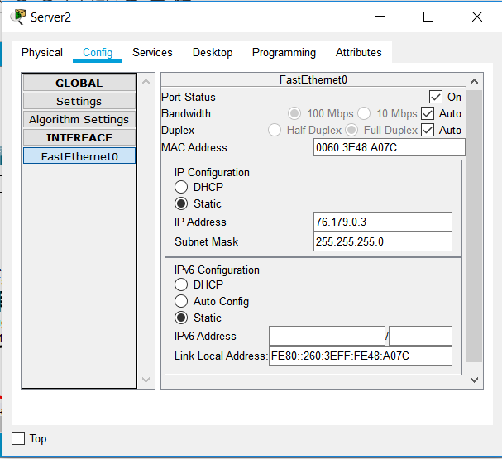

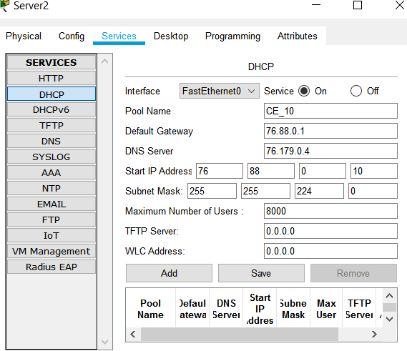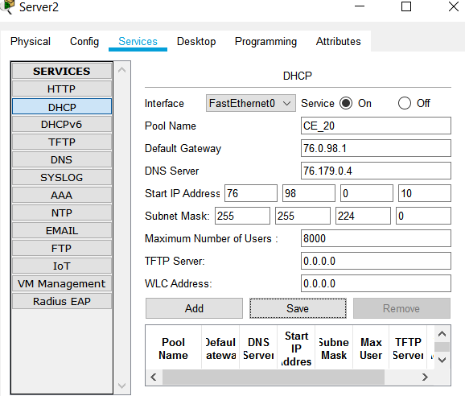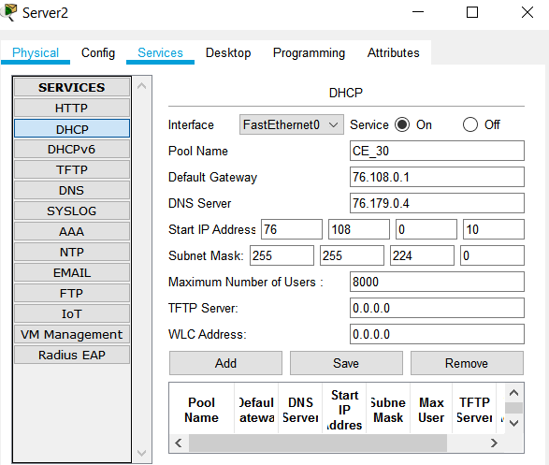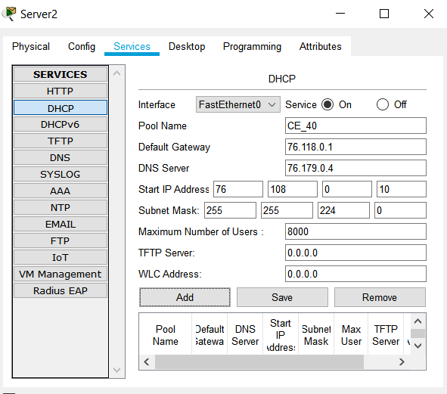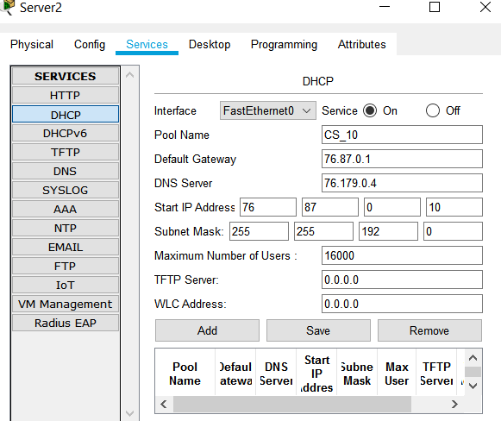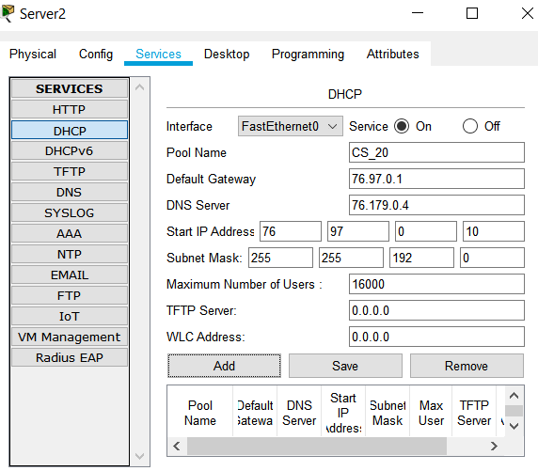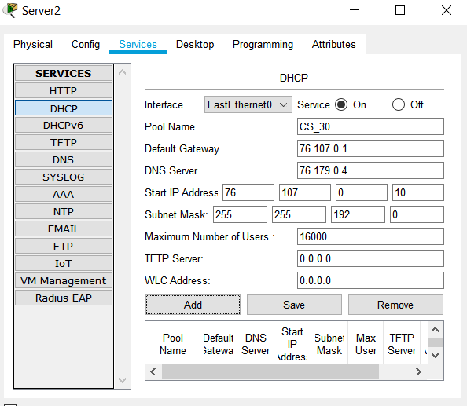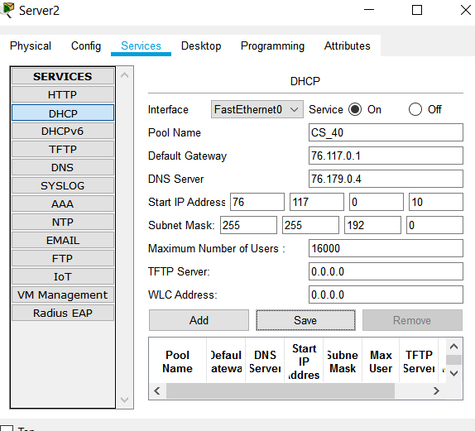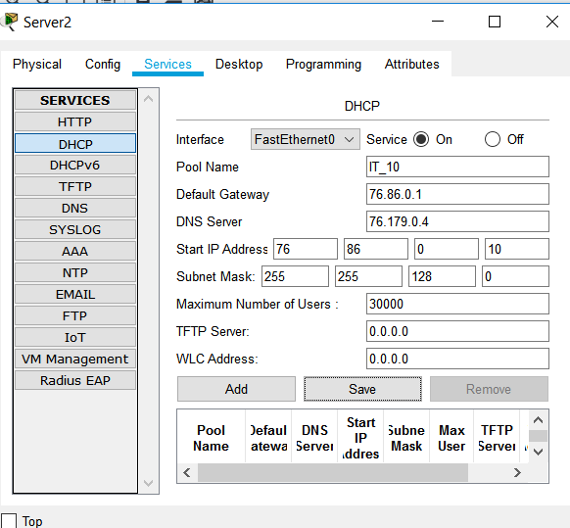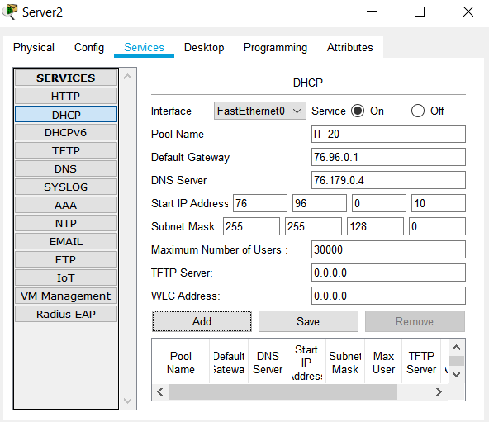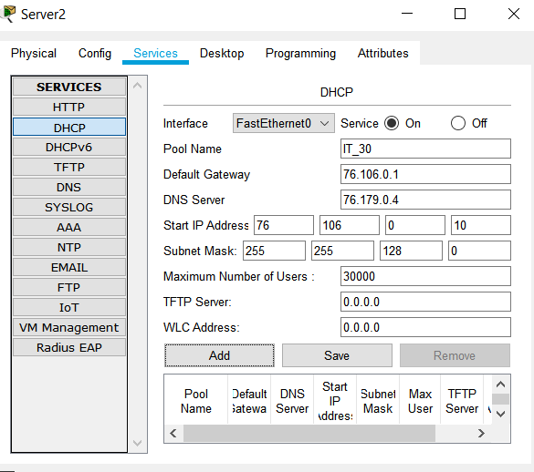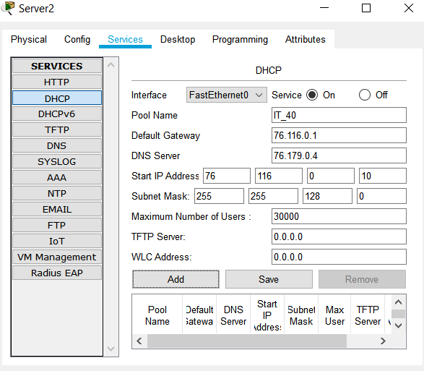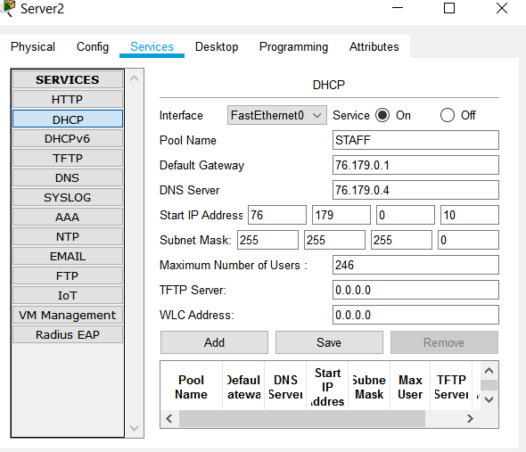

**Dns**

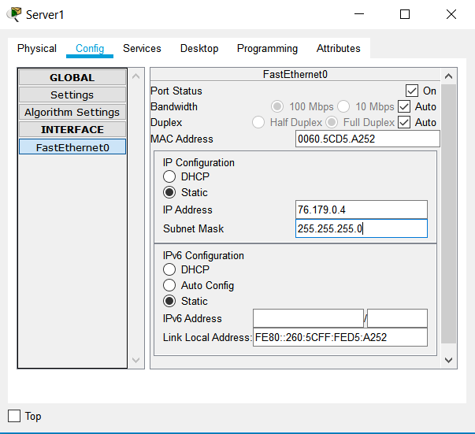

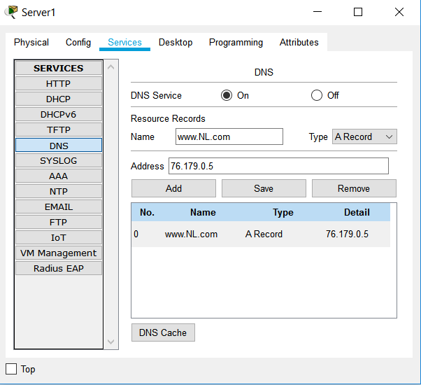

**Web server**

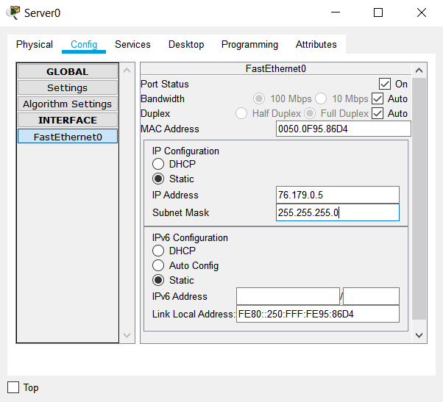

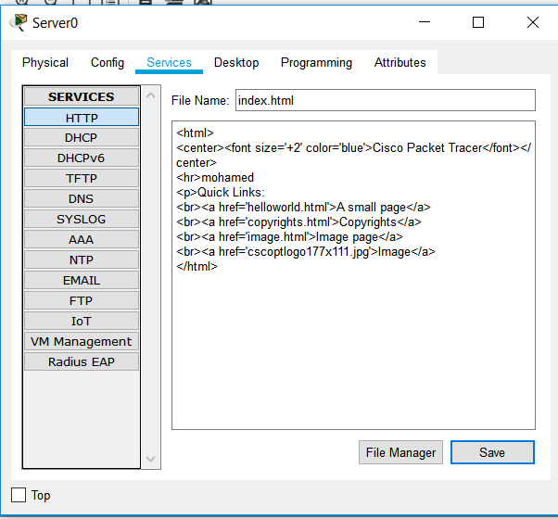

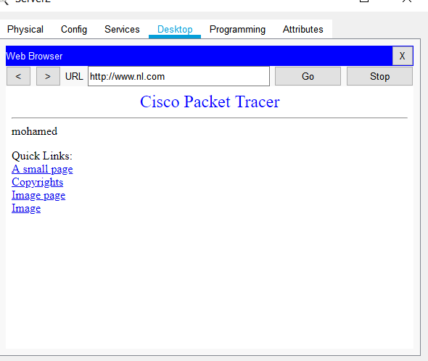

Change the reference bandwidth to be suitable for the topology, and also,you have to change the fiber ports bandwidth to be 1 Gb.•

Core0

core0(config-router)#router ospf 1

core0(config-router)#auto-cost reference-bandwidth 1000

core0(config)#int range f0/0,f1/0,f2/0,f3/0,f4/0,f5/0

core0(config-if-range)#bandwidth 1000

Core 1

Core1(config-router)#router ospf 1

Core1(config-router)#auto-cost reference-bandwidth 1000

core1(config)#int range f0/0,f1/0,f2/0,f3/0,f4/0,f5/0

core1(config-if-range)#bandwidth 1000

D30-2

D30-2(config-router)#router ospf 1

D30-2(config-router)#auto-cost reference-bandwidth 1000

D30-2(config)#int range f0/0,f1/0,f2/0

D30-2 (config-if-range)#bandwidth 1000

D30-1

D30-1(config-router)#router ospf 1

D30-1(config-router)#auto-cost reference-bandwidth 1000

D30-1(config)#int range f0/0,f1/0,f2/0

D30-1 (config-if-range)#bandwidth 1000

D20-2

D20-2(config-router)#router ospf 1

D20-2(config-router)#auto-cost reference-bandwidth 1000

D20-2(config)#int range f0/0,f1/0,f2/0

D20-2 (config-if-range)#bandwidth 1000

D20-1

D20-1(config-router)#router ospf 1

D20-1(config-router)#auto-cost reference-bandwidth 1000

D20-1(config)#int range f0/0,f1/0,f2/0

D20-1 (config-if-range)#bandwidth 1000

D10-2

D10-2(config-router)#router ospf 1

D10-2(config-router)#auto-cost reference-bandwidth 1000

D10-2(config)#int range f0/0,f1/0,f2/0

D10-2 (config-if-range)#bandwidth 1000

D10-1

D10-1(config-router)#router ospf 1

D10-1(config-router)#auto-cost reference-bandwidth 1000

D10-1(config)#int range f0/0,f1/0,f2/0

D10-1 (config-if-range)#bandwidth 1000

Calculate the cost from the IT department to one of the servers.•

From pc 1 to server 2

Fast+fast+giga+giga+giga+fast+fast=100+100+10+10+10+100+100=430

During this topology, how many routers could be removed, and the network will still be working. Explain how is that helpful in designing topologies?

**4router**

**Design for redundant link if one fail other work or load balance between them**

**RESULT**

**PING FROM PC1 TP PC 16**

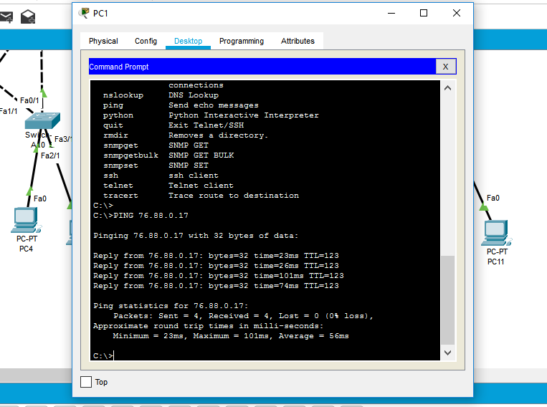

**PC7 TAKE IP FRO DHCP SERVER**

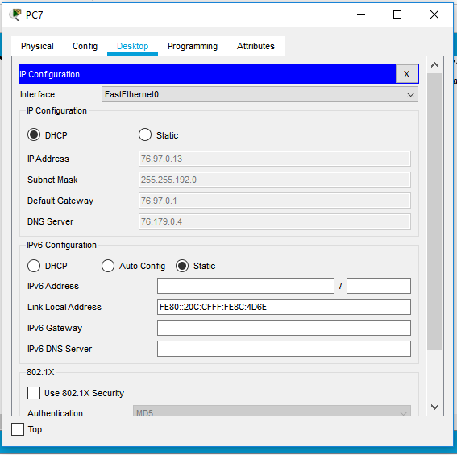

**GO TO WEB SERVER FROM PC7**

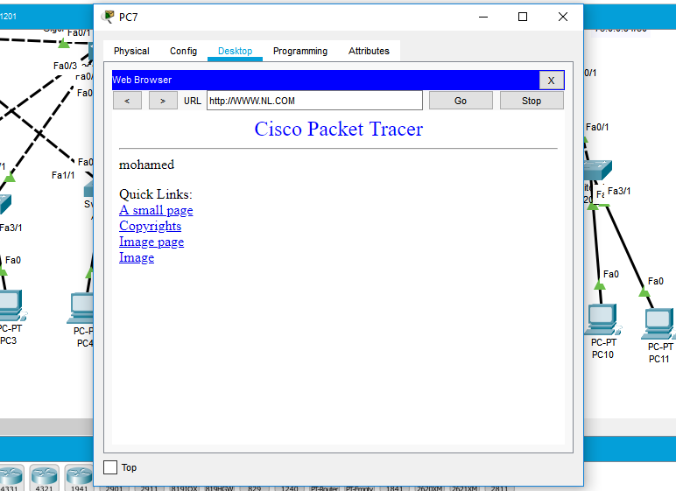

**OSPF IN SHOW IP ROUTE D20-2**

