# Lab 1

1. Install (done)
2. **What is the difference between cat and more command?**
   * Cat prints the content of a file to the terminal while more shows the contents from the top and you can use arrow keys to move up and down and shows you the percentage read in the file.

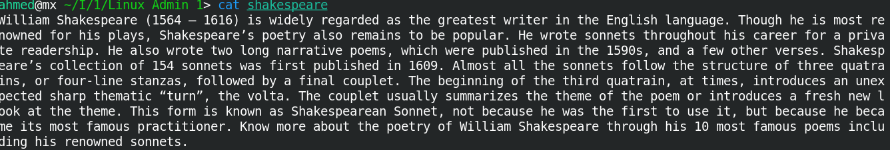

1. **What is the difference between rm and rmdir using man?**
   * rmdir removes directories, rm can be used to remove both directories and files.
2. **Create the following hierarchy under your home directory?**

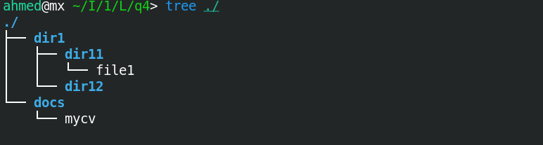

1. **Remove dir11 in one-step. What did you notice? And how did you overcome that?**
   * **Can't remove because it is not empty use –r option**

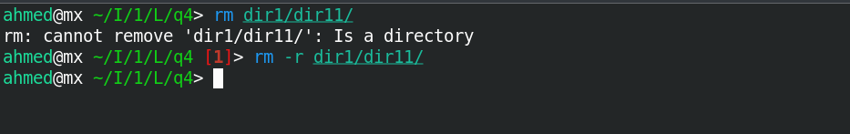

1. Then remove dir12 using rmdir –p command. State what happened to the directory
   * Dir12 and dir1 have been removed.

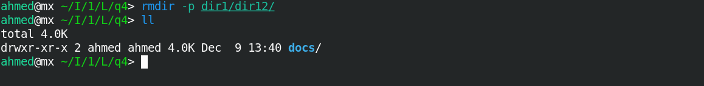

1. The output of the command pwd was /home/user. Write the absolute and relative path for the file mycv.
   * Relative Path: ./docs/mycv
   * Absolute Path: /home/ahmed/docs/mycv

1. **Copy the /etc/passwd file to your home directory making its name is mypasswd.**

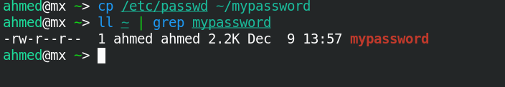

1. **Rename this new file to be oldpasswd.**

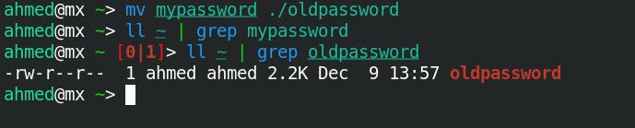

1. **You are in /usr/bin, list four ways to go to your home directory.**
   * **cd ~/**
   * **cd /home/ahmed**
   * **cd ../../home/ahmed**
   * **cd $HOME**
2. **List Linux commands in /usr/bin that start with letter w (Removed)**
3. **Display the first 4 lines of /etc/passwd**

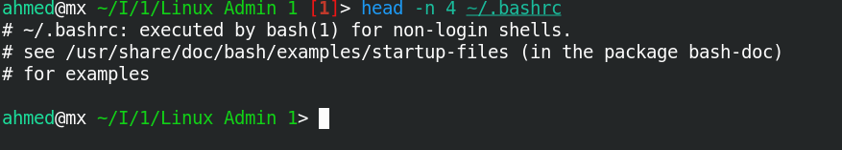

1. **Display the last 7 lines of /etc/passwd**

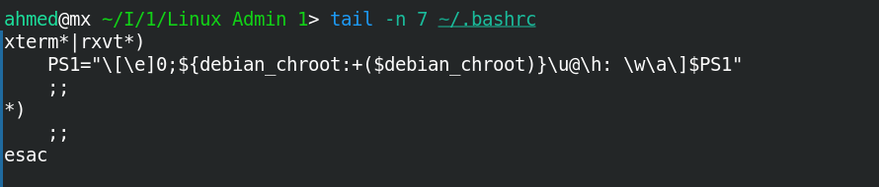

1. **Display the man pages of passwd the command and the file sequentially in one command.**

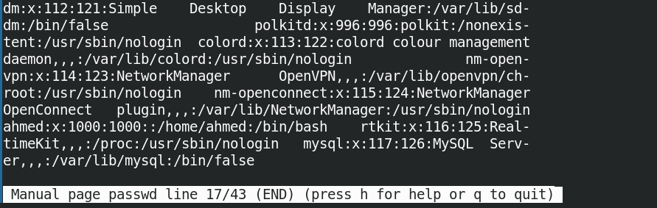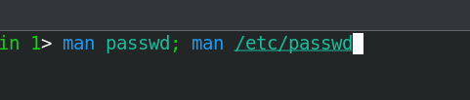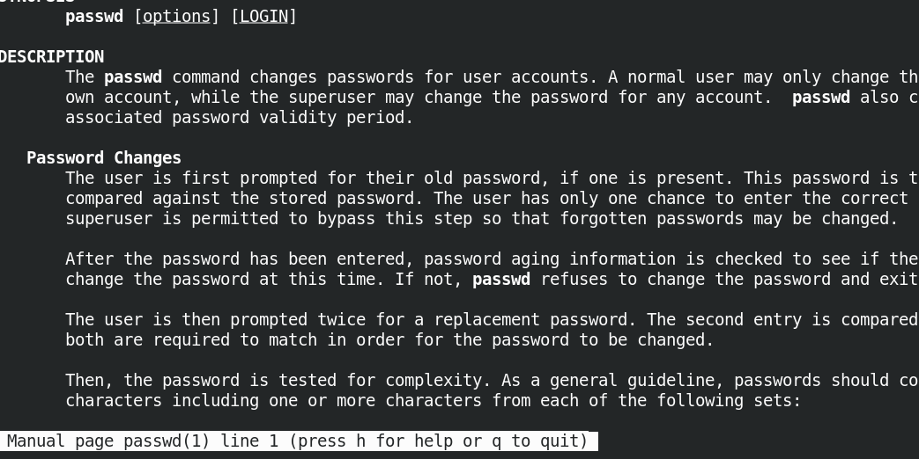

1. **Display the man page of the passwd file.**

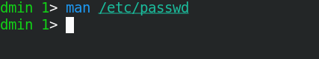

1. **Display a list of all the commands that contain the keyword passwd in their man page.**

